Committee Report
To: | Chair Burley and Members of the Long Term Care Redevelopment Task Force
Committee Date: | June 28, 2022
Subject / Report No: | CAOR-RP-04-22
Title: | Rock Street – Partial Land Transfer Request
Prepared by: | Randy Scherzer
Reviewed by: | Kim Wingrove
Lower Tier(s) Affected: | Municipality of West Grey
Status: | Recommendation adopted by Committee as presented per Resolution CC65-22; Endorsed by County Council July 28, 2022, per Resolution CC67-22.

Recommendation
- That Report CAOR-RP-04-22 be received regarding a request to the Municipality of West Grey to transfer a portion of lands at the end of Rock Street to facilitate the redevelopment of the Rockwood Terrace Campus of Care.

Executive Summary
County staff have had initial discussions with West Grey staff regarding a portion of lands at the end of Rock Street that will be required to facilitate the redevelopment of the Rockwood Terrace Campus of Care in the settlement area of Durham, Municipality of West Grey. The lands in question (Part 1 of Plan 17R-1602) currently form part of a cul-de-sac at the end of Rock Street and would need to be formally ‘closed’ as a public highway and ownership transferred to the County. To facilitate the transfer, a temporary replacement ‘cul-de-sac’ and temporary widening may be required to accommodate traffic utilizing Rock Street during the construction of the Rockwood Terrace Campus of Care. The need for a temporary cul-de-sac and widening will be reviewed by the Kasian Team as part of the overall traffic analysis associated with the Rockwood Terrace Campus of Care project and through further discussions with West Grey staff.

Background and Discussion
County staff have had initial discussions with West Grey staff regarding a portion of lands which form part of a ‘cul-de-sac’ at the end of Rock Street. The lands are described as Part 1 of RP 17R-1602, Geographic Town of Durham, Municipality of West Grey and are highlighted in yellow in Figure 1 below. The subject lands will form part of the overall Rockwood Terrace Campus of Care lands and therefore the lands will need to be formally ‘closed’ as a public highway and transferred to the County. As part of the proposed Rockwood Terrace Campus of Care, Rock Street and South Street East will be extended to connect the two streets in order to provide municipal road access to the Campus of Care. Once the roads have been extended the cul-de-sac at the end of Rock Street will no longer be required.

Figure 1 – Plan 17R-1602
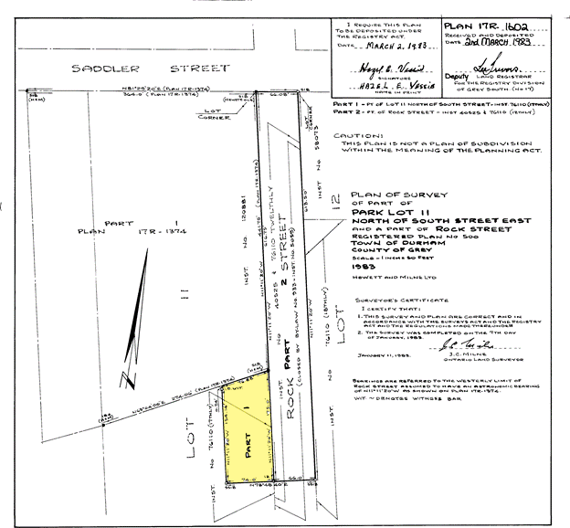
Based on initial discussions with West Grey staff, it was noted that a temporary cul-de-sac may need to be created at the end of Rock Street during the construction of the Campus of Care to accommodate existing traffic utilizing Rock Street. West Grey staff indicated that temporary widening of Rock Street may be required to accommodate on-street parking for the existing Rockwood Terrace staff on the east side of Rock Street during the construction phase. Figure 2 shows the lands that could be required to support a temporary cul-de-sac highlighted in green, the temporary widening of Rock Street that may be required highlighted in yellow, the Rock Street and South Street East road extensions shown in light blue, and the lands being used for the Rockwood Terrace Campus of Care shown in aquamarine. The County owns lands east of Rock Street and therefore if a temporary cul-de-sac and/or widening is required then a portion of the lands could be temporarily transferred to West Grey until such time as the Rock Street East and South Street East extensions are fully constructed. At that time, any lands transferred for the temporary cul-de-sac and/or widening can transferred back to the County. These matters will be reviewed in further detail as part of the Traffic Analysis being conducted by the Kasian design team and through further discussions with West Grey.

Figure 2 – Diagram of Subject Lands
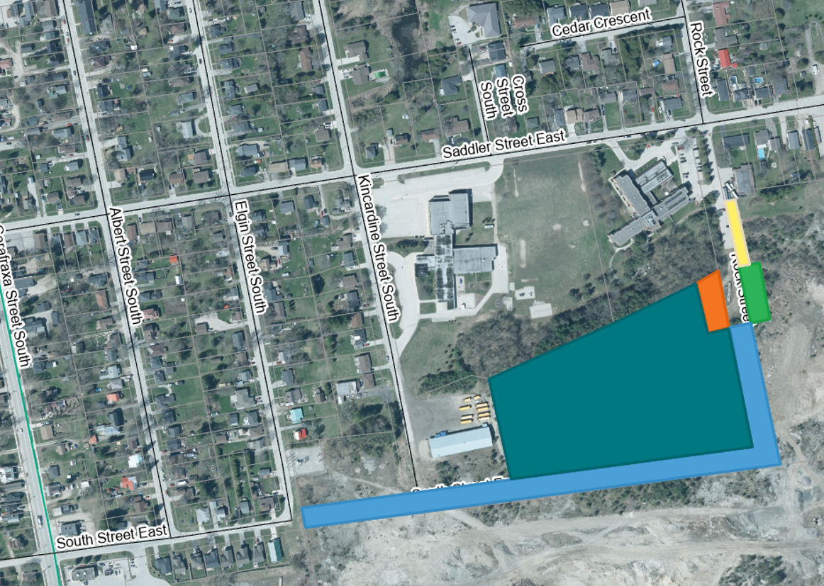

The following are the potential next steps in order to facilitate the transfer of the portion of lands at the end of Rock Street to the County as well as the potential steps required if a temporary cul-de-sac and/or widening is required during the construction phase (see Figure 2):

- The Existing West Cul-de-Sac (orange) currently forms part of Rock Street. It needs to be formally closed as a public highway and ownership transferred to the County so that it may form part of the lands for the Campus of Care.
- In order to facilitate the movement of vehicles on Rock Street south of Saddler Street without the existing West Cul-de-Sac and prior to the establishment of the South Street and Rock Street extensions (light blue), a replacement for the cul-de-sac might be required.
- The County can provide land for a replacement cul-de-sac on the east side of Rock Street if required; this land is identified on the diagram in green (the “Temporary East Cul-de-Sac”). It would need to be transferred to West Grey and West Grey must take steps (if any are necessary) to dedicate it as part of the public highway that is Rock Street.
- Rock Street immediately north of the cul-de-sac lands may need to be temporarily widened to provide parking spaces to offset those that will be displaced by construction activity.
- The County can provide land for the widening referred to in item 4 above if required; it is identified on the diagram in yellow (the “Temporary Rock Street Widening”) and it must be transferred to West Grey and West Grey must take steps (if any are necessary) to dedicate it as part of the public highway that is Rock Street.
- Before either the Temporary East Cul-de-Sac (green) and the Temporary Rock Street Widening (yellow) may serve the roles outlined above, necessary road improvements must be designed and constructed on them. Only once those are complete may the Existing West Cul-de-Sac be closed and transferred to the County.
- Land must be provided for the South Street East and Rock Street extensions (blue). The County can provide this land; it must be transferred to West Grey and West Grey must take steps to dedicate them as extensions of the public highways that are South Street East and Rock Street.
- Before the South Street East and Rock Street extensions may be dedicated as public highways, road improvements must be designed and constructed on them. We also expect that improvements to provide municipal and utility services within their right-of-way will need to be designed and constructed.
- Once the South Street East and Rock Street extensions (blue) are dedicated as public highways, the Temporary East Cul-de-Sac (green) and Temporary Rock Street Widening (yellow) must be closed as public highways and title to them returned to the County for future development of the County-owned lands east of Rock Street.
The timelines to carry out this work have not been fully determined, but the County is prepared to continue to work collaboratively with West Grey to find efficient ways to accomplish this work that will meet the needs and priorities of both West Grey and the County.

In order to formalize the arrangements described above, County staff will prepare a Memorandum of Understanding with West Grey, along with any matters that West Grey would like to include as part of the expansion of the road system related to the redevelopment of the Rockwood Terrace Campus of Care.

Legal and Legislated Requirements
None

Financial and Resource Implications
County staff will assist West Grey with the transfer of lands and any associated legal costs associated with the transfer. There could be additional costs associated with the temporary cul-de-sac and/or temporary widening of Rock Street if required and this will be analysed further as part of the Traffic Analysis currently being conducted by the Kasian project team. Any costs would be part of the overall construction contract for the Campus of Care.

Relevant Consultation
☒ Internal: CAO, Legal Services, Clerks
☒ External: Municipality of West Grey, Colliers Project Leaders, Kasian

Appendices and Attachments
None

