Grey County Logo Committee Report

# Report PSR-TAPS-06-16

**To**: Chair Bell and Members of the Transportation and Public Safety Committee

**From**: Mike Muir, Director of Paramedic Services

Mary Lou Spicer,Deputy Director of Finance

**Meeting Date: April 21, 2016**

**Subject: Paramedic Services 2017 – 2021 Draft Five Year Capital Forecast**

**Status**: Recommendation adopted by Committee as presented per Resolution TAPS51-16; Endorsed by County Council May 3, 2016 per Resolution CC54-16;

## Recommendation

**THAT Report PSR-TAPS-06-16 regarding the Draft Five Year Capital Forecast for 2017 to 2021 for the Paramedic Services department be received as presented and forwarded for inclusion in the corporate Five Year Capital & Extra-Ordinary Expenditures Forecast for consideration by County Council.**

## Background

Attached is a summary of the Five Year Capital Forecast for 2017 to 2021 accompanied by detailed capital project forms for each of the projects being proposed by the Paramedic Services Department for the Committee’s discussion and direction. The forecast continues the planned replacement of vehicles and equipment, provides funds for future capital repairs at the stations and the proposed build of a new station to be located at the Chatsworth Transportation Services depot; there are no new projects contained in the forecast.

The 2017-2021 Five Year Capital Forecast being presented to Committee requires a levy commitment of $599,952 which is an increase of $23,514 over the approved 2016 capital budget.

## Summary

### Vehicles and Equipment

A vehicle and equipment reserve schedule is the basis for determining the annual contribution required to the Paramedic Services reserve and the assumptions that this schedule is based upon are reviewed and updated annually to ensure that adequate funds are set aside for future purchases. An analysis of the reserve shows that an increase to the annual reserve contribution is required and the schedule has been updated to reflect a 3.0% annual increase. All financial costs for vehicles and equipment are presented on separate capital project forms as below:

1. Tablet Computers
2. Ambulance Replacement
3. Stretchers
4. Transfer to Reserves (Vehicle and Equipment Replacement)
5. Emergency Response Unit Replacement

The reserve schedule is refined annually to adjust for changes in estimated replacement costs and estimated useful life spans. The following provides a summary of the lifecycles set for vehicles and equipment:

* Tablet computers used for electronic ambulance call reporting and vehicle mapping applications are scheduled for replacement every five years as a result of receiving a full five year warranty on new computers purchased in 2012.
* All ambulances follow a six year replacement cycle based on mileage, general condition and vehicle repair history. All maintenance is completed by Transportation Services mechanics. Disposal value remains at $5,000; the amount fluctuates depending on the bids received at auction. There has been a reduction of one ambulance from the replacement cycle in 2019; this is the result of the County’s up-staffing of the Craigleith base to 24 hours per day which resulted in the removal of one ambulance from the day shift. Previously, eleven ambulances were on shift during the day shift during the week and ten on weekends; this was adjusted to ten during the day shift during the week and nine on weekends. The fleet includes five additional ambulances that are used in the event of an ambulance out of service for repairs/scheduled maintenance and as a back up if an ambulance is out on a late call so the next shift is able to respond to calls.
* Stretcher replacement will align with the number of ambulances purchased by year. Power assisted stretchers have lifespan of eight years as recommended by the manufacturer. The service introduced power assisted stretchers in 2011 and will continue with power stretchers for all future replacements.
* Emergency Response Units (ERU) utilized by the Duty Supervisors have a replacement cycle of five years due to high use and mileage. Disposal value remains at $2,000 and reflects the historical disposal value for emergency response units.
* The estimated inflationary increase in cost for vehicles (ambulances and ERU) used is 2% based on past experience and continues to be viewed as acceptable for the 2017-2021 capital forecast.
* Cardiac Monitor/Defibrillators are scheduled for replacement in 2016 utilizing a life cycle of seven years.
* Stair Chairs are scheduled for purchase in 2016 and utilizing a life cycle of ten years.
* The Incident Response Unit (trailer) was purchased in 2010 and was given a life cycle of ten years. A review of the condition of the unit in 2016 identified that the life cycle could be extended to fifteen years.

### Building Condition Assessment and Build of Chatsworth Station

* The project sheet “Transfer to/from Reserve Building Condition Assessment (BCA) EMS Station Capital Repairs” sets aside funds for future major capital repairs anticipated within the next 10-15 years including roof, parking lot, HVAC, etc. A building condition assessment was done for the Owen Sound base in 2011; when the BCA is updated in 2016, the Craigleith base will be added. The 2017 BCA transfer to reserve totals $18,331 with $2,000 increases annually based on a review of the cost and timing of future capital repairs. The self-financed debenture of the Craigleith base totals $57,788 and repayment ends in 2016; after utilizing $47,411 of this amount to fund the build of a station at Chatsworth, the remaining funds are available to provide a mechanism to fund future capital projects/repairs with a minimal increase to the levy requirement.
* Included in the 2017-2021 capital budget is the request for funding to build a new ambulance station on County lands to service the Chatsworth, southwest Georgian Bluffs and southeast Meaford areas. This capital request was originally included in the 2015-2019 Five Year Capital Forecast. The new station will be a 2,000 square foot, two bay addition to the existing Chatsworth Transportation Services depot. The 2016 approved budget included $40,000 for engineering, drawings and construction administration. A request for proposal was let on February 25, 2016 and closed on March 18, 2016. The contract was awarded on April 8, 2016. The successful firm will produce design drawings with costing estimates for inclusion in the 2017 budget.

The station would be staffed utilizing existing staffing resources currently in place at the Owen Sound station. When operational, the station will provide greatly improved response times to the Chatsworth and surrounding areas which traditionally have been serviced by the Owen Sound and Markdale stations. Responses directly to the Village of Chatsworth, as well as smaller communities such as Keady and Walter’s Falls will be improved as ambulances responding from Owen Sound must navigate through the city prior to leaving it.

In 2015, the service responded to 431 Code 4 and Code 3 calls to the service area as demonstrated by the map below.

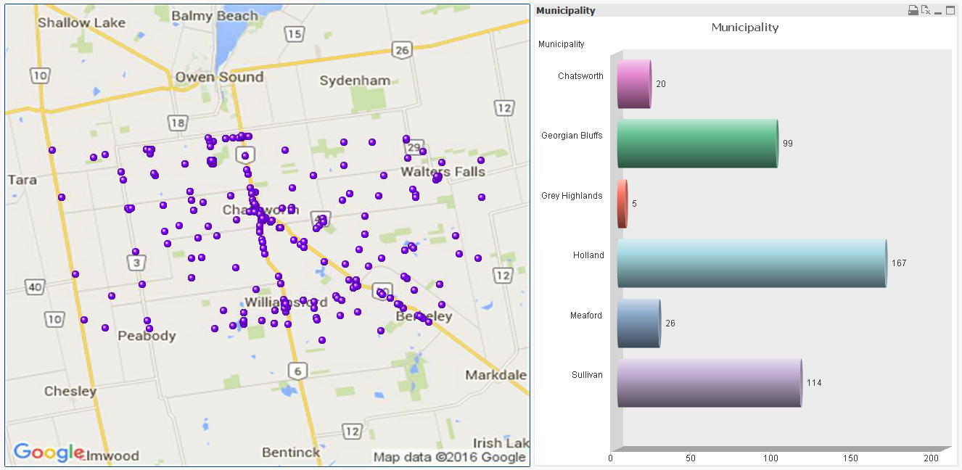

map of 15 kilometer response area that would be serviced by the new baseThe following map identifies a 15 kilometer response area that would be serviced by the new station. The zone buffer will allow for the meeting of the 90th percentile response time target of 15 minutes for CTAS 1 calls within the catchment area.

The new station would be constructed on the Chatsworth Depot site as an addition to the existing works building. The proposed structure is estimated to cost $235.00 per square foot with an overall cost of $517,000 which includes 10% contingency funding. The build would be funded by self-debenture totaling $47,411 per year for a period of 15 years.

### Vehicle and Equipment Reserve Fund Analysis

The capital reserve schedule shows that based upon estimated costs, trade-in values and projected life cycles that the 2016 contribution to reserve should be $651,301 with slight increases each year. However, when this is compared against the December 31, 2015 reserve balance that totals $2,237,393 and projected vehicle and equipment replacement costs over the next five years, staff recommends that the 2016 budgeted transfer to reserve of $518,650 be increased by 3.0% on an annual basis resulting in a recommended transfer to reserve in 2017 of $534,210. The 2015 year end reserve balance reflects the plan to use $100,000 to establish a separate reserve that will be used to fund unbudgeted operating budget expenditures.

The purpose of a stable transfer to reserve is to eliminate spikes in the levy requirement as well as to provide a source of funding when equipment and vehicles are required to be replaced. For example, in the 2016 capital budget $940,618 was budgeted as a transfer from reserve in order to purchase two ambulances, two stretchers, 17 stair chairs and 18 defibrillators. Without the annual reserve contribution, this would create a significant budgetary pressure.

The final page of the reserve schedule titled *“Examination of Reserve Fund Balance to double check if future is adequate with assumptions made”* examines the result of increasing the reserve contribution by 3.0% on an annual basis. The calculation shows that if all assumptions are accurate and no year-end surplus is available to transfer to reserve, there will be a shortfall of $314,069 in 2021.

This does not mean that the reserve will be in a negative balance at that time but rather that for each type of vehicle and equipment that we plan to replace in the future and set aside funds each year for these purchases, at the end of 2021 we will have $314,069 lessin reserve than the calculations indicate is required. Staff will monitor the potential future funding shortfall and continue to update cost assumptions as well as the quantity of vehicles and equipment required but has taken into consideration that the schedule shows that $1,828,739 will be held in reserve at December 31, 2021 for these future purchases. As mentioned above, this takes into account the 2015 recommendation of staff to take $100,000 from the Equipment Reserve and create a separate reserve that could be used as a mechanism to fund unanticipated operating budget expenditures. Based upon this information, staff has reviewed the projection and recommends a budgeted contribution to reserve of $534,210 for 2017 with increases thereafter of 3.0% annually. The reserve schedule is attached to the project sheet titled “Transfer to Reserves (Vehicle and Equipment Replacement)”.

## Financial / Staffing / Legal / Information Technology Considerations

The Building Condition Assessment for the Owen Sound Station and the capital equipment reserve fund schedule have been used to identify priorities and determine when building capital repairs are required as well to ensure that adequate funds have been set aside.

The capital forecast as presented for the Paramedic Services department shows a 2017 net levy amount totaling $599,952, requiring a net levy increase of $23,514 or a 4.08% increase over the 2016 approved capital budget. This $23,514 would reflect a 0.05% increase to the corporate net levy requirement for 2017.

## Link to Strategic Goals / Priorities

The Capital Forecast includes ongoing capital funding to preserve the portfolio of vehicles, equipment and buildings under the care and control of the Transportation and Public Safety Committee, which support Goal 1.6 of the Corporate Strategic Plan. The goal identifies the importance of accelerating Council’s commitment to lifecycle planning for the long term investment of county owned capital assets.

Communication is a key value to the County’s Strategic Plan. The report provides information to Council in regards to the estimated future capital funding requirements and needs.

## Attachments

Attachment to PSR-TAPS-06-16 Paramedic Services 2017-2021 Draft Five Year Capital Forecast

Respectfully submitted by,

Mike Muir

Director Grey County Paramedic Services

Mary Lou Spicer

Deputy Director of Finance