Grey County Logo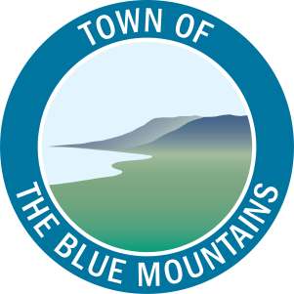

Committee Agenda

# Grey County – The Blue Mountains Task Force January 9, 2020 – Following Committee of the Whole

Heritage Room, Grey County Administration Building

1. **Call to Order**
2. **Declaration of Pecuniary Interest**
3. **Adoption of Minutes**
   1. Grey County – The Blue Mountains Task Force minutes dated October 24, 2019

**That the Grey County – The Blue Mountains Task Force minutes dated October 24, 2019 be adopted as presented.**

1. **Items for Direction and Discussion**
   1. Schedule of Meetings and Grey County – The Blue Mountains Task Force Workplan for 2020
   2. Participation of Grey County staff in the Blue Mountains Budget Public Information Centres and Public Meetings
   3. SWIFT – Update on Proposed Presentation to be presented at County Council
   4. Integration of County Tree By-law with the Blue Mountains’ By-law
   5. Integration of traffic counts through use of OPP Black Cat traffic counters
   6. Notice of Motion introduced by Councillor Odette Bartnicki regarding Prioritization of Attainable Housing
2. **Other Business**
3. **Next Meeting Date**
   1. To be determined
4. **Adjournment**