Grey County Logo Committee Report

# Report PDR-PCD-25-16

**To**: Chair McQueen and Members of the Planning and Community Development Committee

**From**: Randy Scherzer, Director of Planning

**Meeting Date:** June 21, 2016

**Subject: 42T-2010-02 (Taylor Heights Subdivision) – Draft Approval Extension Request**

**Status**:

## Recommendation(s)

**WHEREAS draft plan approval was granted for Plan of Subdivision File 42T-2010-02 (Taylor Heights) by the County of Grey on July 20, 2010 for a six year period;**

**AND WHEREAS a request has been received from the owner’s agent requesting a six year draft approval extension;**

**AND WHEREAS the Township of Chatsworth Council on June 1, 2016 passed a motion supporting the request for an additional six year extension;**

**NOW THEREFORE BE IT RESOLVED THAT the Planning and Community Development Committee receives Planning Report PDR-PCD-25-16;**

**AND THAT the Planning and Community Development Committee hereby grants an extension of draft approval for Plan of Subdivision File 42T-2010-02 to July 20, 2022 under Section 51(33) of the Planning Act, RSO 1990, as amended.**

## Background

Plan of Subdivision File 42T-2010-02 (Taylor Heights) was originally draft approved on July 20, 2010. The original subdivision file (42T-2004-04) had lapsed and the owner at that time applied to reinstate the draft approved subdivision. Phase 1 which consisted of a total of 36 lots has already been registered. Phase 2 which comprises of a total of 21 single detached lots remains draft approved. The subject lands are described as Part of Lot 3, Concession 1 (geographic Township of Sullivan), Township of Chatsworth (see Map 1 below). The subject lands are located west of Highway 6/10, north of Sideroad 1, and would gain access from either Donway Drive or Sullivan Street.

### Map 1: Taylor Heights Subject Lands

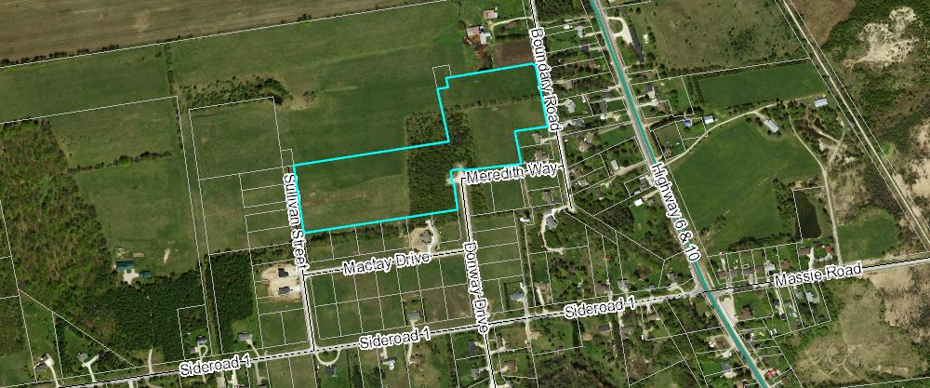The County has received a request from the Owner’s agent requesting an additional six year draft approval extension. The reasons noted in the request letter indicate the following:

* Six years would be consistent with the previous draft approved term approved by the County
* The first phase of the plan consisting of 36 single detached lots has been registered and 30 of these lots have been sold to Barry’s Construction and Insulation Ltd. Barry’s Construction is marketing these lots and have started building on a number of them.
* A booster pump station is required for some of the lots in the first phase and for the lots within Phase 2. The owner is currently in discussions with the Township regarding the booster pump station and it is anticipated that the booster pumping station will be constructed and in operation by 2017.

In a motion dated June 1, 2016, the Council for the Township of Chatsworth supports a 6 year extension to the Taylor Heights Subdivision.

The standard period of time for extensions of draft approval is one year. The granting or supporting of one year extensions has been delegated to the Director of Planning. Extension requests beyond one year are required to be approved by the Planning and Community Development Committee. County staff typically recommends that extensions to draft approval only be for a one year period to ensure that the proponent is continuing to move forward with fulfilling the conditions and to allow local municipalities to have the option of not extending draft approval if the municipality is experiencing servicing capacity issues.

Based on the reasons for the extension request identified in the letter from the Owner’s agent, and based on the Township of Chatsworth supporting the request for a six year extension, County staff recommends that a six (6) year draft approval extension be granted for this development.

## Financial / Staffing / Legal / Information Technology Considerations

At this point there are no financial, staffing, legal or Information Technology considerations. The County has collected a fee for the extension of draft approval.

## Link to Strategic Goals / Priorities

Action 2.10, under Goal 2 of the County’s Strategic Plan requires the continued management of growth and the application of sound land use planning principles. Permitting an extension to draft approval for a previously draft approved subdivision would be considered sound land use planning, given the specific circumstances.

Respectfully submitted by,

Randy Scherzer  
Director of Planning