Grey County Logo Committee Report

| To: | Warden Hicks and Members of Grey County Council |
| --- | --- |
| Committee Date: | October 10, 2019 |
| Subject / Report No: | Addendum to PDR-CW-37-18 |
| Title: | Lora Bay Phase 4 Final Report |
| Prepared by: | Randy Scherzer |
| Reviewed by: | Kim Wingrove |
| Lower Tier(s) Affected: | Town of The Blue Mountains |
| Status: | Recommendation adopted by Committee as presented per Resolution CW200-19; Endorsed by Council October 24, 2019 per Resolution CC83-19; |

# Recommendation

1. **That Addendum to Report PDR-CW-37-18 be received; and**
2. **That all written and oral submissions received on plan of subdivision 42T-2018-10 known as Lora Bay Phase 4 were considered; the effect of which helped to make an informed recommendation and decision; and**
3. **That in consideration of the draft plan of subdivision application 42T-2018-10, for lands described as Block 1 and Part of Block 2, RP 16M-8, in the Town of The Blue Mountains, the Grey County Committee of the Whole approves this plan of subdivision to create a total of thirty-eight residential lots (Lots 1 to 38) and a future multi-residential block (Block 39), subject to the conditions set out in the Notice of Decision.**

## Executive Summary

The County has received a plan of subdivision application (County file number 42T-2018-10) to facilitate the construction of 38 single detached residential units (Lots 1 to 38) and a future development block for multi-residential units (Block 39). Block 39 would be developed through a future site plan and condominium application. Access to the lots would be via two public roads, one would be an extension of West Ridge Drive and the second road would be a crescent shown as Street A on the proposed plan. Servicing to the proposed subdivision will be via municipal water and sewer services, which will be allocated at the draft approval phase. Based on agency review and comments received regarding the proposed plan of subdivision, it is recommended that the proposed plan of subdivision be given draft approval subject to the conditions set out in the attached Notice of Decision.

## Background and Discussion

The County has received a plan of subdivision application, known as Lora Bay Phase 4 to create 38 single detached residential units and a future multi-residential development block (Block 39). The proposal would be to develop Block 39 via a future condominium application and site plan application. The lots would gain access via 2 public roads, the first road being an extension of West Ridge Drive and the second road would be a crescent shown as Street A on the proposed plan.

The proposed subdivision is located on Block 1 and part of Block 2, Plan 16M-8 in the Town of The Blue Mountains. These blocks are part of an overall master planned development known as Lora Bay and this proposed subdivision would represent the fourth phase of this master planned development. The subject lands are currently vacant, with the majority of the block being covered by trees. Map 1 below shows the subject lands and surrounding area, while Map 2 shows the proposed plan of subdivision.

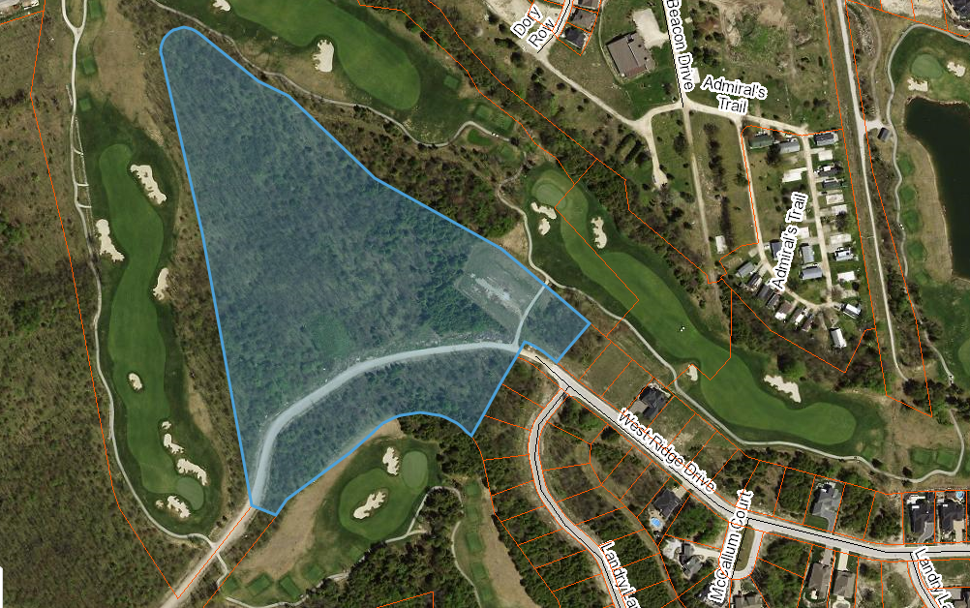

Map 1: Airphoto of Subject Lands

Lands to the north of subject lands are part of the Golf Club at Lora Bay. Further north is a previous phase of the overall Lora Bay development known as Cottages at Lora Bay. Lands to the east include part of the golf course, as well as Phase 2 and 3 of the Cottages of Lora Bay. Lands directly south include golf course lands as well as vacant lands for future phases of the overall Lora Bay development. Lands to the west also include the golf course lands.

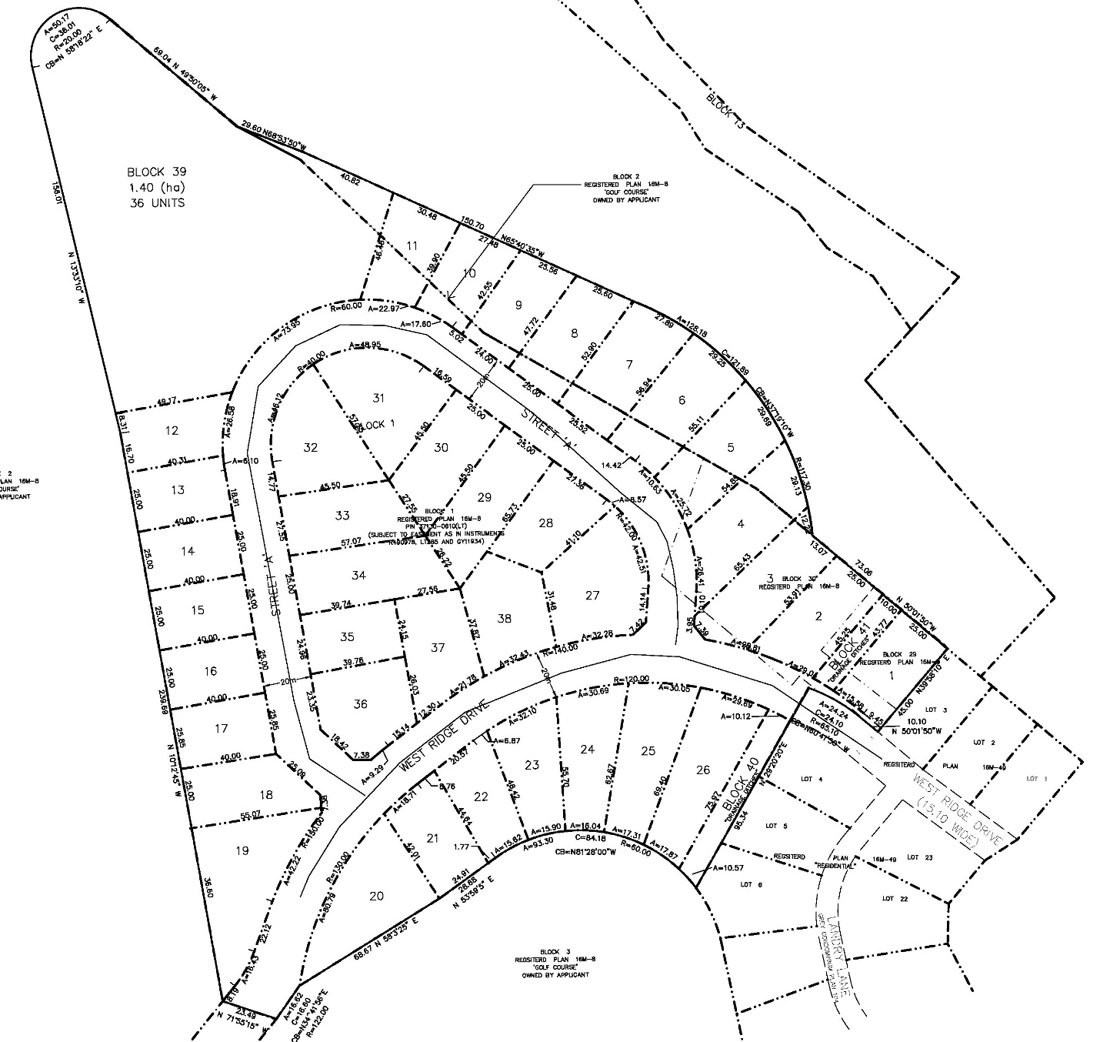

### Map 2: Proposed Plan of Subdivision

The proposed development also requires an amendment to the Town of The Blue Mountains Zoning By-law and an application has been submitted to the Town. The zoning by-law amendment will be considered by the Town at a later date.

Pre-submission consultation between the proponent, the Town of The Blue Mountains, the Grey Sauble Conservation Authority, and the County identified the submission requirements for the proposed plan of subdivision. Additional information was required following the agency review and public meeting which also resulted in minor revisions to the proposed plan. Copies of all background reports and plans can be found at [this link](https://www.grey.ca/planning-development/planning-applications).

### Public and Agency Comments Received

There were members of the public that made written submissions, and oral submissions at the public meeting on January 14, 2019 in the Town of The Blue Mountains. The minutes from the public meeting can be found at [this link](https://docs.grey.ca/share/public?nodeRef=workspace://SpacesStore/cae7f3e7-7ee4-4795-be02-bc9ba6f1c504).

The following people made comments on the plan of subdivision application either in writing or at the public meeting:

* Tony Poole, Lora Bay Condo Corporation 79
* Georgian Cycle and Ski Trail Association
* Patti Piett
* Kevin Green
* David Miller
* Suzette Hastiehouse
* Lyn Logan
* Peg Torrance
* Stu Atkins
* John White
* Paula Hope

The comments received in writing or at the Public Meeting have been summarized into the table below along with a response on how those comments have been considered and addressed.

|  |  |
| --- | --- |
| **Comments Raised** | **How Comments have been considered/addressed?** |
| On-going development should be in accordance to a Master Plan. | An updated Master Concept Plan will be required for future development phases. |
| Road crossings for the Georgian Trail will be generally discouraged | There are no proposed road crossings across the Georgian Trail associated with Phase 4. This will be considered for any future phases. |
| Concerns about construction traffic and recommend that all construction traffic use 39th Sideroad. Barriers should be installed to prevent construction traffic through existing neighbourhood until major activity is completed. | A draft plan condition has been included that requires that the 39th Sideroad be utilized for construction access. Details of construction access will be addressed in the Subdivision Agreement between the Town and the Developer. |
| Concerns about drainage/stormwater issues and ensuring that this development does not exacerbate on-going drainage issues in the area. | A functional servicing report has been submitted and based on review by both the Town and GSCA, they are confident that the existing drainage issues will not be exacerbated by Phase 4. A condition has been included requiring that a detailed stormwater management/drainage report will be submitted to ensure that the stormwater is handled appropriately. The Town is also conducting a sub-regional stormwater review to examine stormwater management within the entire Lora Bay plan area. |
| Short-term accommodations should not be permitted within the proposed residential units. | The proposed zoning by-law amendment will include restrictions on short-term accommodation uses. |
| Concerned about loss of trees. Recommended that a 10 metre buffer be maintained along the entire golf course perimeter. | An Environmental Impact Study and an addendum to that report were submitted with the applications. These have been reviewed by the GSCA and they generally have no objections subject to recommended conditions of draft approval including that a tree retention and management plan be completed to determine the feasibility of maintaining as many existing trees on the lands as possible. This condition has been included. |
| A public trail linkage should be provided through the multi-residential block. Need more pedestrian access points in Lora Bay including sidewalks. | This will be considered as part of the future site plan application for the multi-residential block. The Town has indicated that sidewalks will be provided in accordance with the urban cross section for roads in the municipal engineering standards. |
| Recommended a public meeting for the site plan review of the multi-residential block. | This falls under the Town’s discretion and at this time Town staff have recommended that a public meeting not be considered as there are sufficient controls through zoning and Community Design Guidelines. |
| Questions regarding the application of Lora Bay restrictive covenants to the multi-residential block as it relates to architectural design guidelines. | The Town and the County do not enforce private restrictive covenants. If there are restrictive covenants applied to the land, then any developers will need to consider those for future developments. The Town’s Community Design Guidelines will ensure that the development is compatible. |
| Recommended that West Ridge Drive be assumed by the Town in a timely manner (suggested that this shouldn’t exceed two years). Recommended that the municipal road to 39th Sideroad be constructed now. | The Town has indicated that municipal assumption of the roads will occur once all works have been completed to the satisfaction of the Town. The municipal road extension to 39th Sideroad will be considered as part of Phase 5 in accordance with the Master Development Agreement and once the final road network has been determined for Phase 5. |
| Recommend that golf course equipment stop using West Ridge Drive to access maintenance department to reduce dirt on the roadways. | This matter is not related to this proposed development and relates to the general operation of the private golf course. Any concerns with the operation of the golf course should be directed to the operator of the golf course. |
| Additional amenity space should be considered within Lora Bay. | A total of 3.48 hectares of open space dedications remain outstanding for the Lora Bay Area. Neighborhood/Community Park Blocks will be acquired in future phases in the development. |
| Development needs to be compatible with existing development. Concerns that the proposed density is too high. | The proposed development is consistent with the Master Development Agreement. The future site plan for multi-unit block will be designed to maintain compatibility with zoning and community design guidelines. The proposed multi-residential block is considered to be medium density housing and is permitted by the Town’s Official Plan. |
| Concerned about increase in traffic and parking. | Road improvements are not required for Phase 4 as per the Master Development Agreement and the Traffic Opinion Letter submitted with the development proposal. A further comprehensive review of traffic will be completed for future phases. Adequate parking spaces will be provided for the single detached units. Parking for the multi-residential units will be addressed as part of the site plan process. |

Agency comments were as follows:

* **Historic Saugeen Metis (HSM):** In an email dated October 26, 2018, the HSM noted that they have no objection or opposition to the proposed development.
* **Canada Post:** In a letter dated October 26, 2018, Canada Post noted that the development will be serviced via a central community mailbox. Draft plan conditions have been included to address this matter.
* **Grey Sauble Conservation Authority (GSCA):** In letters dated March 4, 2019 and July 4, 2019, GSCA initially identified some questions with the proposed development. Additional information was provided by the Applicant and based on a review of that information, GSCA recommended that conditions be included requiring that a detailed stormwater management plan be prepared to the satisfaction of GSCA and that a tree/vegetation retention and enhancement plan be completed for the site to the satisfaction of the GSCA. The recommended draft plan conditions have been included.
* **Ministry of Transportation Ontario (MTO):** In comments dated December 13, 2018, MTO indicates that they have no concerns with the proposed Phase 4. MTO notes that the subject lands are outside of the MTO permit control area (jurisdiction).
* **Ministry of Tourism, Culture and Sport (MTCS):** In comments dated January 7, 2019, MTCS notes that the Stage 1 and 2 Archaeological Assessment reports have been entered into the public registry.
* **Town of The Blue Mountains:** A staff report was presented to Town of The Blue Mountains Committee of the Whole and was endorsed by Council on September 9, 2019. The Town Staff report recommended that the Town Council support the proposed subdivision application and recommended some draft plan conditions. The Town’s recommended conditions have been included in the attached draft Notice of Decision.

#### Analysis of Planning Issues

When rendering a land use planning decision, planning authorities must have regard to matters of Provincial Interest under the *Planning Act*, be consistent with the Provincial Policy Statement (PPS) 2014, and conform to any Provincial Plans or Municipal Official Plans that govern the subject lands. In this case, the County of Grey Official Plan and the Town of The Blue Mountains Official Plan have jurisdiction over the subject property. There are no Provincial Plans in place for this part of the Town.

#### Provincial Policy and Legislation

Both the *Planning Act* and the PPS speak to the efficient use of land within settlement areas, where services are readily available. The proposed plan of subdivision is within a settlement area that is serviced by municipal water and sewer services. The PPS indicates that the preferred form of servicing for settlement areas is full municipal services. Municipal water and wastewater treatment capacity is currently available for the proposed units.

The supply of an adequate range of residential housing types is required in both Provincial documents. In this case, the proposed plan of subdivision is providing single detached units and future multi-residential units.

The protection of significant environmental features is also required through the legislation and policy. An Environmental Impact Study and Addendum report were submitted in support of the proposed development. Grey Sauble Conservation Authority (GSCA) have reviewed the reports and recommended conditions of draft approval which have been incorporated into the recommended conditions. Town and County staff will consult with GSCA in order to ensure these conditions have been satisfied prior to final approval being issued.

Section 51(24) of the *Planning Act* also provides criteria which must be considered when assessing any new plan of subdivision. These criteria (in italics), along with staff analysis are as follows:

1. *the effect of development of the proposed subdivision on matters of provincial interest as referred to in section 2;*

The matters of provincial interest have been analyzed earlier on in this section.

1. *whether the proposed subdivision is premature or in the public interest;*

Services can be provided to this subdivision, including future road connections. The lands have also been designated for growth in both the County and Town Official Plan. Furthermore, there is a demand for additional residential units in the Town. As such, the proposed plan of subdivision would not appear to be premature, and is in the public interest.

1. *whether the plan conforms to the official plan and adjacent plans of subdivision, if any;*

The proposed development conforms to both the Town and County Official Plans. This is the 4th Phase of a master planned development and this phase is in accordance with the Master Development Agreement. Future phases of the development will additional studies and reports and further review. Conditions have been included to ensure that the proposed development will be compatible with the existing developments and to ensure that this phase will not add to any existing drainage issues in the area.

1. *the suitability of the land for the purposes for which it is to be subdivided;*

*(d.1) if any affordable housing units are being proposed, the suitability of the proposed units for affordable housing;*

Based on the background reports and technical studies, the subject lands appear suitable for residential development. It is not known if any of the proposed units will be ‘affordable’.

1. *the number, width, location and proposed grades and elevations of highways, and the adequacy of them, and the highways linking the highways in the proposed subdivision with the established highway system in the vicinity and the adequacy of them;*

This item has been reviewed by the proponent, Town staff and County staff. Staff are satisfied that improvements to existing roads and intersections are not required for Phase 4. A comprehensive review of traffic will be completed for future phases of development.

1. *the dimensions and shapes of the proposed lots;*

Based on the shape of the existing parcel of land, and surrounding parcels of land, there are some abnormally shaped lots and blocks in this development. However, through the technical review, and the recommended draft conditions, staff are satisfied that the lands can be appropriately developed as proposed.

1. *the restrictions or proposed restrictions, if any, on the land proposed to be subdivided or the buildings and structures proposed to be erected on it and the restrictions, if any, on adjoining land;*

County staff are not aware of any restrictions or proposed restrictions on the subject lands which would prevent the proposed development. The proposed development is consistent with the Master Development Agreement.

1. *conservation of natural resources and flood control;*

GSCA staff have provided recommended conditions of draft plan approval to address the natural resources on the subject lands. In terms of flood control, a detailed stormwater management plan is required to the satisfaction of the Town in consultation with GSCA. One of the revisions made to the proposed plan was to include an additional drainage block (Block 41) that was requested by the Town for stormwater management purpose.

1. *the adequacy of utilities and municipal services;*

This item is reviewed in other sections of this report. The proposed lands can be adequately serviced.

1. *the adequacy of school sites;*

The two school boards were circulated on this application and did not raise any concerns.

1. *the area of land, if any, within the proposed subdivision that, exclusive of highways, is to be conveyed or dedicated for public purposes;*

As noted above, 3.48 hectares of open space dedications remains outstanding for the Lora Bay Area in accordance with the Master Development Agreement. Neighbourhood/Community Park Blocks will be sought in future phases of the Lora Bay development.

1. *the extent to which the plan’s design optimizes the available supply, means of supplying, efficient use and conservation of energy; and*

In accordance with the Town and County Official Plans, the lands are proposed to be developed at an efficient density, which is also compatible with neighbouring land uses. The lands will connect to the existing road network and services in an efficient manner.

1. *the interrelationship between the design of the proposed plan of subdivision and site plan control matters relating to any development on the land, if the land is also located within a site plan control area designated under subsection 41 (2) of this Act or subsection 114 (2) of the City of Toronto Act, 2006.*

The proposed single detached lots do not require the utilization of site plan control. The multi-residential block will require site plan approval prior to construction within this Block.

The subject plan of subdivision application, with the attached conditions of draft approval, would have regard for matters of Provincial Interest and the criteria of section 51(24) of the *Planning Act*.

#### County Official Plan

The proposed plan of subdivision is on lands designated as ‘Recreational Resort Area’ in the County Official Plan. Recreational Resort Areas are identified as a settlement area and permits development of this nature.

An Environmental Impact Study and Addendum Report were submitted. GSCA has reviewed the studies and has recommended conditions of draft approval which have been incorporated into the recommended conditions.

Section 8.9.1 of the County Plan provides a similar servicing hierarchy to that found in the PPS, which has been noted above. Elsewhere in Section 8.9 of the Plan, are policies which govern roads, transportation, and stormwater management all of which have been addressed as noted above.

It should be noted that the Applicant has requested that the initial draft approval period be for 5 years as they anticipate that they will require this time in order to finalize the development. The Town has supported the initial 5 year draft approval period and County staff have no concerns with this.

#### Town of The Blue Mountains Official Plan

The Town’s Official Plan contains many similar policies to that of the County Official Plan. The Town’s Official Plan designates the subject lands as Residential Recreation Area (RRA) which contemplates development of this nature. In [Town Staff Report PDS.19.95](https://docs.grey.ca/share/public?nodeRef=workspace://SpacesStore/5213c498-982e-44df-aa38-80c5459abcf4), Town Staff indicate that the proposed development conforms to the Town’s Official Plan. County staff agrees with this conclusion.

With the attached recommended draft plan conditions, County staff are of the opinion that the proposed development:

1. has regard for matters of Provincial interest under the *Planning Act*;
2. is consistent with the Provincial Policy Statement;
3. conforms to the County of Grey Official Plan; and
4. conforms to the Town of The Blue Mountains Official Plan.

## Legal and Legislated Requirements

The application was processed in accordance with the *Planning Act.*

## Financial and Resource Implications

There are no anticipated financial, staffing or legal considerations associated with the proposed subdivision, beyond those normally encountered in processing a subdivision application. The County has collected the requisite fee and peer review deposit for this application.

## Relevant Consultation

Internal: Planning, Transportation Services

External: The Public, Town of The Blue Mountains, Grey Sauble Conservation Authority, and other required agencies under the *Planning Act*.

### Appendices and Attachments

*Draft Notice of Decision (conditions of draft approval) – attached*

**NOTICE OF DECISION**

**On Application for Approval of Draft Plan of Subdivision**

**under Subsection 51(37) of the Planning Act**

Draft Plan Approval, is hereby given by the County of Grey for the application regarding the above noted lands. A copy of the Decision is attached.

**PUBLIC AND AGENCY COMMENTS RECEIVED ON THE FILE**

All written and oral submissions received on the application were considered; the effect of which helped to make an informed recommendation and decision.

**WHEN AND HOW TO FILE A NOTICE OF APPEAL**

Notice to appeal the decision to the Local Planning Appeal Tribunal must be filed with the County of Grey no later than 20 days from the date of this notice, as shown above.

The notice of appeal should be sent to the attention of the Director of Planning and Development of the County, at the address shown below and it must,

(1) set out the reasons for the appeal,

(2) be accompanied by the fee required by the Tribunal as prescribed under the Local Planning Appeal Tribunal Act, and

(3) Include the completed appeal forms from the Tribunal’s website.

**WHO CAN FILE A NOTICE OF APPEAL**

Only individuals, corporations or public bodies may appeal decisions in respect of a proposed plan of subdivision to the Local Planning Appeal Tribunal. A notice of appeal may not be filed by an unincorporated association or group. However, a notice of appeal may be filed in the name of an individual who is a member of the association or group on its behalf.

No person* or public body shall be added as a party to the hearing of the appeal of the decision of the approval authority, including the lapsing provisions of the conditions, unless the person or public body, before the decision of the approval authority, made oral submissions at a public meeting or written submissions to the council, or made a written request to be notified of changes to the conditions or, in the Local Planning Appeal Tribunal’s opinion, there are reasonable grounds to add the person or public body as a party. *\*Please note that recent changes have been made to the Planning Act which limits who can appeal a decision related to a plan of subdivision. Please refer to the Planning Act or contact LPAT for more information.*

**RIGHT OF APPLICANT OR PUBLIC BODY TO APPEAL CONDITIONS**

The following may, at any time before the approval of the final plan of subdivision, appeal any of the conditions imposed by the approval authority to the Tribunal by filing a notice of appeal with the approval authority: the applicant; any public body that, before the approval authority made its decision, made oral submissions at a public meeting or written submissions to the approval authority; the Minister; or the municipality in which the subject land is located.

**HOW TO RECEIVE NOTICE OF CHANGED CONDITIONS**

The conditions of an approval of draft plan of subdivision may be changed at any time before the final approval is given.

You will be entitled to receive notice of any changes to the conditions of the approval of draft plan of subdivision if you have made a written request to be notified of changes to the conditions.

**GETTING ADDITIONAL INFORMATION**

Additional information about the application is available for public inspection during regular office hours in the Planning & Development Office at the address noted below or by calling 519-376-2205 or 1-800-567-GREY.

**ADDRESS FOR NOTICE OF APPEAL**

**County of Grey**

**595-9th Avenue East**

**OWEN SOUND, Ontario N4K 3E3**

**Attention: Mr. Randy Scherzer, MCIP RPP**

**Director of Planning & Development**

Plan of Subdivision File No. 42T-2018-10 has been granted draft approval. The County’s conditions of final approval for registration of this draft plan of subdivision are as follows:

**General Requirements**

1. That the final plan shall conform to the Draft Plan of Subdivision File No. 42T-2018- 10 prepared by Zubek, Emo, Patten & Thompson Ltd., Ontario Land Surveyors, dated August 13, 2019 showing:
   1. The extension of West Ridge Drive and Street ‘A’;
   2. 38 Single Detached Lots;
   3. One (1) future multi-residential development block (Block 39) up to a maximum of thirty-six (36) units; and
   4. Two (2) Open Space Blocks (Block 40 and 41).

The legal description of the subject lands is Part of Lot 21, Concession 2, being Part of Blocks 1, 29, 30 Registered Plan 16M-8, Town of the Blue Mountains, County of Grey.

1. That the Owner shall enter into and execute a Subdivision Agreement, in accordance with the Master Development Agreement and Minutes of Settlement, as amended, with the Town of The Blue Mountains (“The Town”), prior to final approval and registration of the Plan to satisfy these conditions and all financial, legal, and engineering matters, including landscaping and the installation of municipal services, and other requirements of the Town and the County of Grey (“the County”), as well as any statutory requirements of other government authorities, including the payment of all applicable Town and County development charges in accordance with the applicable Development Charges By-law.
2. The Owner shall not commence any work on the Lands, including filling, grading, removing trees and/or top soil, installing any works or constructing any buildings or structures until it has entered into a Pre-Servicing Agreement and/or Subdivision Agreement with the Town, in a form satisfactory to the Town.
3. The Owner shall agree in the Subdivision Agreement that all of the works required by the Town, the County, other government authorities and utility providers for the development and servicing of the lands shall be designed and installed in accordance with the Town’s Engineering Standards, and Provincial & Federal Guidelines & Standards, in effect at the date of execution of the Subdivision Agreement. Where compliance with Town Engineering Standards necessitates off- site works, (i.e. stormwater management system upgrades, localized water storage for the multi-residential block) the owner shall enter into agreements with the Town to implement the requisite off-site works, to the satisfaction of the Town.
4. Prior to final approval and registration, the Zoning By-law implementing the subject plan shall be approved under Section 34 and 36 of the Planning Act. The implementing Zoning shall include:
5. A Holding (-h) provision on some or all of the lands (as applicable) which may only be lifted upon:
   1. Registration of an executed Site Plan Agreement on title of the lands for the multi-residential block (Block 39 on Draft Plan);
6. Prior to final approval and registration, the Owner shall remove any existing buildings/structures from the site.
7. The internal public streets shall be named to the satisfaction of the Town in accordance with the Town of The Blue Mountains Street Naming Policy.
8. Prior to final approval and registration, the Owner shall include the following clause in the Subdivision Agreement:

“The Owner, Town and County acknowledge that pursuant to Section 4.1.c of the Master Development Agreement dated October 17, 2005, concepts for the future proposed phases of development will be a requirement of a Subdivision Pre- Consultation Application for future phases pursuant to Section 51(1)(16.1)(a) of the Planning Act. This will include an updated overall Concept Plan for the remaining lands that have been designated for development.”

**Servicing, Grading and Road Requirements**

1. Prior to preparation of a Subdivision Agreement by the Town, the Applicant shall submit the following to the satisfaction of the Town and the County, in consultation with the Grey Sauble Conservation Authority (the “GSCA”),:
2. A detailed engineering and drainage report, in accordance with the Master Development Agreement, and any subsequent reports or studies, which describes the stormwater drainage system for the proposed development on the subject lands. The report should include:
   1. Plans illustrating how the drainage system will integrate into the drainage of surrounding properties;
   2. The stormwater management techniques which may be required to control minor and major flows;
   3. How external flows will be accommodated and the design capacity of the receiving system;
   4. Location and description of all outlets and other facilities which may require permits;
   5. Proposed methods for controlling or minimizing erosion and siltation on-site and/or in downstream areas during and after construction;
   6. Overall grading plans for the subject lands;
   7. Stormwater overland flow routes shall be kept within roads, approved walkways, or an approved easement only.
   8. Confirmation that the treatment and conveyance approaches and facilities will have no negative effect on drainage issues within the Lora Bay area

It is recommended that the Owner or their consultant shall contact the Town and the GSCA, prior to preparing the above report to clarify the specific requirements of this development.

1. A detailed Servicing Plan providing for municipal sewers and water to the satisfaction of the Town.
2. Prior to final approval and registration, the Owner shall agree in the Subdivision Agreement, in wording acceptable to the Town in consultation with the GSCA;
3. To carry out, or cause to be carried out, all the works referred to in condition 10(a) above; and
4. To comply with all statutory requirements of the GSCA, as amended from time to time.
5. Prior to final approval and registration, the Owner shall submit a detailed soils investigation of the site prepared by a qualified geotechnical engineer, to the satisfaction of the Town. A copy of this report shall also be submitted to the Town’s Chief Building Official;
6. The Owner shall convey all road allowances, road widenings, daylighting, pathways, and municipal 0.3m reserves as identified on the final plan.
7. The Owner shall agree to convey the stormwater management blocks, identified as Block 40 and Block 41 on the Draft Plan, to the Town.
8. Prior to final approval and registration, arrangements shall be made to the satisfaction of the Town for any relocation of utilities required by the development of the subject lands, to be undertaken at the Owner’s expense.
9. That this draft approval represents the allocation by the Town of water and wastewater treatment capacity for 38 residential units and up to a maximum of 36 multi-residential units within Block 39.
10. That the Owner shall maintain satisfactory construction/emergency access to the lands from the 39th Sideroad, according to plans approved by the Town. Any necessary improvements required to implement the approved plans shall be completed prior to the issuance of any building permits on the subject lands. The secondary access is to be maintained year-round by the Owner for construction and emergency purposes to the lands until such a time that future phases are developed.

**Landscaping, Trees, Fencing, and Streetscape Requirements**

1. Prior to entering into a Pre-Servicing Agreement or Subdivision Agreement by the Town, the Owner shall complete the following to the satisfaction of the Town in consultation with the GSCA:
2. A Landscape Analysis & detailed Landscape Plan, in accordance with the Municipal Official Plan and Town’s Community Design Guidelines; and
3. A Tree Preservation Plan and Tree Restoration Plan in accordance with the recommendations of the approved Environmental Impact Statement and the Master Development Agreement.

**Parkland and Open Space Requirements**

1. That prior to final plan approval and registration, the Owner shall include the following clause in the Subdivision Agreement:

“The Owner and the Town acknowledge that pursuant to Section 2c of Schedule “H” of the Master Development Agreement dated October 17, 2005, the outstanding parkland requirement for this development subsequent to Phase 2 is 3.48ha. The Owner and the Town acknowledge that this parkland dedication will not be implemented upon registration of Phase 4. Upon registration of phases of the development subsequent to Phase 4, the Owner will satisfy the outstanding parkland requirement of 3.48ha by the dedication to the Town of a block or blocks in a location satisfactory to the Town, or, if the Town determines that it will not require the dedication of land, then by the payment of cash-in-lieu of parkland.”

**Utilities and Canada Post**

1. The Owner shall grant all necessary easements for drainage, utility and servicing purposes, as may be required, to the appropriate agency or public authority.
2. The Owner shall make satisfactory arrangements with Canada Post and the Town, for the installation of Canada Post Community Mailboxes and shall indicate these locations on the appropriate servicing plans. The applicant shall further provide the following for the Community Mailboxes:
3. An appropriately sized sidewalk section (concrete pad), per Canada Post standards, to place the mailbox on, plus any required vehicle lay-bys, walkway access and/or curb depressions for wheelchair access.
4. A suitable temporary Community Mailbox location which may be utilized by Canada Post until the curbs, sidewalks and final grading have been completed at the permanent Community Mailbox Site locations to enable Canada Post to provide mail service to new residences as soon as homes are occupied.

**Administration**

1. The Owner shall agree in the Subdivision Agreement to include the following statements in all offers of purchase and sale for all lots and blocks within the plan:
2. That an easement for a public trail from Street ‘A’ to Golf Course will be provided on Block 39
3. That Block 40 and Block 41 will be developed for stormwater management purposes and shall be left in a naturalized state.
4. That Short Term Accommodation uses shall not be permitted within any portion of the Phase 4 lands.
5. An appropriately worded warning clause for all lots within the plan advising Purchasers of their lot’s proximity to the adjacent golf course and to the potential adverse impacts that might arise from the use, operation and maintenance of said golf course.
6. Prior to final approval and registration, the Subdivision Agreement shall include special provisions addressing the following matters in wording acceptable to the Town:
7. That the Owner shall agree in the Subdivision Agreement that the Recommendations and Mitigation measures identified in Section 6 of the Environmental Impact Statement Update (EIS), Lora Bay Development, Phase 4, dated August 17, 2018 prepared by Hensel Design Group, along with the EIS Addendums dated June 11, 2019 and June 26, 2019, be implemented to the satisfaction of the Town in consultation with the Grey Sauble Conservation Authority.
8. That the Owner shall provide a financial contribution to the design and installation of water distribution system upgrade works, (water booster pumping station upgrades and/or construction of a water storage reservoir), in accordance with the Master Development Agreement and to the satisfaction of the Town.
9. That the Owner shall agree, prior to offering any of the residential lots for purchase, to place a ‘Display Map’ on the wall of the sales office and/or model home in a place visible to the public and prospective purchasers, which indicates the approved location of all sidewalks, walkways, trails, community mail boxes, parks, schools, open space areas, environmental protection areas/tree preservation areas, watercourses, and surrounding land uses. The Owner shall also agree to keep Accepted for Construction drawings in the sales office which show easements, hydrants, utilities, lighting, lot grading, landscaping, and noise attenuation measures, as applicable.
10. That the Owner shall agree that all vacant lots shall be rough graded such that best efforts are taken to ensure there is no standing water and maintained in general conformance with the approved comprehensive grading plan. Efforts will be made to maintain the existing tree cover where applicable until such time as building envelopes have been established. The Owner shall further agree in the Subdivision Agreement to topsoil and seed any rough graded area not proceeding to construction in a timely manner, to the satisfaction of the Town.
11. That the Owner shall agree to engage a qualified engineer and that the Owner’s Engineer certify that their reports conform with applicable standards to the satisfaction of the Town of The Blue Mountains and that the Engineer provides certification that the final constructed works conform to the approved design.
12. That the Owner shall agree to engage a qualified engineer to prepare an As- Built drainage and grading plan for the Phase 4 lands to verify major and minor drainage routes and drainage outlets within the development. The As-Built drainage and grading plan shall also include the linkages to existing stormwater systems for previous phases of development.
13. The Owner shall agree that any temporary stormwater management, construction mitigation, sediment and erosion control measures be approved by the Town and in place prior to site alteration with the exception of site alteration to install such measures.
14. That the Owner shall agree to obtain any required statutory permits from the County of Grey, Town of The Blue Mountains, the Grey Sauble Conservation Authority, or any other applicable authority, prior to any site alteration.
15. The Owner shall agree that the development of the Phase 4 lands shall proceed in one phase, with the exception of Block 39 which shall proceed through approval of a future site plan application and potentially a future plan of condominium/condominium exemption. Should development proceed in sub-phases, the Owner shall agree that an amendment to this agreement and the submission of a phasing plan will be required, to the satisfaction of the County and the Town.
16. The Owner shall agree to the following:
    1. Should previously unknown or unassessed deeply buried archaeological resources be uncovered during development, such resources may be a new archaeological site and therefore subject to Section 48 (1) of the Ontario Heritage Act. The proponent or person discovering the archaeological resources must cease alteration of the site immediately and engage a licensed archaeologist to carry out archaeological fieldwork, in compliance with sec. 48 (1) of the Ontario Heritage Act;
    2. That anyone working on the subject lands who uncovers a burial site containing human remains shall cease fieldwork or construction activities and immediately report the discovery to the police or coroner in accordance with the Funeral, Burial and Cremation Services Act.
17. Prior to the signing of the final plan by the County of Grey, the County is to be advised that all Draft Plan conditions have been carried out to the Town’s satisfaction.
18. If final approval is not given to this plan within five (5) years of the draft approval date, and no extensions have been granted, draft approval shall lapse under Subsection 51(32) of the Planning Act, RSO 1990, as amended. If the owner wishes to request an extension to draft approval, a written explanation along with the applicable application fee and a resolution from the local municipality must be received.
19. That the Owner shall provide the Town of The Blue Mountains with digital copies of the Final Plan in a format acceptable to the Town of The Blue Mountains

**NOTES TO DRAFT APPROVAL**

1. It is the applicant's responsibility to fulfil the conditions of draft approval and to ensure that the required clearance letters are forwarded by the appropriate agencies to the County of Grey, quoting the County file number.
2. An electrical distribution line operating at below 50,000 volts might be located within the area affected by this development or abutting this development. Section 186 - Proximity - of the Regulations for Construction Projects in the Occupational Health and Safety Act, requires that no object be brought closer than 3 metres (10 feet) to the energized conductor. It is proponent’s responsibility to be aware, and to make all personnel on site aware, that all equipment and personnel must come no closer than the distance specified in the Act. They should also be aware that the electrical conductors can raise and lower without warning, depending on the electrical demand placed on the line. Warning signs should be posted on the wood poles supporting the conductors stating “**DANGER - Overhead Electrical Wires”** in all locations where personnel and construction vehicles might come in close proximity to the conductors.
3. Clearances or consultations are required from the following agencies, as well as the appropriate agency or authority providing utilities or services:

Town of The Blue Mountains Grey Sauble Conservation Authority

P.O. Box 310, 32 Mill Street 237897 Inglis Falls Road, RR 4

Thornbury, ON, N0H 2P0 Owen Sound, ON N4K 5N6

Canada Post Corporation 300 Wellington Street London, ON, N6B 3P2

1. With respect to any draft plan conditions requiring clearance or consultation with conservation authorities, for any conditions relating to natural hazards a clearance letter will be required prior to issuing final approval as this falls under the mandate of the conservation authorities. For any matters that are related to natural heritage, this falls under the mandate of the local municipality and the County. The local municipality and the County rely on the services of conservation authorities for natural heritage review and therefore the local municipality and the County will consult with the conservation authority to determine if they are satisfied that those conditions have been addressed. The conditions will clearly note which conditions require clearance from the conservation authority and which requires clearance from the local municipality/County in consultation with the conservation authority. In cases where the local municipality or the County (in consultation with the conservation authority) are not satisfied that conditions related to natural heritage matters have been addressed to their satisfaction then a peer review may be required at the expense of the Owner.
2. We suggest you make yourself aware of the following subsections of the Land Titles Act:
   1. subsection 144(1) requires all new plans to be registered in a Land Titles system if the land is situated in a land titles division; and
   2. subsection 144(2) allows certain exceptions.

The subdivision plan for Registration must be in conformity with the applicable Ontario Regulation under The Registry Act.

1. Inauguration or extension of a piped water supply, a sewage system or a storm drainage system, is subject to the approval of the Ministry of the Environment and Climate Change under the Ontario Water Resources Act, RSO 1990, as amended.
2. All measurements in subdivision final plans must be presented in metric units.
3. The final plan approved by the County must be registered within thirty (30) days or the County may withdraw its approval under subsection 51(32) of the Planning Act RSO 1990, as amended.
4. The required Landscape Analysis shall evaluate existing site vegetation and incorporate it into the Landscape Plan, wherever feasible.
5. The required Tree Preservation Plan shall identify any wooded areas or individual trees which are intended to be retained, and those which are to be removed.