Grey County Logo Committee Report

| **To**: | Warden Hicks and Members of Grey County Council |
| --- | --- |
| **Committee Date:** | March 10, 2022 |
| **Subject / Report No:** | County Official Plan Amendment 42-05-220-OPA-10 / Addendum to Report PDR-CW-20-21 |
| **Title:** | Chapmans Official Plan Amendment # 10 Final Report |
| **Prepared by:** | Scott Taylor |
| **Reviewed by:** | Randy Scherzer |
| **Lower Tier(s) Affected:** | Municipality of West Grey and Municipality of Grey Highlands |
| **Status:** | Recommendation adopted by Committee as presented per Resolution CW44-22; Endorsed by County Council CC27-22 |

## Recommendation

1. **That Addendum to Report PDR-CW-20-21 regarding a proposed County Official Plan Amendment be received;**

## **That the Committee supports the proposed amendment to the County of Grey Official Plan to re-designate a portion of the lands from the ‘Rural’ designation to the ‘Primary Settlement Area’ designation to allow for the expansion of an industrial use on lands legally described as Part lots 94 – 97, Concession 1 South and West of the Toronto Sydenham Road (SWTSR), Municipality of West Grey, geographic Township of Glenelg; and**

## **That the appropriate by-law be prepared for consideration by County Council.**

## Executive Summary

A proposed County official plan amendment application (42-05-220-OPA-10) has been submitted to re-designate a portion of the subject lands to allow for an expansion of Chapmans Ice Cream. The subject lands are in the Municipality of West Grey, although the current Chapmans plant to be expanded is in the Municipality of Grey Highlands. The initial plant expansion would be approximately 8,400 m2 (90,000 ft2) in building size and would also be accompanied by some additional parking areas. Future expansions to the building or parking areas could also be accommodated in the expansion lands. This proposed development also involves zoning by-law amendment and site plan applications to West Grey, as well as a future agreement with West Grey and Grey Highlands. County staff are recommending approval of County Official Plan Amendment # 10.

## Background and Discussion

The County has received an application from David Chapman’s Ice Cream Limited (hereafter referred to as Chapmans), represented by Ron Davidson, Land Use Planning Consultant Inc., to amend the Grey County Official Plan as it applies to the subject lands. The amendment (hereafter referred to as OPA 10), will re-designate approximately 6.6 hectares of land from the ‘Rural’ designation to the ‘Primary Settlement Area’ designation. The subject lands are approximately 44 hectares in size. There are also some designated ‘Hazard Lands’ on the subject property, but these lands are not within the areas to be re-designated.

Although the current Chapmans plant is in Grey Highlands, there are no practical locations on the lands in Grey Highlands to permit this expansion from both operational and land use planning perspectives. Chapmans owns the abutting lands in West Grey, a portion of which would support the expanded buildings and parking facilities. Chapmans currently employs over 800 people, and these development applications would facilitate their continued growth. The plant expansion would be municipally serviced and gain access through the existing road network. A future road access to Highway 10 will be investigated to potentially align with the new access proposed by the residential development application on the northeast side of the Highway.

The proposed development also requires an amendment to the Municipality of West Grey Zoning By-law. Following decisions on the official plan and zoning amendment applications, a site plan control application will also be required. An agreement with the Municipality of Grey Highlands regarding servicing will also be needed.

The subject lands abut the northwest boundary of Markdale, on the south side of Highway 10. The subject lands are located at 775284 Highway 10, legally described as Part lots 94 – 97, Concession 1 SWTSR, geographic Township of Glenelg, now in the Municipality of West Grey. Map 1 below shows an aerial photo of the subject lands highlighted in blue, while Map 2 shows the lands to be re-designated.

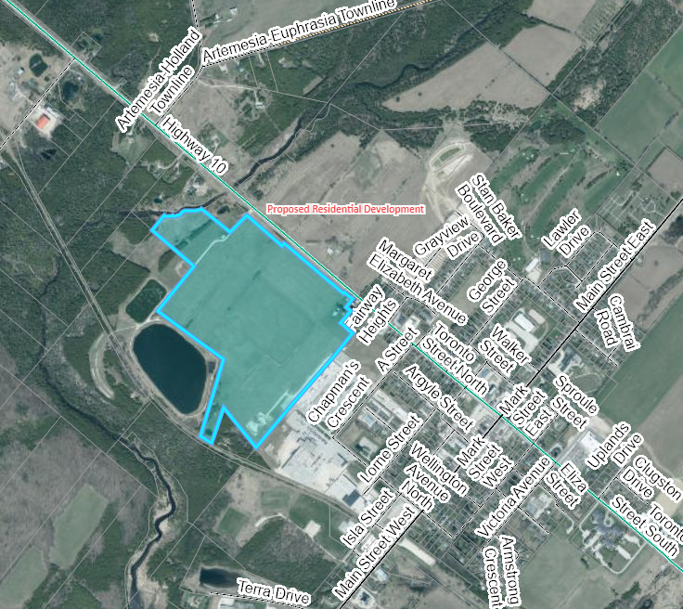

### Map 1: Airphoto of the Subject Lands

The subject lands are currently farmed. Surrounding the proposed expansion site are a mixture of residential, industrial, farmland, future development lands, sewage lagoons, and natural areas.

In support of these applications, the applicant has submitted planning, servicing, traffic, stormwater management, and ecological opinions/reports, as well as site plans. Copies of the reports and background materials can be found at the below link:

[Link to Background Materials](https://www.grey.ca/planning-development/planning-applications)

A joint public meeting with the Municipality of West Grey was held on Monday October 18, 2021. A link to the public meeting minutes can be found [here](https://docs.grey.ca/share/public?nodeRef=workspace://SpacesStore/fa4cad5d-f886-4e2a-bb34-5c7c10e858ae).

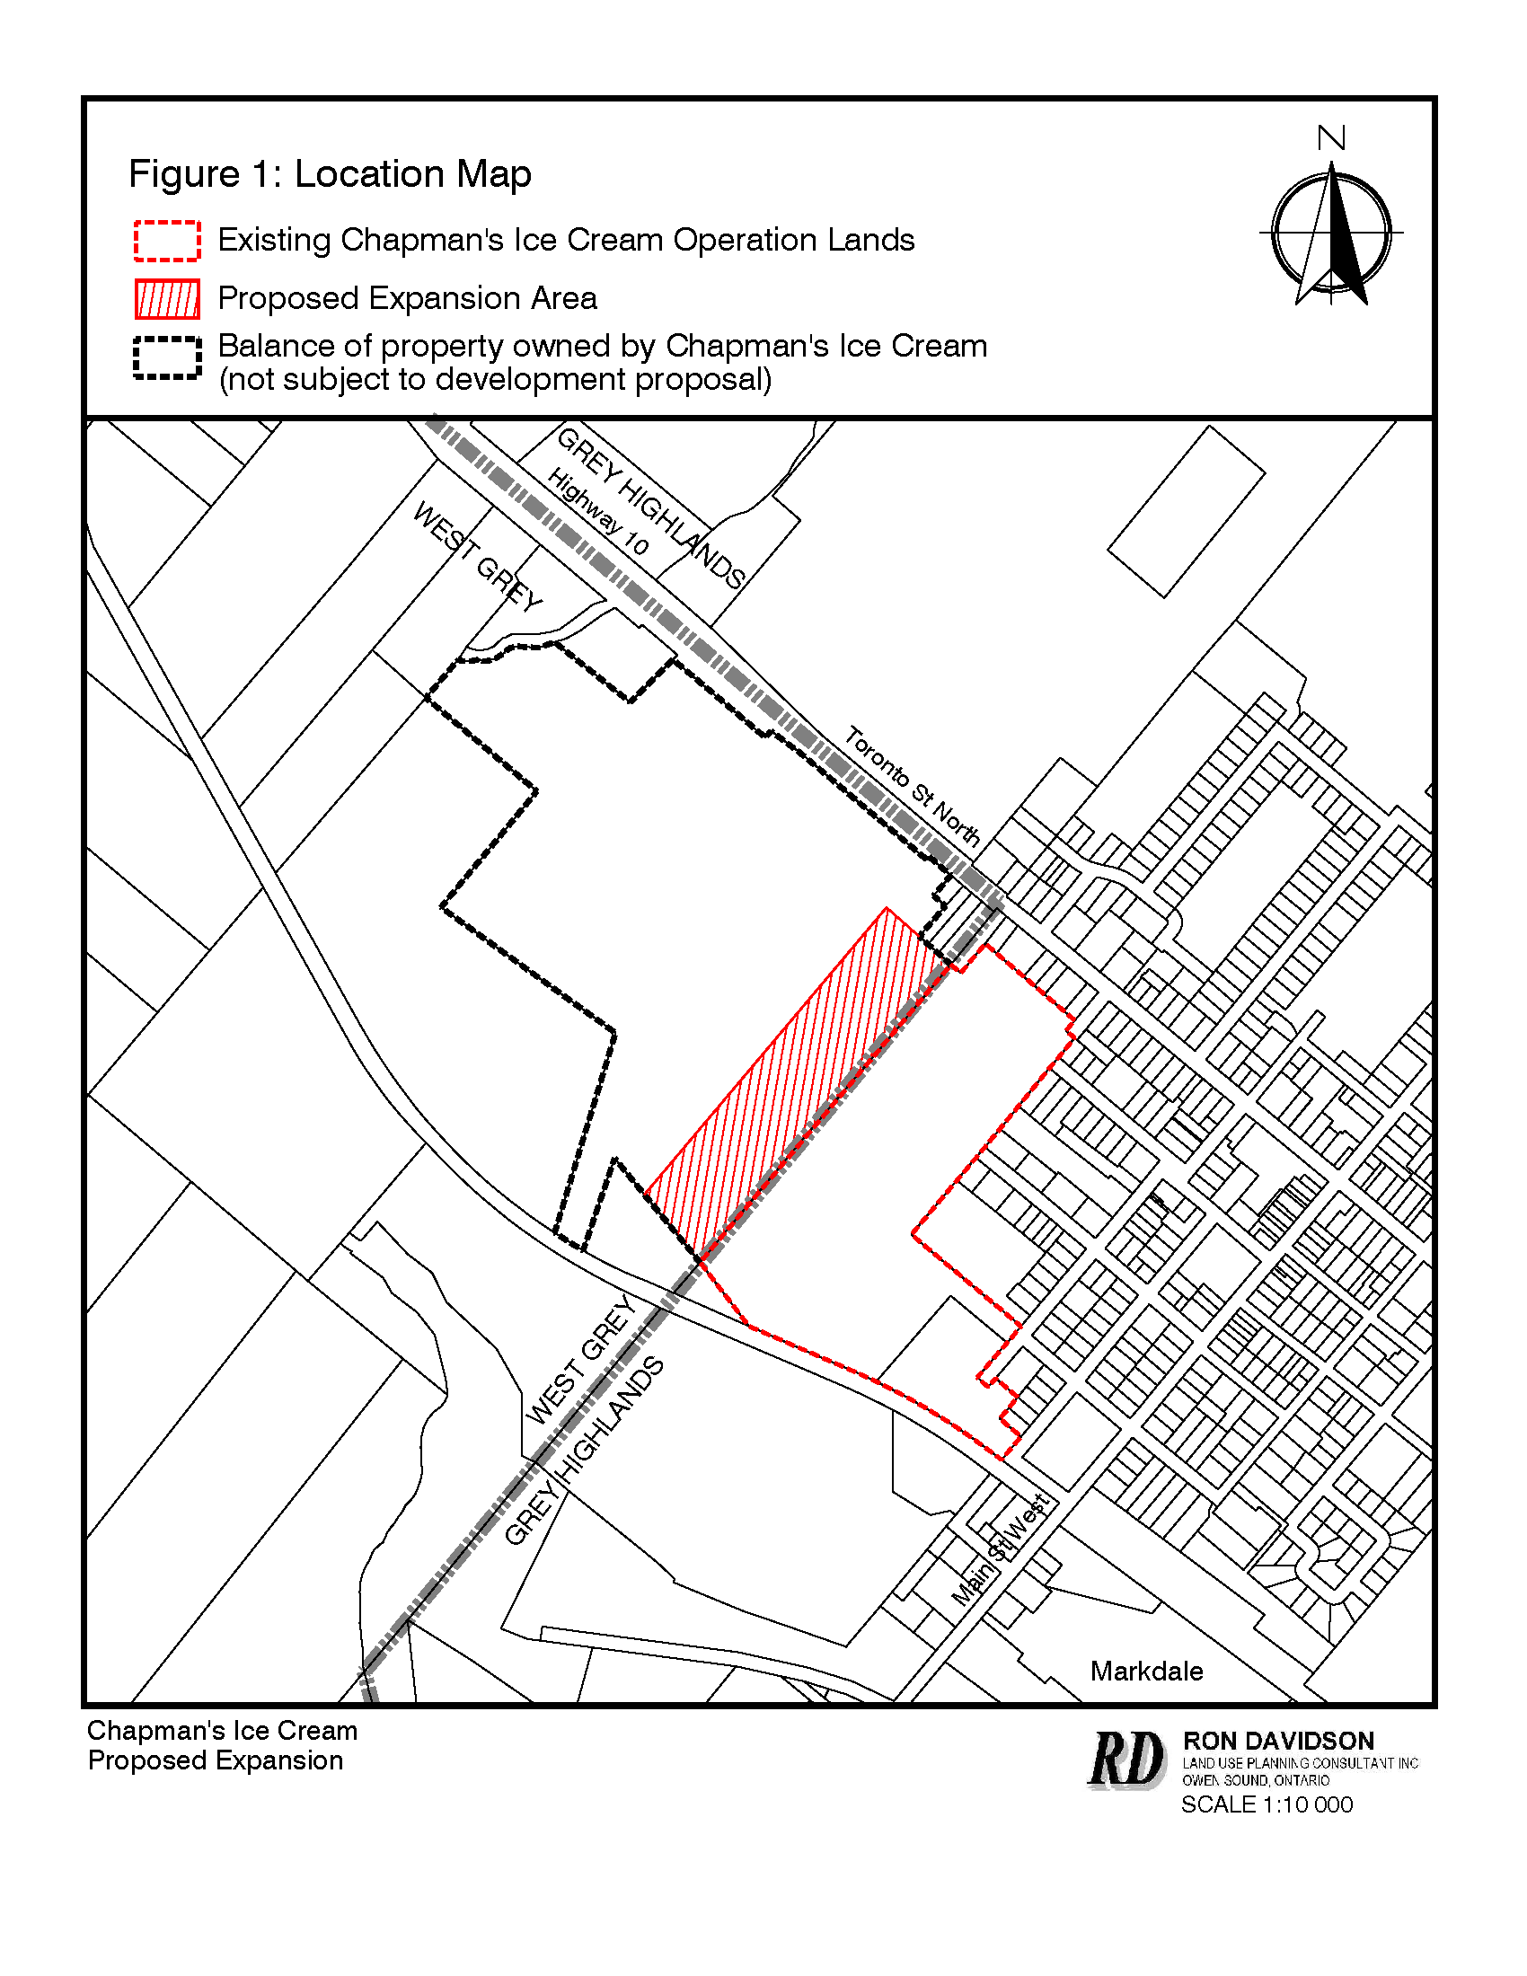

### Map 2: Proposed Expansion Lands (courtesy of Ron Davidson)

## Agency Comments Received

**Enbridge Gas, dated September 26, 2021**

“Enbridge Gas Inc. does not object to the proposed application however, we reserve the right to amend our development conditions.”

**Grey County Transportation staff, dated September 27, 2021**

“The County’s preferred access is alternative 2 at ‘A’ Street on to Highway 10 or alternative 3 being a new access north of ‘A’ Street on to Highway 10.

Increased truck turning traffic at the Grey Road 12 and Highway 10 intersection is not sustainable as any improvements to that intersection are extremely limited based on existing conditions. Any required upgrades would be at the developers cost.

The continued truck use of the Wellington Street access on to Grey Road 12 for the short-term would require truck turning improvements and potential property acquisitions at the developers cost. These improvements would require County Transportation Services approval.

An Encroachment Permit would also be required for any works within a County Road Allowance.”

**Grey County Forestry Trails staff, dated September 27, 2021**

“Provided any on-site drainage is not directed towards the Rail Trail, County staff do not have any concerns with regard to the proposal.”

**Saugeen Valley Conservation Authority (SVCA), dated September 30, 2021**

“SVCA staff has reviewed this application in accordance with our agreement with the Municipality of West Grey and as a service provider to the County of Grey. We have also reviewed the proposed as per our mandated responsibilities for natural hazard management, including our regulatory role under the Conservation Authorities Act.

SVCA staff find the applications for OPA and ZBLA acceptable.

Given the above comments, it is the opinion of the SVCA staff that:

1. Consistency with Section 3.1, Natural Hazard policies of the PPS has been demonstrated.
2. Consistency with Section 2.1, Natural Heritage policies of the PPS has been demonstrated; with the exception of habitat of endangered and threatened species, which the applicant must address.
3. Consistency with local planning policies for natural hazards and natural heritage has been demonstrated; with the exception of habitat of endangered and threatened species, which the applicant must address.”

**Municipality of Grey Highlands staff, dated September 29, 2021**

“Grey Highlands staff have reviewed the proposal and offer the following comments. Please note that Planning staff do not have any concerns associated with the proposed planning amendments.

The existing Chapmans Ice Cream Plant is located within the Municipality of Grey Highlands, as such all existing servicing and transportation networks associated with the existing operation are located in Grey Highlands, and are serviced by Grey Highlands roads, sewer, water, and stormwater infrastructure. It is our understanding that many of these existing services will be extended to service the proposed expansion. As these service extensions may have an impact on municipal infrastructure, Grey Highlands requests that the Municipality be included in any infrastructure review and approval processes associated with this development. Specifically, Grey Highlands requests the opportunity to be involved in the following matters associated with this development:

1. The review and approval of any site plan approvals and agreements.

2. The review and approval of any servicing studies and plans.

3. The review and approval of any stormwater management studies and plans.

4. The review and approval of any traffic impact and routing studies and plans.

5. The review and approval of any building permit applications.

6. The review and approval of any development or servicing agreements.

Please also note that Grey Highlands may also suggest that some of the above studies be peer reviewed.”

**Municipality of West Grey and Municipality of Grey Highlands dated February 9, 2022**

On-going discussions between West Grey, Grey Highlands, and Grey County have been occurring throughout the development review process. These discussions have also included a third-party peer review, completed on behalf of all three parties, of the engineering submissions. Staff from West Grey, Grey Highlands and Grey County met with Chapmans and their development team on February 9th to discuss the outcomes of the peer review, and next steps. Staff from West Grey and Grey Highlands indicated support for Grey County proceeding with a decision on OPA 10. Additional detailed design matters still need to be addressed, but those details can be assessed at the site plan control stage. It was agreed that the zoning could proceed with a holding symbol to recognize the need for site plan approval and a servicing agreement between West Grey and Grey Highlands.

## Public Comments Received

Verbal comments were made at the public meeting by Sean Coll, who asked about access to Highway 10 for this development. No further written or verbal comments by the public were received on this application.

## Analysis of Planning Issues

In rendering decisions, planning authorities must have regard to matters of Provincial interest under the *Planning Act* and be consistent with the Provincial Policy Statement (PPS). Decisions within the County must also conform to the County of Grey Official Plan and any provincial or municipal plans in force and effect. The subject lands are not covered by the Niagara Escarpment Plan or any other provincial plan. The Municipality of West Grey’s Official Plan only covers Durham and Neustadt, and these lands are outside of the Municipality of Grey Highlands, as such these lands are not covered by any municipal official plans.

### Provincial Legislation – The Planning Act

Most notable to the proposed OPA 10 are the following matters of provincial interest from the *Planning Act*, which have been considered with this application.

1. *the protection of ecological systems, including natural areas, features and functions,*

The County Official Plan does not map any significant natural heritage features on the subject expansion lands. Off-site and in other areas of the Chapmans property, there are some Significant Woodlands, Significant Valleylands, and other identified wetlands, which will not be impacted by OPA 10.

The SVCA flagged the potential for endangered or threatened species habitat on the subject lands, and recommended further investigation be completed. In response to these comments, Chapmans provided an opinion from an ecologist. It was noted that there could be potential for Bobolink and Eastern Meadowlark habitat (both of these species are protected under the *Endangered Species Act*) on the subject lands. Further field work is going to be completed in spring of 2022 and Chapmans will be completing the submission of a Notice of Activity and a habitat management plan through the Ministry of the Environment, Conservation and Parks (MECP)’s Registry (Section 23.6 of the ESA’s O. Reg. 242/08). As part of this process Chapmans will be completing the following steps as summarized by Ecologist Natalie Dunn.

*“The notice will be for the removal of habitat associated with the disturbance envelope for the proposed facility. The habitat management plan will describe the location, preparation, and management of the compensation habitat. The compensation habitat proposed will be equal or greater than the habitat being removed. The new or enhanced habitat will be in the same ecoregion as the area where the development will be carried out. The new or enhanced habitat must be monitored for 5 years and managed for 20 years.”*

The implementation of above can be controlled through site plan control and/or through a separate agreement, should the new or enhanced habitat be located off-site.

1. *the protection of agricultural resources of the Province,*

The subject lands are designated as Rural in the County Official Plan, and as such are not considered to be prime agricultural lands.

*(e) the supply, efficient use and conservation of energy and water,*

The proposed expansion will be serviced with municipal water and sewer services from the Municipality of Grey Highlands. An agreement between Grey Highlands and West Grey will be needed for the extension of services. A holding symbol will be placed on the zoning for the lands to ensure development cannot proceed until the servicing agreement is in place. County staff have shared examples of servicing agreements between other municipalities, with West Grey and Grey Highlands, which will help form the basis for this future agreement.

*(k) the adequate provision of employment opportunities,*

Chapmans currently employs over 800 people, and these development applications would facilitate their continued growth.

*(m) the co-ordination of planning activities of public bodies,*

West Grey, Grey Highlands, and Grey County have all been coordinating review of these applications, including using a joint peer reviewer for all three parties. SVCA have provided supportive comments, and future discussions will be required with the Ministry of Transportation (MTO) should a future access onto the Highway be contemplated.

*(o) the protection of public health and safety, and*

The proposed expansion is outside of any areas of natural hazard. This development is being proposed in proximity to Grey Highlands’ sewage lagoons, and a former landfill site. Based on the proximity to the sewage lagoons, residential development is unlikely to be contemplated for this site. That said, the expansion of this industrial use is not viewed as incompatible with the nearby lagoons. With respect to the former landfill site, a MECP D-4 Guideline study has been conducted by the Municipality of Grey Highlands, and determined that these lands are outside of any methane or leachate impacted areas.

A small portion of the subject lands are mapped as being partially within a Wellhead Protection Area (WHPA) ‘D’. There are no anticipated further impacts on this WHPA as a result of the proposed expansion. Staff would note that the existing Chapmans plant is also entirely within the WHPA.

*(p) the appropriate location of growth and development.*

The location of the proposed expansion is the only feasible location for Chapmans additional growth, given the development of their existing property, and lack of any further suitable lands available. As noted above, the subject lands would be unsuitable for other types of urban growth given the proximity to the municipal sewage lagoons. Staff are satisfied that the subject lands represent an appropriate location for the Chapmans expansion.

Proposed OPA 10 has regard for matters of provincial interest under the *Planning Act.*

### Provincial Policy Statement (PPS 2020)

Section 1 of the PPS promotes development and redevelopment within settlement areas on municipal services. The proposed development will be on municipal services, but will represent a small expansion to the settlement area.

Section 1.1.3.8 contains policies with respect to expanding a settlement area and requires that a comprehensive review be submitted in support of such proposals. This section also notes that; *“In undertaking a comprehensive review, the level of detail of the assessment should correspond with the complexity and scale of the settlement boundary expansion or development proposal.”* This settlement area expansion is a little different from others across the County, in that the expansion is needed onto the existing ice cream plant, therefore there is little opportunity to explore alternate locations. Normally through a comprehensive review one would look at other suitable locations in the settlement area first, and if no suitable locations were found then a settlement area expansion would be considered by looking to the east, west, north, and south of the existing settlement area. In this case there were no suitable lands in the settlement area to facilitate this expansion. A fulsome review of all the lands on the periphery of the settlement area was not conducted, based on the need to expand the existing plant and the operational efficiencies that come with constructing a building abutting the current plant.

Section 1.2.6 of the PPS relates to land use compatibility and the need to mitigate any impacts between major facilities and sensitive land uses. Staff are satisfied that the proposed expansion is duly buffered from the residential lands to the northeast, and will not be incompatible with the neighbouring sewage lagoons.

Section 1.3 provides policy direction on employment areas. Chapmans is one of the County’s largest employers. Allowing for the expansion of their operation provides them the ability to continue to grow and offer further employment opportunities to the residents of Grey County. Continued residential growth in Markdale, as seen through recent planning approvals, and application submissions, will provide residents a good opportunity to live and work in this part of the County.

Other sections of the PPS cover similar subject matter as the *Planning Act* including the protection of the environment, avoidance of natural or human-made hazards, etc.

Staff are satisfied that OPA 10 is consistent with the Provincial Policy Statement.

### County of Grey Official Plan

Similar to the PPS, the County Plan contains policies on directing the majority of new development to settlement areas and only expanding settlement areas at the time of comprehensive review. As noted earlier in this report, the subject lands are Rural, but abut the Primary Settlement Area of Markdale. There is currently no opportunity to expand the plant elsewhere within Markdale and the expansion is a natural extension of the existing plant from an operations perspective. The Primary Settlement Area designation will permit the building and parking expansions, in accordance with any zoning and site plan control provisions applied to the property. The proposed development will be outside of the designated Hazard Lands on-site.

Portions of the subject lands are within a Wellhead Protection Area (WHPA)-D, Significant Valleylands, and Other Identified Wetlands. Only WHPA D impacts the expansion lands, while the other environmental features are located outside of the expansion area. There are also some Significant Woodlands on lands adjacent to this property. These matters have generally been addressed in the review of the *Planning Act* and the PPS.

There is no additional water being directed to the County’s CP Rail Trail, and no impacts are anticipated to the trail.

Section 8 of the Plan provides policies on roads and transportation. Chapmans has a significant volume of employees and truck traffic using the current plant. The proposed expansion will result in some increased traffic. Review of this application has generated discussion between County Transportation Services, as well as West Grey and Grey Highlands staff. As part of the site plan application and the review of the residential development across the Highway, there will be additional discussions on potential Highway access and/or any improvements needed to the County or municipal road networks as a result of the Chapmans application.

County staff are satisfied that the proposed OPA 10 conforms to the goals and objectives of the County Official Plan.

## Legal and Legislated Requirements

The application was processed in accordance with the Planning Act.

## Financial and Resource Implications

There are no anticipated financial, staffing, or legal considerations associated with the proposed official plan amendment, beyond those normally encountered in processing an amendment. The County has collected the requisite application fee and peer review deposit for this application.

## Relevant Consultation

Internal: Planning, Transportation Services, and Economic Development Staff

External: Municipality of West Grey, Municipality of Grey Highlands, Ministry of Transportation, required agencies under the *Planning Act*, and the public

### Appendices and Attachments

[Draft OPA 10 By-law](https://docs.grey.ca/share/public?nodeRef=workspace://SpacesStore/cd735e8f-80d0-4dbb-87f6-0580825b2239)

[Draft OPA 10 Land Use Schedule](https://docs.grey.ca/share/public?nodeRef=workspace://SpacesStore/08c11d2a-01ae-4091-8210-a565e9f49ff5)