Grey County Logo Committee Report

| **To**: | Warden Hicks and Members of Grey County Council |
| --- | --- |
| **Committee Date:** | May 23, 2019 |
| **Subject / Report No:** | PDR-CW-27-19 |
| **Title:** | **Power Transmission Line and Crossing Agreement on the CP Rail Trail** |
| **Prepared by:** | Scott Taylor |
| **Reviewed by:** | Randy Scherzer |
| **Lower Tier(s) Affected:** | Township of Chatsworth |
| **Status:** | Recommendation adopted as presented by Committee of the Whole as per Resolution *CW124-19*; Endorsed by County Council on June 13, 2019 as per Resolution *CC43-19.* |

## Recommendation

1. **That Report PDR-CW-27-19 regarding the development of an agreement with Egerton Solar Power LP (directed by its General Partner, MPI FIT 4 Inc.) for the purposes of allowing a portion of the County’s CP Rail Trail to be utilized for a power transmission line and driveway crossing, to support the neighbouring solar power facility be endorsed; and**
2. **That a by-law to adopt the Agreement be prepared for consideration by County Council.**

## Executive Summary

The County has received a request on behalf of Egerton Solar Power LP (directed by its General Partner, MPI Fit 4 Inc.) to permit a transmission line and driveway crossing of the CP Rail Trail in the Township of Chatsworth. The subject lands are located at Part Lot 67, Concession 1 SWTSR, geographic Township of Holland, now in the Township of Chatsworth. A transmission line is proposed across the County’s lands, for a twenty-year timeframe, in order to facilitate a proposed solar panel development. The driveway crossing could continue to remain on-site, following the twenty-year agreement timeframe. The agreement was initially drawn up by outside legal counsel and was reviewed by Grey County’s Director of Legal Services. The proponent has agreed in principle to the terms. County staff are recommending approval of the agreement.

## Background and Discussion

County staff received a request to cross the County’s CP Rail Trail with a transmission line and a driveway from Egerton Solar Power LP (directed by its General Partner, MPI Fit 4 Inc.). There will be no hydro poles installed on the County’s lands. The subject lands are located at Part Lot 67, Concession 1 SWTSR, geographic Township of Holland, now in the Township of Chatsworth. Currently the subject property is bisected by the trail, with the northeast portion gaining access off Highway 10, and the southwest portion needing access across the trail lands. The overhead crossing of the trail by the transmission line, and driveway are required to permit a solar development on both parts of the subject lands (i.e. northeast and southwest of the trail).

The subject lands are located southeast of Berkeley, on the south side of Highway 10. Map 1 below shows the subject lands and surrounding area, while Map 2 shows the proposed transmission line and crossing.

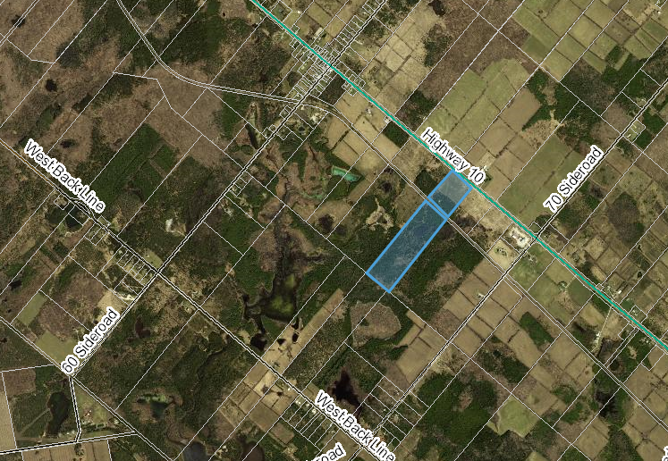

### Map 1: Airphoto of the Subject Property and Surrounding Lands

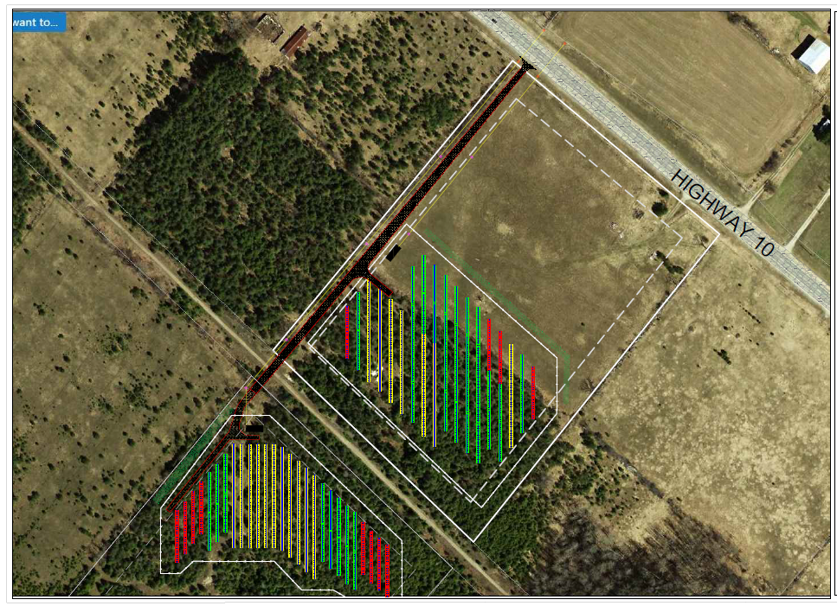

### Map 2: Proposed Transmission Line and Trail Crossing

The draft agreement attached as a link to this report would protect the County from a liability perspective, while still allowing for the multi-use CP Rail Trail to continue. The proponent will also have the ability to access and maintain their transmission line and cross the trail with the driveway. There are clauses in the agreement, and securities in place, to allow for the County to rehabilitate the lands, should the proponent abandon the project in the future.

The Planning department has worked closely with staff from the Grey Sauble Conservation Authority (GSCA), who are contracted to maintain the County’s trails. Advice has also been sought from Clerk’s staff who have more technical knowledge on infrastructure crossings in this regard.

The County maintains the CP Rail Trail, both as a multi-use trail and an infrastructure corridor throughout the County. Other agreements are in place that permit sewers, gas lines, and broadband fibre crossing or running along the trail. Allowing for this transmission line across the trail would be consistent with the County’s objectives for the trail in this regard. The County also has a number of instances where private driveways cross the trail.

## Legal and Legislated Requirements

The agreement was drafted by outside legal counsel (Erroll Treslan, The Alliance Lawyers), and reviewed by the Clerk’s department, and the Director of Legal Services. The draft agreement contains the requisite indemnity and insurance clauses needed to adequately protect the County’s interests, including minimizing any risk, while allowing for the continuation of the trail use.

## Financial and Resource Implications

There are no anticipated financial or staffing considerations associated with the proposed agreement. The legal fees associated with this agreement, $1,500.00, will be paid by the proponent, and $8,000.00 in securities will be collected to ensure the lands are rehabilitated properly following the cessation of the agreement. The terms of the agreement also require the proponent to carry $10,000,000.00 in commercial general liability insurance, and $5,000,000.00 in automotive liability insurance.

## Relevant Consultation

Internal: Clerk’s Department, Director of Legal Services, Grey Sauble Conservation Authority contract staff

External: Erroll Treslan, The Alliance Lawyers

### Appendices and Attachments

[Draft Transmission Line and Crossing Agreement](https://docs.grey.ca/share/public?nodeRef=workspace://SpacesStore/13d1b90a-ae95-4f87-b156-d952cd68977f)

Respectfully submitted by,

Scott Taylor, Senior Planner