Grey County Logo Committee Report

| To: | Warden McQueen and Members of Grey County Council |
| --- | --- |
| Committee Date: | November 26, 2020 |
| Subject / Report No: | TR-CW-24-20 |
| Title: | Road Widening Acquisition Grey Road 32 |
| Prepared by: | Lacey Thompson, Contract and Real Estate Coordinator Pat Hoy, Director of Transportation |
| Reviewed by: | Kim Wingrove, CAO |
| Lower Tier(s) Affected: | Municipality of Grey Highlands |
| Status: | Recommendation adopted by Committee as presented per Resolution CW206-20; Endorsed by County Council December 10, 2020 per Resolution CC05-21; |

## Recommendation

1. That Report TR-CW-24-20 regarding the acquisition of road widening be received and that the properties identified as:
   1. Part of Lot 21 Concession 9 Artemesia being Part’s 1 and 2 Plan 16R-11075; Geographic Township of Artemesia, Municipality of Grey Highlands; and
   2. Part of Lot 139 Concession 2 North East of the Toronto Sydenham Road Artemesia being Part 2 Plan 16R-11082; Geographic Township of Artemesia, Municipality of Grey Highlands; and
   3. Part of Lot 140 Concession 3 North East of the Toronto Sydenham Road Artemesia being Part 5 Plan 16R-11082; Geographic Township of Artemesia, Municipality of Grey Highlands; and

be acquired by The Corporation of the County of Grey; and

1. That the Warden and Clerk be authorized to execute an Encroachment Agreement between The Corporation of the County of Grey and the property owner for property described as Part of Lot 139 Concession 2 North East of the Toronto Sydenham Road Artemesia less Part 2 Plan 16R-11082; Geographic Township of Artemesia, Municipality of Grey Highlands.

## Executive Summary

Property is required from landowners on Grey Road 32 to ensure that the road platform and slope are contained wholly within the road allowance.

## Background and Discussion

In the planning and design phase for the rehabilitation of Grey Road 32 it was discovered that a portion of Grey Road 32 was not located within the legally defined road right-of-way. To ensure that the road platform and slope are contained wholly within the road allowance property acquisition is required.

A legal survey was ordered to identify land required to properly accommodate the road right-of-way. Through this process, several properties were identified as being impacted by the misaligned road right-of-way.

Utilizing Grey County’s Land Acquisition Procedure G-GEN-003-002 Transportation Services initiated negotiations with the impacted landowners.

### Property A – Part’s 1 and 2 16R-11075 (orange on map)

Pursuant to Grey County’s Acquisition of Land Procedure an offer of $2,575.50 was submitted to the landowner. The landowner has accepted this offer.

### Property B – Part 2 16R-11082 (green on map)

Pursuant to Grey County’s Acquisition of Land Procedure an offer of $5,700.00 was submitted to the landowner. The landowner has accepted this offer under the condition that the County allow the existing fence to remain in its current location. The attached Encroachment Agreement will be registered on title to the owner’s lands. The terms of the Encroachment Agreement confirm that if the fence is removed it cannot be replaced in its current location and that if the County deems it necessary for the fence to be removed the County may order the removal of the fence on 30 days written notice to the landowner.

### Property C – Part 5 16R-11082 (purple on map)

Pursuant to Grey County’s Acquisition of Land Procedure an offer of $1,000.00 was submitted to the landowner. The landowner has accepted this offer.

## Legal and Legislated Requirements

The property transfer’s will be registered on title to the lands in the Local Land Registry Office (Grey No.16).

The agreements follow the County’s standard road acquisition agreement template

## Financial and Resource Implications

The attached property requirements amount to a total of $9,275.50 for the required property.

The cost for the legal survey was $3,627.30.

The legal cost to finalize the transfer is estimated to be under $5,000.00.

The anticipated total cost of the acquisition is expected to be approximately $17,902.80.

The funding will come from the Transportation Services Land Acquisition Budget which has a 2020 budget of $102,000. At the time this report was written, $23,581.46 has been spent in 2020 from this budget line.

## Relevant Consultation

Internal  
Clerk’s Department, Director of Legal Services

External  
Property Owners, Land Surveyors

### Appendices and Attachments

Location Map  
Reference Plan 16R-11075  
Reference Plan 16R-11082  
Road Acquisition Agreement Template  
Encroachment Agreement

## Location Map

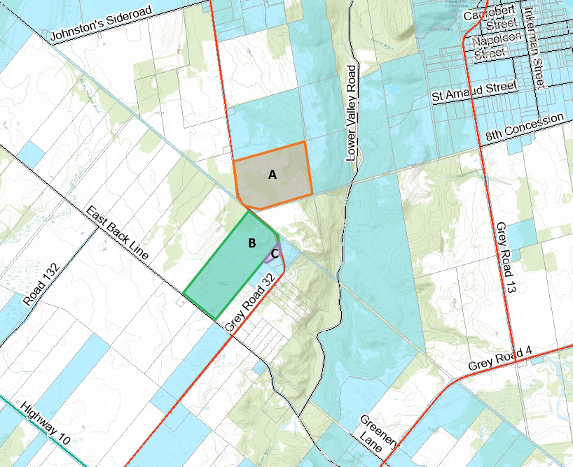

### Plan 16R-11075

### Plan 16R-11075

### Plan 16R-11082

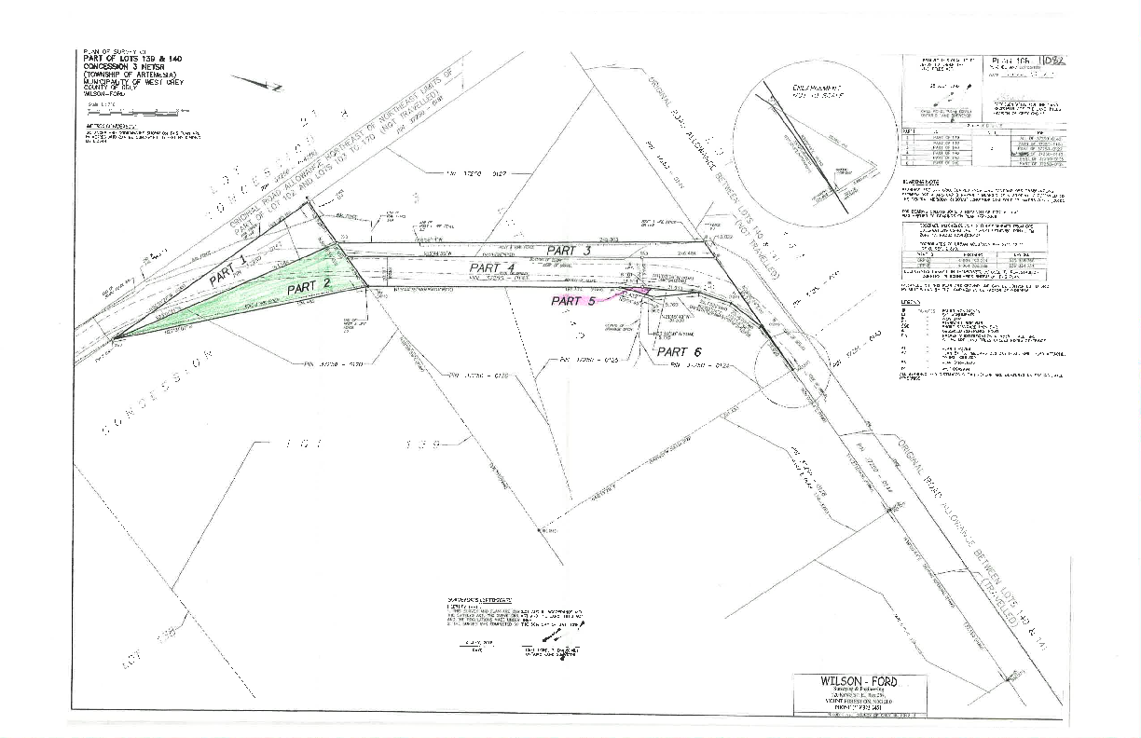

### Road Acquisition Agreement Template

made in duplicate this ________ day of __________________________, 20____

between:

**THE CORPORATION OF THE COUNTY OF GREY**

(herein called the “County”)

- and-

**__________________________________________**

(herein called the “Owner”)

**WHEREAS** the Owner owns a parcel of land situated intheMunicipality/Township of __________________ in the County of Grey; adjacent to County Road ______.

**AND WHEREAS** the County wants to purchase and the Owner is agreeable to sell part of the land for road widening purposes.

The Owner and the County agree that in consideration of the rounded sum of **$_______** which includes compensation for a daylight corner of $__, a fence allowance of $__ for __ metres of fencing and compensation of $__ for hectares of land and tree compensation of $ (which compensation is in accordance with Schedule ‘A’ of Grey County’s Acquisition of Land Procedure No. G-GEN-003-002 which states that compensation is calculated at a rate of $12,600.00 per hectare, $200.00 flat rate for a daylight corner, $12.00 per metre of fencing and tree compensation as negotiated) receipt and sufficiency of which is hereby acknowledged, the parties, intending to be legally bound, agree as follows:

The Owner agrees to sell to the County, a parcel of land with a total area of _______ hectares and being legally described as Part of Lot ___, Concession ___, Municipality/Township of _________ (in the former geographic Township of ______), in the County of Grey depicted as Part(s) ________ on Reference Plan No. _________(the “Purchased Parcel”).

Additional Details: (None) In addition to the purchased parcel, the Owner agrees to sell and County agrees to purchase land that may be required for back slopes at hill cuts or where deep fills are required and to pay $ __ per hectare for any additional such land (the “additional land”).

The Owner agrees to provide the County with a valid Transfer/Deed of Land conveying unencumbered title to, and releasing all claims in respect of, the Purchased Parcel and the additional lands. The Transfer/Deed of Land shall be prepared at the expense of the County by its lawyers.

The Owner shall obtain release of any existing mortgage or other encumbrance on the purchased parcel and additional lands. The Owner represents that spousal consent is not necessary to this transaction under the provisions of the Family Law Act (Ontario), unless the Owner’s spouse has executed the consent below. The Owner represents that the Owner is not a non-resident of Canada within the meaning of the *Income Tax Act.*

The obligation of the County to complete the transaction contemplated by this agreement shall be conditional upon County Council passing a motion approving the acquisition of the Purchased Parcel.

The transaction shall be completed on or before a date specified by the County by notice sent to the Owner not less than 30 days prior to the specified completion date.

If this transaction is subject to Harmonized Sales Tax such tax shall be included in the purchase price.

The heirs, executors, administrators, successors in title and assigns of the Owner are bound by the terms of this agreement.

In witness, the parties have signed, sealed and delivered this agreement.

**The Corporation of the County of Grey**

(seal) Paul McQueen, Warden

Heather Morrison, Clerk

______________________________ (seal)

Owner Witness

______________________________ (seal)

Owner Witness

The undersigned Spouse of the Owner consents to the disposition agreed to herein pursuant to the provisions of the Family Law Act (Ontario), and hereby agree with the County that he or she will execute all necessary documents to complete the sale.

______________________________ (seal)

Spouse of Owner (if not property owner) Witness

**Name of Owner(s) of Property**

___________________

**Address:**

___________________

**Telephone Number:**

___________________

### Encroachment Agreement

**THIS AGREEMENT** made in duplicate this ________ day of ______________, 20____ between:

**NANCY R. BEACON**

(herein called the "Licensee")

- and -

**THE CORPORATION OF THE COUNTY OF GREY**

(herein called the "County")

**WHEREAS** the Licensee is the registered and beneficial owner of lands legally described as Part of Lot 139 Concession 3 North East of the Toronto Sydenham River; being more particularly the whole of the said Lot 139 less those lands described in Instrument GS42994 registered October 29, 1963 and now described as Part 1, Plan 16R-11082, and less those lands described as Part 2, Plan 16R-11082; Geographic Township of Artemesia; Municipality of Grey Highlands, County of Grey and more particularly described in Schedule "A", which abuts the public highway known as Grey Road 32;

**AND WHEREAS** the County owns and maintains the public highway known as Grey Road 32, referred to as the "Road";

**AND WHEREAS** a fence owned, maintained and controlled by the Licensee encroaches upon the Road a distance of approximately 174.5 metres, more particularly shown on Part 2 of reference plan 16R-11082 attached as Schedule "B" and referred to as the "Encroachment";

**AND WHEREAS** the Licensee has requested that the County allow the Encroachment to remain in its existing location and is prepared to accept the conditions set out in this Agreement;

**AND WHEREAS** through the adoption of clause       of       of the       dated      , council did, on      , authorize the execution of an encroachment agreement on certain terms and conditions; and

**AND WHEREAS** the County agrees to permit the Encroachment to continue upon the Road on certain terms and conditions as set out herein.

**IN CONSIDERATION** of other good and valuable consideration and the sum of $2.00 of lawful money of Canada now paid by the Licensee to the County (the receipt whereof is hereby acknowledged) the County grants, subject to the provisions set forth, to the Licensee, a Licence to permit the Encroachment upon the lands of the County, subject to the following provisions:

1. Term
   1. The term of this Licence shall expire on the earlier of:
      1. Five (5) years from the date of execution of this agreement, provided that, at the expiry of the first five (5) years and at the Licensee's request, the County may, at its discretion, extend the term for an additional five (5) year term on the same terms and conditions as agreed to herein;
      2. the date of removal of the Encroachment; or
      3. the date of the sale or transfer of the lands described in Schedule "A", unless the Director of Transportation for the County (the “Director”) has, at the request of the purchaser or transferee of the lands, approved an extension and assignment of this agreement and the purchaser or transferee has executed and registered the extension and assignment agreement prepared by the County.
2. Termination
   1. If the County, acting reasonably, provides written notice that it has deemed that it requires the Encroachment area for road widening or such other reason as it may deem appropriate, the Licensee will remove or relocate the Encroachment at no cost to the County. Such removal or relocation of the Encroachment shall be completed within 30 days of receiving the written notice from the County, or such longer period of time as may be agreed upon by the County; the County agrees that it will not unreasonably refuse to agree to a longer period to remove the Encroachment where such longer period is due to reasonable circumstances, such as weather conditions. If the Licensee neglects, refuses or fails so to remove the Encroachment within 30 days of receiving the aforesaid notice, or such later date as may be agreed, then the County may alter or remove the Encroachment or parts thereof from the Road, as determined by the Director at the cost, charge and expense of the Licensee and the certificate of the Director as to the cost of such alteration or removal and restoration shall be final and binding upon the Licensee and the County may recover such costs from the Licensee.
   2. The Licensee covenants and agrees that at the time the Encroachment is removed in whole or in part, or is in need of replacement, and in any event, upon the expiry or termination of this agreement, the Encroachment shall be removed, at the Licensee's sole expense, so that they are located entirely off the Road and at such time, this agreement shall become null and void and be of no further effect.
3. Licensee’s Responsibilities
   1. The Licensee shall at its own cost, charge and expense and to the satisfaction of the Director:
      1. keep and maintain the Encroachment in a good and proper state of repair and safety;
      2. make no additions or modifications to the Encroachment which are not authorized or contemplated by this agreement; and
      3. comply with such further and additional requirements, as may be required by the Director, acting reasonably.
4. Insurance
   1. The Licensee covenants and agrees to maintain appropriate limits of property insurance and general liability insurance coverage of not less than $1,000,000.00 (One Million) Dollars, on the Encroachment, and shall provide a current certificate of insurance to the County upon execution of this Agreement, and at any time throughout the lifetime of this Agreement upon request by the County.
5. Indemnification
   1. The Licensee shall at all times fully indemnify and save harmless the County, its elected officials, employees, agents, representatives and volunteers harmless from and against all actions, suits, claims and demands whatsoever which may be brought against or made upon the County and from and against all loss, costs, damages, charges and expenses whatsoever which may be incurred, sustained or paid by the County for or by reason of or on account of the permission hereby granted to the Licensee or the exercise by the Licensee of such permission or the erection and maintenance of the Encroachment and appurtenances thereto or anything in any matter relating thereto.

The Licensee grants to the County full power and authority to settle any such actions, suits, claims or demands on such terms as the County may deem advisable and the Licensee covenants and agrees with the County to forthwith pay to the County on demand all moneys paid by the County in pursuance of any such settlement and such sum as shall represent the reasonable costs of the County or its solicitors in defending or settling any such actions, suits, claims or demands, based on a solicitor and own client basis.

1. Notice
   1. Any notice required to be given, served or delivered must be in writing and sent to the other party at the address indicated below, or to such other address as may be designated by notice provided by either party to the other.

For the County:

County Clerk

County of Grey Administration Building

595 9th Ave East

Owen Sound, ON N4K 3E3

Fax: 519-376-8998

Email: [countyclerk@grey.ca](mailto:countyclerk@grey.ca)

For the Licensee:

Nancy R. Beacon

380463 Grey Road 32

Flesherton, ON N0C 1E0

* 1. Any notice to be given by either party to the other shall, in the absence of proof to the contrary, be deemed to have been received by the addressee if:
     1. Delivered personally on a business day, then on the day of delivery;
     2. Sent by prepaid registered post, then on the second day following the registration thereof;
     3. Sent by ordinary mail, then on the fifth business day following the date on which it was mailed; or
     4. Sent by facsimile or email, upon confirmation of successful transmission of the notice.

1. Inspection
   1. The Licensee covenants and agrees that the County, and its respective officers, servants, workers, employees, agents and contractors under its control or supervision or any of them shall have the right from time to time and at all reasonable times during the currency of this agreement, to enter in and upon the lands described in Schedule "A" or any part thereof, with all necessary workers, equipment and material for the purpose of inspecting the Encroachment from the Road in accordance with this agreement. Such inspection shall not free or relieve the Licensee in any way whatsoever from the liability under set out in section 3.0 of this Agreement relating to keeping and maintain the Encroachment in good and proper repair and condition.
2. Grant Not to Affect Possession
   1. Nothing contained in this agreement shall be construed as giving to the Licensee anything more than permission to maintain the Encroachment until such time as this agreement expires or is terminated or the removal of such Encroachment may be required as provided. The parties acknowledge and agree that no length of time, or enjoyment by the Licensee of the permission granted shall enure to, or give any right, title or interest to the Licensee or its successors in title, in the Road or any right to maintain the proposed Encroachment over, under or upon the Road, or shall deprive the County by the operation of any limitation period or otherwise of any right to require the removal of the Encroachment or any restoration of the Road to the satisfaction of the County at the Licensee's expense.
   2. The parties acknowledge and agree that this Licence does not in any way whatsoever diminish the rights of the County, or any gas, telephone, cable, municipal electricity company or other public utility company, their respective officers, servants, workers, employees, agents and contractors, to enter at all times upon the Road for the purpose of constructing, repairing, maintaining, replacing or removing any sewers, mains, culverts, drains, water pipes, gas pipes, poles, wires or other underground services and installations and appurtenances thereto. The Licensee shall not be entitled to any damages or compensation by reason of the exercise of the County's or utility company's rights contained in this clause and the Licensee at its own expense shall carry out such alteration or removal of the Encroachment as the Director may direct pursuant to the exercise of the County's or utility company's rights.
3. Financial Arrangements
   1. The Licensee agrees that any and all costs, sums and expenses paid, incurred or sustained by the County as provided in this agreement shall form and constitute a charge or lien on the lands described in Schedule "A" attached to this agreement, until fully paid.
4. Successors and Assigns
   1. The Licensee covenants and agrees to assign and to transfer this agreement to any successor or assignee of the lands and premises described in Schedule "A" and will obtain from such successor or assignee a covenant in favour of the County that the successor or assignee will be bound by all of the terms and conditions of this agreement from and after the date of its assignment as aforesaid, it being the intention that the owner from time to time of the lands and premises described in Schedule "A" shall have the benefit of and be liable for performance of the obligations contained in this agreement.
5. Registration of the Agreement
   1. The Licensee consents to the registration of this agreement against the title to the lands described in Schedule "A" attached to this Encroachment Agreement.
6. Governing Law
   1. The Licensee shall, at all times during the currency of this licence agreement, be subject to all laws, by‑laws and regulations now or hereinafter enacted, to all statutes, orders and rules made or to be made by a lawfully constituted authority having jurisdiction therein.
7. General
   1. This agreement and everything contained in this agreement shall run with the lands described in Schedule "A" and enure to the benefit of and be binding upon the parties, their heirs, executors, administrators, successors and assigns.

**IN WITNESS WHEREOF** the parties hereto have executed this Agreement as of the day and year set out above:

**THE CORPORATION OF THE COUNTY OF GREY**

_______________________________________________

Paul McQueen, Warden

_______________________________________________

Heather Morrison, Clerk

We have the authority to bind the County.

**______________________________**

Nancy R. Beacon Witness

### Schedule “A”

Part of Lot 139 Concession 3 North East of the Toronto Sydenham River; being more particularly the whole of the said Lot 139 less those lands described in Instrument GS42994 registered October 29, 1963 and now described as Part 1, Plan 16R-11082, and less those lands described as Part 2, Plan 16R-11082; Geographic Township of Artemesia; Municipality of Grey Highlands, County of Grey

Part of PIN 37250-0120  
Roll No.: 42 08 180 002 11500

# Schedule “B”

# Schedule A Drawing