Grey County Logo Committee Report

| **To**: | Warden Hicks and Members of Grey County Council |
| --- | --- |
| **Committee Date:** | April 11, 2019 |
| **Subject / Report No:** | Addendum to PDR-CW-06-18 |
| **Title:** | Plan of Subdivision 42T-2017-05 – Davenport – Revised Submission |
| **Prepared by:** | Randy Scherzer |
| **Reviewed by:** | Kim Wingrove |
| **Lower Tier(s) Affected:** | Township of Georgian Bluffs |
| **Status:** | Recommendation adopted by Committee as presented as per Resolution *CW89-19*; Endorsed by County Council on April 25, 2019 as per Resolution *CC34-19*. |

## Recommendation

1. **That Addendum to Report PDR-CW-06-18 regarding an overview of revised plan of subdivision application 42T-2017-05, that now proposes to establish a plan of subdivision consisting of twenty nine (29) single detached dwelling lots on lands described as Part of Lot 27, Concession 3, (geographic Township of Sarawak) in the Township of Georgian Bluffs, be received for information.**

## Executive Summary

The County received plan of subdivision application (42T-2017-05) in 2018. Initially the proposal was to create a total of eight single detached lots to be serviced with municipal water and private septic systems. Georgian Bluffs later negotiated with Cobble Beach to assume the sewage treatment system from Cobble Beach which will allow the Township to connect other developments. Based on that, the Applicant submitted a revised application proposing 20 lots to be serviced on full municipal services. The County recently received a second revised application which includes additional lands and now proposes a total of 29 single detached lots on full municipal services. Updated reports have been submitted with the proposed revised subdivision application to address the additional lands as well as to address the previous comments raised on the previous submissions. The application and supporting studies have been circulated to prescribed agencies and the public for review and comment. The proposed development also requires an amendment to the Township of Georgian Bluffs Official Plan as well as an amendment to the Township of Georgian Bluffs Zoning By-law. The Township of Georgian Bluffs will be holding a public meeting for the applications on June 5th, 2019. Following the public process, and agency review process, a thorough analysis and staff recommendation will be provided.

## Background and Discussion

The County received a plan of subdivision application back in 2018 that proposed to create a total of 8 single detached lots and a future development block within the settlement area of East Linton. The proposal at the time was to service the development using municipal water and private septic systems. The Township of Georgian Bluffs and Cobble Beach have reached an understanding that the Township would assume the private sewage treatment plant in the near future. This will allow the Township to service other developments outside of Cobble Beach including this proposed development. Based on the servicing potential, the Applicant submitted a revised application proposing a total of 20 single detached lots. Recently the Applicant has submitted a second revised submission which includes additional lands and now proposes to create a total of 29 single detached lots.

The subject lands are located at Part of Lot 27, Concession 3, geographic Township of Sarawak, in the Township of Georgian Bluffs. The subject lands are located south of Church Sideroad East and east of Grey Road 1 (see Map 1 – airphoto of subject lands). The proposed 29 lots would gain access off of two roads to be constructed that would connect to Church Sideroad East (see Map 2 – proposed subdivision plan).

The Cobble Beach development which includes a golf course and residential dwellings is located north of the subject lands. There are existing residential dwellings to the west and east of the subject lands. Directly south of the subject lands is the proposed Georgian Shores development which is currently draft approved for 16 lots and a future development block.

The proposed development also requires an amendment to the Township of Georgian Bluffs Official Plan as well as an amendment to the Township of Georgian Bluffs Zoning By-law.

The Applicant has submitted updated reports with the subdivision application to address the lands that have been added to the application as well as to address the previous comments raised by agencies and members of the public as part of the previous application submissions. Copies of all background reports and plans can be found at [this link](https://www.grey.ca/planning-development/planning-applications).

### Map 1: Airphoto of Subject Lands

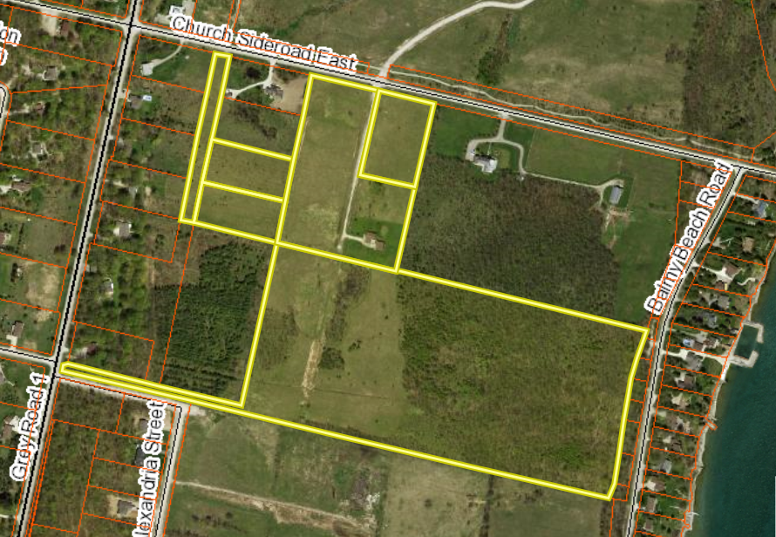

#### Analysis of Planning Issues

When rendering a land use planning decision, planning authorities must have regard to matters of Provincial Interest under the *Planning Act*, be consistent with the Provincial Policy Statement (PPS) 2014, and conform to any Provincial Plans or official plans that govern the subject lands. In this case, the County of Grey Official Plan and the Township of Georgian Bluffs Official Plan all have jurisdiction over the subject property.

#### Provincial Policy and Legislation

Both the *Planning Act* and the PPS speak to the efficient use of land within settlement areas, where services are readily available. The proposed plan of subdivision is within a settlement area that will be serviced by municipal water and municipal sewage system once the Cobble Beach system has been assumed by the Township. The PPS indicates that the preferred form of servicing for settlement areas is full municipal services.

### Map 2: Proposed Revised Subdivision Plan

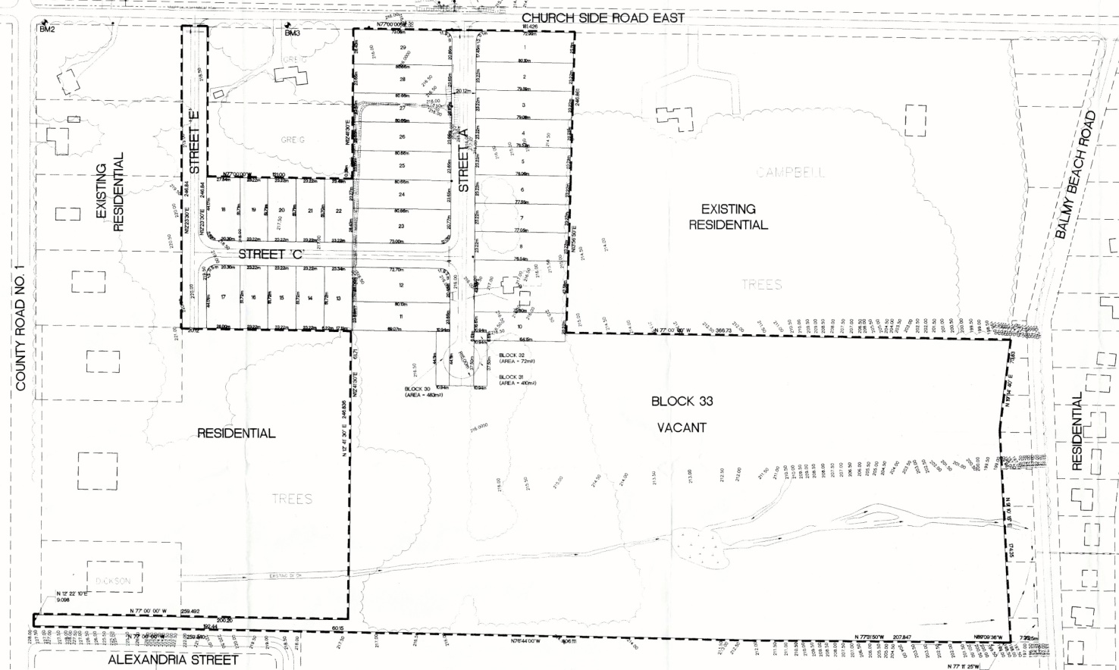

#### County Official Plan

The proposed plan of subdivision is designated as ‘Secondary Settlement Area’ within the County Official Plan. Parts of the subject lands are also identified as a Special Policy Area (karst topography) and Significant Woodlands.

Section 2.8 of the County Plan provides policies on both the Special Policy Area and Significant Woodlands that have been identified on the subject lands. An Environmental Impact Assessment and a Hydrogeological Report have been submitted to address these matters. These studies have been circulated to various agencies for review.

### Township of Georgian Bluffs Official Plan

The Township of Georgian Bluffs Official Plan designates the subject lands as ‘Future Development’ with a small strip of land on the eastern boundary of the subject lands designated as ‘Environmental Hazard’. The proposed Georgian Bluffs Official Plan Amendment would designate the lands where the proposed lots are located as ‘Residential’ with the remaining lands being kept as ‘Future Development’ and ‘Environmental Hazard’.

A detailed analysis of Provincial, County, and Township policy has not been offered at this stage; however, following the public and agency review processes, a comprehensive planning analysis and final recommendations will be provided.

## Legal and Legislated Requirements

The application will be processed in accordance with the Planning Act.

## Financial and Resource Implications

There are no anticipated financial, staffing or legal considerations associated with the proposed subdivision, beyond those normally encountered in processing a subdivision application. The County has collected the requisite fees and peer review deposit for this application.

## Relevant Consultation

Internal: Planning Staff

External: Township of Georgian Bluffs, required agencies under the Planning Act, and the public.

### Appendices and Attachments

*None*