Grey County Logo Committee Report

| **To**: | Warden Halliday and Members of Grey County Council |
| --- | --- |
| **Committee Date:** | September 13, 2018 |
| **Subject / Report No:** | PDR-CW-29-18 Information Report |
| **Title:** | Stonebrook Phase III Plan of Subdivision 42T-2018-07 |
| **Prepared by:** | Scott Taylor |
| **Reviewed by:** | Randy Scherzer |
| **Lower Tier(s) Affected:** | Municipality of Grey Highlands |
| **Status:** | Recommendation adopted by Committee of the Whole as presented per Resolution CW220-18; Endorsed by County Council on September 27, 2018 per Resolution CC90-18. |

## Recommendation

1. **That Report PDR-CW-29-18 regarding an overview of proposed plan of subdivision application 42T-2018-07, consisting of fifty-four (54) townhouse units on lands described as Part of Lots 98 and 99, Concession 1 NETSR, Part 1 of 17R181 (geographic Village of Markdale) in the Municipality of Grey Highlands, be received for information.**

## Executive Summary

The County has received a plan of subdivision application known as Stonebrook Phase III (County file number 42T-2018-07) to create 54 new townhouse units on eight blocks within the settlement area of Markdale. The units will connect to a new street joining Margaret Elizabeth Avenue to Grayview Drive. Servicing to the proposed subdivision will be via municipal water and sewer services. Various technical reports have been submitted with the proposed subdivision application, as well as a zoning by-law amendment and a consent application to the Municipality of Grey Highlands. The applications and supporting studies will be circulated to prescribed agencies and the public for review and comment. A future public meeting will be held for the subject applications. Following the public process, and agency review process, a thorough analysis and staff recommendation will be provided.

## Background and Discussion

The County has received a plan of subdivision application, known as Stonebrook Phase III, that proposes to create eight blocks, with 54 townhouse units on a new street. The proposed subdivision is located on Part of Lots 98 and 99, Concession 1 NETSR, Part 1 of 17R181 (geographic Village of Markdale) in the Municipality of Grey Highlands. The subject lands are approximately 2.75 hectares in size. These lands are located in the northwest end of Markdale abutting existing residential development, including some County owned housing units, the police station, and across Grayview Drive from the golf course. Map 1 below shows the subject lands and surrounding area, while Map 2 shows the proposed plan of subdivision.

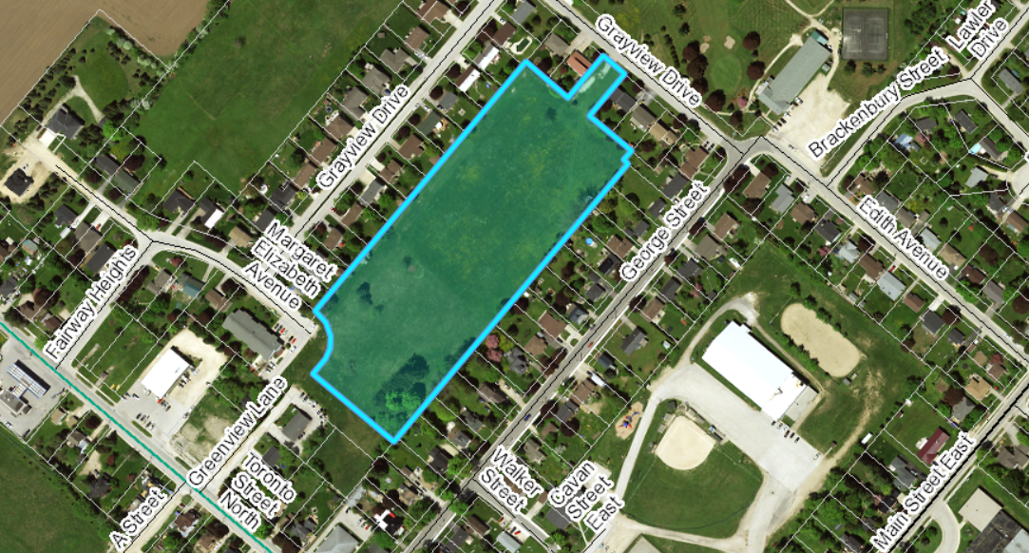Map 1: Airphoto of Subject Lands

The proposed lots would front onto a new street connecting Margaret Elizabeth Avenue to Grayview Drive. The proposal is to service the new lots with municipal water and sewer. The subject lands are currently vacant.

Stonebrook Phase I is draft approved for 55 units, and Phase II is being recommended for draft approval of 24 units on September 13, 2018. The Phase I and II lands are located to the northwest of the proposed Phase III lands.

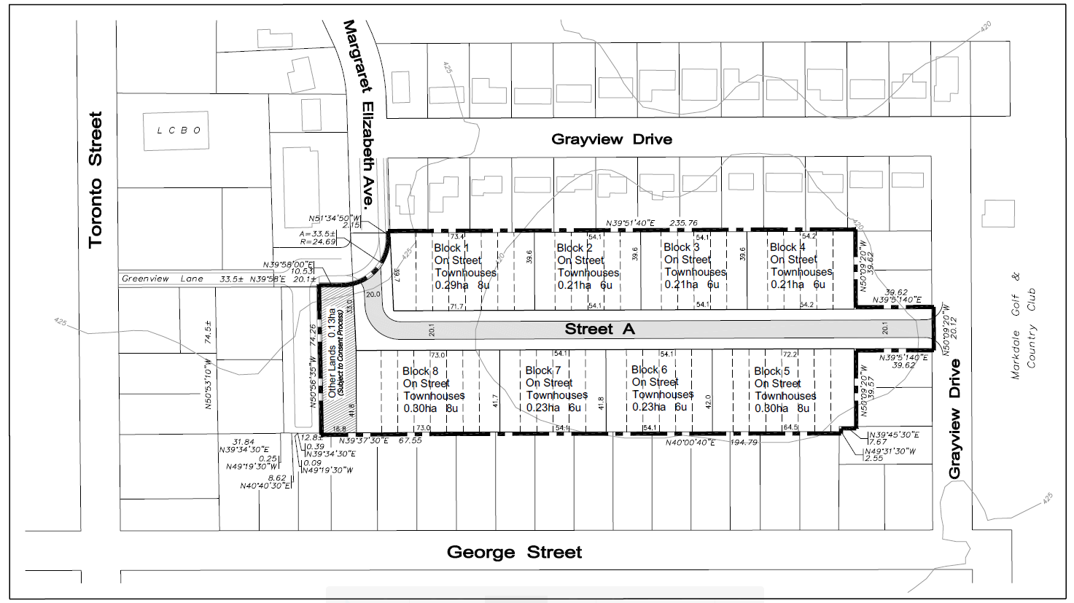

### Map 2: Proposed Plan of Subdivision

(Map 2 Courtesy of Georgian Planning Solutions and Design Plan Services)

The proposed development also requires an amendment to the Municipality of Grey Highlands Zoning By-law and a consent application.

Pre-submission consultation between the proponent, the Municipality of Grey Highlands and the County identified the submission requirements for the proposed plan of subdivision. Copies of all background reports and plans can be found at [this link](https://www.grey.ca/planning-development/planning-applications).

#### Analysis of Planning Issues

When rendering a land use planning decision, planning authorities must have regard to matters of Provincial Interest under the *Planning Act*, be consistent with the Provincial Policy Statement (PPS) 2014, and conform to any Provincial Plans or Municipal Official Plans that govern the subject lands. In this case, the County of Grey Official Plan and the Municipality of Grey Highlands Official Plan have jurisdiction over the subject property. There are no Provincial Plans in place for this section of Grey Highlands.

#### Provincial Policy and Legislation

Both the *Planning Act* and the PPS speak to the efficient use of land within settlement areas, where services are readily available. The proposed plan of subdivision is within a settlement area that is serviced by municipal water and sewer services. The PPS indicates that the preferred form of servicing for settlement areas is full municipal services. Municipal water capacity is currently available for the proposed units. Municipal wastewater treatment capacity is currently in ‘short supply’ and there are other developments in the application process that are also vying for this same capacity. The Municipality has undertaken an optimization program of their wastewater treatment that should provide the required capacity. A decision from the Ministry of the Environment Conservation and Parks on the wastewater treatment optimization is expected to come very soon. The Functional Servicing Report has noted that the development may not proceed until the increased capacity has been approved through the wastewater treatment optimization.

The supply of an adequate range of residential housing types is required in both Provincial documents. In this case, the proposed plan of subdivision is providing townhouse units in clusters of 6 and 8 units apiece.

Other policies in the PPS speak to connected, walkable communities, with provisions for public parkland and open space. The proposed subdivision will provide connections to adjacent roads (Grayview Drive and Margaret Elizabeth Avenue). Sidewalks are being proposed in this subdivision. Parkland has not been proposed at this time, as the developer intends to instead offer cash-in-lieu of parkland.

Following the public and agency review periods, staff will provide a more fulsome analysis of the Provincial legislation and policy.

#### County Official Plan

The proposed plan of subdivision is on lands designated as ‘Primary Settlement Area’ in the County Official Plan. Primary Settlement Areas are identified as principal centres in which to focus new residential growth in the County. The County Plan sets an average residential development density of 20 units per net hectare within this designation, but generally defers to detailed Municipal Official Plan policies and development standards.

Section 5.3 of the County Plan provides a similar servicing hierarchy to that found in the PPS, which has been noted above. Elsewhere in section 5 of the Plan, are policies which govern roads, transportation, and stormwater management. Similar to Phases I and II, Phase III is proposing to convey stormwater onto off-site lands, where a combined management system is being proposed. County Official Plan policies will be further assessed following agency review and the public process.

## Legal and Legislated Requirements

The application will be processed in accordance with the *Planning Act.*

## Financial and Resource Implications

There are no anticipated financial, staffing or legal considerations associated with the proposed subdivision, beyond those normally encountered in processing a subdivision application. The County has collected the requisite fee and peer review deposit for this application.

## Relevant Consultation

Internal: Planning and Housing

External: The public, Municipality of Grey Highlands, and required agencies under the *Planning Act*.

### Appendices and Attachments

None