Grey County Logo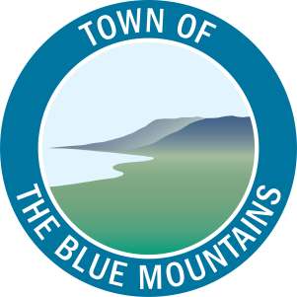

Committee Agenda

# Grey County – The Blue Mountains Task Force February 13, 2020 – Following Committee of the Whole

Bay Room, Grey County Administration Building

1. **Call to Order**
2. **Declaration of Interest**
3. **Items for Direction and Discussion**
   1. Workplan for 2020
4. **Other Business**
5. **Adjournment**