Grey County Logo Committee Report

| **To**: | Warden Milne and Members of Grey County Council |
| --- | --- |
| **Committee Date:** | April 27, 2023 |
| **Subject / Report No:** | Minor Exemption / PDR-CW-16-23 |
| **Title:** | Tyrolean Minor Exemption Application |
| **Prepared by:** | Scott Taylor |
| **Reviewed by:** | Randy Scherzer |
| **Lower Tier(s) Affected:** | Town of The Blue Mountains |
| **Status:** | Recommendation adopted by Committee as presented per Resolution CW70-23; Endorsed by County Council on May 11, 2023, per Resolution CC36-23. |

## Recommendation

1. **That report PDR-CW-16-23 be received, and**
2. **That the application for a Minor Exemption under the County’s Forest Management By-law for lands legally described as Part Lot 19; Concession 1, Plan 824, Part Lot 6 and RP;16R10341 Part 3, also known as 302 Grey Road 21,** **in the geographic Township of Collingwood, Town of The Blue Mountains, be approved.**

## Executive Summary

The County received a minor exemption application to the County’s Forest Management By-law to clear a pocket of trees for equestrian trail riding, paddock, and stable lands. Following public and agency comments, as well as a peer review of the application, the proponent has reduced the scope of their application to just the trail riding lands and removing some dead and hazardous trees. The County’s By-law Enforcement Officer and environmental peer reviewer are supportive of the tree removal, subject to some considerations outlined in this report. County staff are recommending approval of the revised minor exemption application.

## Background and Discussion

An application for a minor exemption was received for clear-cutting under the County’s Forest Management By-law.

The subject lands are legally described as Part Lot 19; Concession 1, Plan 824, Part Lot 6 and RP;16R10341 Part 3, in the geographic Township of Collingwood, Town of The Blue Mountains, also known as 302 Grey Road 21.

The subject lands are approximately 67 hectares in size with approximately 48 hectares of woodlands. This property contains a horse stable and paddock areas, as well as trails which were formerly used for horseback trail riding. The applicant has stated that due to years of run-off and flooding in the area, it has caused damage to the woodlands, much of which are dead or dying, and it creates unsafe conditions for the horseback trail rides in the area. The stated purpose of this application was to (a) re-establish those trails which have been made unsafe due to the presence of dead, dying, and hazardous trees, and (b) to allow for the expansion of the paddock areas on-site. Following review and comments on the minor exemption application it was subsequently revised to only consider the re-establishment of the trails and removal of some dead and hazardous trees.

The subject property is in the east end of the County abutting Grey Road 21 and the Town of Collingwood. Surrounding the subject lands are a mixture of forested lands and developed lands (residential and golf course).

In the County Official Plan, this property is designated as ‘Recreational Resort Area’ and ‘Wetlands’. Appendix B to the Plan identifies an ‘Other Identified Wetland’ and pockets of ‘Significant Woodlands’ on the property. The proposed tree clearing is outside of the designated Wetlands on-site.

As noted above, this application initially proposed to remove a larger swath of trees on-site (see Map 1 below). The County received comments raising concerns and questions over the proposed tree clearing. In response to those concerns, a peer reviewer was hired, who worked with the County and the proponent to assess the impact and refine the proposal. Map 2 below shows the revised tree clearing area.

In support of the application the proponent submitted an Arborists Report, an Environmental Impact Study (EIS), and addendum responses to the comments received and the peer review. As part of their work, the proponent also consulted with the Ministry of the Environment, Conservation and Parks (MECP) with respect to potential for Species at Risk (SAR) on-site. There are protections being recommended for the retainable Butternut trees on-site. Note that in this case ‘retainable’ is based on the health of the tree. Some of the Butternuts on-site could not be retained based on their existing health.

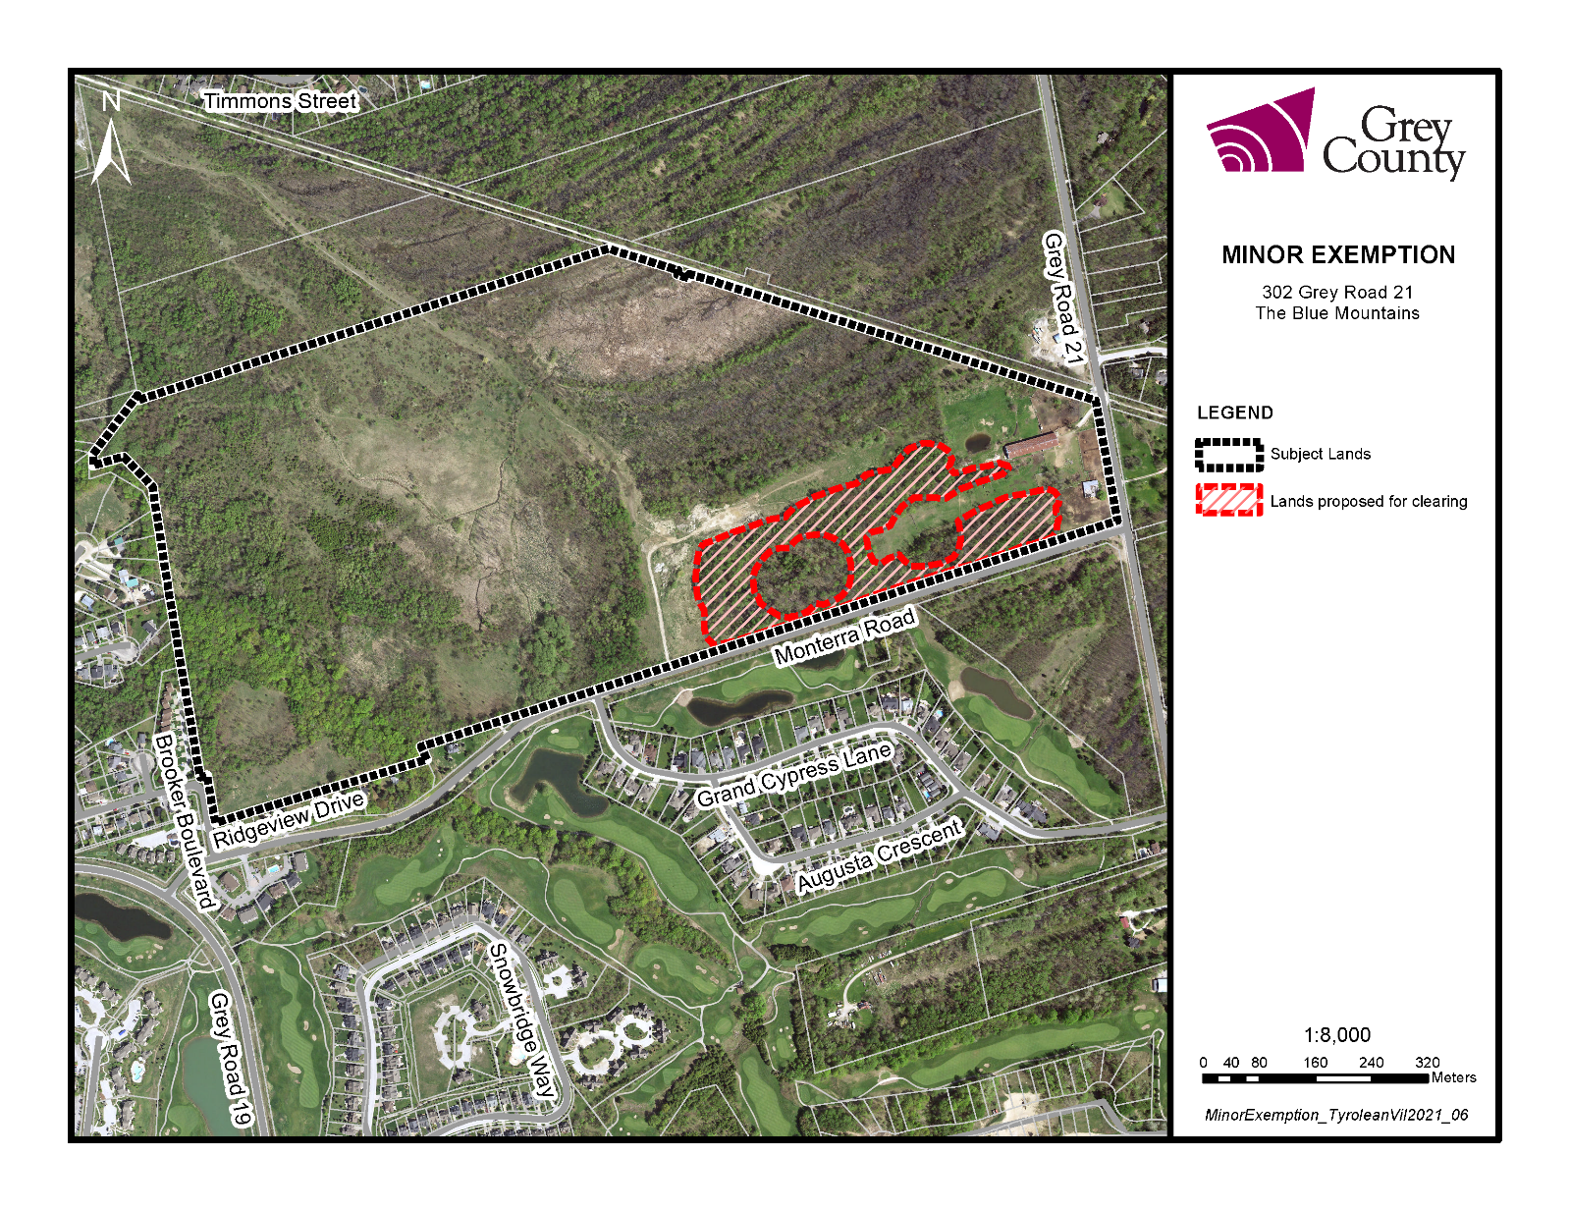

### Map 1 – Initial Forest Clearing Request

In Map 2 below, the blue marked trails represent the areas to be cleared, while the shaded green areas are the existing paddocks on-site. The yellow and green dots are the Butternut trees on-site which must be retained and buffered by 50 metres. The red dots are those Butternut trees which can be removed based on the condition of the trees.

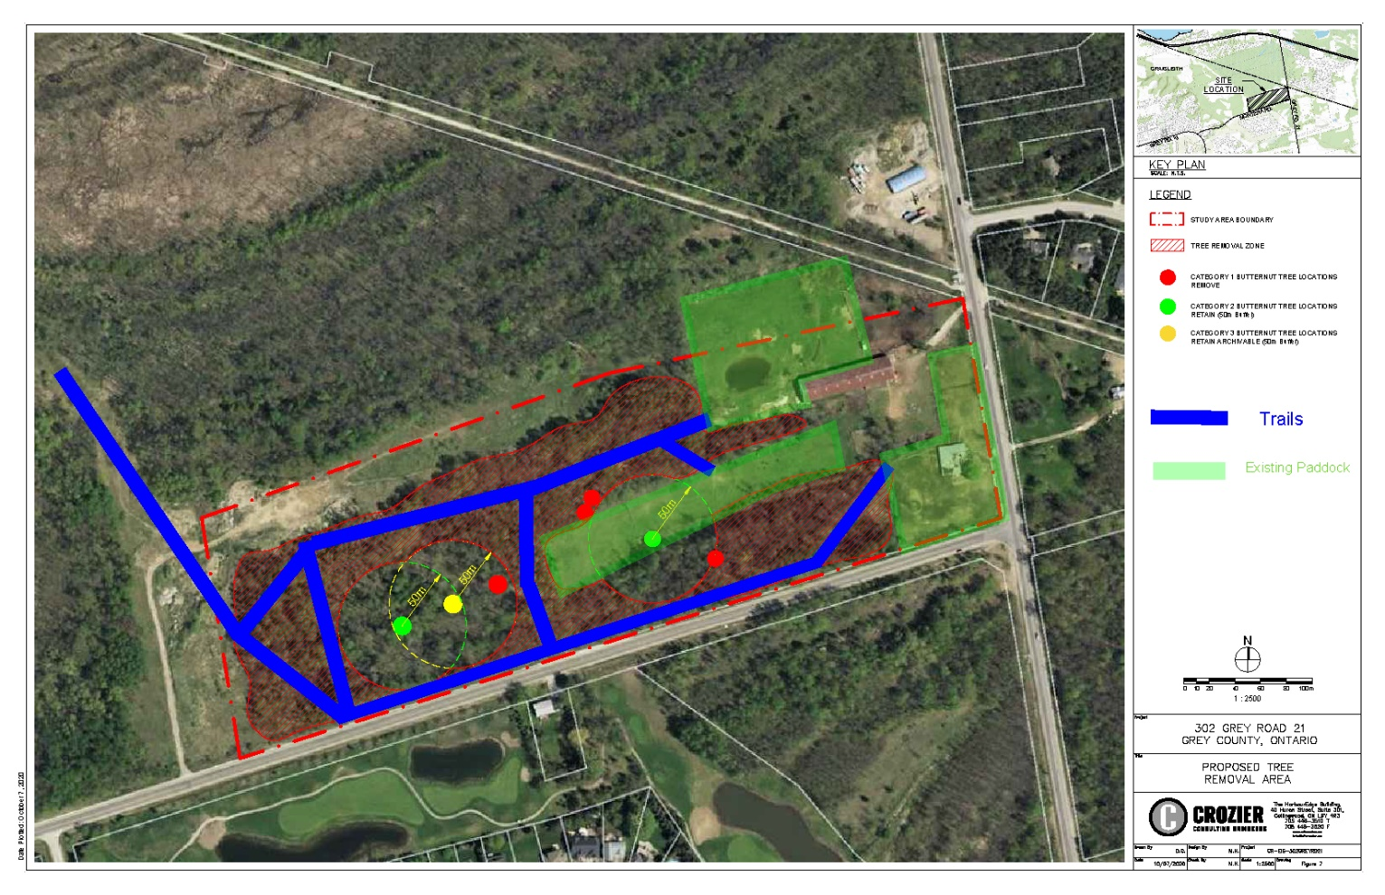

### Map 2 – Revised Forest Clearing Request

### Agency and Public Comments Received

Under the Forest Management By-law, adjacent landowners, conservation authorities, Municipal, and County staff are to be notified and/or consulted when an application is received.

### Public Comments

County staff received comments from the following people on this minor exemption application:

* Blue Mountain Watershed Trust Foundation,
* Allen Jones,
* Lucy Richmond,
* Betty and John Rossimel,
* Bahram Sedighi,
* Tony and Jasmina Slepanek,
* Pamela Spence, and
* Bruce Yama.

Many of the above provided detailed comments on the proposed minor exemption application. A brief summary of the comments received is as follows:

* Opposed to the proposed tree clearing,
* What is the justification for the tree cutting proposed,
* Concerns over the number of trees proposed to be removed, as well as the trees already removed by other developments in this area,
* Questions over the exact area to be cut vs. the remainder of the trees on-site,
* Concerns about the future plans for this site and whether or not the tree clearing would lead to non-farm development of the property,
* This proposal is premature until future development plans are known for the site and any planning approvals are granted,
* Concerns over impact on climate change considering the climate emergency,
* The woodland performs important water retention and carbon dioxide sequestration functions and should be preserved,
* Concerns that the arborists report over-states the percentage of deadwood on-site,
* Are there plans to replace the trees being removed elsewhere,
* Concerns about the impact on wetlands and wildlife in the area,
* Concerns over the wetland boundaries on-site,
* Questions about where this fits within other development plans for the area,
* Concerns about this development not following through on obligations, similar to other developments in the past,
* Concerns over flooding impacts and the capacity of culverts in the area,
* Existing flooding impacts in this area have yet to be addressed,
* Is a drainage study needed for this site,
* Questions over which level of government is accountable for drainage under the *Municipal Act,*
* Current infrastructure is insufficient in this area and no further development should be considered, until a plan is in place for infrastructure improvements,
* As much of the cut material as possible should be ‘chipped’ and left on-site,
* Questions over which Conservation Authority has jurisdiction over this site,
* Has fill already been placed or moved around on-site,
* Concerns over conformity to planning policies and zoning provisions,
* Concerns that the Ministry of Natural Resources and Forestry’s letter has been mischaracterized,
* Questions about the EIS, its scope, and whether it fulfills the criteria needed,
* Questions over the use of the term ‘minor exemption’ when the application is for tree cutting,
* Impacts on Georgian Trail users and the loss of shade these trees provide, and
* Concerns over the notification given for this application.

**Staff Response**

Based on the public and agency comments, an environmental peer review of this application was completed. The peer reviewer recommended minimizing the level of tree removal on-site for a variety of reasons including but not limited to the following items:

* water retention and not exacerbating any existing flooding concerns in the area,
* minimizing impact on nearby wetlands,
* preserving the health and integrity of the woodlands,
* using existing cleared areas as paddocks, rather than clearing new paddock areas,
* providing for reasonably sized trails which still meet the needs, safety, and enjoyment of trail users and the proponent, and
* ensuring protection of sensitive features on-site.

The peer reviewer has also made specific recommendations for how and when trees can be removed from the site, in order to minimize impacts on the remaining trees, and plant/wildlife species on-site. These recommendations have been included later in this report.

Staff offer the following responses to some of the other comments raised:

* the proponent has no development plans for this portion of the property beyond the re-establishment of horse-riding trails at this time,
* any future development or tree clearing would be required to go through planning approvals, or a future minor exemption application at that time,
* the scope of an EIS is commiserate with the level of proposed development or clearing, i.e., future development residential or commercial on-site, should it be proposed, would require a different level of EIS, versus that needed for the re-establishment of trails and removal of dead/hazardous trees,
* the proposed clearing has been reduced in response to comments received and technical review of the EIS,
* the Town of The Blue Mountains is working on a [Town-wide Master Drainage Plan Environmental Assessment](https://www.thebluemountains.ca/planning-building-construction/current-projects/municipal-infrastructure-projects/town-wide-master),
* County staff have confirmed that this site is under the jurisdiction of the Grey Sauble Conservation Authority (GSCA), and does not also include Nottawasaga Valley Conservation Authority (NVCA) lands,
* the notification for this application was done in accordance with section 5 of the [County’s Forest Management By-law](https://docs.grey.ca/share/public?nodeRef=workspace%3A//SpacesStore/17818388-3d7c-4b6c-8119-632de6758b5a).

### Agency Comments

The GSCA, NVCA, the Town of The Blue Mountains, the County’s Forestry By-law Enforcement Officer, and Peer Reviewer provided comments on this application. Staff have included summaries or key items from each of their submitted comments below.

**GSCA**

GSCA staff noted the following with respect to this minor exemption application:

*“Development taking place on these lands may require permission from the conservation authority to confirm that the control of flooding, erosion, dynamic beaches, pollution or the conservation of land are not affected. GSCA also regulates the alteration to or interference in any way with a watercourse or wetland. The proposed tree clearing is occurring within an area that is regulated by our office, this area is regulated as it has been identified as flood prone. The act of tree clearing would not require a permit from our office, however, if there was any proposed grading works (placement or removal of fill or alteration to existing grades), or additional site alterations proposed, a permit may be required. We recommend that the applicant contact our office should this be the case, to determine if a permit is required and what information may be needed to support a permit application.*

*The subject area noted for tree removal is not currently identified as hazardous in our mapping. We note that no site inspection has been completed related to this circulation and regulation and hazard mapping may be subject to change.*

*We note that natural heritage features have been identified on the subject lands through previous study. We recommend that all activities on the subject lands are completed in conformity with relevant provincial and federal legislation and requirements, and in-line with the provided EIS, comments from the Ministry of The Environment, Conservation and Parks, and arborist report.”*

Staff would note that the GSCA comments were received prior to the passing of Bill 23.

**NVCA**

NVCA staff noted: *“I just checked our mapping and the property in question is entirely within the GSCA watershed.”*

**Town of The Blue Mountains**

Town Council also passed the following motion with respect to this application:

*“THAT Council of the Town of The Blue Mountains receives the June 24, 2021, correspondence from County of Grey regarding Woodland Clearing - Tyrolean Village Resorts Limited and refers the correspondence to the Planning Department to respond, with a copy provided to Council, and to respond to the comments of Ms. Richmond regarding this matter.”*

Town staff shared the following comments in relation to this proposal:

*“It is recommended that the County have this scoped EIS peer-reviewed to confirm that the general recommendations and mitigation proposed (in Section 8.0) and the conclusions presented (in Section 9.0) in support of the tree removals are valid.*

*Further we note that the proposed tree removal area is within the Grey Sauble Conservation Authority (GSCA) regulatory area, and as such, we would suggest that the County contact the GSCA for its comments related to the scope EIS.*

*The Town has no further comments on this matter subject to a peer review of the EIS to the satisfaction of the County and the Grey Sauble Conservation Authority, and provided the proposed tree cutting is determined to have no negative impact on the nearby wetlands and another other natural heritage features and ecological functions.”*

**County By-law Enforcement Officer**

Lee Thurston, the County’s By-law Enforcement Officer provided the following comments on the application.

*“I have read the reports and visited the site.  It’s a low-lying area that most likely is very wet in the spring. The tree report provided with the application is accurate. Most of the trees are poor/low quality and low value species…*

*as long as they adhere to the recommendations of the EIS and the MECP then I have no issue with the removal.  It’s interesting that they are going to have an arborist mark the trees for removal.”*

**County Peer Reviewer – Natural Resource Solutions Inc. (NRSI)**

NRSI provided a series of comments on this minor exemption application in relation to the; original proposal, Arborists Report, EIS, as well as the addenda submissions, and the revised tree clearing proposal. NRSI worked closely with County staff and the environmental experts on behalf of the proponent to refine any proposed clearing to minimize impacts. It is important to note that the scope of the proposed clearing was significantly reduced, and that the clearing being recommended for approval is for the re-establishment of the trails, and not for development, building purposes, or paddock expansions. NRSI has recommended the following conditions be attached to this minor exemption:

1. That the proposed trails be a maximum of 5 metres in width, but ideally kept as narrow as possible.
2. That the tree clearing be conducted during the winter under frozen ground conditions to (a) to minimize soil exposure, compaction, rutting, and minimize impacts on the lands and remaining trees/vegetation, and (b) to avoid impacts to migratory birds and species at risk bats.
3. The future trail alignment and trees requiring removal should be marked prior to the commencement of tree removal operations. Trees should be marked at eye-level on at least two faces of the stem with hi-visibility marking paint. Trees should also be marked with a strip of paint at the butt in order to verify only marked hazard trees have been removed, following the removal activity.
4. Trees identified as hazards for removal should only be those identified based on appropriate tree risk assessment practices and should be identified by the applicant’s Arborist and reviewed by County Forestry Officer or similarly qualified County personnel prior to removal.
5. Woodland connectivity between the subject land’s woodland and larger woodland to the north should be maintained.
6. Tree removal activities must be completed in such a way as to maintain the ridge/trough topography throughout the subject lands and avoid impacts within low-lying wetland areas. Should tree removal activities amount to a disturbance in soils or site alteration, consultation with the Grey Sauble Conservation Authority may be required.

County staff are recommending approval of the revised minor exemption application, subject to the six considerations shared by NRSI above.

## Legal and Legislated Requirements

The application was processed in accordance with the County’s Forest Management By-law*.*

## Financial and Resource Implications

At this time, there are no expected financial or resource considerations beyond those normally encountered in processing a Minor Exemption application. The County has received an application fee with the file, and the peer review was paid for by the proponent.

## Relevant Consultation

Internal: Planning, Grey County By-law Enforcement Officer, and Peer Reviewer (NRSI)

External: Town of The Blue Mountains, Grey Sauble Conservation Authority, and the public.

### Appendices and Attachments

*None*