Grey County Logo Committee Report

# Report PDR-PCD-29-14

**To**: Chair Wright and Members of the Planning and Community Development Committee

**From**: Randy Scherzer, Director of Planning

**Meeting Date:** September 16, 2014

**Subject: Blue Bay Villas – proposed redline revisions - 42-CDM-2013-03**

**Status**: Recommendation adopted by Committee as presented per Resolution PCD100-14; Endorsed by County Council October 7, 2014 per Resolution CC136-14;

## Recommendation(s)

**WHEREAS plan of condominium application 42-CDM-2013-03 known as Blue Bay Villas was draft approved on February 18, 2014;**

**AND WHEREAS the County has received proposed redline revisions from the owner to revise the draft approved plan by changing a total of 4 townhouse units into a total of 4 semi-detached units;**

**NOW THEREFORE BE IT RESOLVED THAT Report PDR-PCD-29-14 be received;**

**AND THAT in consideration of the draft plan of condominium and the matters to have regard for under Subsection 51(24) of the Planning Act RSO 1990 as amended, the Grey County Planning and Community Development Committee hereby approves the redline request for Plan of Subdivision 42-CDM-2013-03, subject to the revised conditions set out in the Notice of Decision.**

## Background

Plan of Condominium File 42-CDM-2013-03 (Blue Bay Villas) was draft approved on February 18, 2014 which draft approved a total of 41 condominium townhouse units on 2.02 hectares of land. The draft approved condominium is located on lands legally described as Part of Block 75, Plan 16M-15, Part 2 on Plan 16R-10059, Township of Georgian Bluffs (geographic Township of Sarawak) – (see Map 1 below). The subject lands are located on the southwest corner of McLeese Drive and Cobble Beach Drive in the settlement area known as Cobble Beach. The current owner of the subject lands is Georgian Villas Inc. (Cobble Beach) and the agent is Design Plan Services.

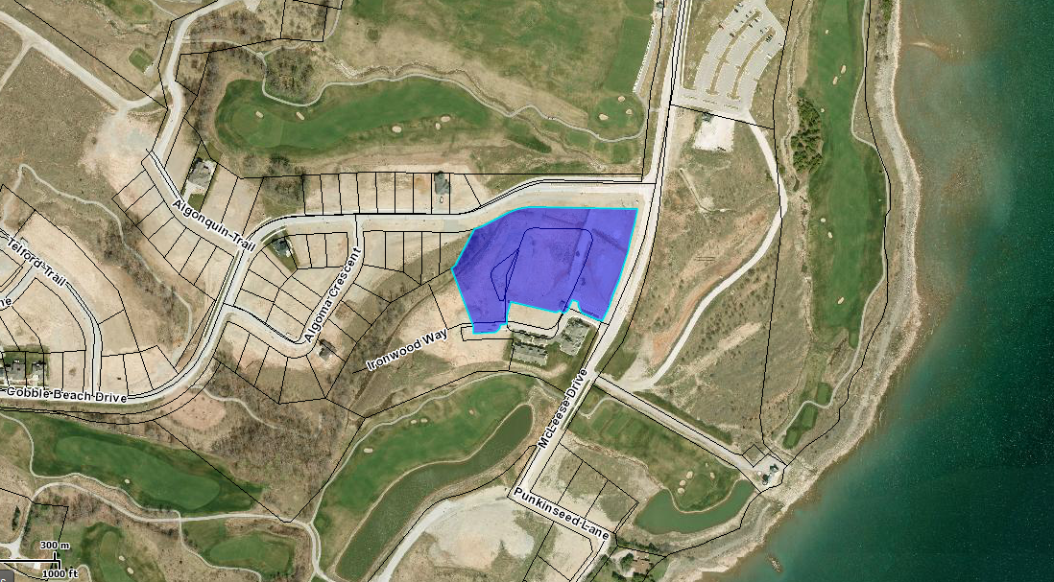

### Map 1: Blue Bay Villas Subject Lands

The owner of the subject lands has submitted a request for a redline revision to the draft approved condominium. The proposed revision to is to split Block 6, which is currently draft approved for 4 townhouse units, and split it into two Blocks (identified as Blocks 6 and 6A on the proposed revised plan), with each proposed block containing 2 semi-detached dwellings. There is no proposed change to the total number of units.

The proposed redline revisions were circulated to various agencies as well as members of the public that requested notice of the application as part of the previous draft approval process. Below is a link to the proposed revised plan:

[42-CDM-2013-03 Blue Bay Villas Map](https://greydocs.ca/urm/idcplg?IdcService=GET_FILE&dDocName=GC_233384&RevisionSelectionMethod=LatestReleased&Rendition=Web)

### Agency Comments Received

Grey Sauble Conservation Authority (GSCA) – The GSCA in correspondence dated July 31, 2014 indicates that they have no comments to offer for the proposed redline revisions.

Township of Georgian Bluffs - In correspondence dated September 3, 2014 the Township indicates that they support the proposed changes and note that changes are required to amend the schedule in the Site Plan Agreement following the County’s approval of the redline revisions.

City of Owen Sound – The City of Owen Sound Council considered the matter at their meeting on August 25, 2014 and has no comment.

### Public Comments Received

There were no comments received from members of the public with respect to the proposed redline revisions.

### Analysis of Planning Issues:

Planning authorities must have regard to matters of Provincial interest, the criteria of the *Planning Act* and be consistent with the Provincial Policy Statement (PPS). Within Grey County they must also make decisions that conform to the County of Grey Official Plan.

### Provincial Legislation – The Planning Act

Section 1.1 of the *Planning Act* outlines the purposes of the Act. The purposes of the Act promote sustainable economic development in a healthy natural environment within a land use planning system, led by provincial policy and matters of provincial interest. Section 2 of the *Planning Act* outlines matters of Provincial Interest, which decision makers must be consistent with when carrying out their responsibilities under the Act.

The proposed redline revisions have regard for matters of Provincial Interest under *The Planning Act*.

### Provincial Policy Statement (PPS)

A key goal of the PPS is directing new growth to serviced settlement areas, and promoting the vitality of such settlement areas through re-development and intensification. The condominium development is located within the settlement area known as Cobble Beach in the Township of Georgian Bluffs and will be serviced with municipal water and private communal sewage services.

It can be concluded that the proposed revisions to the draft plan of condominium, with the recommended conditions of draft approval, is consistent with the PPS.

### County of Grey Official Plan

The County Official Plan designates the subject lands as ‘Primary Settlement Area’. The lands are designated as ‘Village Centre’ in the Cobble Beach Secondary Plan (County OPA#32). The permitted uses in the ‘Village Centre’ designation include a wide variety of uses including medium density residential dwellings, high intensity residential dwellings, commercial, institutional and open space uses. Therefore, semi-detached units are considered as a permitted use.

The proposed draft plan of condominium, with the recommended conditions of draft approval conforms to the County Official Plan.

The current zoning for the subject lands permits semi-detached dwelling units and therefore a zoning by-law amendment is not required to support the proposed redline revisions.

A revised site plan application will be submitted to the Township of Georgian Bluffs should the redline revisions be approved.

A further note has been included in Condition 1 which would provide the flexibility to convert townhouse units into semi-detached units without a further redline revision. This would allow the developer to adjust the unit types to the market conditions. In order to consider semi-detached units on the other blocks, zoning requirements would need to be met and the changes would need to be incorporated into the site plan. The total number of units would also need to remain the same.

## Financial / Staffing / Legal / Information Technology Considerations

At this point there are no financial, staffing, legal or IT considerations beyond those normally encountered in processing a redline revision. The County has collected an application and associated fee for the proposed redline revisions.

## Link to Strategic Goals / Priorities

Action 2.10, under Goal 2 of the County’s Strategic Plan requires the continued management of growth and the application of sound land use planning principles. Permitting residential growth in a settlement area, which efficiently uses municipal infrastructure, and provides for a range of housing opportunities, could be considered sound land use planning.

Respectfully submitted by,

Randy Scherzer  
Director of Planning

**NOTICE OF DECISION**

**On Application for Approval of Draft Plan of Subdivision**

**under Subsection 51(45) of the Planning Act**

Draft Plan Approval was given by the County of Grey on February 18, 2014. A request has been made to revise the draft plan. **Revised** Draft Plan Approval is hereby given by the County of Grey for the application regarding the above noted lands. A copy of the Decision is attached.

**WHEN AND HOW TO FILE A NOTICE OF APPEAL**

Notice to appeal the decision to the Ontario Municipal Board must be filed with the County of Grey no later than 20 days from the date of this notice, as shown above.

The notice of appeal should be sent to the attention of the Director of Planning and Development of the County, at the address shown below and it must,

(1) set out the reasons for the appeal, and

(2) be accompanied by the fee prescribed under the Ontario Municipal Board Act.

**WHO CAN FILE A NOTICE OF APPEAL**

Only individuals, corporations or public bodies may appeal decisions in respect of applications for approval of draft plans of subdivision to the Ontario Municipal Board. A Notice of Appeal may not be filed by an unincorporated association or group. However, a Notice of Appeal may be filed in the name of an individual who is a member of the association or group.

**RIGHT OF APPLICANT OR PUBLIC BODY TO APPEAL CONDITIONS**

The applicant or any public body may, at any time before the final plan of subdivision is approved, appeal any of the conditions imposed by the County of Grey to the Ontario Municipal Board by filing with the Director of Planning and Development of the County, or her delegate, a Notice of Appeal.

**HOW TO RECEIVE NOTICE OF CHANGED CONDITIONS**

The conditions of an approval of draft plan of subdivision may be changed at any time before the final approval is given.

You will be entitled to receive notice of any changes to the conditions of the approval of draft plan of subdivision if you have either,

(1) made a written request to be notified of the decision to give or refuse to give approval of draft plan of subdivision, or

(2) make a written request to be notified of changes to the conditions of approval of the draft plan of subdivision.

**GETTING ADDITIONAL INFORMATION**

Additional information about the application is available for public inspection during regular office hours in the Planning & Development Office at the address noted below or by calling 519-376-2205 or 1-800-567-GREY.

**ADDRESS FOR NOTICE OF APPEAL**

**County of Grey**

**595-9th Avenue East**

**OWEN SOUND, Ontario N4K 3E3**

**Attention: Mr. Randy Scherzer, MCIP RPP**

**Director of Planning & Development**

Plan of Condominium File No. 42-CDM-2013-03 was granted draft approval on February 18, 2014. The draft plan is hereby **Revised**. The County’s conditions of approval for this draft Plan of Condominium are amended as follows:

No. Conditions

1. Condition 1 of the original conditions of draft approval given on February 18, 2014 is hereby deleted and replaced with the following:

**“That draft plan approval applies to the Draft Plan of Condominium 42-CDM-2013-03 prepared by Design Plan Services Inc. dated June 25, 2014 showing a total of 37 townhouse condominium units within 11 blocks (Blocks 1 to 5 and Blocks 7 to 12), and 4 semi-detached units within Block 6 and Block 6A, as well as one common elements roadway block within Part of Block 75, Registered Plan 16M-15, Part 2 on 16R-10059 in the Township of Georgian Bluffs, County of Grey. The Township has reviewed and approved proposed servicing that corresponds with the above-noted plan.**

**Any further proposed conversions from townhouse units to semi-detached units in Blocks 1 to 5 and Blocks 7 to 12 can be considered subject to the zoning requirements being met, the changes being incorporated into the site plan, and provided that the total unit count does not change.**

1. That all other conditions of draft approval as granted on February 18, 2014 remain in effect.