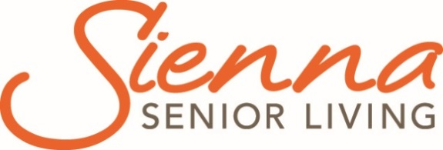

Grey Gables
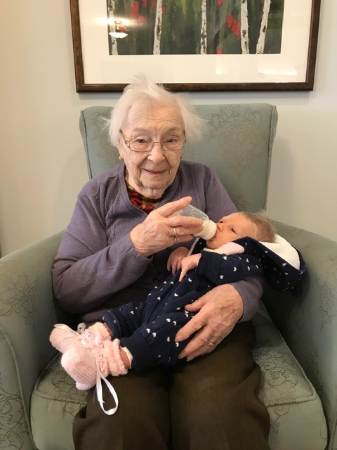

  - Grey County Operations Report to Committee of Management
  - Open Session

  - Submission Date: June 11, 2019
  - Information for the Months of: April and May 2019

Financials
1st Quarter | Budget | Actual | Variance
Nursing Envelope Revenue | $887, 064 | $844,597 | ($42,467)
Nursing Expenses |  | $802, 845 | $84,219
Net Nursing Envelope |  |  | $41,752
Program Envelope Revenue | $76,284 | $77,422 | $1,138
Program Expenses |  | $74,981 | $1,303
Net Program Envelope |  |  | $2,441
Raw Food Revenue | $58,035 | $57,453 | ($582)
Food Expenses |  | $40,242 | $17,792
Net Food |  |  | $17,210
Other Accommodation Revenue | $593,475 | $535,935 | ($57,540)
Other Accommodation Expenses |  | $458,729 | $134,746
Net Other Accommodation |  |  | $77,206
Note: Revenue includes provincial grant funding, resident fees and net levy requirement

Variance Explanation
Nursing – Wages and benefits are underspent in the first quarter however the expense for agency staffing offsets the variance. Staff training programs and service agreements will be paid in future quarters.
Programs – Currently operating within budget.
Raw Food – Invoices and payments are being verified. The Nutrition Manager will be working with the Sienna Partner to create an action plan to address any variance.
Other Accommodation – Envelope reflects a positive variance due to: not all professional and consulting fee invoices had been processed for the first quarter, IS transfer payment was not completed in the 1st quarter financials and the increase in hours for scheduling support was delayed pending budget approval.

Scorecard: Quality
Publicly reported indicators- Q3 2018 (October- December 2018)
Indicates Better than Ontario Average
Indicates Worse than Ontario Average

Indicator | HQO Best Practice | Ontario  Average | Sienna Average | Grey Gables
 |  |  |  | Q2 Jul-Sept/18 | Q3 Oct-Dec/18 | Change
Improved or remained independent in mid-loss ADL | 30.4% | 29.2% | 27.2% | 37.1% | 34.6
Worsened ADL | 25% | 33% | 30.2% | 41.7% | 44% | ↑
Worsened behavioural symptoms | 8% | 12.7% | 10.5% | 19.1% | 16.1% | ↓
Worsened mood from symptoms of depression | 13% | 23% | 16.9% | 33% | 28.2% | ↓
Taken antipsychotics without a diagnosis of psychosis | 25.3% | 19.5% | 17.4% | 25.6% | 23.1% | ↓
Has fallen | 9% | 16.4% | 16.3% | 12.8% | 13.2%
Worsened stage 2 to 4 pressure ulcer | 1% | 2.7% | 2.2% | 3.3% | 3.3% | =
New stage 2 to 4 pressure ulcer | 1% | 2.2% | 1.8% | 2.6% | 2.8% | ↑
Daily physical restraints | 3% | 4.3% | 0.9% | 3.8% | 1.5%
Worsened bladder continence | 12% | 17.8% | 16.3% | 27.6% | 31.3% | ↑
Has pain | 7% | 5.8% | 2.5% | 3.1% | 2.1%
Worsened pain | 6% | 9.8% | 6.9% | 14.9% | 13.5% | ↓

The third quarter data was recently released by the Canadian Institute for Health Information (CIHI). Grey Gables remains above the provincial average in eight areas however four of these areas have improved over the previous quarter.

Two areas of focus over the reporting period and actions include:
1. Use of antipsychotic medication:
- Enhanced monitoring of medication use through audits and pharmacy reviews
- Education for Registered Staff and Medical professionals regarding medication use and diagnosis
- Audit and follow up with Sienna Informatics partner related to data quality
2. Worsened Behaviour Symptoms:
- BSO team actively involved in staff education, resident assessment and care plan development
- Shift huddles include updates and communication regarding responsive behaviours

Ministry of Health and Long-Term Care (MOHLTC) Compliance Orders /Inspection Findings Summary
A Ministry of Health and Long Term Care Inspector was on site at Grey Gables for six days starting May 7. The visit was follow up from the 2018 Resident Quality Inspection, two family complaints and two critical incident reports. The MOHLTC report is pending.

Scorecard: People
- Grey Gables Hair Salon is well utilized by many residents. To enhance the resident experience, the Hair Stylist has created a personalized play list for each client. When someone arrives for their appointment, she simply says, ‘Alexa play Jane’s playlist’ and they are surrounded by their favourite tunes. This special touch helps residents relax and enjoy their time.
- A Laundry team member has taken extra steps related to staff wellness and ensures that the staff room is stocked with healthy snacks and beverages. She uses funds from the social committee fund that all staff contribute towards.
- A special shout out to a team member from the Resident Experience Department who every year, on a day off, takes a resident to the cemetery to help look after her parents’ plot. This is something that is appreciated by the participating resident.
- Recruitment strategies have been successful over the reporting period, resulting in the hiring of 7 PSWs, 1 cook, and 1 RPN.

Sienna Support Services Updates
- Quality and Informatics Partner- April 11 and May 1, 2019
- Resident Experience Partner- April 8, 2019 teleconference, April 24, 2019 on site
- Nutrition Conference – April 7, 2019, May 22, 2019 “What’s Cooking” teleconference.
- Clinical Partner – April 11 and May 2 teleconference, and May 7, 2019
- Region 7 Executive Directors Meeting – April 25, 2019
- CARF webinars – April 10, 24, May 8, 22, 2019
- Sienna Leadership Symposium May 27 – May 29, 2019

Projects, Location Events and Other
Some highlights of events and activities in this reporting period include:
- Mother’s Day Sunday afternoon event May 12, ‘Celebrating the Sweetness of Mom’. Music, sweet treats and a live dessert auction was enjoyed by 150 people.
- Capital projects are underway and include the replacement of a washing machine in the laundry room and the maintenance and repair of the home’s fences and railings. Flooring replacement has also been completed in a main stairwell and office space.

Occupancy
2019 Occupancy Data | Reporting Period | Year to Date
Occupancy | 99.5% | 98.9%
Move-Ins | 3 | 11
Discharges | 3 | 10

Regulatory Visits i.e. Ministry of Labour, Public Health
April 4, 2019 – Public Health Inspection, no areas of non-compliance identified.

Occupational Health and Safety Issues
There were no occupational health and safety issues during this reporting period.

Emergency Preparedness and Environmental concerns (including emergency codes practiced)
Code Red was practiced on all three shifts in April and May. Additionally, Code Yellow was practiced in May.

In follow up to a recent fire inspection the installation of a new fire door on the oxygen storage room and new lighted exit signs in the lower level has been completed.

Written and Verbal Complaints Summary
No complaints received during this reporting period.

Compliments Summary
A number of verbal compliments were received over the month related to the cleanliness of the home, the care and the food.
Many positive comments and notes were received following the Mother’s Day Event held on May 12, 2019.

Resident and Family Satisfaction Survey
There is no update during this reporting period.

Resident/Family Council Updates
A Resident Council meeting was held April 30, 2019 and May 28, 2019. There were no areas of concern raised.
The Family Council meeting held on April 16, 2019 and May 21, 2019. There were no areas of concern raised.

