Grey County Logo Committee Report

# Report PDR-PCD-13-14

**To**: Chair Wright and Members of the Planning and Community Development Committee

**From**: Randy Scherzer, Director of Planning

**Sarah Morrison, Intermediate Planner**

**Meeting Date:** April 15, 2014

**Subject: Potential Land Acquisition – Forest Property Adjacent to Dornoch Tract, Municipality of West Grey**

**Status**: **Recommendation Adopted as Presented per *PCD48-14*; Endorsed by Council per *CC59-14* May 6, 2014**

## Recommendation(s)

**WHEREAS Committee through closed session authorized staff to act as an agent for County Council to enter into negotiations with the executors of the Estate of Bruce A. Krug to purchase a 100 acre forest property legally described as Lot 9, Concession 3 EGR, geographic Township of Glenelg, Municipality of West Grey, which is directly adjacent to the Dornoch County Forest Tract;**

**AND WHEREAS the property was appraised at a value of $155,000;**

**AND WHEREAS an Offer to Purchase has been accepted by the Estate of Bruce A. Krug in the amount of $155,000, plus the non-recoverable portion of HST if applicable, conditional upon the approval of Council;**

**NOW THEREFORE BE IT RESOLVED THAT Report PDR-PCD-13-14 be received;**

**AND THAT a by-law be prepared to authorize the Warden and Clerk to sign the final agreement of purchase and sale to acquire the subject property in accordance with the Sale and Acquisition of Land Policy G-GEN-003;**

**AND THAT the purchase of the subject lands be funded from the Forestry Reserve in the amount of $100,000, with the remaining amount to be funded from any surplus realized in the 2014 General Forestry operating budget, and if insufficient funds exist, that any shortfall in funding be funded from the One Time Funding Reserve;**

**AND THAT the $25,000 in forestry revenue estimated to be realized in 2014 from the subject property be transferred to the Forestry Reserve;**

**AND THAT any other additional expenses related to the purchase of the property, including legal expenses, be funded from any surplus realized in the 2014 General Forestry operating budget, and if insufficient funds exist, that any shortfall in funding be funded from the Forestry Reserve.**

## Background

The executors of the Estate of Bruce A. Krug approached the County to see if the County was interested in purchasing a forested parcel of land immediately north of the Dornoch Tract (20). The property is composed of 100 acres and is legally described as Lot 9, Concession 3 EGR in West Grey, geographic Township of Glenelg (see map below). The executors of the Estate had the property appraised in May 2013 for a total estimated value of $155,000.

A property assessment was performed by Carl Sadler and Chris Hachey. The subject lands are located between 400 acres of Saugeen Valley Conservation Authority (SVCA) land to the north and 300 acres of Grey County land (Dornoch Tract) to the south. The property has 21 acres of good quality cedar that could be strip cut in 2014 to produce approximately $25,000 in forest revenue. The property also has 32 acres of tolerant hardwood in need of an improvement harvest that would produce approximately $30,000 in forest revenue. The hardwood harvest could be carried out when the Dornoch hardwoods are due for management in 2018.

### Map of Subject Property

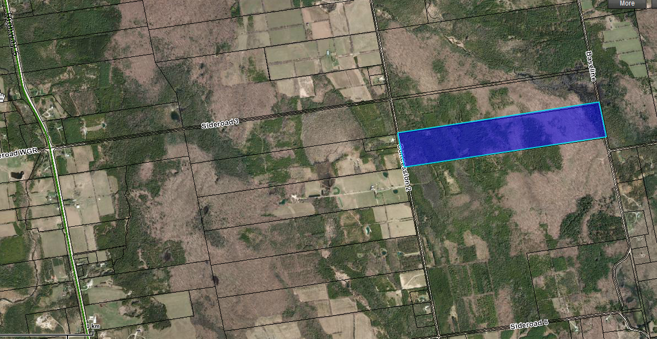

There are a number of existing trails throughout the Dornoch Tract. With the purchase of the subject property, existing trails in the Dornoch Tract could be extended into the subject lands providing further recreational opportunities for the public. Also by adding the subject lands to the Dornoch Tract, it will ensure that the forest is managed using sustainable forest management practices for the foreseeable future. With the lands to the north being owned by SVCA and the lands to the south owned by the County, the purchase of the subject lands would result in a contiguous 800 acre natural forest block under public ownership. The property would be a great addition to the County forest holdings.

Through closed session, the Planning and Community Development Committee directed staff to enter into negotiations with the Estate of Bruce A. Krug to acquire the property for a maximum amount as directed by Committee. An offer to purchase was sent to the solicitor for the Estate and the offer of $155,000 plus the non-recoverable portion of HST (if applicable) was accepted. If HST applies, the non-recoverable portion of HST is $2,728. Below is a link to the accepted Agreement of Purchase and Sale:

[Agreement of Purchase and Sale Krug Forest](https://greydocs.ca/urm/idcplg?IdcService=GET_FILE&dDocName=GC_213570&RevisionSelectionMethod=LatestReleased&Rendition=Web)

## Financial / Staffing / Legal / Information Technology Considerations

It was noted in Confidential Report PDR-PCD-09-14 that the funding for the purchase of the property would come from the Forestry Reserve and the projected income from the revenue. Any remaining purchase price would be funded from One Time Funding. It should be noted that the Forestry Reserve at the end of 2013 was $199,984. It is recommended that the purchase of the subject lands be funded from the Forestry Reserve in the amount of $100,000, with the remaining amount to be funded from any surplus realized in the 2014 General Forestry operating budget, and if insufficient funds exist, that any shortfall in funding be funded from the One Time Funding Reserve. It is also recommended that the $25,000 in forestry revenue estimated to be realized in 2014 from the subject property be transferred to the Forestry Reserve.

There would be associated legal costs with the acquisition which are estimated to be approximately $800 which are recommended to be funded from any surplus realized in the 2014 General Forestry operating budget, and if insufficient funds exist that any shortfall in funding be funded from the Forestry Reserve.

Estimated signage costs for the subject lands would be $200 which can be covered through the existing operational budget.

## Link to Strategic Goals / Priorities

The acquisition of this property will add to the County owned forest properties portfolio. This property, like all other County owned forest properties will continue to be managed using good forestry practices while allowing an appropriate range of recreational opportunities, supporting Goal 3.6 of the County’s Strategic Plan.

Respectfully submitted by,

Randy Scherzer  
Director of Planning

Sarah Morrison  
Intermediate Planner