Grey County Logo Committee Report

| To: | Warden and Members of County Council |
| --- | --- |
| Committee Date: | June 9, 2022 |
| Subject / Report No: | TR-CW-25-22 |
| Title: | Transportation Organizational Review |
| Prepared by: | Pat Hoy, Director of Transportation Services |
| Reviewed by: | Randy Scherzer, Deputy CAO |
| Lower Tier(s) Affected: | All |
| Status: |  |

# Recommendation

1. **That Report TR-CW-25-22 regarding 2022 Transportation Services Organizational Review and Staffing be received; and**
2. **That staff be directed to implement the recommendations in the report as outlined and as resources are available to do so.**

## Executive Summary

Grey County Transportation Services last had an external review in 2011 and there have been significant changes in the department and the industry since that time. Increasing workload due to regulatory requirements and growth-related service enhancements, e.g. permit and encroachment approvals, reviewing development applications, etc., as well as upcoming retirements, difficulties in securing part time and seasonal staff have created challenges to effectively address operational requirements.

Strategy Corp. was retained to complete a comprehensive organizational review project to recommend a long-term sustainable structure that would improve the efficiency and effectiveness of the delivery of Transportation Services and guide the department in proactively planning to meet future requirements by identifying key positions and skill areas.

## Background and Discussion

**Organizational Report**

Grey County Transportation Services awarded RFP-TS-31-21 to Strategy Corp. on September 24, 2021. The proposal was for an organizational review study . The main deliverables of the project were as follows:

1. ***Environmental Scan***

* *Conduct benchmarking comparisons to select upper tier municipalities and examine approaches employed by other municipalities to grow and develop their transportation staff skills and leadership abilities, increase staff satisfaction and commitment to quality. Identify innovative practices and methods.*

1. ***Organizational Review***

* *Investigate and understand the Transportation department’s current organizational structure, services, and service delivery, identify opportunities for improved operational efficiency and effectiveness of the delivery of services.*

1. ***Process Mapping***

* *Review the current staffing model to assess the workflow within the department and recommend efficiencies in work assignments and communication processes.*

1. ***Staff Review***

* *Interview union and non-union staff to develop an understanding of their perceptions of the current service delivery model, with a focus on goals and objectives, management processes, the use of technology and equipment, opportunities for process improvements, etc.*

1. ***Competency Development for Succession Planning***

* *Recommend competency and skills development to meet current and future business needs*
* *Recommend a methodology or map to develop, implement and manage a succession plan*

1. ***Organizational Design - Future State Recommendation***

* *Provide and present a report which summarizes the information collected and provides recommendations on opportunities identified. Prioritize the recommendations, a suggested timeline and an implementation plan framework.*

Grey established a project team to guide the project. After a startup meeting in October 2021, Strategy Corp. completed various consultations including solo interviews, group interviews and online questionnaires. These included Transportation unionized and non-unionized staff, other Grey County departments, member municipality staff, elected representatives and industry stakeholders.

**Implementation Considerations and Next Steps for Organizational Restructuring**

Page 68 of the final Strategy Corp report outlines the recommended option implementations. The report includes the following implementation process:

Phase the Change – This includes creating a manageable change timeline.

Involve and Inform Staff – This emphasizes the goal of involving all staff as part of the process. Transportation Services staff works throughout Grey County and the goal of including all employees is vital to the reorganization success. We outlined some of the major findings with the staff during the 2022 spring training and would like to complete more thorough tailgate meetings after the report is received by the Committee of the Whole.

Address Other Gaps – The implementation of the new structure should also make every attempt to fill any outstanding gaps also mentioned in the report. This makes proper job description and recruitment very important to ensure the right person is doing the right job. Transportation Services plans on taking a measured approach to the recommended structure.

Align with Other Recommendations – Some recommendations align with ones already being undertaken by other departments. Multiple departments will benefit if the changes are completed together.

**Critical Staffing Changes**

*Administration and Manager, Administration 2022*

The biggest modification in the proposed structure is the creation of the Administration division to go along with Engineering and Maintenance (now Operations) divisions. As page 92 of the Strategy Corp. review shows, strategy and policy development and special projects are not dedicated to a single person or area of the department. This ends up creating a ‘side of the desk’ project management strategy.

Transportation has struggled to complete large scope multi agency projects. This new division of the department will mainly be responsible for coordinating the administrative actions of the department, coordinating subject matter experts to move large multi-faceted projects forward. An example would be the outstanding items identified in the Transportation Master Plan. It is the intention of Transportation Services to undertake the creation of an Urban Road and Road Exchange Task Force following the election of the new Council. This task force, with the help of staff, would be tasked with finalizing urban road authority and/or policy changes and finalizing proposed road exchanges going forward.

*Senior Supervisor in Operations 2022*

The Maintenance Manager has not historically had a backup position with the exception of the Maintenance Management Assistant (position currently vacant) and the four (4) Area Supervisors who are each responsible for one of the patrol areas.

There are two benefits to adding the Senior Supervisor in Operations.

1. The Manager will now have a knowledgeable maintenance supervisor to assist with operations both internally and externally. This position has grown, and responsibilities have multiplied.
2. It creates a new management position between the field positions and the Maintenance Manager position which makes succession planning seamless when required.

The Operations Senior Supervisor position has been posted using existing funding from another position. The Maintenance Manager is retiring in 2023. The new staff member should experience a full year of operations alongside the Manager to ensure as much knowledge transfer as possible.

*Intermediate Engineering Technologist - 2022*

This funded position has remained vacant for almost a year pending the finalization of the evaluation report. This position has currently been posted with interviews beginning shortly. Grey currently completes the majority of construction designs in house. As projects increase in scope due to upcoming road platform widening, having multiple designers and draftspersons on staff becomes more important than ever. Prior to 2011, Grey Transportation was tendering most of the engineering design, tender completion, and project management (contract administration). Grey has realized significant savings assembling a knowledgeable engineering support team.

Field Staff

Transportation Services Operations (formerly Maintenance) is carried out by 8 non union, 43 fulltime and 20 seasonal and parttime staff who are represented by CUPE. The following is included on Page 29 of the Strategy Corp. Review:

*In addition to the trends above impacting workload, there is real lived experience amongst staff that the current resource levels (even if all vacancies are filled) are insufficient. If even one staff in a patrol area is off for any reason,* ***there is a significant ripple effect across the team that often leads to more costly overtime hours required of the remaining team****. This is partly relieved during peak periods with seasonal staff available, but still poses challenges at all other times of year. Note: detailed workload indicators and/or overtime information was not available as part of this review, further validation of staffing gaps is required by GCTS as a follow-up activity.*

This issue is exacerbated by the fact that the staff accumulates many OT/lieu hours during storm events. Grey used to employ many casual operators. But now, operators with their DZ license are not as available for part time work as they used to be.

Grey County plans on bringing in-house the two (2) currently outsourced plow routes in Georgian Bluffs in 2024. Additional workers will be needed to complete these routes which are currently patrolled but not plowed by Grey.

Further financial and operational analysis as well as consultation with the union will be undertaken in the near future. A report regarding changes to field positions will be brought back for Council consideration.

**Other important Organizational Initiatives**

Strategy Corp. also compiled many further recommendations and categorized them according to timeline and impact. The excerpt from the report is below:

*Below is a high-level implementation roadmap that takes all the 21 recommendations in this report (aside from those related to organizational structure itself) and provides a suggested cadence for implementation of these activities. The cadence is based on two factors: (1) the logical sequencing given that many recommendations have complementary elements or dependencies on each other; and (2) the expected impact of, and effort to execute the recommendation. The cadence is informed by the evidence gathered in this review about the implementation considerations and general environment within GCTS.*

Staff are recommending that the 21 recommendations be implemented on a go forward basis by integrating into Department workplans.

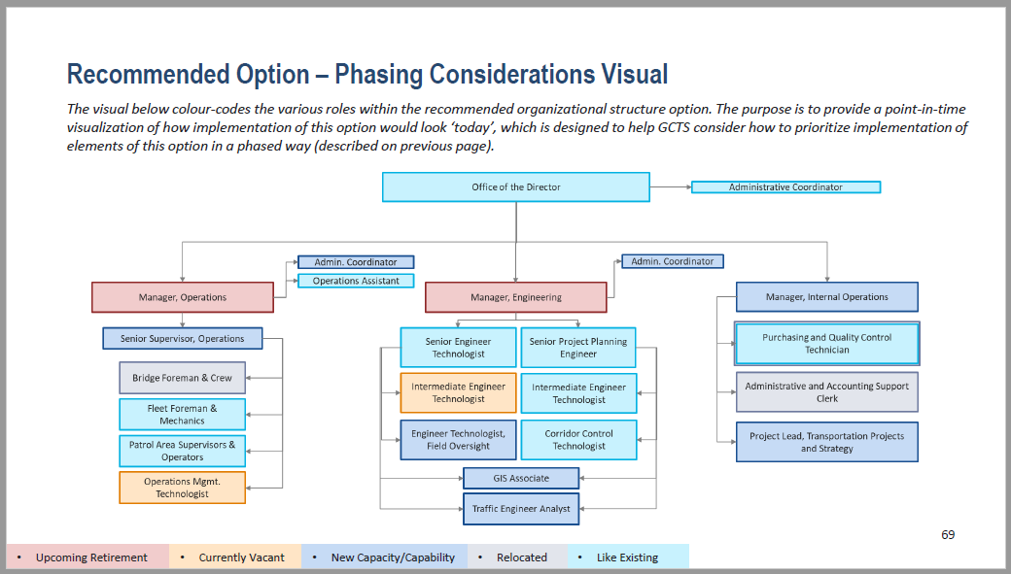

Manager, Administration

|  |  |  |  |
| --- | --- | --- | --- |
| **Recommendation No & Description** | **Short Term (0-12 months)** | **Medium Term (12-24months)** | **Long Term (24-36 months)** |
| 1. Go forward with planned policy and process improvement and documentation projects contemplated by GCTS | x |  |  |
| 2. Clarify roles and responsibilities and dedicate some departmental resources to take on departmental policy development | x |  |  |
| 3. Implement structured opportunities for collaboration and integration within and between divisions and mandate their occurrence |  | x |  |
| 4. Introduce a formal policy and procedure to manage, prioritize and collaborate to address complaints and inquiries from stakeholders/the public. | x |  |  |
| 5. Immediately initiate a process to begin succession planning for retirements expected in the next 12 – 36 months. | x |  |  |
| 6. Introduce an HR partner resource within Grey County | x |  |  |
| 7. Formalize and roll-out the GCTS’ learning and development infrastructure (and supporting budget) to support current and future staff |  |  | x |
| 8. Continue with the planned 2023 GCTS compensation review planned as part of the broader GC Human Resources project pipeline |  | x |  |
| 9. Address skill and capacity gaps that exist within the current complement of staff through training and development, job description/compensation review, and resource increases where possible |  | x |  |
| 10. Implement two-way communication channels and forums for staff across GCTS to share key information and broadlymaintain the Department operations and projects. | x |  |  |
| 11. Enhance management / field staff relationships and rapport through formal and informal relationship-building | x |  |  |
| 12. Set a clear path forward for the Department through the development of a multi-year Strategic Plan that sets out a vision, mission, values and key priorities for the Department. |  | x |  |
| 13. Continue with the CityWorks, HRIS (and other technological) implementation effort and confirm that data and reporting considerations have been accounted for | x |  |  |
| 14. Develop and implement KPIs for the Department’s key functional areas to help with internally monitoring performance and, more broadly, in the development of reports and documents like business cases and Council Reports |  | x |  |
| 15. Leverage templates, approaches and lessons learned from the asset management and road assessment tracking and reporting mechanisms. | x |  |  |
| 16. Provide all GCTS staff with a working department e-mail address, and the required hardware to access it on an ongoing basis |  | x |  |
| 17. Continue with the HRIS and CityWorks design and implementation within the Department | x |  |  |
| 18. Assess staff skill level/perception of skill in technology and computer-related tasks |  | x |  |
| 19. Consider implementing online permitting for all areas within GCTS as is a currently done with special event permitting |  |  | x |
| 20. Ensure sufficient software and hardware access and uptime for staff providing services within the Patrol areas. | x |  |  |
| 21. Consider the feasibility of introducing a repair bay in the South half of Grey County |  |  | x |

## Legal and Legislated Requirements

There are no legal or legislated requirements relating to this report.

## Financial and Resource Implications

All operational priorities and staffing have been included and will continue to be included in the budget for Council consideration. The non-union staff complement is shown in the table below:

|  |  |  |  |  |  |  |  |  |
| --- | --- | --- | --- | --- | --- | --- | --- | --- |
|  | **2022** | | **2023** | | **2024** | | **Future Consideration** | |
| **Non-Union Position**  **And Start Date** | **2022 Budget (incl. benefits)** | **Proposed for 2022** | **FTE Increase** | **Estimated Budget Impact** | **FTE Increase** | **Estimated Budget Impact** | **FTE Increase** | **Estimated Budget Impact** |
| Administration Manager (September 2022) | $0 | $53,000 | 1 | $130,200 |  |  |  |  |
| Senior Supervisor, Operations  (August 2022) | $0 | $49,800 | 1 | $121,700 | - | - | - | - |
| Intermediate Engineering Technologist  (Mid June 2022) | $101,700 | $49,000 | - | - | - | - | - | - |
| Operations Management Technologist* | $101,700 | $0 | - | - | - | - | - | - |
| GIS Associate (2024) | - | - | - | - | 1 | $97,600 | - | - |
| **Future Considerations** | | | | | | | | |
| Engineer Technologist – Field Oversight | - | - | - | - | - | - | 1 | $106,400 |
| Traffic Engineer Analyst | - | - | - | - | - | - | 1 | $106,400 |
| Project Lead, Transportation Projects and Strategy | - | - | - | - | - | - | 1 | $125,500 |
| Admin. Coordinators (Two positions) | - | - | - | - | - | - | 2 | $169,600 |
| **Total** | **$203,400** | **$151,800** | **2** | **$251,900** | **1** | **$97,600** | **5** | **$507,900** |
| **2022 Est. Surplus** |  | **$51,600** |  |  |  |  |  |  |

*This position was budgeted for 2022 but is being deferred to be filled in 2023.

The estimated surplus for non-union employee pay is $51,600. This assumption is based upon start dates aligning to estimates, and the results of job evaluations for new positions. The additional costs in 2023 would be incorporated into the 2023 budget.

## Relevant Consultation

Internal – Transportation Services staff survey, Finance staff, Deputy CAO, CAO

External – Member municipality survey.

### Appendices and Attachments

[Grey Transportation Services - Strategy Corp](https://docs.grey.ca/share/public?nodeRef=workspace://SpacesStore/22f6d696-ac93-4910-8b71-94195a268f0e)