Grey County Logo Committee Report

# Report PDR-PCD-30-15

**To**: Chair Wright and Members of the Planning and Community Development Committee

**From**: Scott Taylor, Senior Planner

**Meeting Date:** July 21, 2015

**Subject: Proposed Caframo Niagara Escarpment Plan Amendment**

**Status**: Recommendation adopted by Committee as presented per Resolution PCD100-15; Endorsed by County Council August 4, 2015 per Resolution CC113-15;

## Recommendation(s)

**THAT Report PDR-PCD-30-15 regarding the proposed Caframo Niagara Escarpment Plan Amendment (file number PG 207 15) be supported,**

**AND FURTHER THAT this Report be forwarded onto the Niagara Escarpment Commission, and copied to the Township of Georgian Bluffs, as the County of Grey comments on the Niagara Escarpment Plan Amendment application.**

## Background

On May 27, 2015 the County was circulated a proposed **Niagara Escarpment Plan Amendment (NEPA), Niagara Escarpment Commission file number PG 207 15, for the Caframo property in the Township of Georgian Bluffs. Through the NEPA and the associated zoning by-law amendment and site plan control applications from the Township, Caframo is looking to expand their operations and buildings by 2,235 m2, within the confines of the existing property. The proposed expansion would result in the creation of approximately 45 new jobs.**

**The subject lands are located at 501273 Grey Road 1 on the north side of the road, between Wiarton and Oxenden. Surrounding the subject property is a mixture of cottage/residential development, in addition to forest/farm lands, and the airport across Grey Road 1. The subject property is approximately 3.5 hectares in size and contains three main buildings. An airphoto of the site and surrounding lands has been included below.**

**In support of the application the developer prepared a number of background studies and technical reports, including planning, engineering, and a detailed history of the site.**

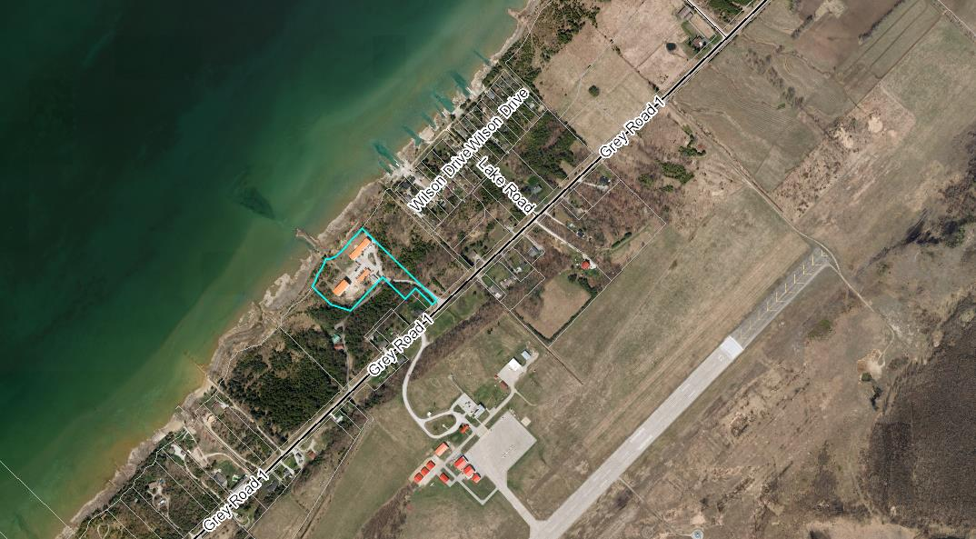

#### Map 1: Airphoto of the subject property and surrounding lands

### Comments from the Township of Georgian Bluffs

Staff at the Township prepared a staff report dated June 10, 2015, which provided an update on the zoning by-law amendment application and comments on the proposed NEPA. Within the report it was noted that there were no objections at the public meeting and that agency comments have been generally supportive. Township staff noted that they have *“no concerns with the proposed permitted use and special provisions”.* The recommendation from staff was that the Township received the report, and that the report be forwarded onto the Niagara Escarpment Commission.

### Planning Analysis

Application of the Provincial Policy Statement (PPS) to this development proposal is somewhat tough to interpret. Generally speaking the PPS divides the Province into Settlement Areas and Rural Areas (which includes Prime Agricultural Lands). At the County and Niagara Escarpment Plan level the subject lands carry a recreational designation which contemplates growth; and is treated ‘akin to a settlement area’ in the County Plan, rather than being a settlement area. There is a small portion of the property in the Escarpment Protection Area, but this is outside of where the development is being contemplated. The proposed industrial expansion is beyond what would normally be considered within a recreational designation, and beyond a minor expansion to an existing use, which is why the NEPA has been triggered. There is however merit to considering such an expansion of an existing use, where it can be demonstrated to be compatible with neighbouring lands uses, the natural environment and the Niagara Escarpment.

Section 1.6.6.5 of the PPS speaks to permissions for partial services for existing development or for minor infilling or rounding out. The existing Caframo operation is serviced by municipal water from Wiarton and a private septic system. The septic system is being replaced, and, according to the materials submitted with the application, has recently been granted permits for the septic replacement by the Township of Georgian Bluffs and the Grey Sauble Conservation Authority (GSCA). The proposed development is not a heavy user of water or waste water and generally would only use the services for employee bathrooms.

Section 2.1 of the PPS speaks to the protection of significant natural heritage features across the Province. No significant natural heritage features were identified on-site. While a full Environmental Impact Study (EIS) was not completed for the property, there was a tree inventory and preservation plan done. The site has historically been heavily disturbed based on the industrial uses on-site dating back to the early 1900’s. The proposed development on-site has been strategically located such that it is within previous building footprints and the existing disturbed areas on-site. In more recent years the site has been re-vegetated significantly. The new development will be set back from the shores of the bay, and stormwater quality controls have been built into the stormwater management plan to ensure minimal impacts.

Section 2.6 of the PPS speaks to the conservation of significant cultural and archaeological resources within the Province. As part of the background information supplied with this application there was an archaeological review completed and dialogue with the Saugeen Ojibway Nation environmental office. Based on the level of historical disturbance on-site, and the new development generally being proposed within previous building footprints, there were no further archeological concerns with respect to this site.

The subject property is designated primarily as ‘Escarpment Recreation Area’ within the County Plan. A small portion of the property which encompasses a portion of a wooded area and a portion of the driveway is designated as ‘Niagara Escarpment Plan Area’ within the County Plan. There are no mapped environmental constraints on the subject lands within the County Plan. The subject lands are however on Georgian Bay which requires a 30 metre setback to the banks.

The Escarpment Recreation designation within the County Plan generally defers to the more detailed policies of municipal planning documents and the Niagara Escarpment Plan. Although the County does not normally see industrial development proposed within this designation, the development proposal in question is an expansion to a long-established use on-site. In pre-submission consultation discussions on this application County staff noted that a County Official Plan Amendment would not be required for this application.

In considering any new or expanded industrial development in areas where other sensitive land uses may also be sited, it is appropriate to consider appropriate separation distances between land uses. In this case, utilization of Ministry of the Environment and Climate Change (MOECC) D-6 Guidelines would be appropriate. The proponent has supplied materials which speak to the nature of the existing and proposed industrial operations on-site. Noise and effluent are not generated on-site, based on the hand-assembly methods, and parts being trucked in, rather than machined on-site. Employee bathrooms generally represent the only use of water/wastewater on-site. County staff do not perceive land use compatibility issues between the Caframo expansion and neighbouring residences. The County would however recommend that the NEPA and zoning amendment carefully limit future uses on-site, including future industrial uses, such that a noxious industrial use could not be sited here, should Caframo ever cease to exist on-site. Such provisions on future use changes have been built into the NEPA, and the planning controls at Georgian Bluffs.

The subject lands are located on Grey Road 1, which is a County road. Section 5.2.2(6)(f) of the OP states;

*“Any applications for consent for severance, change of zoning, plan of subdivision, minor variance and/or development agreement for land abutting Provincial Highway or County road shall be referred to the appropriate approval authority prior to approval in order to determine if the use, siting, and/or right-of-way width are adequate and meet the provisions of this Plan.”*

Comments have been received from the County Transportation Services department stating that they have no objections. Although not strictly subject to the NEPA, the supporting materials submitted with this application indicate that a realignment of the entrance onto Grey Road 1 is being considered. This realignment is necessary as the existing entrance infringes upon the neighbouring vacant lot. A permit will be needed from the County Transportation Services department to realign this entrance; however a Traffic Impact Study will not be required.

## Financial / Staffing / Legal / Information Technology Considerations

At this stage there are no additional financial, staffing, legal, or information technology considerations arising out of this report. The County is not being required to make a planning decision on this development, as those powers rest with the Niagara Escarpment Commission and the Township of Georgian Bluffs.

Should the development be approved, then the expansion to Caframo is projected to result in the creation of approximately 45 new jobs, which would be good for the area.

## Link to Strategic Goals / Priorities

Should the NEPA application be approved, it would touch on a number of strategic goals for the County including the expansion of the prosperity base and the creation of sound land use planning policies.

The proposed NEPA, with some of the safeguards outlined above, would appear to;

* have regard for matters of Provincial Interest under the *Planning Act*,
* be consistent with the Provincial Policy Statement, and
* conform to the goals and objectives of the County Official Plan.

The support of such an expansion would also align with Economic Development objectives for the County.

## Attachments

Respectfully submitted by,

Scott Taylor, MCIP, RPP  
Senior Planner

Director Sign Off: Randy Scherzer