Grey County Logo Committee Report

# Report FR-CS-32-14

**To**: Chair Pringle and Members of the Corporate Services Committee

**From**: Kevin Weppler, Director of Finance

**Meeting Date:** October 14, 2014

**Subject: Rural Ontario Municipal Association – Special Underwriting Group – 2014 Supplemental Assessment for the underwriting periods 1998 through to 2004.**

**Status**: Recommendation adopted by Committee as presented per Resolution CS84-14; Endorsed by County Council per Resolution CC154-14 November 4, 2014;

## Recommendation(s)

**WHEREAS the County of Grey has received a 2014 Supplemental Assessment in the amount of $33,902, plus applicable taxes;**

**NOW THEREFORE BE IT RESOLVED THAT Report FR-CS-32-14 regarding the Rural Ontario Municipal Association (ROMA) – Special Underwriting Group - 2014 Supplemental Assessment for the underwriting periods of 1998 through to 2004 be received;**

**AND THAT the Director of Finance be authorized to submit payment to OMEX for the County of Grey’s share of this 2014 Supplemental Assessment;**

**AND FURTHER THAT the funds required in the amount of $33,902, plus applicable taxes be allocated from the County’s Insurance Reserve.**

## Background

For the years 2004 to 2008 the County of Grey participated in the Ontario Municipal Insurance Exchange (OMEX) Reciprocal Insurance Program. Previous to this period of time the County participated from 1999 to 2004 under the Rural Ontario Municipal Association (ROMA) Special Underwriting Group (SUG) Reciprocal Insurance Program.

In 1997 the ROMA Insurance Program Inc. partnered with Jardine OMEX Insurance Brokers (JLT Canada) to create a new insurance reciprocal product for rural municipalities. OMEX agreed to make the ROMA reciprocal insurance program possible by allowing a Special Underwriting Group to exist under OMEX’s license.

In early 2004 reciprocal members were made aware that the ROMA SUG was not adequately funded to cover its known and potential liabilities. The ROMA SUG Committee, who provided oversight for the SUG, transferred management responsibility from JLT Canada to OMEX. Later the Committee decided to cease issuing new insurance policies effective December 31, 2004, and to run off the SUG’s existing claims’ liabilities. A supplemental assessment was issued in 2004, followed by a second assessment in 2008.

Under the Reciprocal Agreement, ROMA SUG members are eligible to receive a portion of surplus premiums, if they exist, and are responsible for paying a supplemental assessment, if underwriting periods have a deficit. Currently, for the underwriting periods the County of Grey participated in the ROMA SUG reciprocal, there is an underwriting period that is in a surplus position along with underwriting periods that are in a deficit position. The program is overall in a deficit position of $2,462,348 with the County of Grey’s portion of this deficit equaling $33,902 plus applicable taxes.

As per the letter received from OMEX, which is dated September 10, 2014, there are no known outstanding claims for the ROMA SUG. However, as per Section 8.03 of the reciprocal agreement, the County continues to be contractually responsible for any claims that may be reported at a future date.

This assessment is the 3rd Supplemental Assessment that the County has received from OMEX related to the ROMA SUG program. The following table has been provided to illustrate the Assessments that have been assessed and the underwriting periods these were based on.

**ROMA SUG Supplemental Assessments**

| **Supplemental Assessment Notice Date** | **Supplemental Assessment Amount** |
| --- | --- |
| 2004 | $83,986 |
| 2008 | $346,953 |
| 2014 | $33,902 |
| **Total Supplemental Assessments To Date** | **$464,841** |

## Financial / Staffing / Legal / Information Technology Considerations

This Supplemental Assessment was not known at the time the 2014 budget was drafted and approved. The Supplemental Assessment amount will be required to be expensed to the 2014 budget and therefore it is being recommended that this expense be funded by allocating funds from the County’s Insurance Reserve. This reserve as of December 31, 2013 had a balance of $254,171. This Reserve is projected to have a 2014 year-end balance of $112,245, once the 2014 supplemental assessments issued by OMEX ($137,689 plus applicable taxes) and the ROMA SUG ($33,902 plus applicable taxes) have been transferred from this reserve.

As stated previously, as per Section 8.03 of the reciprocal agreement, the County continues to be contractually responsible for any claims that may be reported at a future date.

## Link to Strategic Goals / Priorities

To ensure that Council’s goals of financial sustainability and public accountability are maintained.

## Attachments

ROMA Insurance Program - 2014 Supplemental Assessment 1998 to 2004 dated September 10 and 25, 2014

Respectfully submitted by,

Kevin Weppler

Director of Finance

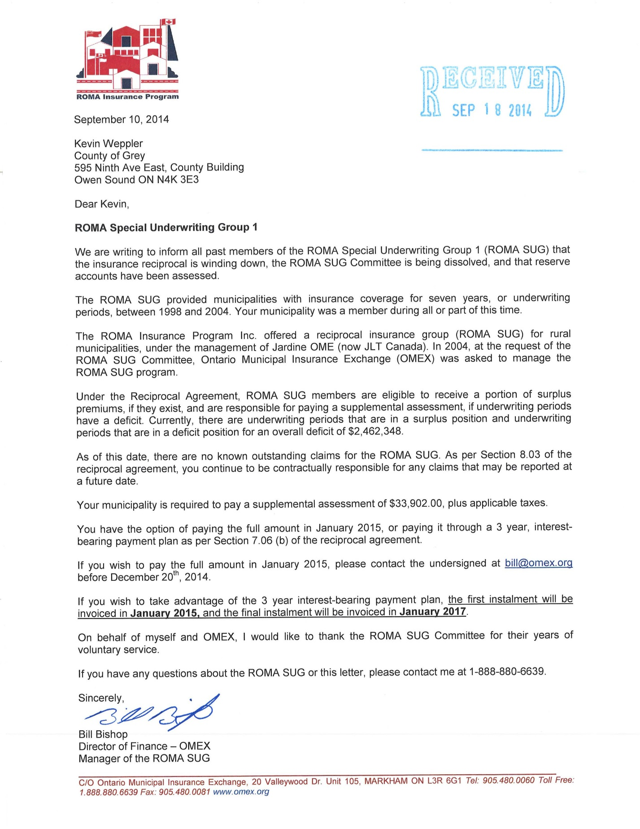

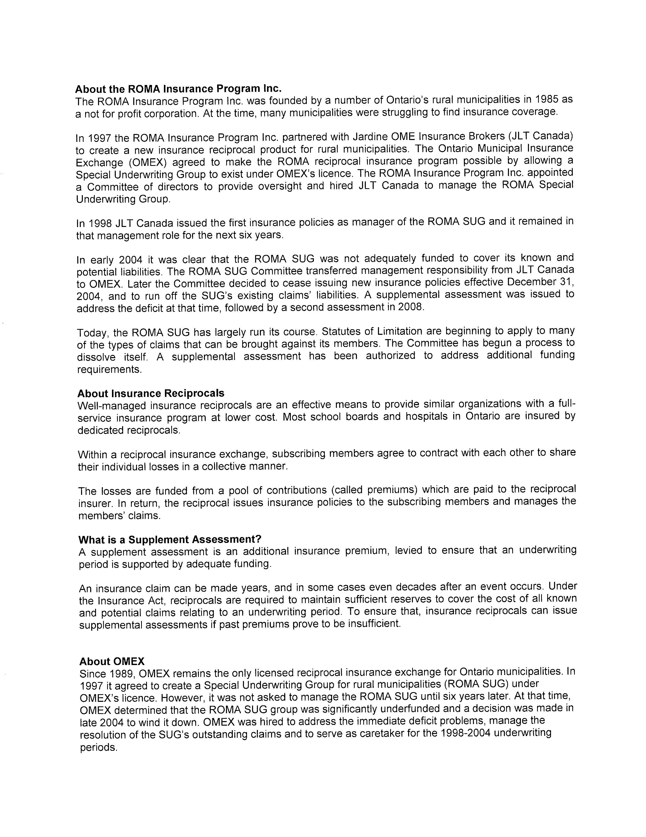

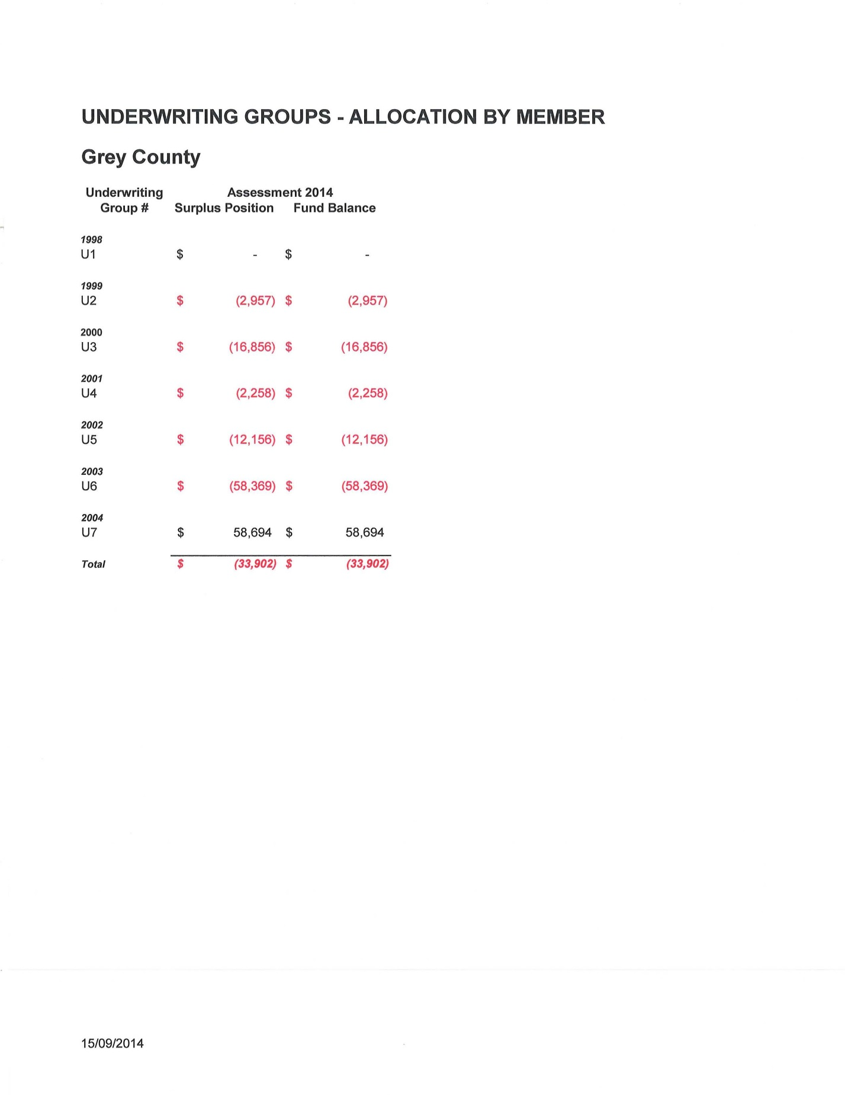

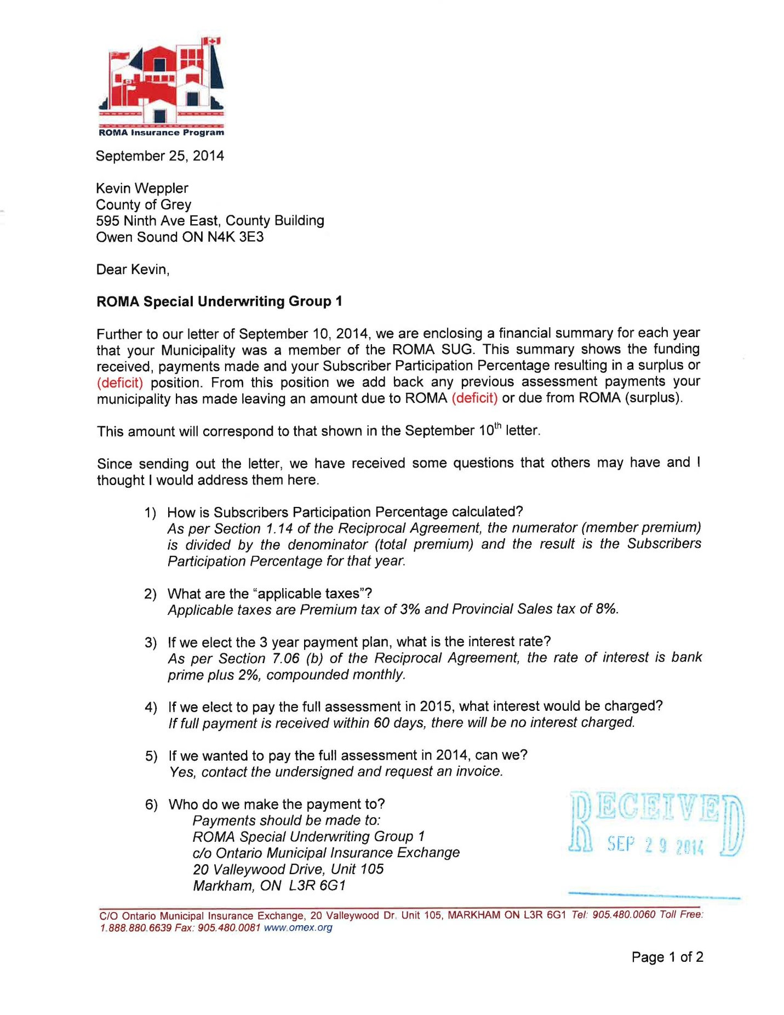

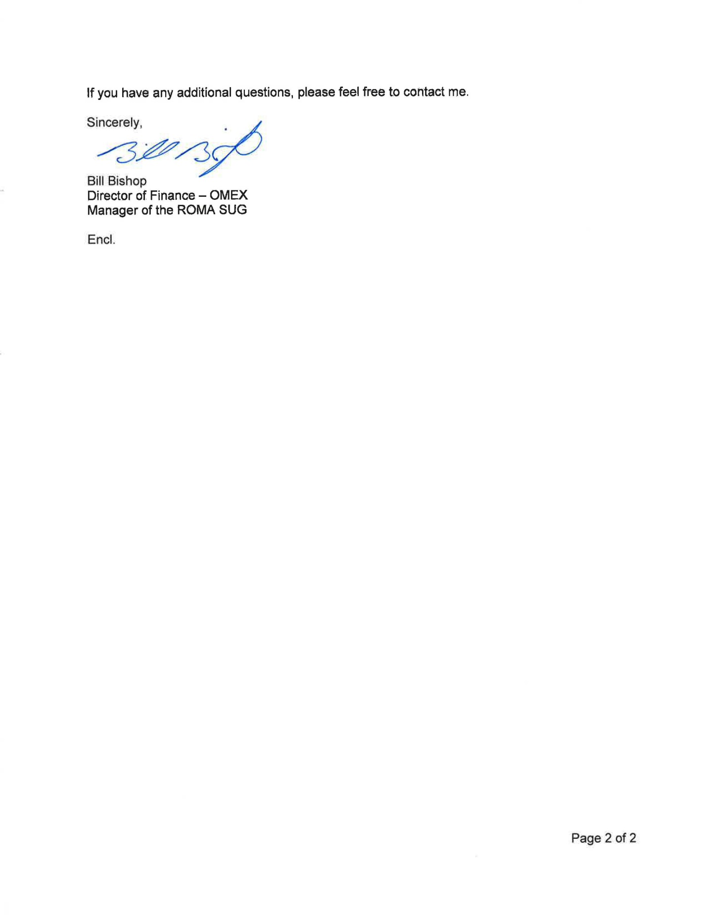

Chart entitled ROMA Special Underwriting Group 1
County of Grey
2014 Assessment