Grey County Logo Committee Report

| **To**: | Warden McQueen and Members of Grey County Council |
| --- | --- |
| **Committee Date:** | May 28, 2020 |
| **Subject / Report No:** | PDR-CW-26-20 Information Report |
| **Title:** | Broos Plan of Subdivision 42T-2020-01 |
| **Prepared by:** | Scott Taylor |
| **Reviewed by:** | Randy Scherzer |
| **Lower Tier(s) Affected:** | Municipality of West Grey |
| **Status:** | Recommendation adopted by Committee as presented per Resolution CW95-20; Endorsed by County Council June 11, 2020 per Resolution CC58-20 |

## Recommendation

1. **That Report PDR-CW-26-20 regarding an overview of proposed plan of subdivision application 42T-2020-01, consisting of up to two-hundred and five (205) residential units which would consist of one hundred and eighteen (118) single detached dwellings, and up to eighty-seven (87) townhouse dwellings on lands described as** Part of Divisions 2 and 3 of Lot 24, Concession 1 East of the Garafraxa Road (EGR)**, geographic Township of Glenelg, now in the Municipality of West Grey, be received for information.**

## Executive Summary

The County has received a plan of subdivision application known as the Broos Subdivision (County file number 42T-2020-01), to create up to 205 new residential units in the Municipality of West Grey. The proposed dwellings are a mixture of single detached and townhouse dwellings. Access to the subdivision would be from an extension of Jackson Street and two entrances off Durham Road East. Servicing to the proposed subdivision will be via municipal water and sewer services. Various technical reports have been submitted with the proposed subdivision application, as well as a zoning by-law amendment application to the Municipality of West Grey. The applications and supporting studies will be circulated to prescribed agencies and the public for review and comment. Following the public process, and agency review process, a thorough analysis and staff recommendation will be provided.

## Background and Discussion

The County has received a plan of subdivision application, known as the Broos subdivision to create up to 205 residential units, consisting of 118 single detached dwellings and up to 87 townhouse dwellings. Access to the lots would be via internal streets that would connect to an extension of Jackson Street and via two entrances off Durham Road East. Servicing to the proposed subdivision will be via municipal water and sewer services.

The subject lands are located in the settlement area of Durham. This property is immediately east of the recently approved Sunvale subdivision, in the northeast quadrant of Durham. The subject property is legally described as Part of Divisions 2 and 3 of Lot 24, Concession 1 East of the Garafraxa Road (EGR), geographic Township of Glenelg, now in the Municipality of West Grey.

The subject lands are approximately 14.08 hectares in size, and are currently undeveloped, with some treed areas in the north portion of the property.

Surrounding this site are a mixture of residential lands, farmlands, and natural areas. The Sunvale subdivision to the west is currently under construction. The subject lands are in the Primary Settlement Area of Durham, but the lands to the north and the east are outside of the settlement area boundaries. Further east of the property is a large conservation area owned and operated by the Saugeen Valley Conservation Authority (SVCA).

The proposed development also requires an amendment to the Municipality of West Grey zoning by-law.

Pre-submission consultation between the proponent, the Municipality of West Grey, the SVCA, and the County identified the submission requirements for the proposed plan of subdivision. Copies of all background reports and plans can be found at [this link](https://www.grey.ca/planning-development/planning-applications).

Map 1 below shows the proposed plan of subdivision, while Map 2 shows the subject lands and surrounding area.

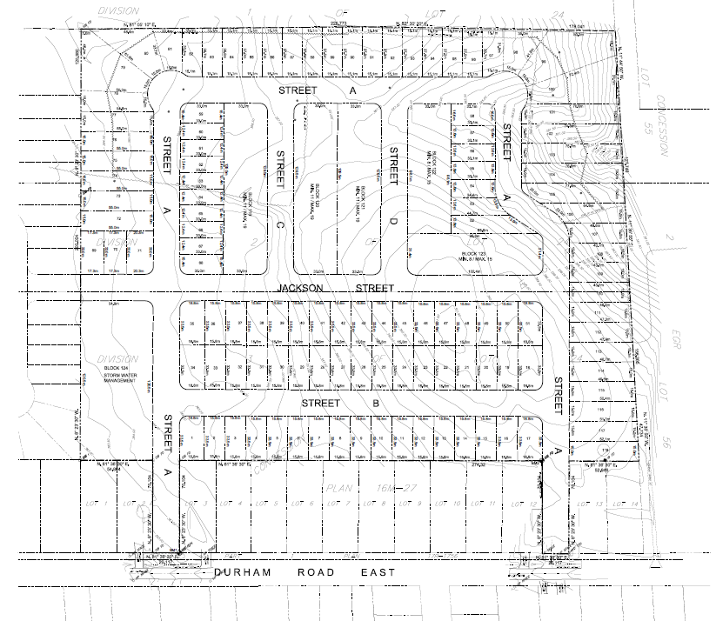

### Map 1: Proposed Plan of Subdivision

(Map 1 Courtesy of Cobide Engineering Inc.)

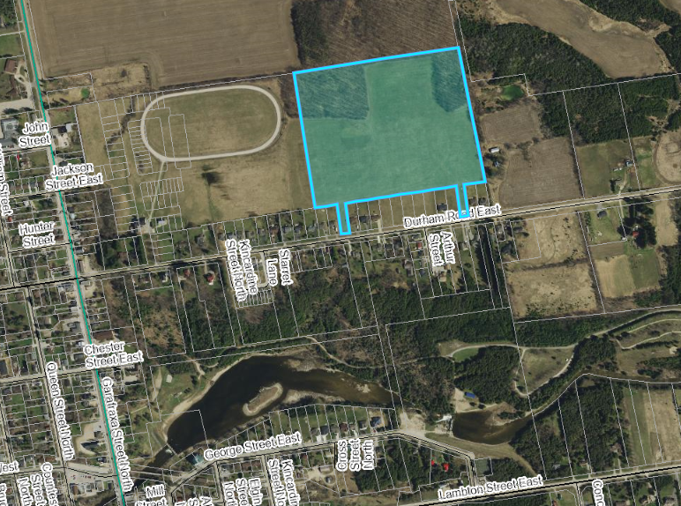

Map 2: Location of Subject Lands

#### Analysis of Planning Issues

When rendering a land use planning decision, planning authorities must have regard to matters of Provincial Interest under the *Planning Act*, be consistent with the Provincial Policy Statement (PPS) 2020, and conform to any Provincial Plans or Municipal Official Plans that govern the subject lands. In this case, the County of Grey Official Plan and the Municipality of West Grey Official Plan have jurisdiction over the subject property. The subject lands are located outside of the Niagara Escarpment Plan area.

#### Provincial Policy and Legislation

Both the *Planning Act* and the PPS speak to the efficient use of land within settlement areas. The proposed plan of subdivision is within an existing settlement area and will be serviced via municipal water and sewer services. The PPS indicates that municipal services are the preferred form of servicing for settlement areas.

The supply of an adequate range and distribution of residential housing types is required in both Provincial documents. In this case, the proposed plan of subdivision is providing single detached and townhouse dwellings at a density which aligns with the County and West Grey Official Plans.

Other policies in the PPS speak to connected, walkable communities, with provisions for public parkland and open space. The proposed subdivision is not proposing any parkland at this time but is proposing sidewalks.

Following the public and agency review periods, staff will provide a more fulsome analysis of the Provincial legislation and policy.

#### County of Grey Official Plan

The proposed plan of subdivision is on lands designated as ‘Primary Settlement Area’ in the County Official Plan. Development in Primary Settlement Areas shall generally achieve an average development density of 20 units per net hectare or higher. The proposed development would be approximately 19.6 to 24 units per net hectare, depending on how many townhomes are built in the proposed blocks.

Significant Woodlands and a small portion of a Wellhead Protection Zone are located on the subject property. An Environmental Impact Study (EIS) was completed for this property. As part of the development review process the Municipality of West Grey’s Risk Management Official (RMO) will review the development with respect to any impacts on the municipal drinking water source.

The County Plan also requires the protection of cultural and archaeological resources. A Stage 1 – 2 Archaeological Assessment was conducted for this development.

The County Plan provides a similar servicing hierarchy to that found in the PPS, which has been noted above. Elsewhere in the Move Grey portion of the Plan, are policies which govern roads, transportation, and stormwater management. A Traffic Impact Study, a Functional Servicing Report, and a Stormwater Management Report were all submitted with the development applications.

#### Municipality of West Grey Official Plan

The subject lands are designated as ‘Residential’ in the West Grey Official Plan. Similar to the County Official Plan, this property is within a designated settlement area in the West Grey Plan, which permits the type of residential development being contemplated.

As noted above, a rezoning application has also been submitted to the Municipality and will be processed simultaneously with the subdivision.

A more thorough analysis of the County and West Grey Official Plan policies will follow the agency review and the public process.

## Legal and Legislated Requirements

The application will be processed in accordance with the *Planning Act.*

## Financial and Resource Implications

There are no anticipated financial, staffing or legal considerations associated with the proposed subdivision, beyond those normally encountered in processing a subdivision application. The County has collected the requisite fee and peer review deposit for this application.

## Relevant Consultation

Internal: Planning

External: The public, Municipality of West Grey, Saugeen Valley Conservation Authority, and required agencies under the *Planning Act*.

### Appendices and Attachments

None