Grey County Logo Committee Report

| To: | Warden Hicks and Members of Grey County Council |
| --- | --- |
| Committee Date: | January 10, 2019 |
| Subject / Report No: | PDR-CW-09-19 |
| Title: | Markdale CP Rail Trail Parking Lot – Local Official Plan Amendment and Zoning By-law Amendment |
| Prepared by: | Randy Scherzer |
| Reviewed by: | Kim Wingrove |
| Lower Tier(s) Affected: | Municipality of Grey Highlands |
| Status: | Recommendation adopted by the Committee of the Whole as presented as per Resolution *CW18-19;* Endorsed by County Council on January 24, 2019 as per Resolution *CC12-19*. |

## Recommendation

1. That Report PDR-CW-09-19 be received which provides an overview of a potential opportunity to utilize a portion of the Markdale CP Rail Trail Parking Lot for a future affordable housing build; and
2. That support be provided in principle to proceed with a local official plan amendment and zoning by-law amendment in cooperation with the Municipality of Grey Highlands to redesignate and rezone the Markdale CP Rail Trail Parking Lot; and
3. That staff be directed to investigate this opportunity further and to bring back a report which would identify any further requirements to offer these lands for the construction of affordable housing units.

## Executive Summary

The Markdale CP Rail Trail Parking lot is located in the community of Markdale adjacent to the CP Rail Trail. The lands are currently designated as Employment Area in the Municipality of Grey Highlands Official Plan and portions are zoned as Commercial (C2), Development (D) and Hazard Lands (H). The Municipality of Grey Highlands is currently in the process of reviewing other properties that could be utilized to construct affordable housing units and is in the process of preparing a proposed official plan amendment and zoning amendment. One property that was identified that could be utilized to construct affordable housing units was the Markdale CP Rail Trail Parking Lot. This lot has been used in the past by Chapman’s under a lease agreement as an overflow parking area for their employees. The intent would be to maintain a portion of the parking lot for trail users and for Chapman’s if still required. Should the lands be redesignated and rezoned, staff will bring forward a report in 2019 that would further explore this opportunity and to identify any further requirements.

## Background and Discussion

The Markdale CP Rail Trail parking lot is located in the community of Markdale and is located adjacent to the CP Rail Trail. The lands are directly northeast of the CP Rail Trail and south of Grey Road 12/Main Street West (see Figure 1). This parking area has been historically leased by Chapman’s which they have they have used as overflow parking for their employees.

### Figure 1 – Location of Subject Lands

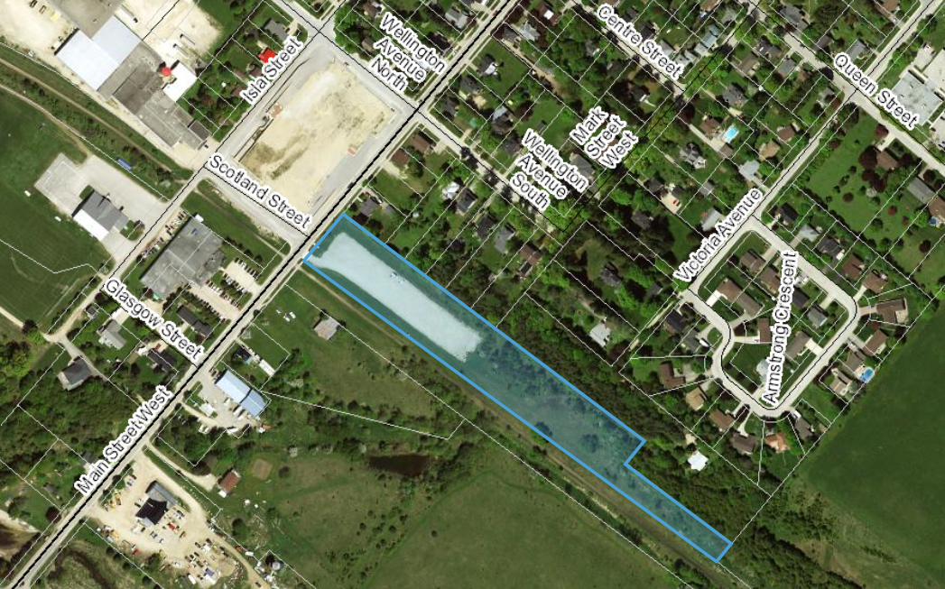

The lands are currently designated as Employment Area in the Municipality of Grey Highlands Official Plan and are zoned as Commercial (C2), Development (D) and Hazard Lands (H). The lands are approximately 1.65 hectares (4.08 acres) in area. County staff recently met with Grey Highlands staff to look at potential properties that could be used for future affordable housing projects. Based on this review, the Municipality of Grey Highlands is in the process of preparing a local official plan amendment and zoning by-law amendment that would redesignate and rezone properties to residential that would permit affordable housing builds in the future. One property that was identified as a potential affordable housing site was the CP Rail Trail Parking area.

The CP Rail Trail Parking area is designated as ‘Employment Area’ in the Grey Highlands Official Plan. The Provincial Policy Statement (PPS) requires a comprehensive review to be completed when proposing either a settlement area expansion or when redesignating employment lands to a non-employment land use. In this case, the comprehensive review is required to ensure that there will be sufficient employment lands available within the Municipality of Grey Highlands to accommodate future employment growth should these lands be redesignated. Grey Highlands staff are currently in the process of preparing the comprehensive review analysis which is required to justify the proposed local official plan amendment. The County is the approval authority for local official plans and local official plan amendments and therefore the County will be making a final decision on this local official plan amendment if adopted by the Municipality of Grey Highlands. For any local official plan amendments, we recommend pre-submission consultation to ensure that there are no delays following adoption. County staff and Grey Highlands staff have been working cooperatively to ensure that there is adequate information to support the proposed local official plan amendment. County staff will also be attending the public meeting for the local official plan amendment as there are County lands involved.

Further site investigations will be required in order to consider the use of these lands for affordable housing. The key will be to ensure that any development will not impact the future use of the CP Rail Trail and to ensure that a parking area is maintained for trail users and for Chapman’s use if still required. If the lands are redesignated and rezoned, and if it is determined that the lands are suitable for constructing affordable housing units, the County could then deem the lands surplus and offer these lands through a future request for proposal process similar to the process recently completed in Durham. The lands could be offered up through the proposed Community Improvement Plan program that the County and the Municipality are proposing to implement in 2019.

It is recommended that support in principle be provided to consider redesignating/rezoning these lands through the local official plan amendment and zoning by-law amendment being prepared by the Municipality of Grey Highlands. It is further recommended that staff be directed to further investigate the opportunity to offer up at least of portion of these lands as a future affordable housing build project once the Community Improvement Plan program is in place. Staff will bring forward a report in 2019 with further information.

## Legal and Legislated Requirements

*Planning Act*

## Financial and Resource Implications

County staff will continue to work with Grey Highlands to prepare the local official plan amendment and zoning by-law amendment. Should the lands be redesignated/rezoned, further site investigations will be required. Some of the requirements could require an environmental site assessment and a record of site condition. Staff will investigate these requirements further and bring forward a staff report in 2019 which would also outline any budget requirements to make the lands ‘shovel ready’.

## Relevant Consultation

Internal (Planning, Transportation Services, Housing, Economic Development, Clerks, Chief Administrative Officer, Director of Legal Services, Grey Sauble staff – re: trail management)

External (Municipality of Grey Highlands, Chapman’s, Saugeen Valley Conservation Authority)

### Appendices and Attachments

*None*