Grey County Logo Committee Report

| **To**: | Warden Hicks and Members of Grey County Council |
| --- | --- |
| **Committee Date:** | September 23, 2021 |
| **Subject / Report No:** | Hanover Official Plan Amendment # 3 / Report PDR-CW-21-21 |
| **Title:** | Hanover Official Plan Amendment # 3 Final Report |
| **Prepared by:** | Scott Taylor |
| **Reviewed by:** | Randy Scherzer |
| **Lower Tier(s) Affected:** | Town of Hanover |
| **Status:** | Recommendation adopted by Committee as presented per Resolution CW154-21; |

## Recommendation

1. **That Report PDR-CW-21-21 regarding adopted Hanover Official Plan Amendment # 3 be received; and**
2. **That the Committee of the Whole hereby approves Town of Hanover Official Plan Amendment # 3 as adopted by By-law No. 3162-21, subject to the following modifications attached to Report PDR-CW-21-21 as Schedule 1 and dated September 23, 2021.**

## Executive Summary

The Town of Hanover recently adopted Official Plan Amendment # 3 to their Town Official Plan. This amendment replaces the Town’s former ‘Special Policy Area’ designation with individual designations, as well as a new ‘Electric Utilities’ designation for the Hydro One lands. Amendment # 3 follows extensive work that the Town has undertaken to examine their boundary and growth needs to accommodate future development. County staff are recommending approval of this amendment with minor modifications as discussed with and supported by Town staff.

## Background and Discussion

The County has recently received the adopted Town of Hanover Local Official Plan Amendment # 3 (hereafter referred to as LOPA 3). LOPA 3 specifically addresses the Town’s ‘Special Policy Area’ designation, which included four areas of the Town that were ‘set aside’ from being given development designations, pending the completion of further work to determine what the lands were most needed and suited for. The Town, along with a team of consultants, has now completed that work and proposes to designate Special Policy Areas 1 – 4 as individual designations, including ‘Residential’, ‘Industrial’, ‘Future Development’, and a new ‘Electric Utilities’ designation (for the Hydro One lands). ‘Hazard’ lands have also been mapped and designated throughout the Special Policy Areas. A link to LOPA 3 has been included in the Attachments section of this report. Map 1 below shows Special Policy Areas 1 – 4 (shown in dark grey) in the current Town Plan, while Map 2 shows the proposed new designations through LOPA 3 (shown in yellow, orange, dark blue, and light grey).

The Town has been examining their future growth needs for decades, but more recently the discussion was reignited in ~2008 – 2009 by the County Official Plan Five Year Review, referred to as OPA 80. In 2010 the Town prepared a comprehensive review to justify a settlement area expansion to accommodate future growth. Following that comprehensive review and appeals to OPA 80, sections of land in the neighbouring Municipality of West Grey were given a ‘Future Secondary Plan Area’ overlay to recognize their role in fulfilling Hanover’s future growth needs.

As part of that 2010 comprehensive review, the Town also recommended a new Special Policy Area designation. This designation was assigned to four areas that were previously designated as Future Development, which were given assumptions about what their future land use would be (e.g. for Special Policy Area 3 it was assumed it would be 50% Residential and 50% Industrial), though not designated for growth at that time. In 2014, through official plan amendment # 19 to the previous Town of Hanover Official Plan, the Special Policy Areas were implemented.

In 2015 the Ontario Municipal Board (known now as the Ontario Land Tribunal) approved OPA 122 to the County Official Plan, which re-designated some of the Future Secondary Plan Area lands to ‘Highway Commercial’ and ‘Open Space’.

Since 2018, the Town has been working with a team of consultants to (a) map out how these Special Policy Areas could be developed and (b) to determine what additional lands would need to be added to the Town to accommodate their future growth needs. In determining the logical development designations for the Special Policy Areas, the Town has employed land economists, planners, agrologists, and ecologists. The findings of this work are well researched and laid out. Town staff have also involved the County throughout this process. It is important to note that LOPA 3 only deals with lands inside the current Town boundaries and is not an expansion to their settlement area or municipal boundaries.

The Town hosted a public meeting for LOPA 3 on March 15, 2021, and later adopted the amendment on July 12th, 2021.

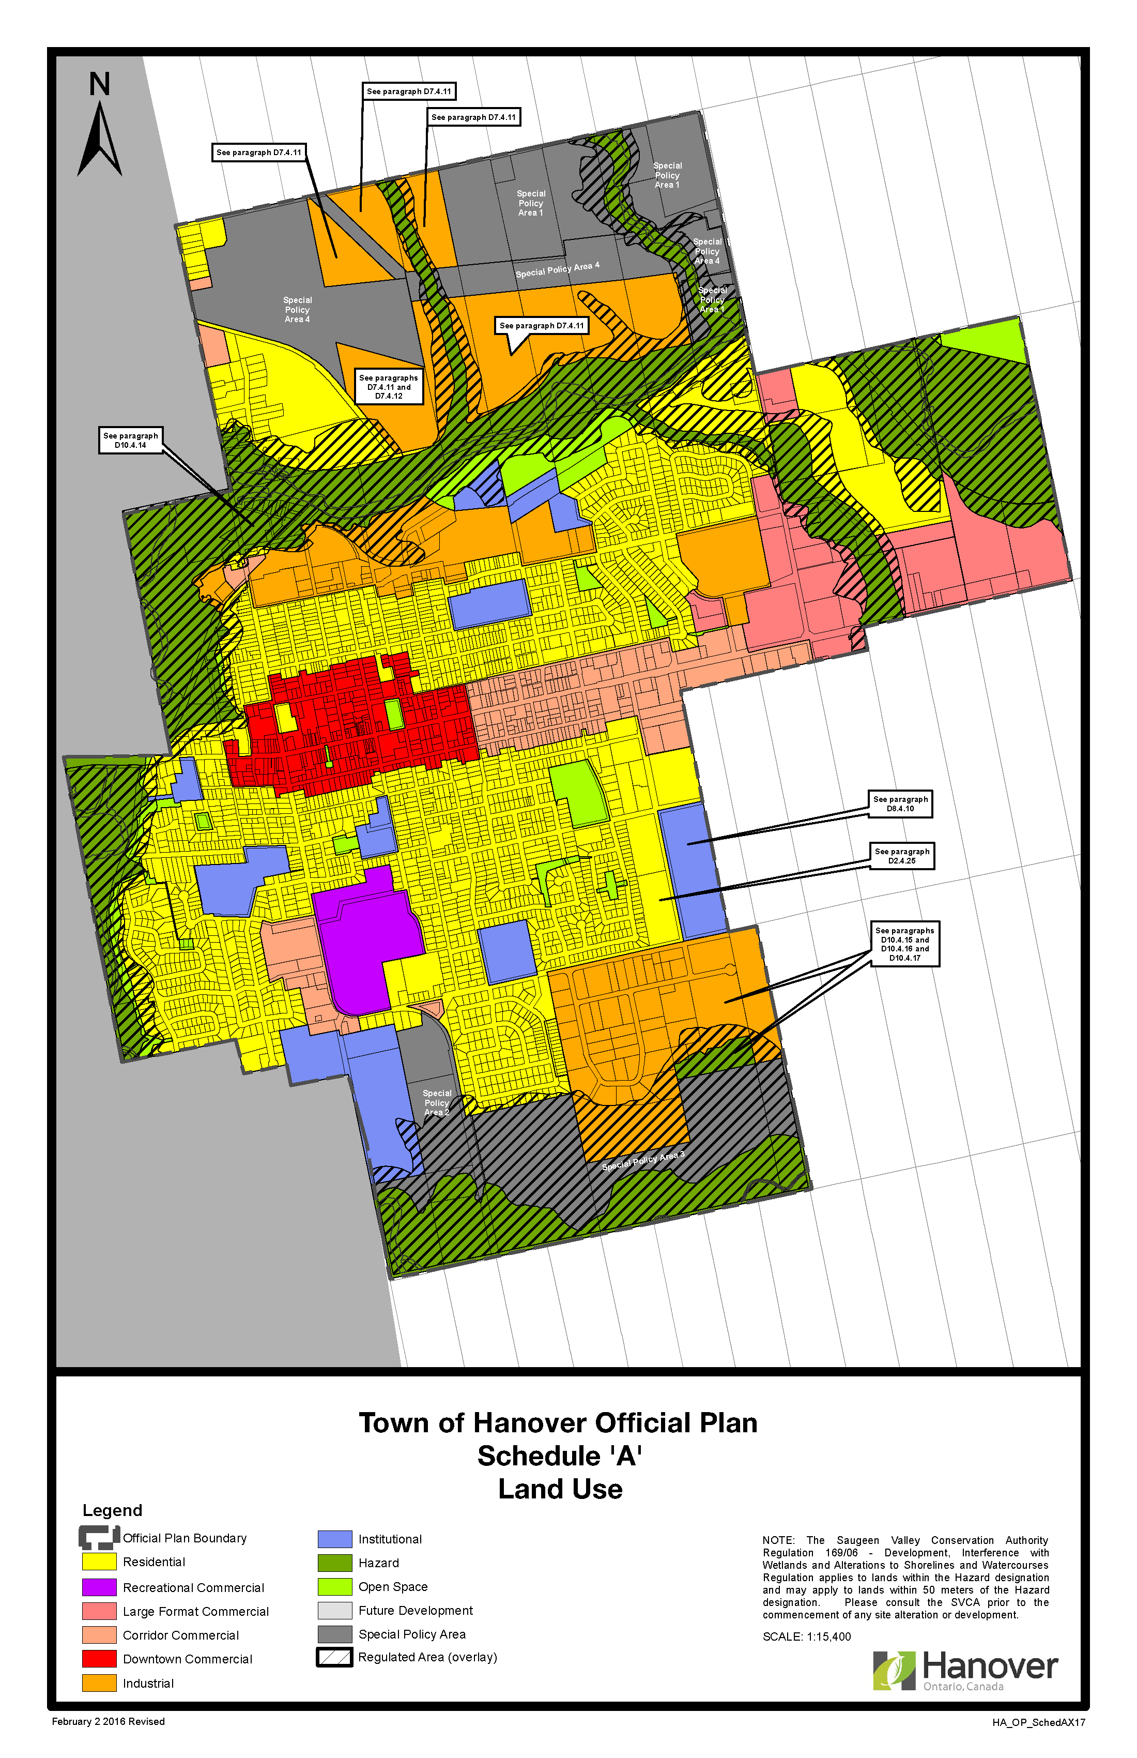

### Map 1: Current Hanover Official Plan Schedule A

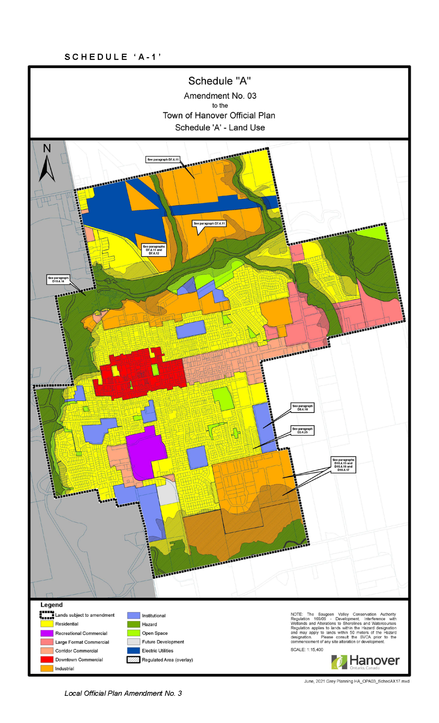

### Map 2: Adopted LOPA 3 Hanover Official Plan Schedule A

Note Map 2 above shows the adopted LOPA 3. A minor modification, through modification #1 in Schedule 1 attached to this report, is proposed to Map 2 to include a reference to section D7.4.13. [Link to Revised schedule A](https://docs.grey.ca/share/public?nodeRef=workspace://SpacesStore/4ec0ba16-8783-476c-a9e1-4c0cdf2238f8)

## Comments Received

Through written and verbal comments at the public meeting, the Town received comments from the following people and agencies;

* Brian Whaling,
* Henry Lansink,
* MHBC Planning on behalf of Maple Leaf Foods,
* Saugeen Valley Conservation Authority, and
* County of Grey.

The comments received did result in changes to LOPA 3 following the public meeting and prior to adoption by Town Council. Rather than formally summarizing the comments here, staff will note how they’ve been addressed through the analysis section of this report.

## Analysis of Planning Issues

In rendering decisions, planning authorities must have regard to matters of Provincial interest under the *Planning Act* and be consistent with the Provincial Policy Statement (PPS). Decisions within the County must also conform to the County of Grey Official Plan and any Provincial plans in force and effect. There are no Provincial plans in effect for the Town of Hanover. Decisions should also conform to the overall goals and objectives of the Town Official Plan.

### Provincial Legislation – The Planning Act

Most notable to this proposed official plan amendment are the following clauses from the *Planning Act*, which have been analyzed below.

1. *the protection of ecological systems, including natural areas, features and functions,*

Staff Comment: The Town employed Palmer Environmental to assess the natural environment as it relates to the Special Policy Area lands. Town, County, and SVCA staff have reviewed the Palmer Report, which is included as an Appendix to LOPA 3. This report appears to generally address the requirements of the *Planning Act*, PPS and the County Plan as it applies to significant natural heritage features. Further study may be required on some of these lands as part of individual development applications.

At the public meeting Brian Whaling noted the following, as quoted from the public meeting minutes:

*“concerns regarding the re-designation of SPA* [Special Policy Area] *3 to residential due to the area being a wetland, inhibiting topography and highway access as well as it not being economically viable to service. Mr. Whaling proposed that a more feasible option for land use would be light industrial, warehousing or business park, which would align with the industrial park use to the east and poultry operation to the west. He also noted the concern that by designating these lands as residential development that it would take away from more practical developable lands elsewhere.”*

The SPA 3 lands were shown as a mixture of Residential and Industrial prior to the public meeting. Following the public meeting these were changed to Industrial, as per Mr. Whaling’s comments above.

*(f) the adequate provision and efficient use of communication, transportation, sewage and water services and waste management systems,*

Staff Comment: The Town employed GM BluePlan to assess the servicing and engineering needs for the former Special Policy Area lands. High level recommendations have been made on how the lands can be serviced.

Prior to LOPA 3, the Town Plan already included Schedule ‘C’, which mapped out the Town’s current and future transportation plans. While further detailed work will be required as these lands develop, the Town has provided a suitable level of engineering planning for the former Special Policy Area lands.

The north end of Hanover contains a major Hydro One facility and corridor, which was upgraded most recently as part of the Bruce to Milton power line expansions. These lands had historically caused Hanover some difficulty in their growth forecasting, as many of them appeared ‘on paper’ to be vacant developable lands. In practice however, there were large swaths of land which are not developable for anything other than trails or infrastructure, based on the hydro facility and corridor. The Town is now proposing to designate these lands as ‘Electric Utilities’ to reflect their proper status and to avoid any confusion with them being counted as open development lands.

*(h) the orderly development of safe and healthy communities,*

Staff Comment: The main purpose of LOPA 3 was to examine lands which are largely undeveloped to determine what they are needed and best suited for. Working with their consultants, the Town examined all land uses from residential to industrial to other needs. As part of this analysis, the Town also considered what neighbouring lands are used for, and therefore what would be compatible on the Special Policy Area lands. This analysis was done at a relatively high level to determine the overall land use designations, but a more detailed planning and compatibility analysis will be completed as part of future development applications (e.g. plans of subdivision, site plan, etc.).

*(j) the adequate provision of a full range of housing, including affordable housing,*

Staff Comment: LOPA 3 will include new designated Residential lands which will help serve the need for housing in the coming years. At this stage it is not known the exact number or type of residential units, but the Town Plan does have policies with respect to density and a range of unit types. Future subdivision applications will be required to conform to these policies.

Mr. Lansink’s comments to designate his lands as Residential has been accommodated by the Town, though the lands will continue in their current use for the foreseeable future.

*(k) the adequate provision of employment opportunities,*

Staff Comment: Large new swaths of designated Industrial lands are being included as part of LOPA 3. These lands will help service the Town’s employment needs moving forward, as their current industrial park nears capacity.

The comments from MHBC Planning on behalf of Maple Leaf Foods relate to their client’s ability to continue to use an existing agri-food processing facility. MHBC Planning offered some suggested wording changes to the Future Development policies for this property that would (a) recognize the existing use and (b) consider the land use compatibility for future neighbouring uses. Land use compatibility studies would be triggered for either a plant expansion or new residential development in proximity to the plant. The Town has implemented the proposed MHBC wording in the adopted LOPA 3.

*(m) the co-ordination of planning activities of public bodies,*

Staff Comment: Various Town departments, the SVCA, and the County have all provided feedback into LOPA 3. This amendment is a key milestone to the Town’s future growth. While LOPA 3 deals with lands inside the Town’s boundaries, Hanover is also discussing expansion beyond their boundaries with their neighbours.

*(o) the protection of public health and safety, and*

Staff Comment: As noted in (h) and (k) above, land use compatibility was a key consideration feeding into LOPA 3. Particularly in siting new designated Industrial lands, the Town has had to consider the proximity to other sensitive uses such as designated Residential lands. The reciprocal is also true as it applies to the current Maple Leaf Foods facility and any new Residential lands being proposed in proximity to this operation.

Another key element to the protection of public health and safety has been the feedback of SVCA in mapping and refining the Hazard lands. Some of the southern Special Policy Area lands contain significant elevation changes, and some of the northern lands abut the river. SVCA’s feedback on the mapping has been incorporated into LOPA 3.

*(p) the appropriate location of growth and development.*

Staff Comment: This item has generally been addressed by the background studies prepared by the Town and their consulting team. Through LOPA 3 the Town has mapped out their future growth lands to ensure that land is being used efficiently and is compatible with the built and natural environment.

County staff are satisfied that LOPA 3 as modified has regard for matters of Provincial interest under the *Planning Act.*

### Provincial Policy Statement (PPS 2020)

Many policy areas in the PPS overlap with the planning analysis of the *Planning* Act completed above. For the sake of brevity, the below planning analysis will be kept brief to avoid overlapping content.

Section 1 of the PPS promotes development and redevelopment within settlement areas. A key tenant of the PPS is the efficient use of land and servicing within settlement areas, to avoid the unnecessary expansion of infrastructure or settlement area boundaries. Section 1.1.3.8 contains policies with respect to expanding a settlement area and requires that a comprehensive review be submitted in support of such proposals. The Town of Hanover completed a scoped comprehensive review in 2021 that indicated the Town will have a shortfall of residential and employment lands to meet its projected needs over the next 25-year planning period. The LOPA 3 lands will be serviced by municipal water and sewer services and are within the current designated settlement area.

Section 1.3 provides policy direction on employment areas, both the siting of new employment areas and the protection of existing employment lands from incompatible uses. Section 1.2.6 of the PPS relates to land use compatibility and the need to mitigate any impacts between major facilities and sensitive land uses. The newly designated Industrial lands through LOPA 3 should help to provide appropriate employment opportunities in locations that are adequately buffered from neighbouring sensitive uses.

Section 1.4 of the PPS requires municipalities to;

1. *“maintain at all times the ability to accommodate residential growth for a minimum of 15 years through residential intensification and redevelopment and, if necessary, lands which are designated and available for residential development; and*
2. *maintain at all times where new development is to occur, land with servicing capacity sufficient to provide at least a three-year supply of residential units available through lands suitably zoned to facilitate residential intensification and redevelopment, and land in draft approved and registered plans.”*

The newly designated Residential lands through LOPA 3 will aid Hanover in ensuring they have the ability to accommodate residential growth, although they will not fully accommodate the Town’s 25-year growth needs for Residential lands.

Sections 2.1 and 3.1 of the PPS, addressing the natural environment and hazard lands, have generally been addressed under the *Planning Act* analysis above.

County staff are satisfied that LOPA 3 as modified is consistent with the Provincial Policy Statement 2020.

### County of Grey Official Plan

Similar to the PPS and *Planning Act*, many of the policies of the County Plan overlap with planning analysis already completed. For the sake of brevity, the below planning analysis will be kept brief to avoid overlapping content.

The entirety of the Town of Hanover, save and except for the designated ‘Hazard Lands’, is designated as a ‘Primary Settlement Area’ in the County Official Plan. The Primary Settlement Area designation is meant to provide for a variety of land use types including residential, industrial, commercial, institutional, etc. Policies in the County Plan also provide for density targets for new residential growth in this designation. LOPA 3 would implement this vision for the Town of Hanover by opening up new lands for development, while also recognizing hydro infrastructure and hazard areas.

Portions of the former Special Policy Area lands have been mapped as ‘Significant Woodlands’, watercourses, and are adjacent to ‘Significant Valleylands’, in the appendices to the County Plan. As noted earlier in this report, Palmer Environmental have completed work on this topic which is of sufficient detail for this planning exercise. Additional study, including the need for Environmental Impact Studies (EIS) may be required as part of future development applications.

Portions of the former Special Policy Area lands abut County Roads 10 and 28. Detailed review of future development proposals and applications will be required by County Transportation Services at that time, but no new roads, intersections, or accesses, are being proposed at this time.

County staff provided feedback throughout the LOPA 3 review process and any comments or concerns were addressed in the adopted LOPA 3.

County staff are satisfied that LOPA 3 as modified conforms to the County Official Plan.

### Proposed Modifications

The modifications proposed in Schedule 1 attached to this report are largely editorial or typographical in nature and do nothing to change the intent or application of what Town of Hanover Council adopted in LOPA 3. These modifications have been discussed with Town staff who have noted their support for the modifications.

## Legal and Legislated Requirements

The application was processed in accordance with the *Planning Act* and notice of decision will be circulated as per required.

## Financial and Resource Implications

There are no anticipated financial, staffing, or legal considerations associated with the proposed official plan amendment, beyond those normally encountered in processing an amendment.

## Relevant Consultation

Internal: Planning and Transportation Services

External: Town of Hanover required agencies under the *Planning Act*, and the public

### Appendices and Attachments

[Adopted Hanover Official Plan Amendment # 3](https://docs.grey.ca/share/public?nodeRef=workspace://SpacesStore/3565a4eb-3968-4c9b-a2c4-df30ac4eb3c2)

Schedule 1: Proposed Modifications to Town of Hanover Official Plan Amendment No. 3

Schedule 1: Proposed Modifications to Town of Hanover Official Plan Amendment # 3

| **Modification**  **Number** | **OPA # 3 Section or Schedule**  **Number** | **Recommended Modification** | **Policy or Principle Basis for the Proposed Modification** |
| --- | --- | --- | --- |
| 1 | A | Schedule A is hereby deleted and replaced by a new Schedule A dated September 2021 | The adopted Schedule A incorrectly referenced section D7.4.11, which has been deleted and replaced by the correct reference to section D7.4.13. A link to the revised Schedule A has been included below:  [Link to Revised schedule A](https://docs.grey.ca/share/public?nodeRef=workspace://SpacesStore/4ec0ba16-8783-476c-a9e1-4c0cdf2238f8) |
| 2 | Part B of the Amendment, Section 2.0 Item 2 | Item 2 is hereby deleted and replaced by the following:  “Section D11 is deleted and replaced with the following: Lands within the Future Development designation are the site of an existing agricultural processing related use. Notwithstanding the Future Development designation applied to 90 10th Avenue, an agricultural processing operation shall be permitted to continue to operate on the lands in the form and manner in which it operated on the day prior to the approval of Official Plan Amendment No.3. Any future expansion of the operation shall require an Amendment to the Zoning By-law, and the submission of a Land Use Compatibility Study, in accordance with municipal and provincial standards, to assess the impacts of the expansion, if any, and any mitigation measures required to address compatibility with sensitive land uses. The costs and responsibility for the mitigation measures shall be borne by the operator of the agricultural processing facility. If the existing use ceases, an Official Plan Amendment shall also be required to support an alternative land use." | The former Item 2 referenced the wrong policy section i.e. it referenced section D2.3.2 when it should have referenced D11. This new change to section has been combined with the proposed changes in the former Item 5. |
| 3 | Part B of the Amendment, Section 2.0 Item 5 | Item 5 is hereby deleted and Items 6 and 7 are renumbered accordingly. | This Item is no longer needed as it has been combined with Item 2 and the modifications to section D11. |
| 4 | Part B of the Amendment, Section 2.0 Item 6 | Item 6 is hereby modified by replacing the reference to ‘Section D11’ with a reference to ‘Section D.2.3.2’. No other modifications are proposed to the text of this section. | Former Items 2 and 6 were incorrectly switched to reference the wrong sections. This has been corrected through modifications 2 and 4 to Hanover Official Plan Amendment 3. |