Grey County Logo Committee Report

| **To**: | Warden McQueen and Members of Grey County Council |
| --- | --- |
| **Committee Date:** | February 27, 2020 |
| **Subject / Report No:** | County Official Plan Amendment 42-03-580-OPA-148 / Report PDR-CW-14-20 |
| **Title:** | Sarawak Quarry Expansion Official Plan Amendment Merit Report |
| **Prepared by:** | Stephanie Lacey-Avon |
| **Reviewed by:** | Randy Scherzer |
| **Lower Tier(s) Affected:** | Township of Georgian Bluffs |
| **Status:** | Recommendation adopted by Committee as presented per Resolution CW54-20; Endorsed by County Council March 12, 2020 per Resolution CC35-20; |

## Recommendation

1. **That Report PDR-CW-14-20 regarding a proposed County Official Plan Amendment be received; and**

## **That the proposal proceeds to a Public Meeting to consider an amendment to the County of Grey Official Plan on lands designated ‘Agricultural’ and ‘Rural’, to permit the expansion of an existing quarry at Part Lot 36, Concession 2, geographic Township of Sarawak, Township of Georgian Bluffs, provided the Township is prepared to hold a joint public meeting in consideration of the necessary local amendment requirements.**

## Executive Summary

A proposed County official plan amendment application (42-03-580-OPA-148) has been submitted to amend the mineral resource extraction policies to permit the expansion of an existing quarry operation on lands designated ‘Agricultural’ and ‘Rural’. Schedule B of the County Official Plan does not identify the subject lands as an ‘Aggregate Resource Area’. County Official Plan aggregate resources and mineral resource extraction land use types policies require an amendment to the plan where a new or expanded pit operation is proposed outside of an Aggregate Resource Area. This amendment application would also involve a zoning by-law amendment application to the Township of Georgian Bluffs.

## Background and Discussion

The County has received an application from Dave Munro (representing 660341 Ontario Inc. c/o Harold Construction Ltd.) to amend the Grey County Official Plan. The amendment would allow the expansion of an existing quarry operation onto lands that are not designated as an ‘Aggregate Resource Area’. The existing quarry operation – Sarawak Quarry - is currently owned and operated by Harold Sutherland Construction Ltd. The subject lands are 32.5 ha (80.3 acres) in size. The proposed licensed area will apply to 15.55 hectares and only 14.4 hectares of this area is proposed for extraction.

The proposed development also requires an amendment to the Township of Georgian Bluffs zoning by-law.

The subject lands are located at Part Lot 36, Concession 2, geographic Township of Sarawak, Township of Georgian Bluffs. Map 1 illustrates the subject lands and the lands to be licensed.

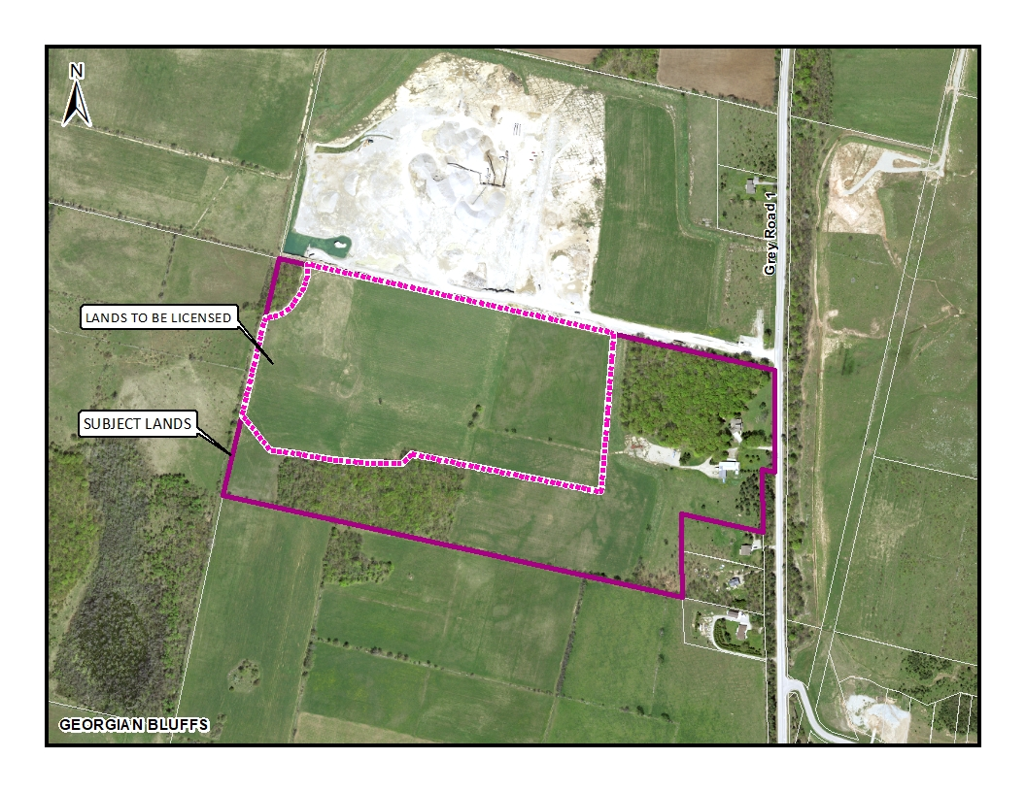

#### Map 1: Airphoto of the Subject Lands

The subject property is designated ‘Agricultural’ and ‘Rural’. The lands to be licensed are designated ‘Agricultural’. The reason for this amendment is that Schedule B of the County Official Plan does not identify the subject lands as an ‘Aggregate Resource Area’ and Section 5.6.4 of the County Official Plan requires an official plan amendment for all new or expanding quarry operations that are proposed within the County except for those proposed within the Niagara Escarpment Plan Area. The subject lands were previously used for cash-crop purposes. Alternative locations were considered and reviewed for the proposed quarry expansion on lands that were not classified through the Canada Land Inventory Classes as Class 1,2,3 lands. Reasoning has been provided by the applicant explaining why the subject lands are well suited for the proposed quarry expansion.

The existing Aggregate Resource Act License for the operating quarry immediately to the north is a class A license, licensed to extract on an annual basis 400,000 tonnes. Including the proposed expansion, the cumulative extraction will remain 400,000 tonnes. This will limit the possibility of increasing traffic flow to and from the subject site. Haulage routes will continue to utilize the existing entrance located off Grey Road 1 for the expansion. The subject quarry expansion will be a below the water table operation.

The surrounding lands to the subject site are a mix of residential and agricultural uses. There is a residential subdivision located to the southeast of the subject lands along Ishwar Drive. The lands to the south and west are used primarily for agricultural purposes. The lands immediately to the north is the applicant’s existing quarry.

The noise impact assessment and blast impact assessment identified 5 sensitive receptors (residential properties within 500 metres of the proposed licensed area). These sensitive receptors (residential) range approximately between 225 and 340 metres from the proposed expansion lands.

Ron Davidson, a land use planning consultant has submitted a Planning Justification Report in support of the proposal. The following background information has also been provided as part of the overall submission: site plans, combined level 1 & 2 hydrogeological study, natural environment technical report: level 1 & 2, noise impact assessment, blast impact assessment, karst hazard assessment, and a stage 1-2 archaeological assessment.

There are proposed amendments to the Aggregate Resources of Ontario Provincial Standards under the Aggregate Resources Act on the Ontario’s Regulatory Registry for review and comment by March 30th, 2020. Staff have not yet reviewed and provided comment on the proposed changes to the Act but will account for any effects these changes may have with respect to the subject application.

Dave Munro (representing Sutherland Construction) has also processed the Quarry License Application under the Aggregate Resources Act (ARA). There are no outstanding objections or concerns from any of the agencies or the general public. A copy of the report and background materials can be found at the below link:

[Link to Background Materials](https://www.grey.ca/planning-development/planning-applications)

## Analysis of Planning Issues

In rendering decisions, planning authorities must have regard to matters of Provincial interest under the *Planning Act* and be consistent with the Provincial Policy Statement (PPS). Decisions within the County must also conform to the County of Grey Official Plan, and in this case the Township of Georgian Bluffs local official plan, and any Provincial plans in force and effect.

A detailed planning analysis has not been undertaken at this stage. Following the public process, and agency comments, a thorough analysis and staff recommendation will be provided. Key Provincial and County policies have been flagged below for consideration.

### Provincial Legislation – The Planning Act

Most notable to this proposed official plan amendment are the following clauses from the *Planning Act*, which will need to be considered.

1. **the protection of ecological systems, including natural areas, features and functions,**

There are significant woodlands identified on the subject lands along the east and southern portions.

1. **the protection of agricultural resources of the Province,**

The subject lands are designated ‘Agricultural’ and ‘Rural’ as per Schedule A of the County Official Plan. The licensed area for the quarry operation will be entirely located in the lands designated ‘Agricultural’. As outlined by the Provincial Policy Statement and County Official Plan, specific policy provisions are required to be met prior to establishing a quarry operation on lands designated as ‘Agricultural’.

1. **the supply, efficient use and conservation of energy and water,**

A combined level 1 & 2 hydrogeological study has been submitted as part of this application.

**(o) the protection of public health and safety**

The accompanying studies submitted (noise impact assessment, blast impact assessment, hydrogeological study) as part of this application aim to assess public health and safety matters in this proposal.

### Provincial Policy Statement (PPS 2014)

Section 2.3.6.1 of the PPS outlines that non-agricultural uses in prime agricultural areas may only be permitted for extraction of minerals, petroleum resources and mineral aggregate resources. Part of the proposed licensed area lands are designated Agricultural.

Furthermore, section 2.5 details criteria for mineral aggregate resources and the extraction process. There is general support for mineral resource extraction. Subsection 2.5.4 specifies criteria required to review should resource extraction take place in prime agricultural areas. Complete rehabilitation to an agricultural condition is not required under certain circumstances. The proposed quarry expansion will be a below the water table operation, making the rehabilitation to a pre-extraction agricultural capability unfeasible.

### County of Grey Official Plan

Section 5.6.4(1)(c) of the County Official Plan requires an amendment to a proposed mineral aggregate extraction expansion beyond the areas identified as an ‘Aggregate Resource Area’ on Schedule B.

Section 5.6.4(2) also indicates that new or expanded pit operations proposed for areas outside of the ‘Aggregate Resource Area’ require an official plan amendment.

Section 7 (Natural Grey) of the County Official Plan is also considered as part of the review of this application in order to account for any potential disturbances to the natural environment. A more thorough review of the natural environment features on and adjacent to the subject lands shall be provided through a review of the ‘Natural Environment Technical Report’.

As noted above, following the public and agency processes, a thorough planning analysis and staff recommendation will be provided. Staff will also review the comments from agencies that were submitted as part of the Aggregate Resource Act (ARA) process.

## Legal and Legislated Requirements

The application will be processed in accordance with the Planning Act.

## Financial and Resource Implications

There are no anticipated financial, staffing or legal considerations associated with the proposed official plan amendment, beyond those normally encountered in processing an amendment. The County has collected the requisite application fee and peer review deposit for this application.

## Relevant Consultation

Internal: Planning Staff

External: Township of Georgian Bluffs, required agencies under the *Planning Act*, and the public

### Appendices and Attachments

*None*