DRAFT

Contents
Executive Summary 3
Key 2023 Proposed Budget Investments 5
2023 Budget’s Estimated County Tax Impact 6
2023 Operating and Capital Budget – Net Levy Requirements 7
2023 Budget 8
Budget Background 9
Building the Budget 9
Function Responsibilities 10
HIGHLIGHTS Corporate Services 11
HIGHLIGHTS Planning and Community Development 12
HIGHLIGHTS Human Services 13
HIGHLIGHTS Transportation and Public Safety 15
Our People 16
Funding Services 17
2023 Budget Analysis (Net Dollars) by Function 18
Additional 2023 Budget Information and Details – Contact Us: 23

Executive Summary

Grey County covers a large geography of more than 4,500 km² and serves a permanent population of over 100,000. Grey County’s annual budget supports the operation of provincially mandated programs and services, local initiatives necessary for the development of vibrant healthy communities and maintains assets valued historically at over $497 million.
The 2023 Budget has operating and capital expenses of $225.1 million. After operating and capital revenues, reserves and capital financing are calculated, $67.9 million needs to be raised through taxes to maintain and enhance existing services.
Growth across Grey County has generated new assessment of $1,591,700. This is included in County revenue, bringing the net levy increase for 2023 to 1.49% or $1,000,000.

Impacts to the 2023 Budget
Our goal in budgeting is to provide stable budgets and adequate service levels to our ratepayers through minimal levy increases. Changes to federal and provincial government funding, inflation, increased demands for service and other factors all impact the annual budgeting process. In 2023, Grey County expects to see costs rise more than they typically have in recent years. We know our residents and businesses face similar challenges.
Collective Bargaining: In 2023, Grey County will be involved in ongoing negotiation with one employee group and will start the bargaining process with another three. The budget includes estimated cost increases associated with new collective agreements.
Inflation: Last year Grey County experienced increases of 10% to 30% in various construction costs. Increases to the costs of labour, fuel, materials, asphalt, concrete, and other spending, all impacts the 2023 budget. The Non-Residential Building Cost Index increased 15.6% over 2021 in the third quarter last year. Staff expect to continue to see rising costs that are higher than normal in 2023.
Asset Management: Grey County’s Asset Management Plan recommends increasing the investment for infrastructure by an additional 0.36% each year for 15 years, starting in 2023.
Bill 23 (More Homes Built Faster Act): Effects of the new legislation which took effect on November 28, 2022, are tough to predict until all regulations are released. There will be resourcing impacts from the loss of conservation authority’s performing natural heritage reviews. As well, Grey County is no longer able to collect development charges for affordable housing builds.
In-Year Approvals: 2022 Council approved service enhancements that are fully costed in the 2023 budget.

Key 2023 Proposed Budget Investments

The 2023 budget has been developed to maintain current programs, enhance service levels, and support important projects as we adjust to changes in Provincial funding levels for some services. Some 2023 investments are highlighted below.

Maintaining Infrastructure
- Investing more than $30 million into construction and resurfacing of Grey County roads
- Investing $5.46 million for capital work on Housing projects
- Investing $2.88 million to complete renovations for the 14th Street, Owen Sound Supportive Housing Building
- Purchasing four ambulances (two carried over from 2022), 11 automatic CPR machines and three power load stretchers
Investing in People
- Aligning staffing to meet operational requirements:
  - HR Business Partner to support Long-Term Care
  - IT Business Analyst Programmer
  - One full time and one contract Climate Change staff
  - Transitioning part time operations staff to six full time operators. Adding two technologists and two apprentices for succession planning purposes
- Continuing support for Georgian College and the Marine Emergency Duties Training and Research Centre
- Completing a Market Salary Review for all non-union staff to support recruitment, retention, and long-term planning
Investing in Quality of Life
- Continuing support for the Community Safety & Well-Being project in partnership with Bruce County
- Providing additional Long-Term Care staffing to focus on direct resident care and infection prevention as required by legislation
- Contributing $622,700 to the Affordable Housing Fund to support the financial viability of future housing projects.
- Continuing to support the health needs of our vulnerable populations through remote visits for Community Paramedicine, Community Paramedicine for Long Term Care and SOS program.

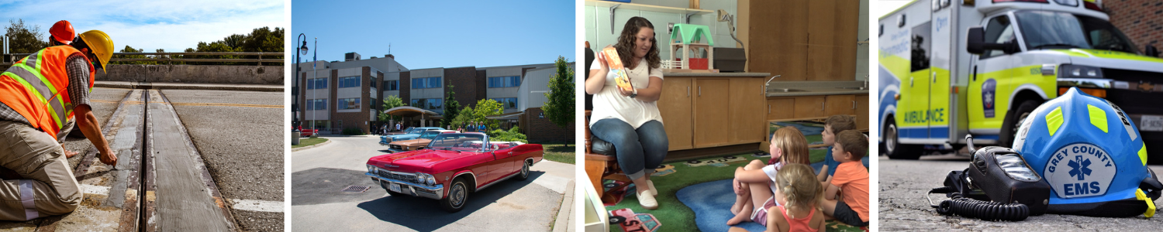

2023 Budget’s Estimated County Tax Impact

APPROXIMATE TAX INCREASE PER RESIDENTIAL
PROPERTY ASSESSMENT*
County Tax Rate Increase
% | $ | per $100,000
1.49 | 1,000,000 | $5.59

2023 Average Increase per Household Single Detached Home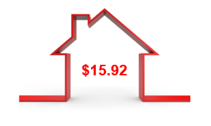

The assessed value of every property in Grey County is established by MPAC. Property owners receive a notice of assessment each year that provides the current value of their property. As of December 2022, the median assessed value of all residential properties in Grey County is $285,000.
Every property owner receives an annual property tax bill from their local municipality that represents the total of their County, education and lower tier municipal taxes.

2023 Operating and Capital Budget – Net Levy Requirements

Function | 2022  Net Levy | 2023  Net Levy | Increase / (Decrease) | %  Change of Levy
Corporate Services | $12,522,700 | $12,251,600 | $(271,100) | (0.40)%
Planning & Community Development | $4,710,400 | $5,248,000 | $537,600 | 0.80%
Human Services | $26,570,500 | $28,126,200 | $1,555,700 | 2.32%
Transportation Services | $21,555,400 | $22,313,300 | $757,900 | 1.13%
Funding Required | $65,359,000 | $67,939,100 | $2,580,100 | 3.85%
Estimated New Assessment Growth and Tax Ratio Adjustments – Owen Sound | $1,580,100 |  | ($1,580,100)
Additional Funding to be Raised from Taxation  Net Levy Increase | $66,939,100 | $67,939,100 | $1,000,000 | 1.49%

The additional property tax revenue from new construction, often referred to as assessment growth, is incorporated into the 2023 budget based on the Municipal Property Assessment Corporation’s (MPAC) roll edition of assessment values.

For 2023, a 1% levy increase equals approximately $669,400.

2023 Budget

Budget Background
Grey County delivers a wide range of services and programs. As a Consolidated Municipal Service Manager, we are mandated to deliver many important social and community health services.
Service and Programs
- Providing 319 long-term care beds (includes 3 temporary licensed beds)
- Maintaining 995 units of safe and affordable housing across the county
- Responding to more than 28,000 annual calls through Paramedic Services
- Delivering income support
- Helping families access affordable child care
- Maintaining over 1,654 lane km of roads and more than 192 bridges and structures over 3 metres
It is Grey County’s responsibility to deliver these and other programs and services as required by regulations and our agreements with funding partners. The annual budget determines how resources are directed towards services for the year.
Grey County is committed to the coordinated delivery of responsive and cost-effective services that strengthen the economic, social, environmental and cultural well-being of the diverse communities it serves.

Building the Budget
Each department meets with the Chief Administrative Officer or Deputy CAO, the Director of Finance and Deputy Treasurer to review the departmental revenues, expenditures, net levy requirements and any service level or staffing enhancements. The Senior Management Team then further reviews and discusses these proposed budget plans.
Once these reviews are complete, the corporate budget overview and background is provided to County Council to inform councillors of the overall 2023 funding requirements recommended by staff.
Council discusses the proposed budget by function at a special budget workshop. Here council can ask questions, provide further direction to staff or approve the budget.
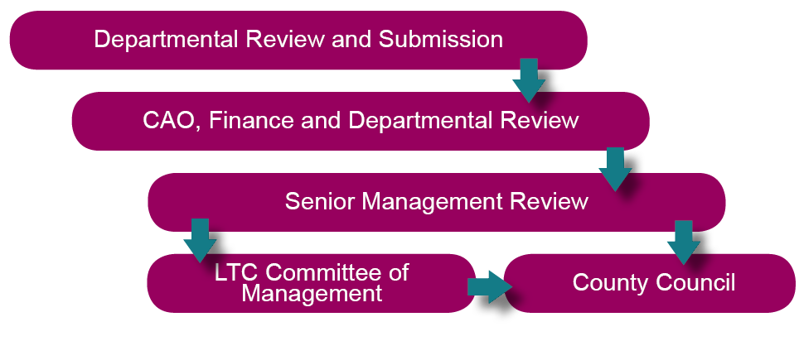

Function Responsibilities

Grey County uses functions to discuss business and reports. Each function focuses on specific areas of municipal service.

Corporate Services | Planning and Community Development
- Finance - budgets, assessment, and taxation  - Purchasing and asset management  - County Clerk - general legislation and by-laws  - Provincial Offences Administration (courts)  - Risk management and emergency management  - Human Resources  - Records Management  - Information Technology  - Legal Services  - Corporate Communications  - Climate action | - Planning matters (official plans, subdivision and condominium plans, etc.)  - Forestry and Trail Management  - Economic Development and Tourism and Culture  - Business Enterprise Centre  - Sydenham Campus - Regional Skills Training, Trades & Innovation Centre  - Agriculture  - Grey Roots Museum and Archives  - Grey Transit Route (GTR)
Human Services | Transportation Services
- Ontario Works  - Early Learning and Child Care  - Long-Term Care (Lee Manor, Rockwood Terrace and Grey Gables)  - Affordable housing, non-profit housing and homelessness prevention  - Community and social support programs  - Paramedic services  - Community paramedicine program  - Public access defibrillation | - Engineering, maintenance and construction of roads, bridges, and culverts  - Winter maintenance of roads  - Traffic signals  - Permits for entrances, right of way use  - Mechanical repairs and maintenance of Transportation and Paramedic Services fleet, Grey Bruce Health Services’ patient transfer vehicles and The Blue Mountains’ fire vehicles

HIGHLIGHTS Corporate Services

Corporate Services provides support to all aspects of County operations. Net function requirement (operating and capital) of $12,251,600 a decrease of $271,100 as compared to 2022. Notable impacts to the budget include:
- Additional HR, IT and Climate Action staff positions to support increasing workloads and workplans
- $10,000 from reserve to implement Agenda Management Software
- $110,000 from reserve to transition from the County’s current Document Management System to Microsoft SharePoint and avoid duplicate licensing costs
- $200,000 from reserve to purchase new budgeting software
- $300,000 from reserve for the purchase of a centralized Human Resources Information System (HRIS) software
- $40,000 from reserve to undertake a Workplace Violence and Risk Assessment
- $324,500 from reserve for the Corporate Telephone System Replacements
- $55,200 from reserve to undertake third party assessments and audits of the County’s cyber security measures
- $130,000 from the capital projects reserve for Admin Building HVAC control system upgrade
- $152,600 for HVAC components at Admin Building (through use of Safe Restart Funding)
- $200,000 to support the Marine Emergency Duties Training Facility (year 9 of 10-year commitment) funded through the One Time Funding Reserve
- $255,000 for Climate Change Action Plan implementation projects funded from reserves

HIGHLIGHTS Planning and Community Development

Net function requirement (operating and capital) of $5,248,000 an increase of $537,600 over 2022. Notable impacts to the budget include:
- $30,000 from reserve for the implementation of Surplus Lands for Affordable Housing, supporting the Housing Action Plan
- $100,000 from reserves to partner with Indigenous groups and local municipalities for the Archeological Management Plan
- $70,000 from the One Time Funding Reserve to support the Buckthorn Invasives Management Program; this new program in collaboration with Grey Sauble Conservation Authority works to protect our environment and natural assets
- CP Rail Trail bridge and culvert rehabilitation
- $209,300 from reserve for CP Rail Trail improvements, bridge and culvert rehabilitation, survey work, signage and parking upgrades
- Attraction and retention initiatives to support workforce development for key sectors totaling $21,500
- In partnership with Bruce County, a $299,100 federal grant to build regional capacity that supports newcomer integration through welcoming communities
- Sydenham Campus innovation centre and business incubator implementation with $275,000 to purchase Fab Lab equipment for prototyping and training, and $100,000 to support business scaling though Catapult Grey Bruce. This is being fully funded through FedDev Ontario grants.
- $350,000 from reserve to complete HVAC improvements at Sydenham Campus
- $50,000 from One-Time Funding reserve to complete renovations to better position staff office space
- Investment in a full-time Campus Coordinator at Sydenham to ensure efficient operations, to market and organize rentals at the space
- $98,600 to update the Grey County Gallery, partially funded through the Canada Cultural Spaces Fund
- $250,000 from reserve for flat roof replacement at Grey Roots
- $180,000 from the One Time Funding Reserve for local municipal community improvement plans to advance municipal priorities, such as housing.
- $66,400 to replace signs and implement new signage to support sustainable tourism, with 60% funded through a federal grant
- $1.42 Million to operate Grey Transit Route (GTR) with 69% of the cost covered through provincial grants, contributions from other municipalities, cost recoveries and fare revenue. Eliminating Route 6 from Flesherton to Hanover as of April 1, 2023. Grey County’s investment in operating the service is $447,400 an increase of $167,100 over 2022

HIGHLIGHTS Human Services
Net function requirement (operating and capital) of $28,126,200 an increase of $1,555,700 over 2022. Notable impacts to the budget include:

Ontario Works and Early Learning and Child Care
- $8,322,100 in Canada Wide Early Learning and Child Care (CWELCC) funding to support the 52.75% child care fee reduction for children under the age of six
This funding will also support increased wages for eligible child care staff
- A Provincial funding reduction of $491,561 for Ontario Works due to the Employment Services Transformation has led to a $234,700 funding shortfall after adjusting gross expenses. This budget contains $39,800 in reserve funding, $10,000 in Homelessness Prevention funding with the remaining shortfall of $184,900 included in the net levy
- Architect fees and related costs prior to Hanover EarlyON building construction planned to begin in 2024
Housing and Homelessness Support
- Contribution of $622,700 to the Affordable Housing Fund
- $5.46M 85% from reserves and grants with the balance from taxation for 72 housing capital projects
- $509,000 from Canada Ontario Community Housing Initiative (including $248,000 carried from 2022) for window replacement projects, administration funds and capital projects. 2023/2024 funding allocations have not been received and staff assume they will remain at 2022/2023 levels.
- $2.88 million to complete renovations for the 14th Street Supportive Housing Building
- $146,200 reduction in administration funds for provincially funded housing programs
- Increased utility costs for the buildings

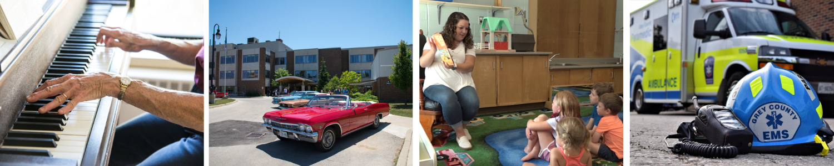

HIGHLIGHTS Human Services Continued
Long-Term Care
- Additional licence and funding for three beds on a temporary basis
- No adjustment in 2023 for provincial level of acuity funding (Case Mix Index) across the province
- Additional provincial funding for increased direct care staffing hours to support physical and emotional needs of long-term care residents
- Ongoing COVID-19 expenditure funding as well as Infection Prevention and Containment (IPAC) funding
- Replacement of doors, signage and air make up system at Grey Gables
- Replacement of flooring and tubs at Lee Manor
- Lifecycle replacement beds and technology
- $9.16M from reserve for design work in 2023 for the
redevelopment of Rockwood Terrace
Paramedic Services
- Adapting to call volumes increasing year over year
- Increased fuel and vehicle maintenance costs
- Increased self-insured WSIB costs
- Purchasing 4 ambulances (2 carried over from 2022), 11 automatic CPR machines and 3 power load stretchers
- Providing outreach services in the community to vulnerable people through the newly provincially funded Supportive Outreach Service (SOS program)

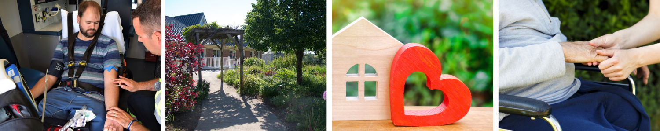

HIGHLIGHTS Transportation Services

Net function requirement (operating and capital) of $22,313,300 an increase of $757,900 over 2022. Notable impacts to the budget include:

- Increase of $406,400 for increased fuel / material costs and staffing for winter / fleet maintenance
- Increase of $531,300 for insurance and implementing recommendations of the Transportation Servicies Review for supervision, overhead, staffing and succession planning.
- An additional $271,800 infrastructure investment for a total annual contribution of $1,026,100 (or 1.57% of the levy) to close the infrastructure gap (recommended by the 2021 Asset Management Plan)
2023 Road Construction Projects
- Pulverizing and Paving portions of Grey Road 4, 7 and 18
- Overlay on a portion of Grey Road 2 and 19
- Reconstruction of a portion of Grey Road 7 and 27
- Intersection upgrades at Grey Road 3 and 4 as well as Grey Road 19 and 21
- Retaining wall on Grey Road 3 and urbanization of Grey Road 28
- Purchase of 2 half-ton trucks and 1 one ton truck
- Purchase of 2 tandem trucks and 2 roll off tandems (roll off tandems carried over from 2022)
- Purchase of a payloader and rubber tire excavator
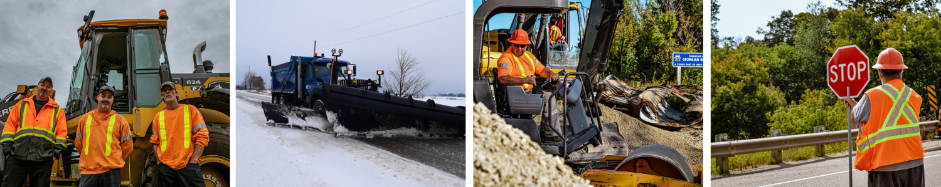

Our People

1032 employees (full-time, part-time, students and contract) deliver Grey County services. Unionized staff are represented by nine separate bargaining units as outlined in the table.
The collective bargaining process in 2023 will involve ongoing negotiating with one employee group and commencing the bargaining process with other groups.
The 2023 budget includes a 2.00% Cost of Living Adjustment (COLA) wage increase for the 254 non-union team members with the exception of the Director level staff and above, which will not receive a COLA adjustment in 2023.

Breakdown of unionized staff
Employee Group | # of Employees | Contract End Date
ONA Registered Nurses  (3 – LTC Homes) | 28 | March 31, 2023
OPSEU  Lee Manor | 235 | December 31, 2022
UNIFOR  Rockwood Terrace | 151 | January 31, 2023
OPSEU  Social Services | 36 | December 31, 2021
OPSEU  Grey Gables | 129 | December 31, 2023
OPSEU Paramedic Services | 136 | December 31, 2023
CUPE Transportation Services | 63 | May 31, 2024

Funding Services
 | Total Gross Expenditures  ($000s) | Fed/Prov Grant Funding ($000s) | Net Reserve Funding ($000s) | Other Funding ($000s) | Net Levy ($000s) | Portion of County Levy | Per $100,000  Residential  Assessment Value**
Corporate Services Function  Other Administration | 16,582 | (30) | (613) | (5,380) | 10,559 | 15.54% | $0.87
Health Care and Education Funding | 1,893 | 0 | (200) | 0 | 1,693 | 2.49% | $0.14
Planning and Community Development Function | 9,690 | (1,739) | (1,778) | (925) | 5,248 | 7.72% | $0.43
Human Services Function  Social Services  (Ontario Works & Child Care) | 37,693 | (33,470) | (416) | (360) | 3,447 | 5.07% | $0.28
Affordable Housing | 22,874 | (5,231) | (3,562) | (5,938) | 8,143 | 11.99% | $0.67
Long Term Care | 50,690 | (26,690) | (8,606) | (7,118) | 8,276 | 12.18% | $0.68
Paramedic Services | 20,111 | (10,754) | (978) | (119) | 8,260 | 12.16% | $0.68
Transportation Services Function | 57,850 | (4,468) | (28,329) | (2,740) | 22,313 | 32.84% | $1.84
Total | 217,383 | (82,382) | (44,482) | (22,580) | 67,939 | 100.00% | $5.59
*All numbers are rounded
**Estimate at this time. Final tax rate will not be finalized until annual tax policy items are endorsed by County Council.
Other funding includes application fees, donations, long-term care resident fees, housing tenant rent, admissions, sponsorship etc.

2023 Budget Analysis (Net Dollars) by Function

 | 2022 |  |  | 2023
 | BUDGETS |  |  | BUDGETS |  |  | Change
 |  |  | Combined | Operating | Capital | Combined | 23 Levy to 22
FUNCTION | Net Operating Budget | Net Capital Budget | Net Tax Levy | Net Operating Budget | Net Capital Budget | Net Tax Levy | Increase / (Decrease)
CORPORATE SERVICES
Council | $843,900 | $0 | $843,900 | $860,100 | $0 | $860,100 | $16,200
Administration Departments | $6,669,900 | $351,600 | $7,021,500 | $7,655,200 | $217,900 | $7,873,100 | $851,600
Workers Comp & Wkly Indem. Self Ins. | $0 | $0 | $0 | $0 | $0 | $0 | $0
Information Services | $0 | $0 | $0 | $0 | $0 | $0 | $0
Assessment (MPAC) | $1,885,000 | $0 | $1,885,000 | $1,885,000 | $0 | $1,885,000 | $0
Provincial Offences | ($200,000) | $0 | ($200,000) | ($174,100) | $0 | ($174,100) | $25,900
Property | $275,000 | $793,400 | $1,068,400 | $291,500 | $742,400 | $1,033,900 | ($34,500)
Taxation and Other | ($396,300) | $0 | ($396,300) | ($919,800) | $0 | ($919,800) | ($523,500)
Sub Total | $9,077,500 | $1,145,000 | $10,222,500 | $9,597,900 | $960,300 | $10,558,200 | $335,700
Health Unit | $1,632,600 | $0 | $1,632,600 | $1,693,400 | $0 | $1,693,400 | $60,800
Hospital Grants & Health Care Funding | $467,600 | $0 | $467,600 | $0 | $0 | $0 | ($467,600)
Georgian College - MED Training Centre | $200,000 | $0 | $200,000 | $0 | $0 | $0 | ($200,000)
Sub Total | $2,300,200 | $0 | $2,300,200 | $1,693,400 | $0 | $1,693,400 | ($606,800)
Total Corporate Services | $11,377,700 | $1,145,000 | $12,522,700 | $11,291,300 | $960,300 | $12,251,600 | ($271,100)

 | 2022 |  |  | 2023
 | BUDGETS |  |  | BUDGETS |  |  | Change
 |  |  | Combined | Operating | Capital | Combined | 23 Levy to 22
FUNCTION | Net Operating Budget | Net Capital Budget | Net Tax Levy | Net Operating Budget | Net Capital Budget | Net Tax Levy | Increase / (Decrease)
PLANNING & COMMUNITY DEVELOPMENT
PLANNING, AGRICULTURE, FORESTRY & TRAILS, ECONOMIC DEVELOPMENT, TOURISM, & GREY ROOTS
Planning & Studies | $652,900 | $0 | $652,900 | $978,200 | $18,600 | $996,800 | $343,900
Agriculture | $166,800 | $0 | $166,800 | $180,400 | $0 | $180,400 | $13,600
Forestry & Trails | $145,600 | $100,000 | $245,600 | $136,000 | $110,000 | $246,000 | $400
Economic Development & Tourism | $1,533,900 | $206,000 | $1,739,900 | $1,864,400 | $26,500 | $1,890,900 | $151,000
Grey Roots | $1,645,100 | $260,100 | $1,905,200 | $1,730,500 | $203,400 | $1,933,900 | $28,700
Total Planning & Community Development | $4,144,300 | $566,100 | $4,710,400 | $4,889,500 | $358,500 | $5,248,000 | $537,600

 | 2022 |  |  | 2023
 | BUDGETS |  |  | BUDGETS |  |  | Change
 |  |  | Combined | Operating | Capital | Combined | 23 Levy to 22
FUNCTION | Net Operating Budget | Net Capital Budget | Net Tax Levy | Net Operating Budget | Net Capital Budget | Net Tax Levy | Increase / (Decrease)
Human Services
Ontario Works & Child Care
Social Assistance | $71,100 | $0 | $71,100 | $82,500 | $0 | $82,500 | $11,400
Ontario Works | $1,884,700 | $0 | $1,884,700 | $1,942,800 | $0 | $1,942,800 | $58,100
Early Learning and Child Care | $1,134,500 | $0 | $1,134,500 | $1,128,100 | $0 | $1,128,100 | ($6,400)
County Social Initiatives | $263,900 | $0 | $263,900 | $293,400 | $0 | $293,400 | $29,500
Sub Total | $3,354,200 | $0 | $3,354,200 | $3,446,800 | $0 | $3,446,800 | $92,600
Housing
Housing | $5,939,200 | $1,931,900 | $7,871,100 | $6,519,600 | $1,623,700 | $8,143,300 | $272,200
Sub Total | $5,939,200 | $1,931,900 | $7,871,100 | $6,519,600 | $1,623,700 | $8,143,300 | $272,200
Paramedic Services
Paramedic Services | $7,660,000 | $137,700 | $7,797,700 | $8,099,700 | $160,200 | $8,259,900 | $462,200
Sub Total | $7,660,000 | $137,700 | $7,797,700 | $8,099,700 | $160,200 | $8,259,900 | $462,200
Long Term Care
Long Term Care Administration | $0 | $0 | $0 | $0 | $0 | $0 | $0
Grey Gables | $1,658,200 | $193,800 | $1,852,000 | $1,779,800 | $264,200 | $2,044,000 | $192,000
Lee Manor | $2,046,700 | $164,700 | $2,211,400 | $2,444,800 | $206,000 | $2,650,800 | $439,400
Rockwood Terrace | $1,977,500 | $145,600 | $2,123,100 | $2,074,800 | $145,600 | $2,220,400 | $97,300
Long Term Care Redevelopment | $0 | $1,361,000 | $1,361,000 | $0 | $1,361,000 | $1,361,000 | $0
Sub Total Long Term Care | $5,682,400 | $1,865,100 | $7,547,500 | $6,299,400 | $1,976,800 | $8,276,200 | $728,700
Total Human Services | $22,635,800 | $3,934,700 | $26,570,500 | $24,365,500 | $3,760,700 | $28,126,200 | $1,555,700

 | 2022 |  |  | 2023
 | BUDGETS |  |  | BUDGETS |  |  | Change
 |  |  | Combined | Operating | Capital | Combined | 23 Levy to 22
FUNCTION | Net Operating Budget | Net Capital Budget | Net Tax Levy | Net Operating Budget | Net Capital Budget | Net Tax Levy | Increase / (Decrease)
TRANSPORTATION SERVICES
Transportation Services
Ordinary Maintenance | $3,250,200 | $0 | $3,250,200 | $3,522,400 | $0 | $3,522,400 | $272,200
Winter Maintenance | $4,752,000 | $0 | $4,752,000 | $5,158,400 | $0 | $5,158,400 | $406,400
Facilities, Depots and Domes | $278,400 | $324,700 | $603,100 | $283,700 | $364,700 | $648,400 | $45,300
Supervision, Overhead and Administrative Summary | $3,004,100 | $0 | $3,004,100 | $3,535,400 | $0 | $3,535,400 | $531,300
Machinery & Equipment Summary | $0 | $0 | $0 | $0 | $0 |  | $0
Major Road and Bridge Construction Summary | $0 | $9,946,000 | $9,946,000 | $0 | $9,448,700 | $9,448,700 | ($497,300)
Total Transportation Services | $11,284,700 | $10,270,700 | $21,555,400 | $12,499,900 | $9,813,400 | $22,313,300 | $757,900

 | 2022 |  |  | 2023
 | BUDGETS |  |  | BUDGETS |  |  | Change
 |  |  | Combined | Operating | Capital | Combined | 23 Levy to 22
FUNCTION | Net Operating Budget | Net Capital Budget | Net Tax Levy | Net Operating Budget | Net Capital Budget | Net Tax Levy | Increase / (Decrease)
TOTAL TO RAISE FROM TAXATION | $49,442,500 | $15,916,500 | $65,359,000 | $53,046,200 | $14,892,900 | $67,939,100 | $2,580,100
 |  |  | 2023 Levy Increase Over 2022 Approved Budget |  |  | $2,580,100
Calculation of Tax Rate Increase |  |  | Less: Estimated New Assessment Growth |  |  | ($1,591,700)
 |  |  | Add: Tax Ratio Adjustments Owen Sound |  |  | $11,600
for 2023 | 2022 New Growth |  | 2023 Budgetary Levy Increase Net of New Growth |  |  | $1,000,000
1% = $669,400 | $1,591,700 |  | 2023 Budgetary Increase over the 2022 Approved Budget |  |  | 1.4939%

The 2023 New Growth of $1,591,700 is based on the Municipal Property Assessment Corporation’s (MPAC) roll edition of assessment values.

Additional 2023 Budget Information and Details – Contact Us:

County of Grey
595 9th Avenue East
Owen Sound, ON N4K 3E3
519-376-2205
Grey.ca

Office of the Warden and CAO
Brian Milne, Grey County Warden - warden@grey.ca
Kim Wingrove, Chief Administrative Officer - cao@grey.ca

Finance Department
Mary Lou Spicer, Director of Finance – marylou.spicer@grey.ca

