Grey County Logo Committee Report

| **To**: | Warden McQueen and Members of Grey County Council |
| --- | --- |
| **Committee Date:** | September 10th, 2020 |
| **Subject / Report No:** | County Official Plan Amendment 42-10-510-OPA-4 / PDR-CW-31-20 |
| **Title:** | 423020 Harbour Drive Official Plan Amendment Number 4 Final Report |
| **Prepared by:** | Hiba Hussain |
| **Reviewed by:** | Randy Scherzer |
| **Lower Tier(s) Affected:** | Municipality of Meaford |
| **Status:** | Recommendation adopted by Committee as presented per Resolution CW160-20; Endorsed by County Council September 24, 2020 per Resolution CC75-20; |

## Recommendation

1. **That Addendum to Report PDR-CW-31-20 regarding Official Plan Amendment 4 be received;**
2. **That all written and oral submissions on Official Plan Amendment Number 4 were considered and helped to make an informed recommendation and decision; and**
3. **That Amendment Number 4 to the County of Grey Official Plan to re-designate the lands from the ‘Rural’ and ‘Hazard Lands’ designations to the ‘Rural with Exceptions’ and ‘Hazard Lands’ designations to allow for new lot creation, where the remnant lot gains access via an unopened municipal road allowance for the lands described as Lot 5 and Lot 6, and Part Lot 7, Broken Front Concession, geographic Township of Sydenham now in the Municipality of Meaford, be supported, and a by-law to adopt the County Official Plan Amendment be prepared for consideration by County Council.**

## Executive Summary

The proposed County Official Plan Amendment 4 would consider exceptions to the Transportation Policies in Move Grey, Agricultural and Rural sections to permit lot creation, where the remnant lot has access via an unopened municipal road allowance. Typically, such lot creation is not permitted without access onto a year-round open and maintained municipal road, or through a plan of condominium.

A Consent application has been submitted to the Municipality of Meaford to sever the lands into two parcels. These lots were originally separate parcels of land and have inadvertently merged into a single piece of land. The proposed severed parcel would gain access off Queens Bush Drive, while the proposed retained parcel would gain access via the unopened municipal road allowance. The proposed retained parcel contains nine existing seasonal cottages that have historically gained access from the municipal unopened road allowance. No new development is proposed on the retained parcel and a holding symbol will be placed on the property by the municipality preventing any new development on the retained parcel until such time as the unopened road allowance is upgraded to an opened and maintained road. A Zoning By-law amendment is also required to amend Section 9 to By-law 60-2009 which will revise the Environmental Protection (EP) zoning on the subject lands and will identify a specified building envelope through a Rural-Exception zone (RU-279).

## Background and Discussion

The subject lands are located at Lot 5 and 6, and Part Lot 7 Broken Front Concession, geographic Township of Sydenham now in the Municipality of Meaford. Map 1 shows the subject lands and surrounding area, while Figure 1 shows the proposed severance.

The subject lands are approximately 37.6 hectares (92.9 acres) in total. The severed portion of the lands will be approximately 19.8 hectares (49 acres) in size with approximately 26 m (85 ft) of frontage on Queen’s Bush Road. The retained parcel of land containing nine (9) existing seasonal cottages will maintain an area of approximately 17.8 hectares (44 acres) with continued existing seasonal access from the municipal unopened Harbour Drive road allowance. These existing lots of record have inadvertently merged on title. The applicant requests to recreate the lots as they have historically existed in order to pursue the sale of the severed parcel. No new development is being permitted on the retained parcel through these planning applications.

Surrounding the subject lands are Rural lands to the east and the south. To the west of the property is located a Rural residential subdivision and north of the property is Georgian Bay.

The subject property is designated ‘Rural’ and ‘Hazard Lands’ in the County Official Plan. An amendment is being requested in this location because the applicant is proposing to server the subject property into two lots. The policies within Recolour Grey do not permit lot creation on a municipal unopened road allowance unless through a Plan of Condominium. A County Official Plan Amendment would allow the applicant to sever the property into two, allowing the retained lot to have access off the municipal unopened Harbour Drive road allowance. No new development is proposed on the retained lot. The proposed development also requires an amendment to the Municipality of Meaford’s zoning by-law and a consent application.

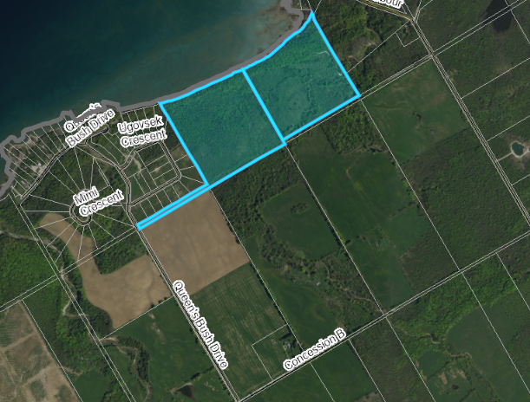

##### **Map 1: Location of the Subject Lands**

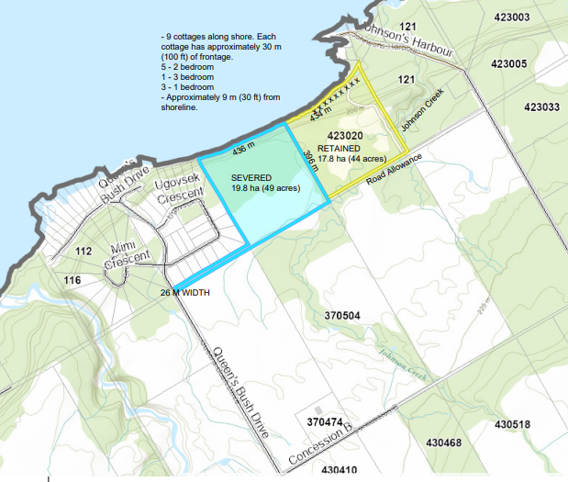

##### **Figure 1: Drawing of the Proposed Consent**

Kristine Loft, of Loft Planning Inc. has submitted a Planning Justification Report in support of the proposal. Loft Planning Inc. did engage the Municipality and the County in pre-submission consultation for this proposal. A copy of the Report and background materials can be found at the below link:

[Link to Background Materials](https://www.grey.ca/planning-development/planning-applications)

A joint public meeting was held with the Municipality of Meaford on July 20, 2020, to gather input on these applications. A link to the public meeting minutes can be found in the Appendices and Attachments section of this report.

### Public and Agency Comments Received

#### Public Comments

No public comments have been received.

#### Agency Comments

Comments were received from the following agencies.

##### Historic Saugeen Metis (HSM)

In comments dated June 22, 2020 the HSM Lands, Resources and Consultation Department noted they have no concerns with the proposed development.

##### Grey Sauble Conservation Authority (GSCA)

In comments dated July 15, 2020, GSCA noted that,

1. Consistency with Section 3.1 of the PPS has been demonstrated;

2. Ontario Regulation 151/06 does apply to the subject site. A permit from GSCA may be required prior to any development or site alteration taking place within the severed parcel;

3. Consistency with Section 2.1 of the PPS has been demonstrated;

4. The subject site is not located within an area that is subject to the policies contained in the Saugeen, Grey Sauble, Northern Bruce Peninsula Source Protection Plan.

In order to achieve consistency with Section 3.1 of the PPS, our office recommends that approval of the subject application is conditional on the completion of a Zoning By-law Amendment to appropriately zone the identified hazard areas as ‘Environmental Protection (EP)’ in the Municipality’s Zoning By-law.

In addition, development on the subject property should be restricted to the development envelopes outlined on the attached maps, and that any development request be accompanied by an engineered lot grading and drainage plan.

If an additional Planning Act application is pursued in order to facilitate further development on the proposed parcel, or if development is proposed outside of the identified development envelopes, our office recommends that an Environmental Impact Study (EIS) is completed.

##### Enbridge Gas

In comments dated June 8, 2020, Enbridge Gas Inc. stated that they do not object to the proposed application however, they reserve the right to amend their development conditions.

##### Municipality of Meaford

##### A Municipality of Meaford staff report has been linked to in the Appendices and Attachments section of this report, which has been endorsed by Meaford Council, and supports the proposed development. The associated zoning by-law amendment was approved by Meaford council and no appeals were received on the decision. The associated consent application has been deferred until the decision on the County Official Plan Amendment has been made.

### Analysis of Planning Issues

In rendering decisions, planning authorities must have regard to matters of Provincial interest under the *Planning Act* and be consistent with the Provincial Policy Statement (PPS). The decisions must also conform to the County of Grey Official Plan, and the Municipality of Meaford Official Plan. The subject lands are outside of the Niagara Escarpment Plan area. Following the legislative and policy analysis review, staff have also included some general planning discussion pertinent to this development.

#### Provincial Legislation – The Planning Act

Most notable to this proposed official plan amendment, are the following matters of provincial interest (in italics) from the *Planning Act*, which will need to be considered, along with a staff comment below each one.

*(a) the protection of ecological systems, including natural areas, features and functions;*

The subject property contains Hazard Lands on both the retained and severed portion which are partially regulated by the Grey Sauble Conservation Authority (GSCA). Recolour Grey also identifies the existence of Significant Woodlands and Johnson Creek which traverses a portion of the property. GSCA staff recommend that a Zoning By-law amendment be applied to appropriately zone the identified Hazard Lands on the property. In addition, for any future development proposed on either parcel, or development proposed outside of the identified development envelope on the severed parcel, the GSCA will require the completion of an engineered lot grading and drainage plan, and an Environmental Impact Study (EIS). At this time no development, other the severance, is proposed on either parcel, but there is an identified building envelope on the severed portion where a house could be built, as mapped by the GSCA. The retained parcel cannot be further developed until such time as there is proper road access.

*(b) the protection of the agricultural resources of the Province;*

Recolour Grey indicates that the subject property is surrounded by Rural lands. The Rural designation is more permissive and allows for smaller lot creation. The County Official Plan allows for rural lot creation provided it meets lot density requirements. The proposed severance will meet lot density requirements. The impact to the surrounding Rural properties will be limited as the separate lots existed historically but merged on title.

*(h) the orderly development of safe and healthy communities;*

The proposed lot creation will re-create two former lots that have merged on title. The severed lot will be a developable lot with access onto an open and maintained public road. A remnant retained parcel will continue to be accessed via an unopened municipal road allowance (as is currently the case); however, this official plan and zoning amendment, in addition to the consent, will not allow any new development on the retained parcel. This item will be discussed in detail in the Grey County Official Plan section.

#### Provincial Policy Statement (PPS) 2020

Section 1.1.4 of the PPS identifies the importance and the purpose that Rural areas serve within municipalities. Section 1.1.5 of the PPS identifies the permitted uses which are allowed including residential development and lot creation. Generally, new development within the Rural area shall be compatible with the rural landscape, sustainable by rural service levels, and should not create constraints on the surrounding Rural uses.

Section 2.1 of the PPS requires the protection of natural heritage features. This item has generally already been covered under the discussion on the *Planning Act.*

Section 3.1 of the PPS directs development away from hazardous areas. As noted above, the GSCA has identified a building envelope on the severed parcel and no new development is being permitted on the retained parcel. Should future road access be provided to the retained parcel, an EIS would be required and development would need to avoid the mapped hazard lands on-site.

#### County of Grey Official Plan

In the Rural section of Recolour Grey, section 5.4.3 outlines the consent policies. It states,

1) All consents for new lot *development* shall be no smaller than 0.8 hectares in area, and the maximum lot density shall not be exceeded as outlined in Table 9 below. The lot density is determined based on the original Township lot fabric (i.e. as determined by the original crown survey) and shall be pro-rated up or down based on the size or the original Township lot.

The subject property comprises the entirety of original township lots 5 and 6, as well as a small strip of lot 7 which extends to Queen’s Bush Drive. The proposed severance would sever the property down the lot line between lots 5 and 6 recreating the original township lots. Note these lots were formerly separated before inadvertently merging on title. The proposed severed and retained lots are 19.8 and 17.8 hectares respectively. Therefore, the lot density policies noted above will be met.

Minimum Distance Separation (MDS) formulae would be typically required by the County Official Plan when lot creation occurs in the Rural land use type. There are no livestock barns or manure storage facilities within 750 metres of the subject lands, therefore MDS has been met.

In the Agricultural section of Recolour Grey, section 5.22 states

22) That access to the site is from a public road of reasonable construction, and open and maintained on a year round basis, and is appropriate for the use proposed. Access shall not result in traffic hazards due to poor sight lines or proximity to an intersection and shall conform to Section 8 of this Plan.

In the Rural section of Recolour Grey, 5.4.2 states

2) Minimum lot size within the *Rural land use type* for *non-agricultural uses* shall be determined by the zoning by-law of the local municipality and shall address the requirements of Sections 8 and 9 of this Plan. Unless otherwise specified new *non-farm sized* lots shall be a minimum of 0.8 hectares in size.

Further, the Move Grey portion of Recolour Grey speaks to transportation and road policies that impact the entire County. Section 8.3.4 provides policies regarding private roads and seasonally maintained roads. It states,

4) New lot creation is not permitted on a private road unless the roads are established through a plan of condominium.

The proposed severed lot which will be a rural development lot, which has access to an opened and maintained road, Queen’s Bush Drive. GSCA has identified a development envelope for the severed lot. The proposed retained lot currently and following the proposed consent would have access via an unopened road allowance, Harbour Drive. Before the proposed severed and retained parcels accidently merged on title, the retained lot historically had access to the site from Harbour Drive. The retained lot currently contains nine (9) seasonal cottages that utilize the unopened municipal road allowance to access their cottages. The seasonal use of the retained lands has long been accessed via the unopened road allowance (i.e. no winter maintenance). No change to this seasonal use is proposed therefore private maintenance of municipal owned property will be required. This will not change with the proposed severance as no new development will be allowed on the retained lands until the road has been upgraded to an opened and maintained road. Road access to the 9 seasonal cottages is not feasible from Queen’s Bush Drive via the severed lot, so severing the lot 6 and 7 lands will not eliminate any future access to the cottages. The municipality has not identified any issue with poor sight lines or proximity to an intersection as issues.

The Municipality of Meaford Planning Department prepared a report dated February 24th, 2020 that addressed the issue of lot creation on an unopened municipal road allowance. At that time, the applicant had approached the Municipality of Meaford to acquire the unopened municipal road allowance from the Municipality in order to facilitate the severance. After an internal analysis of municipal planning and transportation policies was completed, staff concluded that it was in the interest of the municipality to maintain the land in municipal ownership as an unopened road allowance. The report further states,

“Considering the above noted matters, staff are of the opinion that it is in the municipal interest, at this time, to maintain the land in municipal ownership as an unopened road allowance. It is expected that this will maintain flexibility for the Municipality in dealing with the lands and ditch on a go forward basis, while facilitating the seasonal status-quo use of the lands by the abutting owners.

The existing use of the allowance – providing strictly seasonal access to the immediately abutting lands- falls within the scope of the common law rights of access of these abutting landowners with respect to the allowance. This circumstance is different than other recent use requests for unopened allowances in that the landowners are not requesting permission to maintain or alter the allowance in any manner. Should year-round access or private maintenance activities be requested by these owners in the future, any necessary agreements, permits or insurances (or the upgrade/opening of the allowance) can be investigated at that time.

Staff are continuing to work on an inventory of unopened allowances and their use/condition. Following the completion of this inventory, staff intend to develop a comprehensive policy approach and standard use agreement and/or maintenance permit process to facilitate more formalized permissions and agreements where appropriate.”

The applicant’s planner, Kristine Loft, indicated in her planning report that the property owners are open to discussion with respect to an Agreement with the municipality. The Municipality of Meaford has determined that it is in their Municipal interest to allow for the lot creation where the retained lot has access on an unopened municipal road allowance until they have a formal inventory of their road system, including unopened road allowances. Lastly, an existing Holding Symbol on the retained lands will place limitation on any new development from occurring on the retained parcel.

In terms of the natural hazard and natural heritage features located on the subject property, section 7.2 (3) and (9) states that buildings and structures, and site alterations are generally not permitted within the Hazard Lands designation, but can be allowed if the hazards can be safely addressed in consultation with the conservation authority. Section 7.4 (1) outlines Significant Woodland policies which states that no development or site alteration may occur in these areas unless an EIS has been completed to assess impacts. Lastly, section 7.9 (2) indicates that no development is permitted within 30 metres of a stream, river or lake unless an EIS has been completed. As mentioned in the *Planning Act* review, the GSCA has reviewed the proposed severance and requires a zoning by-law amendment be applied so that the identified hazard area mapping is applied in the Municipality’s Zoning By-law. Further, the GSCA has identified a building envelope on the severed lands. If an additional *Planning Act* application is pursued in order to facilitate further development on the retained parcel, or if development is proposed outside of the identified development envelope on the severed parcel, than an EIS will be required, and proper road access would be required. The GSCA does not require an EIS for the current proposed severance and identified building envelope.

#### Municipality of Meaford Official Plan

The Municipality’s official plan designates the subject lands as ‘Rural’ and ‘Environmental Protection’.

A Municipality of Meaford staff report has been linked to in the Appendices and Attachments section of this report, which provides an analysis of the relevant planning and transportation policies. This report highlights in detail the justification for allowing lot creation on an unopened municipal road allowance.

With the associated zoning by-law amendment to implement the comments of the GSCA, proposed official plan amendment # 4;

* has regard for matters of Provincial Interest under the *Planning Act*,
* is consistent with the Provincial Policy Statement,
* conforms to the goals and objectives of the County Official Plan, and
* conforms to the Municipality of Meaford Official Plan.

## Legal and Legislated Requirements

The application was processed in accordance with the requirements of the *Planning Act.*

## Financial and Resource Implications

There are no anticipated financial, staffing or legal considerations associated with the proposed official plan amendment, beyond those normally encountered in processing an amendment. The County has collected the requisite application fee for this application. Should the County’s decision be appealed, it may result in greater financial and legal considerations, as well as additional staff time.

## Relevant Consultation

Internal: Planning Staff

External: The Public, Municipality of Meaford, Grey Sauble Conservation Authority, and required agencies under the *Planning Act*.

### Appendices and Attachments

[Public Meeting Minutes - July 20, 2020](https://docs.grey.ca/share/public?nodeRef=workspace%3A//SpacesStore/865edd2d-9e16-4bd4-b201-b08635620c25)

[Draft Official Plan Amendment 4](https://docs.grey.ca/share/public?nodeRef=workspace%3A//SpacesStore/c340429d-4c6e-46ee-be7d-864faca5cd65)

[Draft Official Plan Amendment 4 Schedule](https://docs.grey.ca/share/public?nodeRef=workspace%3A//SpacesStore/c39ded6e-8d17-49a4-96dd-023dfd1621f7)

[Closure and Transfer Request - Municipal Report](https://docs.grey.ca/share/public?nodeRef=workspace://SpacesStore/80f5fb63-cf37-47cf-8919-363e715cb690)