Grey County Logo Committee Report

|  |  |
| --- | --- |
| **To**: | Warden McQueen and Members of Grey County Council |
| **Committee Date**: | January 9, 2020 |
| **Subject / Report No**: | PDR-CW-05-20 |
| **Title**: | Flato East - Redline Revision – 42T-2015-05 |
| **Prepared by**: | Randy Scherzer |
| **Reviewed by**: | Kim Wingrove |
| **Lower Tier(s) Affected**: | Township of Southgate |
| **Status**: | Recommendation adopted by Committee as presented per Resolution CW19-20; Endorsed by County Council January 23, 2020 per Resolution CC18-20; |

# Recommendation

1. **That all written and oral submissions received on the proposed redline revisions to plan of subdivision 42T-2015-05 were considered which helped to make an informed recommendation and decision; and**
2. **That PDR-CW-05-20 be received, and that in consideration of the draft plan of subdivision 42T-2015-05, and the matters to have regard for under Subsection 51(24) of the Planning Act, the County of Grey Committee of the Whole hereby approves the revised plan of subdivision on lands described as Part of Lots 233 and 234, Concession 1, (geographic Township of Proton) in the Township of Southgate.**

## Executive Summary

The report considers proposed revisions to draft plan of subdivision 42T-2015-05 known as Flato East. The current draft plan consists of a total of 500 residential units (310 detached dwellings and 190 townhouses). The revisions propose to increase the width of a walkway portion of a park block (Block 356) and to move it south in order to accommodate overland flow drainage from Flato North and to lower the southern end of the trail in elevation. The changes to the walkway portion of the park block results in a slight shift of the lot boundaries for Lots 52 to 56. The total number of draft approved lots would remain the same. All written and verbal comments regarding the proposed revisions have been considered and it is recommended that Committee approve the revisions to the draft plan.

## Background and Discussion

The County has received a redline revision application that proposes minor changes to draft plan of subdivision 42T-2015-05 known as Flato East. The draft approved plan is in the settlement area of Dundalk on lands situated southwest of Highway 10 and will eventually gain access off of Highway 10 and also connect to Flato West and Flato North. The lands are described as Part of Lots 233 and 234, Concession 1, (geographic Township of Proton) in the Township of Southgate (see Figure 1 – Subject Lands).

### Figure 1: Subject Lands – Flato East

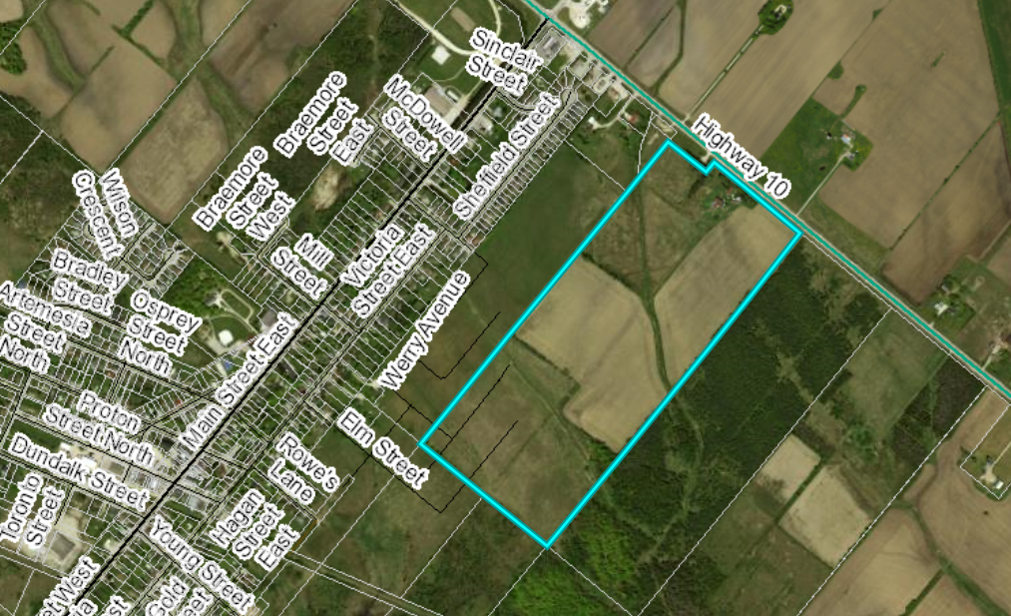

The revisions propose to increase the width of a walkway portion of a park block (Block 356) and to move it south in order to accommodate overland flow drainage from Flato North and to lower the southern end of the trail in elevation. The changes to the walkway portion of the park block results in a slight shift of the lot boundaries for Lots 52 to 56. The total number of draft approved lots would remain the same. (see Figure 2 – Excerpt of Proposed Revision Plan).

The Applicant has submitted a Planning Summary Letter and a Revised Draft Plan. Copies of all background reports and plans can be found at [this link.](https://www.grey.ca/planning-development/planning-applications)

### Figure 2: Excerpt of Proposed Revised Plan

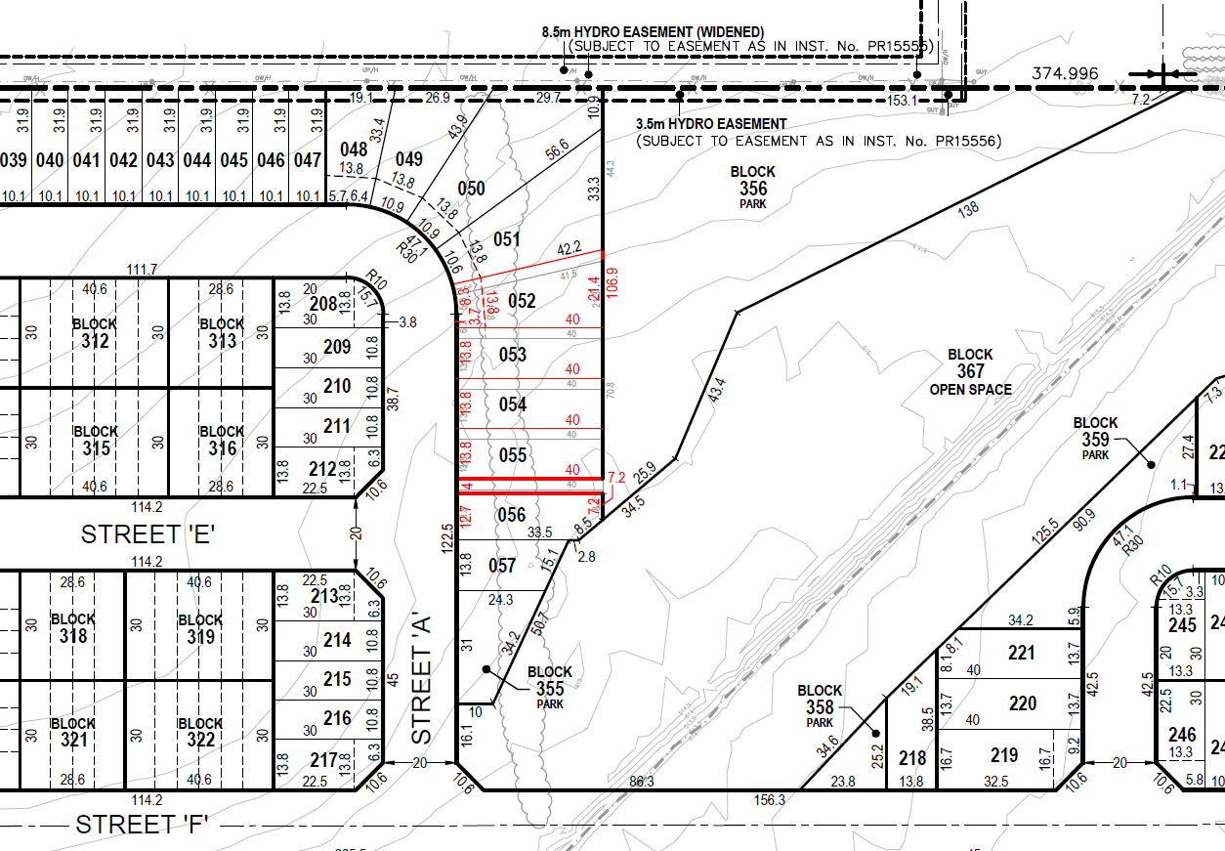

### Public and Agency Comments Received

#### Public Comments

As part of the planning application process, there were no public comments received.

#### Agency Comments

As part of the planning application process comments were received by the following groups, agencies and public bodies.

##### Grand River Conservation Authority (GRCA)

In a letter dated December 2, 2019, the GRCA notes that they have no objections to the proposed revisions.

##### Grey County Transportation Services

In an email dated December 4, 2019, Grey County Transportation Services indicated that they have reviewed the file and have no further comments.

##### Ministry of Municipal Affairs and Housing

In correspondence dated December 4, 2019, Ministry of Municipal Affairs and Housing note that the Ministry of Environment, Conservation and Parks has reviewed this matter and have no comments on the proposed redline revisions.

##### Township of Southgate

In email correspondence dated December 18, 2019, Township staff indicate that they have no concerns with respect to the proposed revisions. The public meeting for the implementing zoning by-law amendment will be held in January.

## Analysis of Planning Issues

When rendering a land use planning decision, planning authorities must have regard to matters of Provincial Interest under the *Planning Act*, be consistent with the Provincial Policy Statement (PPS) 2014, and conform to any official plans or provincial plans that govern the subject lands. In this case, the County of Grey Official Plan and the Township of Southgate Official Plan have jurisdiction over the subject property.

### The Planning Act

Section 1.1 of the *Planning Act* outlines the purposes of the Act. The purposes of the Act promote sustainable economic development, in a healthy natural environment, within a land use planning system led by provincial policy and matters of provincial interest. Section 2 of the *Planning Act* outlines matters of Provincial Interest, which decision makers must be consistent with when carrying out their responsibilities under the Act. The proposed revisions are minor in nature and result in improvements to the overall design. The subject redline revision application, with the attached revised conditions of draft approval, have regard for matters of Provincial Interest under the *Planning Act* including Section 51(24).

### Provincial Policy Statement (PPS)

A key goal of the PPS is directing new growth to serviced settlement areas, and promoting the vitality of such settlement areas through re-development, infill and intensification. The subject lands have been designated for residential growth and are within a settlement area.

Section 1.6.6.1 of the PPS outlines the servicing hierarchy to be utilized in the Province of Ontario. At the top of the hierarchy are municipal water and sewer services. The proposed development will be serviced by municipal water and sewer services.

It can be concluded that the proposed redline revisions, with the attached revised conditions of draft approval, are consistent with the PPS.

### County Official Plan

The proposed plan of subdivision is designated as ‘Primary Settlement Area’ within the County Official Plan. These lands are fully serviced by municipal water and sewer services and therefore conform to section 5.3 of the County Plan. Subject to the revised conditions of draft approval attached to this report, the application conforms to the goals and objectives of the County of Grey Official Plan.

## Legal and Legislated Requirements

The application has been processed in accordance with the *Planning Act*.

## Financial and Resource Implications

There are no anticipated financial, staffing or legal considerations associated with the proposed redline revisions, beyond those normally encountered in processing the application. The County has collected the requisite fee for this application.

## Relevant Consultation

Internal: Planning Staff, Transportation Services

External: Township of Southgate, agencies under the Planning Act.

### Appendices and Attachments

*Revised Conditions of Draft Approval (attached)*

# **NOTICE OF DECISION**

**On Application for Revision to Approval of Draft Plan of Subdivision**

**under Subsection 51(45) of the Planning Act**

Draft Plan Approval was originally given by the County to Plan of Subdivision 42T-2015-05 on November 10, 2016 and later revised on February 23, 2017 and June 13, 2019. Revised Draft Plan Approval is hereby given by the County of Grey for the application regarding the above noted lands. A copy of the Decision is attached.

**PUBLIC AND AGENCY COMMENTS RECEIVED ON THE FILE**

All written and oral submissions received on the application were considered; the effect of which helped to make an informed recommendation and decision.

**WHEN AND HOW TO FILE A NOTICE OF APPEAL**

Notice to appeal the decision to the Local Planning Appeals Tribunal must be filed with the County of Grey no later than 20 days from the date of this notice, as shown above.

The notice of appeal should be sent to the attention of the Director of Planning and Development of the County, at the address shown below and it must,

(1) set out the reasons for the appeal,

(2) be accompanied by the fee prescribed under the Local Planning Appeals Tribunal Act, and

(3) Include the completed appeal form from the LPAT’s website.

**WHO CAN FILE A NOTICE OF APPEAL**

Only individuals, corporations or public bodies may appeal decisions in respect of a proposed plan of subdivision to the Local Planning Appeal Tribunal. A notice of appeal may not be filed by an unincorporated association or group. However, a notice of appeal may be filed in the name of an individual who is a member of the association or group on its behalf.

No person**\*** or public body shall be added as a party to the hearing of the appeal of the decision of the approval authority, including the lapsing provisions of the conditions, unless the person or public body, before the decision of the approval authority, made oral submissions at a public meeting or written submissions to the council, or made a written request to be notified of changes to the conditions or, in the Local Planning Appeal Tribunal’s opinion, there are reasonable grounds to add the person or public body as a party.

**\***Notwithstanding the above, only a ‘person’ listed in subsection 51(48.3) of the Planning Act may appeal the decision of the County of Grey to the Local Planning Appeal Tribunal (LPAT) as it relates to the proposed plan of subdivision. Below is the prescribed list of ‘persons’ eligible to appeal a decision of the County of Grey related to the proposed plan of subdivision as per subsection 51(48.3) of the Planning Act.  These are recent changes that have been made to the Planning Act by the province. A link to the revised Planning Act can be found here - <https://www.ontario.ca/laws/statute/90p13>. For more information about these recent changes, please visit the LPAT website or contact LPAT - <https://elto.gov.on.ca/tribunals/lpat/about-lpat/>.

The prescribed list of ‘persons’ eligible to appeal a decision of the County on the proposed plan of subdivision as per subsection 51(48.3) of the Planning Act is as follows:

1. A corporation operating an electric utility in the local municipality or planning area to which the plan of subdivision would apply.
2. Ontario Power Generation Inc.
3. Hydro One Inc.
4. A company operating a natural gas utility in the local municipality or planning area to which the plan of subdivision would apply.
5. A company operating an oil or natural gas pipeline in the local municipality or planning area to which the plan of subdivision would apply.
6. A person required to prepare a risk and safety management plan in respect of an operation under Ontario Regulation 211/01 (Propane Storage and Handling) made under the Technical Standards and Safety Act, 2000, if any part of the distance established as the hazard distance applicable to the operation and referenced in the risk and safety management plan is within the area to which the plan of subdivision would apply.
7. A company operating a railway line any part of which is located within 300 metres of any part of the area to which the plan of subdivision would apply.
8. A company operating as a telecommunication infrastructure provider in the area to which the plan of subdivision would apply.

**RIGHT OF APPLICANT OR PUBLIC BODY TO APPEAL CONDITIONS**

The following may, at any time before the approval of the final plan of subdivision, appeal any of the conditions imposed by the approval authority to the Tribunal by filing a notice of appeal with the approval authority: the applicant; any public body that, before the approval authority made its decision, made oral submissions at a public meeting or written submissions to the approval authority; the Minister; or the municipality in which the subject land is located.

**HOW TO RECEIVE NOTICE OF CHANGED CONDITIONS**

The conditions of an approval of draft plan of subdivision may be changed at any time before the final approval is given.

You will be entitled to receive notice of any changes to the conditions of the approval of draft plan of subdivision if you have made a written request to be notified of changes to the conditions.

**GETTING ADDITIONAL INFORMATION**

Additional information about the application is available for public inspection during regular office hours in the Planning & Development Office at the address noted below or by calling 519-376-2205 or 1-800-567-GREY.

**ADDRESS FOR NOTICE OF APPEAL**

**County of Grey**

**595-9th Avenue East**

**OWEN SOUND, Ontario N4K 3E3**

**Attention: Mr. Randy Scherzer, MCIP RPP**

**Director of Planning & Development**

Plan of Subdivision File No. 42T-2015-05 has been revised and granted draft approval. The draft plan is hereby revised. The County’s conditions of final plan approval for this draft Plan of Subdivision are amended as follows:

No. Conditions

1. Condition 1 of the draft plan conditions approved on November 10, 2016 and revised on February 23, 2017 and June 13, 2019 is hereby deleted and replaced with the following:

**That this approval applies to the draft Plan of Subdivision as prepared by MHBC Planning dated December 11, 2015 and revised November 1, 2019, showing a total of 500 residential lots, 310 lots for detached dwellings (Lots 1 to 47, 166 to 217, and 233 to 310) and 190 residential lots for townhouse dwellings within Blocks 311 to 349, eleven park blocks (Blocks 350 to 360), three stormwater pond blocks (Blocks 361 to 363), four open space blocks (Blocks 364 to 367), three future right of way blocks (Blocks 368 to 370), one road widening block (Block 371), 0.3 metre reserve(s) (Block 372), and an overland flow/walkway block (Block 373) and Streets ‘A’ to ‘J’.**

1. That all other conditions of draft approval as granted on November 10, 2016 and revised on February 23, 2017 remain in effect.