Grey County Logo Committee Report

# Report PDR-CW-02-17

**To**: Warden Barfoot and Members of Grey County Council

**From**: Randy Scherzer, Director of Planning

**Meeting Date:** January 12, 2017

**Subject: Draft Approval Extension – Delphi Court, Town of The Blue Mountains (42-CDM-2013-01)**

**Status**: Recommendation adopted by Committee of the Whole as presented per Resolution CW01-17; Recommendation adopted by Council as presented January 26, 2017 per Resolution CC05-17;

## Recommendation

1. **That Report PDR-CW-02-17 be received and that an extension of draft approval for Plan of Condominium File 42-CDM-2013-01 be granted to October 15, 2019 as per Section 51(33) of the Planning Act, RSO 1990, as amended.**

## Background

Plan of Condominium Application 42-CDM-2013-01 received draft approval on October 15, 2013. The draft approved condominium includes a total of eleven (11) vacant land condominium units consisting of two single detached units (two existing chalets), two semi-detached units, and seven townhouse units on approximately 0.44 hectares of land. The subject lands are described as Parts 5 and 10, Plan 16R-9532 and Block 4 of Plan 16M-37, geographic Township of Collingwood, Town of The Blue Mountains. The lands are situated north of Highway 26 and are directly across the highway from the Georgian Peaks Ski Club (see Map 1 below).

The County has received a request from the Owner requesting a three (3) year draft approval extension.

A letter has been received from the Town of The Blue Mountains indicating that they support the three year extension request.

The standard period of time for extensions of draft approval is one year. The granting of one year extensions has been delegated to the Director of Planning. Extension requests beyond one year are required to be approved by the Planning and Community Development Committee. County staff typically recommends that extensions to draft approval only be for a one year period to ensure that the proponent is continuing to move forward with fulfilling the conditions and to allow local municipalities to have the option of not extending draft approval if the municipality is experiencing servicing capacity issues.

Based on the Town of The Blue Mountains supporting the extension request, County staff recommends that a three (3) year draft approval extension be granted.

### Map 1 – Air Photo of the Subject Property

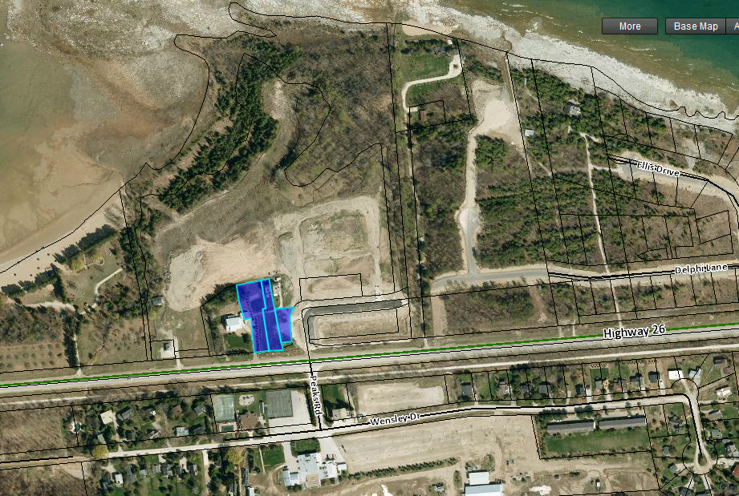

## Financial/Staffing/Legal/Information Technology Considerations

At this point there are no financial, staffing, legal or Information Technology considerations. The County has collected a fee for the extension of draft approval.

## Link to Strategic Goals/Priorities

Action 2.10, under Goal 2 of the County’s Strategic Plan requires the continued management of growth and the application of sound land use planning principles. Permitting an extension to draft approval for a previously draft approved subdivision would be considered sound land use planning, given the specific circumstances.

Respectfully submitted by,

Randy Scherzer  
Director of Planning