Grey County Logo Committee Report

| **To**: | Warden Halliday and Members of Grey County Council |
| --- | --- |
| **Committee Date:** | November 8, 2018 |
| **Subject / Report No:** | PDR-CW-38-18 Information Report |
| **Title:** | Kilsyth Plan of Subdivision (Barry’s Construction) 42T-2018-11 |
| **Prepared by:** | Scott Taylor |
| **Reviewed by:** | Randy Scherzer |
| **Lower Tier(s) Affected:** | Township of Georgian Bluffs |
| **Status:** | Recommendation adopted by the Committee as presented as per Resolution CW268-18; Endorsed by County Council on November 22, 2018 as per Resolution CC110-18. |

## Recommendation

1. **That Report PDR-CW-38-18 regarding an overview of proposed plan of subdivision application 42T-2018-11, consisting of thirty-three (33) residential parcels on lands described as Part of Lot 9, Concession 7 and Part Lots 71, 75, 78, 85, 86, 87, Unnamed Street and Lots 72, 73, 74, Plan 117, Township of Georgian Bluffs, g**eographic Township of Derby**, be received for information.**

## Executive Summary

The County has received a plan of subdivision application known as the Kilsyth Subdivision (County file number 42T-2018-11), to create 33 new single detached residential lots in the Township of Georgian Bluffs. Access to the lots would be off a new road, connecting to Grey Road 5 (Main Street) and Concession 7 (Mill Street). Based on the configuration of the subdivision, some lots would also gain access off Grey Road 5. Servicing to the proposed subdivision will be via individual well and septic systems, as municipal services do not exist in Kilsyth. Various technical reports have been submitted with the proposed subdivision application, as well as an official plan amendment and a zoning by-law amendment to the Township of Georgian Bluffs. The applications and supporting studies will be circulated to prescribed agencies and the public for review and comment. Following the public process, and agency review process, a thorough analysis and staff recommendation will be provided.

## Background and Discussion

The County has received a plan of subdivision application, known as the Kilsyth Subdivision to create 33 single detached residential lots. A parkland block and two stormwater management facilities are also being proposed through the plan of subdivision.

The subject lands are located in the Secondary Settlement Area of Kilsyth. The proposed subdivision is located on Part of Lot 9, Concession 7 and Part Lots 71, 75, 78, 85, 86, 87, Unnamed Street and Lots 72, 73, 74, Plan 117, Township of Georgian Bluffs, geographic Township of Derby.

The majority of the lots would front onto a new municipal road, which would connect Grey Road 5 (Main Street) to Concession 7 (Mill Street), while some lots would front directly onto Grey Road 5.

The subject lands are approximately 17.09 hectares in size. The subject lands are currently occupied by a barn. A house and shed were recently removed from the subject property. Servicing to the new lots will be via private well and septic systems.

Map 1 below shows the subject lands and surrounding area, while Map 2 shows the proposed plan of subdivision.

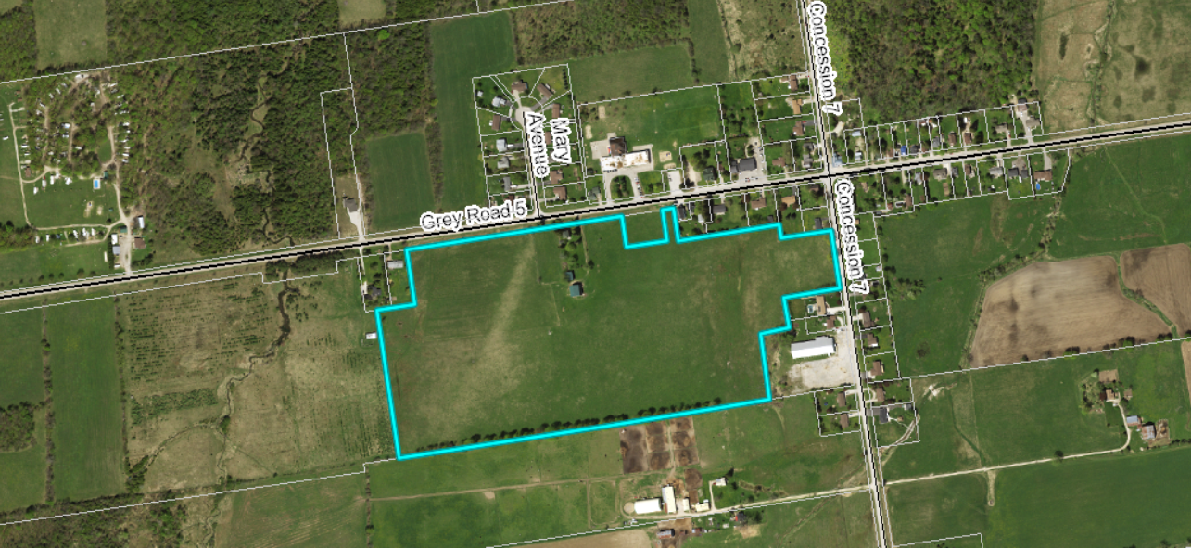

Map 1: Airphoto of Subject Lands

This site is located in the southwest end of Kilsyth in close proximity to; residential development, the former Derby School site, the community centre, a campground, farm lands, and a church.

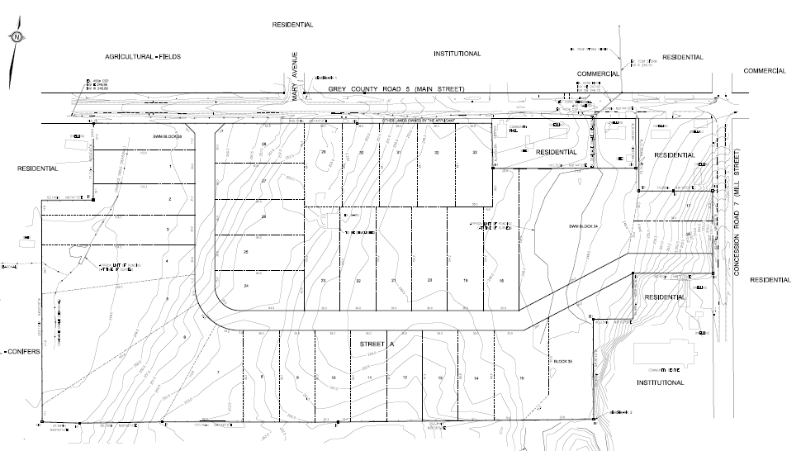

### Map 2: Proposed Plan of Subdivision

(Map 2 Courtesy of GM BluePlan Engineering)

The proposed development also requires amendments to the Township of Georgian Bluffs official plan and zoning by-law.

Pre-submission consultation between the proponent, the Township of Georgian Bluffs, the Grey Sauble Conservation Authority, and the County identified the submission requirements for the proposed plan of subdivision. Copies of all background reports and plans can be found at [this link](https://www.grey.ca/planning-development/planning-applications).

#### Analysis of Planning Issues

When rendering a land use planning decision, planning authorities must have regard to matters of Provincial Interest under the *Planning Act*, be consistent with the Provincial Policy Statement (PPS) 2014, and conform to any Provincial Plans or Municipal Official Plans that govern the subject lands. In this case, the County of Grey Official Plan and the Township of Georgian Bluffs Official Plan have jurisdiction over the subject property. There are no Provincial Plans in place for this section of the County.

#### Provincial Policy and Legislation

Both the *Planning Act* and the PPS speak to the efficient use of land within settlement areas. The proposed plan of subdivision is within an existing settlement area that will be serviced via individual wells and septic systems. While, the PPS indicates that the preferred form of servicing for settlement areas is full municipal services; Kilsyth does not have such services. The PPS does contemplate new development on private servicing within rural areas and smaller settlements such as this.

The supply of an adequate range and distribution of residential housing types is required in both Provincial documents. In this case, the proposed plan of subdivision is providing new single detached lots, which are the common form of housing in Kilsyth.

Other policies in the PPS speak to connected, walkable communities, with provisions for public parkland and open space. The proposed subdivision will provide connections to adjacent roads, however based on the density of development, sidewalks are not being proposed at this time. Parkland has been included in this development in excess of the 5% minimum required by the *Planning Act*.

The protection of significant environmental features is also required through the legislation and policy. Although the County Plan does not map any significant natural features on the site, an Environmental Impact Study was conducted, examining the potential for impacts on threatened species and nearby watercourses.

Following the public and agency review periods, staff will provide a more fulsome analysis of the Provincial legislation and policy.

#### County of Grey Official Plan

The proposed plan of subdivision is on lands designated as ‘Secondary Settlement Area’ in the County Official Plan. Secondary Settlement Areas are identified as locations in which to focus new residential growth in the County, at appropriate densities for the level of servicing available.

The County Plan also requires the protection of cultural and archaeological resources. A Stage 1 – 2 Archaeological Assessment was conducted for this development.

Section 5.3 of the County Plan provides a similar servicing hierarchy to that found in the PPS, which has been noted above. Elsewhere in section 5 of the Plan, are policies which govern roads, transportation, and stormwater management. County Official Plan policies will be further assessed following agency review and the public process.

#### Township of Georgian Bluffs Official Plan

The subject lands are designated as ‘Future Development’, ‘Residential’, and ‘Environmental Hazard’ in the Township Official Plan. Similar to the County Official Plan, this property is also within the settlement area boundaries in the Township Plan. An official plan amendment has been submitted to re-designate the Future Development portion of these lands to the Residential designation.

Other Official Plan policies in the Township Plan mimic those in the County Plan and the PPS. A more thorough analysis of the Township Official Plan policies will follow the agency review and the public process.

## Legal and Legislated Requirements

The application will be processed in accordance with the *Planning Act.*

## Financial and Resource Implications

There are no anticipated financial, staffing or legal considerations associated with the proposed subdivision, beyond those normally encountered in processing a subdivision application. The County has collected the requisite fee and peer review deposit for this application.

## Relevant Consultation

Internal: Planning and Transportation Services

External: The public, Township of Georgian Bluffs, and required agencies under the *Planning Act*.

### Appendices and Attachments

None