Grey County Logo Committee Report

| **To**: | Warden Hicks and Members of Grey County Council |
| --- | --- |
| **Committee Date:** | June 13, 2019 |
| **Subject / Report No:** | Addendum to PDR-CW-18-19 |
| **Title:** | Cobble Beach – Redline Revisions – 42T-2004-02 |
| **Prepared by:** | Randy Scherzer |
| **Reviewed by:** | Kim Wingrove |
| **Lower Tier(s) Affected:** | Township of Georgian Bluffs |
| **Status:** | Recommendation adopted by Committee of the Whole as presented as per Resolution *CW133-19*; Endorsed by Council on June 27, 2019 as per Resolution *CC47-19*. |

## Recommendation

1. **That all written and oral submissions received on the proposed redline revisions to plan of subdivision 42T-2004-02 were considered which helped to make an informed recommendation and decision; and**
2. **That the Addendum to PDR-CW-18-19 be received, and that in consideration of the draft plan of subdivision 42T-2004-02, and the matters to have regard for under Subsection 51(24) of the Planning Act, the County of Grey Committee of the Whole hereby approves the revised plan of subdivision on lands described as Part of Lot 29 to 31, Concession 3, Part 24 of RP 16R9233, (geographic Township of Sarawak) in the Township of Georgian Bluffs.**

## Executive Summary

The report considers some proposed revisions to draft plan of subdivision 42T-2004-02 known as Cobble Beach. The current draft plan consists primarily of residential, parkland and open space uses to a maximum of 312 residential units (excluding the mixed use and multiple residential blocks). The revisions propose to change the road network by eliminating a cul-de-sac and connecting two roads, and to identify individual lots within Blocks 50 to 56. All written and verbal comments regarding the proposed revisions have been considered and it is recommended that Committee approve the revisions to the draft plan.

## Background and Discussion

The County has received a request for redline revision to the Cobble Beach draft plan of subdivision (County file number 42T-2004-02). Plan of Subdivision File No. 42T-2004-02 was granted draft approval on October 13, 2005 and later revised on October 12, 2006. Plan of Subdivision File No. 42T-2006-12 lapsed on March 15, 2015. Draft Plan of Subdivision 42T-2004-02 was revised in February 2016 by adding the previously draft approved lots/blocks from 42T-2006-12 along with some other minor revisions. The combined draft plans consist primarily of residential, parkland and open space uses to a maximum of 312 residential units (excluding the mixed use and multiple residential blocks). The subject lands are located east of Grey Road 1 and north of Cobble Beach Drive.

The Applicant is requesting revisions to Blocks 50 to 56 in the current draft approval plan. The following are the proposed revisions:

* Street D to be extended northwards and connect to Street G. The cul-de-sac at the end of Street G would be removed;
* Individual residential lots (Lots 50 to 56, 68 to 125) are proposed to replace residential Blocks 50 to 56; and,
* 65 residential lots are proposed with lot frontages ranging from 16.7 metres to 33.8 metres, and lot areas ranging from 668 square metres to 1,251 square metres.

The current draft approved plan provides a range of 54 to 77 residential units within Blocks 50 to 56. The redline revision proposes 65 residential units which is within the current draft approved range. The total count of residential units of the overall development will change from a range of 233 to 312 residential units to 244 to 300 residential units which is within the range that has been draft approved.

Pre-submission consultation between the proponent, the Township and the County identified the submission requirements for the proposed plan of subdivision. The following reports have been submitted with the subdivision application;

1. Planning Justification Report memo,
2. Functional Servicing and Stormwater Management Report, and
3. Revised Draft Plan.

Copies of all background reports and plans can be found at [this link.](https://www.grey.ca/planning-development/planning-applications)

### Figure 1: Subject Lands – Proposed Revisions Cobble Beach

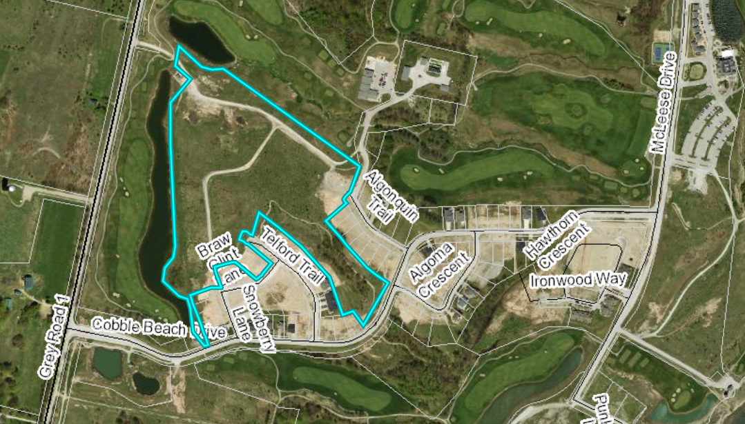

### Figure 2: Proposed Revised Plan

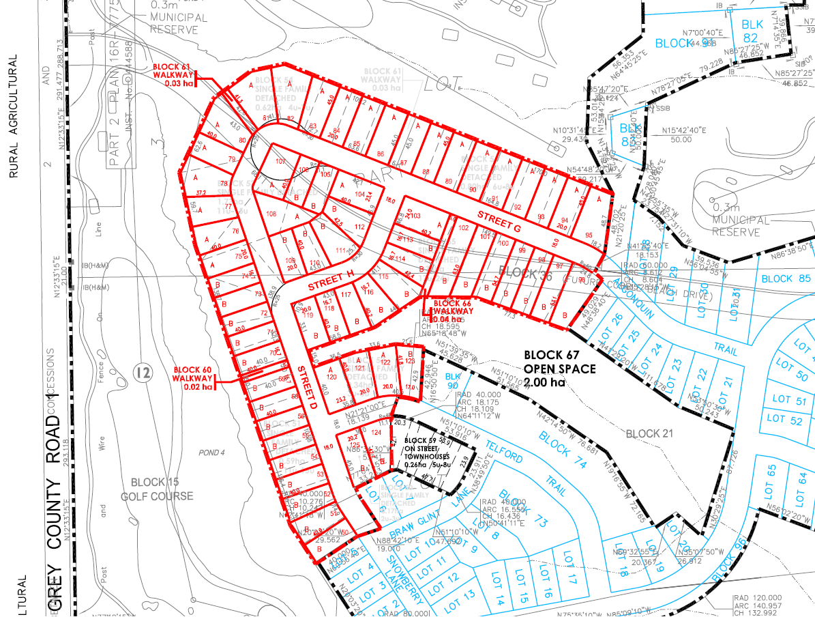

### Public and Agency Comments Received

The Township held a public meeting on April 10, 2019 for the proposed revisions.

#### Public Comments

As part of the planning application process, there were no public comments received.

#### Agency Comments

As part of the planning application process comments were received by the following groups, agencies and public bodies.

##### Grey Sauble Conservation Authority (GSCA)

In a letter dated March 19, 2019, the GSCA notes that they have reviewed the revised stormwater management report and indicate that they have no objections to the subject redline revisions. They note that a permit is required from their office for any development and site alteration within the regulated area.

##### Historic Saugeen Metis (HSM)

In an email dated March 1, 2019, the HSM Lands, Resources and Consultation Department indicated that they have reviewed the relevant documents and have no objection or opposition to the proposed development.

##### Source Water Protection – Risk Management Office

In a letter dated March 4, 2019 the Risk Management Office indicated that the subject lands fall within an Intake Protection Zone 2 where the vulnerability score is 4.8, no threat policies apply at this time for this zone and vulnerability score. Therefore they note that no policies apply to the activities identified in this application under the Source Protection Plan.

##### Grey County Transportation Services

In an email dated March 11, 2019, Grey County Transportation Services indicated that they have no concerns with the change in the plan configuration of the redline revision.

##### Canada Post

In correspondence dated March 4, 2019, Canada Post has reviewed the proposal and has determined that the development will be serviced by centralized mail delivery provided through community mail boxes.

##### Township of Georgian Bluffs

On May 8, 2019, the Council for the Township of Georgian Bluffs passed a motion supporting the proposed redline revisions. Township staff prepared a report and noted that no one spoke in support of or in opposition to the application and no additional comments have been submitted since the public meeting. Township staff concur that the changes are minor and recommended that Township Council support he application as presented.

## Analysis of Planning Issues

When rendering a land use planning decision, planning authorities must have regard to matters of Provincial Interest under the *Planning Act*, be consistent with the Provincial Policy Statement (PPS) 2014, and conform to any official plans or provincial plans that govern the subject lands. In this case, the County of Grey Official Plan (including the Cobble Beach Secondary Plan) and the Township of Georgian Bluffs Official Plan have jurisdiction over the subject property.

### The Planning Act

Section 1.1 of the *Planning Act* outlines the purposes of the Act. The purposes of the Act promote sustainable economic development, in a healthy natural environment, within a land use planning system led by provincial policy and matters of provincial interest. Section 2 of the *Planning Act* outlines matters of Provincial Interest, which decision makers must be consistent with when carrying out their responsibilities under the Act. The proposed revisions are minor in nature and result in improvements to the overall design. The subject redline revision application, with the attached revised conditions of draft approval, have regard for matters of Provincial Interest under the *Planning Act* including Section 51(24).

### Provincial Policy Statement (PPS)

A key goal of the PPS is directing new growth to serviced settlement areas, and promoting the vitality of such settlement areas through re-development, infill and intensification. The subject lands have been designated for residential growth and are within a settlement area.

Section 1.6.6.1 of the PPS outlines the servicing hierarchy to be utilized in the Province of Ontario. At the top of the hierarchy are municipal water and sewer services. The proposed development will be serviced by municipal water and sewer services.

It can be concluded that the proposed redline revision application, with the attached revised conditions of draft approval, is consistent with the PPS.

### County Official Plan

The proposed plan of subdivision is designated as ‘Primary Settlement Area’ within the County Official Plan. A Secondary Plan has previously been approved for Cobble Beach which has been included in the County Official Plan. The Cobble Beach Secondary Plan sets out specific policies for the overall development of Cobble Beach. The subject lands are designated as ‘Residential’ and ‘Open Space’ within the Cobble Beach Secondary Plan which contemplates the development as proposed.

These lands are fully serviced by municipal water and sewer services and therefore conform to section 5.3 of the County Plan.

Section 6.12.1 of the County Plan addresses criteria to be considered in any new plan of subdivision or condominium. Specifically, section 6.12.1(a)(vi) of this section states,

*“The street pattern of the proposed plan and how it fits with the surrounding neighbourhood. Plans which utilize a grid pattern or a modified grid pattern shall be considered more favourably than those with a curvy street pattern or cul-de-sacs,”*

The proposed revisions would change the road network by eliminating a cul-de-sac and connecting two roads which further addresses the policy noted above.

Subject to the revised conditions of draft approval attached to this report, the applications conform to the goals and objectives of the County of Grey Official Plan.

## Legal and Legislated Requirements

The application has been processed in accordance with the *Planning Act*.

## Financial and Resource Implications

There are no anticipated financial, staffing or legal considerations associated with the proposed redline revisions, beyond those normally encountered in processing the application. The County has collected the requisite fee for this application.

## Relevant Consultation

Internal: Planning Staff, Transportation Services

External: Township of Georgian Bluffs, required agencies under the Planning Act, and the public.

### Appendices and Attachments

*Revised Conditions of Draft Approval (attached)*

[*Conditions of Draft Approval approved February 16, 2016*](https://docs.grey.ca/share/public?nodeRef=workspace://SpacesStore/b146b218-4c56-4b08-b4dd-44e823bea291)

# **NOTICE OF DECISION**

**On Application for Revision to Approval of Draft Plan of Subdivision**

**under Subsection 51(45) of the Planning Act**

Draft Plan Approval was originally given by the County to Plan of Subdivision 42T-2004-02 on October 13, 2005 and later revised October 12, 2006 and February 16, 2016. Revised Draft Plan Approval is hereby given by the County of Grey for the application regarding the above noted lands. A copy of the Decision is attached.

**PUBLIC AND AGENCY COMMENTS RECEIVED ON THE FILE**

All written and oral submissions received on the application were considered; the effect of which helped to make an informed recommendation and decision.

**WHEN AND HOW TO FILE A NOTICE OF APPEAL**

Notice to appeal the decision to the Local Planning Appeal Tribunal (LPAT) must be filed with the County of Grey no later than 20 days from the date of this notice, as shown above.

The notice of appeal should be sent to the attention of the Director of Planning and Development of the County, at the address shown below and it must,

(1) set out the reasons for the appeal,

(2) be accompanied by the fee prescribed under the LPAT Act, and

(3) Include the completed appeal form from the LPAT’s website.

**WHO CAN FILE A NOTICE OF APPEAL**

Only individuals, corporations or public bodies may appeal decisions in respect of applications for approval of draft plans of subdivision to the LPAT. A Notice of Appeal may not be filed by an unincorporated association or group. However, a Notice of Appeal may be filed in the name of an individual who is a member of the association or group.

**RIGHT OF APPLICANT OR PUBLIC BODY TO APPEAL CONDITIONS**

The applicant or any public body may, at any time before the final plan of subdivision is approved, appeal any of the conditions imposed by the County of Grey to the LPAT by filing with the Director of Planning and Development of the County, or her delegate, a Notice of Appeal.

**HOW TO RECEIVE NOTICE OF CHANGED CONDITIONS**

The conditions of an approval of draft plan of subdivision may be changed at any time before the final approval is given.

You will be entitled to receive notice of any changes to the conditions of the approval of draft plan of subdivision if you have either,

(1) made a written request to be notified of the decision to give or refuse to give approval of draft plan of subdivision, or

(2) make a written request to be notified of changes to the conditions of approval of the draft plan of subdivision.

**GETTING ADDITIONAL INFORMATION**

Additional information about the application is available for public inspection during regular office hours in the Planning & Development Office at the address noted below or by calling 519-376-2205 or 1-800-567-GREY.

**ADDRESS FOR NOTICE OF APPEAL**

**County of Grey**

**595-9th Avenue East**

**OWEN SOUND, Ontario N4K 3E3**

**Attention: Mr. Randy Scherzer, MCIP RPP**

**Director of Planning & Development**

That the Redline Revision to Plan of Subdivision File No. 42T-2004-02 has been granted draft approval. The previous conditions of draft approval that were approved on October 13, 2005 and later revised on October 12, 2006 and February 16, 2016 are hereby revised as follows.

No. Conditions

1. Condition 1 of the draft plan conditions approved as revised on February 16, 2016 is hereby deleted and replaced with the following:

**That this approval applies to the draft plan originally prepared by Hewett & Milne Limited, as revised by Design Plan Services dated November 16, 2018 showing a total of 96 single detached residential lots, 16 single detached residential blocks/units (total range of 131 units to 176 units), 3 on street townhouse blocks (total range of 17 to 28 townhouse units), 10 open space/public park blocks, 4 heritage site blocks, 3 walkway blocks, 1 public utility block, 4 golf course blocks, 1 mixed use block, 3 multiple family blocks, and various roads on Part Lots of 28 to 34, Concession 3 in the Township of Georgian Bluffs (geographic Township of Sarawak) in the County of Grey.**

1. Condition 2 of the draft plan conditions approved as revised on February 16, 2016 is hereby deleted and replaced with the following:

**This draft plan consists primarily of residential, parkland and open space uses to a maximum of 300 units (excluding the mixed use and multiple family blocks). The type and location of these units will be determined through the zoning by-law amendment process. Prior to final approval, the Township of Georgian Bluffs shall confirm to the County that the subject lands are appropriately zoned to implement the subject plan.**

1. Condition 3 of the draft plan conditions approved as revised on February 16, 2016 is hereby deleted and replaced with the following:

**That the lot layout for Single Detached Residential Blocks 40 to 49 and Blocks 30 to 35 be determined and approved by the Township of Georgian Bluffs in accordance with the following densities while ensuring conformity with the effective zoning by-law provisions of the Township and that confirmation of the acceptance of the lot pattern be provided to the County of Grey prior to final approval being given:**

| **Block Number** | **Minimum/Maximum Lots** | **Block Number** | **Minimum/Maximum Lots** |
| --- | --- | --- | --- |
| 30 | 13 to 17 lots | 42 | 3 to 5 lots |
| 31 | 7 to 9 lots | 43 | 2 to 3 lots |
| 32 | 8 to 10 lots | 44 | 5 to 7 lots |
| 33 | 10 to 14 lots | 45 | 2 to 3 lots |
| 34 | 13 to 17 lots | 46 | 3 to 5 lots |
| 35 | 14 to 18 lots | 47 | 10 to 12 lots |
| 40 | 15 to 17 lots | 48 | 11 to 15 lots |
| 41 | 7 to 10 lots | 49 | 8 to 14 lots |

1. Condition 6 of the draft plan conditions approved as revised on February 16, 2016 is hereby deleted and replaced with the following:

**That Block 4 be deeded to the Township of Georgian Bluffs for parkland purposes as a portion of the overall 5% parkland dedication as required by the Planning Act and that Blocks 2, 3, 5, 7, and Blocks 62 to 65, and 67 be deeded to the Township, if determined acceptable to the Township. If the Blocks are not conveyed to the Township as public open space, they shall be retained by the owner as private open space. The owner shall convey up to 5% of the land included in the plan to the municipality for park or other public recreational purposes. Alternatively, the municipality may accept cash-in-lieu of all or a portion of the remainder of the conveyance.**

1. Condition 7 of the draft plan conditions approved as revised on February 16, 2016 is hereby deleted and replaced with the following:

**That Block 60, 61 and 66 be deeded to the Township of Georgian Bluffs for open space/walkway purposes including utility easements if necessary.**

1. Condition 14 of the draft plan conditions approved as revised on February 16, 2016 is hereby deleted and replaced with the following:

**That prior to the registration of any lot containing a grassland area identified within the Scoped Site Environmental Impact Study prepared by SAAR Environmental dated August 1, 2006 within Lots 50 to 56 and Lots 68 to 80, an Ecological Planting Plan shall be completed by a qualified consultant for the grassland areas satisfactory to the Grey Sauble Conservation Authority and the Township of Georgian Bluffs. The findings and conditions of the Ecological Planting Plan shall be included within the Subdivision Agreement which shall also require that restrictive covenants be placed on the title of individual lots to ensure the grassland area is maintained.**

1. That all other conditions as draft approved on February 16, 2016 remain in effect.