Grey County Logo Committee Report

| **To**: | Warden Halliday and Members of Grey County Council |
| --- | --- |
| **Committee Date:** | May 10, 2018 |
| **Subject / Report No:** | Minor Exemption / PDR-CW-17-18 |
| **Title:** | Marvara Farms Limited Minor Exemption Application |
| **Prepared by:** | Scott Taylor |
| **Reviewed by:** | Randy Scherzer |
| **Lower Tier(s) Affected:** | Municipality of Grey Highlands |
| **Status:** | Recommendation adopted by the Committee of the Whole as presented per Resolution CW127-18; Endorsed by County Council on May 24, 2018. |

## Recommendation

1. **That Report PDR-CW-17-18 be received and that the application for a Minor Exemption under the County’s Forest Management By-law for Lots 38 – 40, Concession 2 South of the Durham Road (SDR) and Lots 41 – 45, Concession 3, SDR, in the geographic Township of Artemesia, Municipality of Grey Highlands, be approved.**

## Executive Summary

The County originally received a minor exemption application to the County’s Forestry Management By-law in August 2016 to clear two pockets of forested land consisting of 12 acres of pine plantation and 27 acres of natural mature secondary growth forest. Following the completion of an Environmental Impact Study (EIS) the request for clearing was scoped to 2.5 acres of pine plantation and 0.7 acres of natural mature secondary growth forest. The purpose of the clearing is to install two laneways to connect farm fields to improve the efficiency of the farm operation. County staff are recommending approval of the revised minor exemption application.

## Background and Discussion

An application for a minor exemption was received for clear cutting under the County’s Forestry Management By-law.

The subject lands are located at Lots 38 – 40, Concession 2 South of the Durham Road (SDR) and Lots 41 – 45, Concession 3, SDR, in the geographic Township of Artemesia, Municipality of Grey Highlands. The lands have frontage on three roads, South Line A, Boar Farm Road, and the Artemesia-Southgate Townline. In total, the farm holdings at this location are approximately 760 acres in size. The cleared portions of this property are actively farmed.

Proton Station is located approximately 1.7 kilometres to the southeast of the subject property. Surrounding the subject lands are a mixture of farmed and forested lands.

In the County Official Plan this property is designated as ‘Rural’, ‘Hazard Lands’, ‘Wetlands’, and ‘Agricultural’. Appendix B to the Plan also identifies pockets of ‘Significant Woodlands’, ‘Other Identified Wetlands’, and a watercourse on the property.

In the initial application, the applicant sought to clear 12 acres of pine plantation and 27 acres of natural mature secondary growth forest (see Map 1 below). The purpose of the application was to connect cleared farm areas on-site, in order to improve the efficiency of the farm operation. Following the circulation of this initial application, as well as comments from the Saugeen Valley Conservation Authority (SVCA), the Municipality of Grey Highlands, and the County’s By-law Enforcement Officer, the applicant completed an EIS. Following the recommendations of the EIS, the applicant revised their application to install two laneways by clearing only 2.5 acres of pine plantation, and 0.7 acres of natural mature secondary growth forest (see Map 2 below). The revised proposal has the effect of connecting the farmed portions of the property, but will remove far less trees than originally proposed.

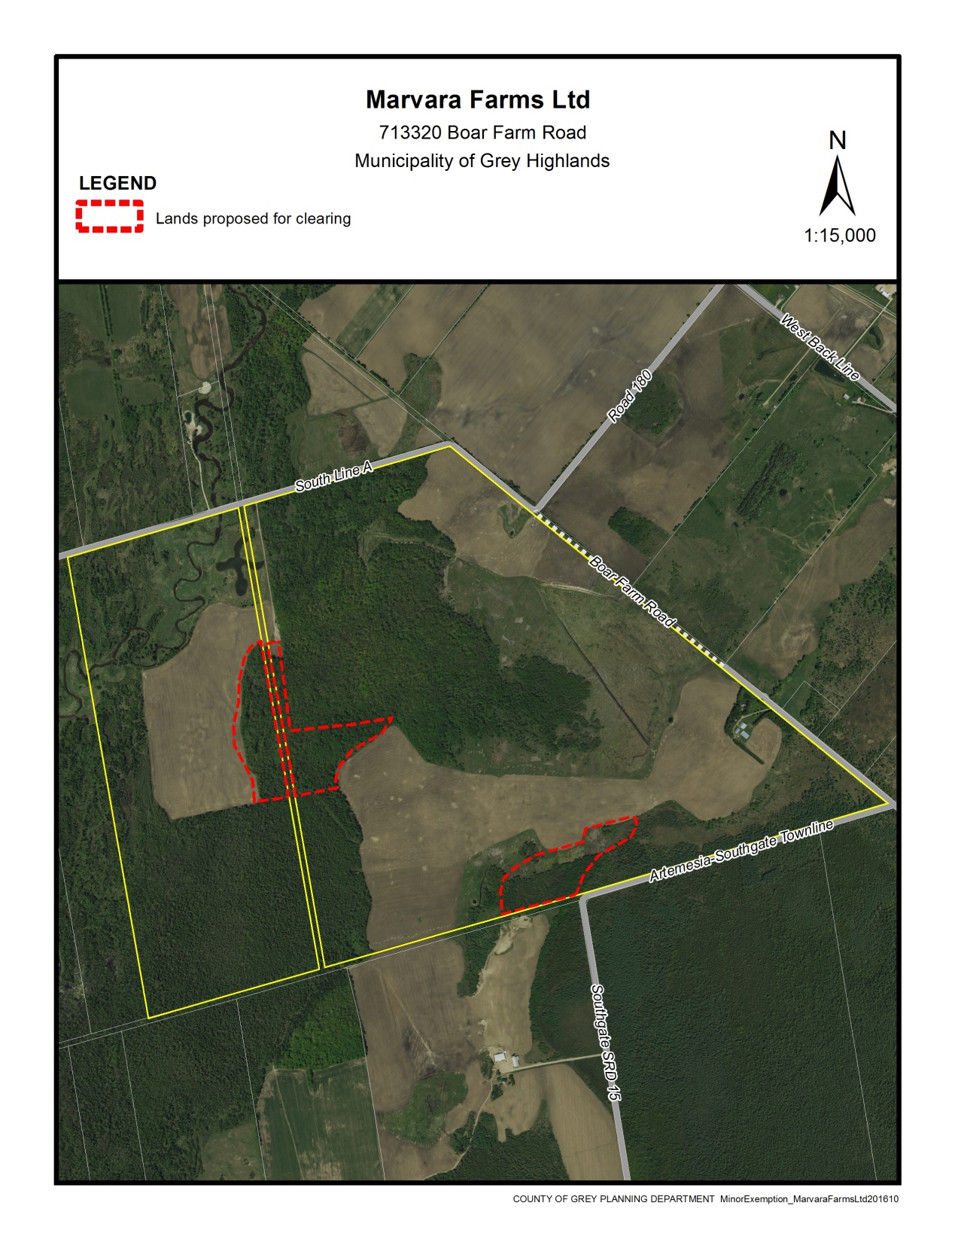

### Map 1 – Original Forest Clearing Request

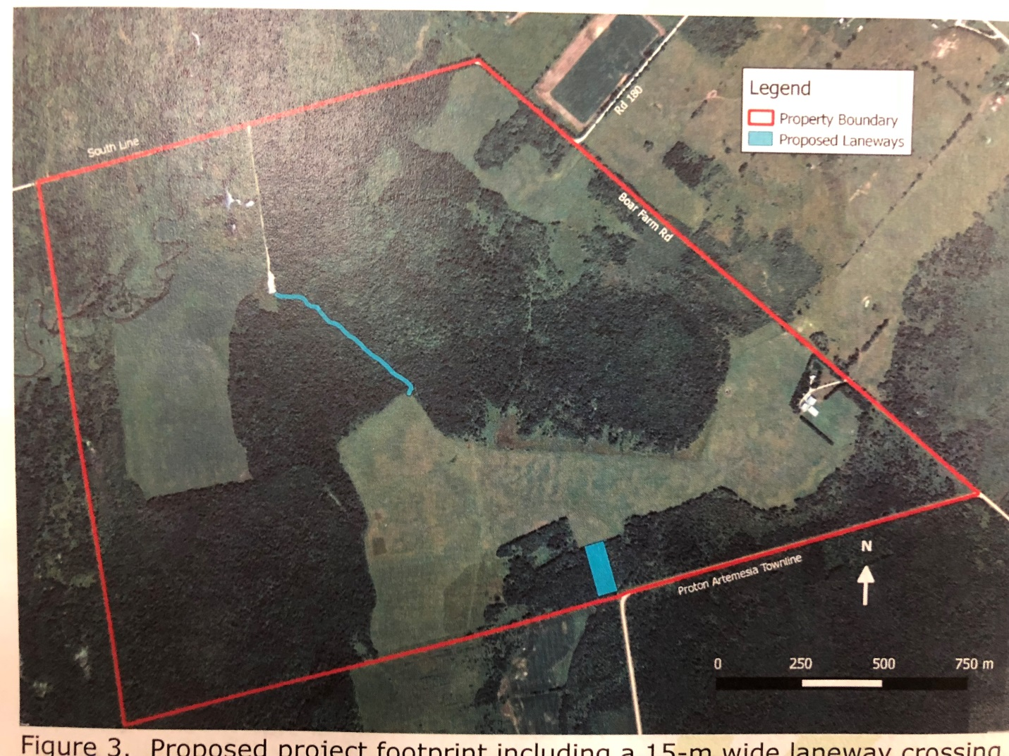

#### Map 2 – Proposed Revised Clearing (Map Courtesy Blazing Star Environmental)

### Agency and Public Comments Received

Under the Forest Management By-law, adjacent landowners, conservation authorities, Municipal, and County staff are to be notified and/or consulted when an application is received.

### Public Comments

No public comments were received during the processing of this application.

### Agency Comments

The SVCA, the Municipality of Grey Highlands, and the County’s Forestry By-law Enforcement Officer provided comments on this application. Most of the comments received were with regard to the original proposal to clear approximately 39 acres of land. Initial comments from SVCA and the County’s Forestry By-law Enforcement Officer raised concerns with the application, and recommended the completion of an EIS. Grey Highlands provided initial comments with respect to ownership of a road allowance separating pockets of the northerly area to be cleared.

Following the completion of the EIS, SVCA staff have issued comments dated April 19, 2018 noting that they now support the proposed minor exemption application. SVCA staff have noted that portions of the property are within their Regulated Area, and that permits will be required for the proposed laneways. The County’s Forestry By-law Enforcement Officer has now also indicated support for this revised proposal. This proposal is no longer looking to acquire or clear any lands abutting the unopened road allowance. The Municipality of Grey Highlands had requested that all SVCA and County environmental criteria be addressed, and through the EIS and revised proposal these criteria have been addressed.

The EIS has addressed the requirements of the County Official Plan and the Provincial Policy Statement (PPS) that County staff would normally see during a development application under the *Planning Act.*

County staff are recommending approval of the revised minor exemption application.

## Legal and Legislated Requirements

The application will be processed in accordance with the County’s Forest Management By-law*.*

## Financial and Resource Implications

At this time there are no expected financial or resource considerations beyond those normally encountered in processing a Minor Exemption application. The County has received an application fee with the file.

## Relevant Consultation

Internal: Planning and Grey County By-law Enforcement Officer

External: Municipality of Grey Highlands, Saugeen Valley Conservation Authority, and the public.

### Appendices and Attachments

*None*