Grey County Logo Committee Report

| **To**: | Warden Hicks and Members of Grey County Council |
| --- | --- |
| **Committee Date:** | May 9, 2019 |
| **Subject / Report No:** | Addendum to PDR-CW-33-18 Final Report |
| **Title:** | Saugeen Cedar Heights East of Plan of Subdivision 42T-2018-09 |
| **Prepared by:** | Scott Taylor |
| **Reviewed by:** | Randy Scherzer |
| **Lower Tier(s) Affected:** | Town of Hanover |
| **Status:** | Recommendation adopted as presented by Committee of the Whole as per Resolution *CW108-19*; Endorsed by County Council as per Resolution *CC41-19*. |

## Recommendation

1. **That Addendum to Report PDR-CW-33-18 be received; and**
2. **That all written and oral submissions received on plan of subdivision 42T-2018-09 known as Saugeen Cedar Heights East were considered, the effect of which helped to make an informed recommendation and decision; and**
3. **That in consideration of the draft plan of subdivision application 42T-2018-07, for lands described as Part of Lots 11, 12, 13, and 14, Concession 1 NDR, Town of Hanover, g**eographic Township of Bentinck**, the Grey County Committee of the Whole approves this plan of subdivision to create seventy-nine (79) residential units, a block for a further twenty (20) residential units, in addition to blocks for open space and utilities, and roads, subject to the conditions set out in the Notice of Decision.**

## Executive Summary

The County has received a plan of subdivision application known as Saugeen Cedar Heights East (County file number 42T-2018-09) to create 79 new residential units in the Town of Hanover, in addition to a block for a further 20 residential units. The units will be a mix of single detached, semi-detached, and townhouse units. Access to the lots would be via a series of new roads, connecting to 25th Avenue and 14th Street. Servicing to the proposed subdivision will be via municipal water and sewer services. The Town of Hanover has already passed the associated zoning by-law amendment for this development. Based on agency review and comments received regarding the proposed plan of subdivision, it is recommended that the proposed plan of subdivision be given draft approval subject to the conditions set out in the attached Notice of Decision.

## Background and Discussion

The County has received a plan of subdivision application, known as Saugeen Cedar Heights East to create 99 residential units. The proposed types of housing include;

* 49 detached dwelling lots,
* 18 lots for semi-detached dwellings,
* 12 lots for townhouses, and
* an additional block for 20 additional townhouses (Block 80).

The lots would front onto 25th Avenue, which is being extended from Bren Lea Estates in the north, and 14th Street, which is being extended from the west. A future road would also extend from the southeasterly limit of this subdivision, on the abutting lands, to 10th Street (Grey Road 4) to meet the signalized intersection at the Walmart and Crabby Joes plaza.

The proposed subdivision has been changed from the original submission, in response to public comments, in order to;

1. include a further road connection to the north (Street ‘C’), and
2. include an additional residential unit (which resulted from the re-design to accommodate Street ‘C’).

The additional road connection will facilitate the development of an otherwise land-locked parcel, which can now be developed in connection with Block 88 from this draft plan.

The proposed subdivision is located on Part of Lots 11, 12, 13, and 14, Concession 1 NDR, Town of Hanover,geographic Township of Bentinck. The subject lands are approximately 17.86 hectares in size. The subject lands are currently vacant, with some treed areas, and some farmed portions of the site. The proposal is to service the new lots with municipal water and sewer.

This site is in the northeast end of Hanover abutting; the river, residential development (constructed and in process), vacant lands, and some commercial developments.

The associated zoning by-law amendment application has already been approved by the Town of Hanover.

Pre-submission consultation between the proponent, the Town of Hanover, the Saugeen Valley Conservation Authority, and the County identified the submission requirements for the proposed plan of subdivision. Copies of all background reports and plans can be found at [this link](https://www.grey.ca/planning-development/planning-applications).

Map 1 below shows the subject lands and surrounding area, while Map 2 shows the proposed plan of subdivision.

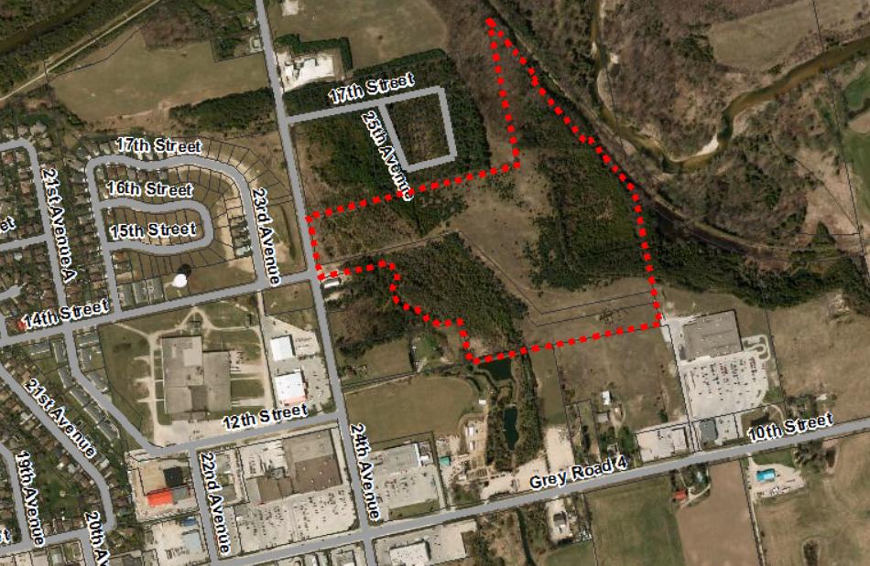

Map 1: Airphoto of Subject Lands

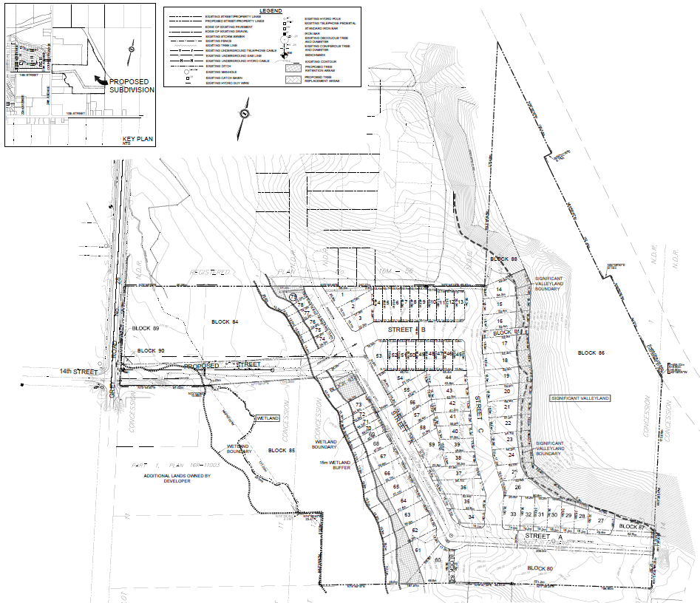

### Map 2: Proposed Draft Plan of Subdivision

(Map 2 Courtesy of Cobide Engineering)

### Public and Agency Comments Received

There was one member of the public that made oral submissions at the public meeting, which was held on November 5, 2018 in the Town of Hanover. The minutes from the public meeting can be found at [this link](https://docs.grey.ca/share/public?nodeRef=workspace://SpacesStore/30295975-7c91-4d04-b63c-85bd74e80703).

Jack Schenk was the only member of the public to make oral or written comments. His comments were summarized in the public meeting minutes as follows:

“Jack Schenk, owner of property located north and abutting the proposed development, stated that there is approximately 1.5 to 2.0 acres of developable lands that if not included within this Draft Plan and Zoning By-law Amendment would be land locked from future development. His concern is that the adjoining lands have not been taken into consideration for the newly created Bren Lea Plan nor this proposed Cedar Heights East Plan. He would be willing to discuss a future revision on this plan rather than hold up the approvals on tonight’s agenda.”

Agency comments were as follows:

* **Enbridge Gas Distribution:** In comments dated October 24, 2018, Enbridge Gas Distribution noted that they do not object to the proposed application(s) and do not currently have gas piping within the immediate area.
* **Historic Saugeen Metis (HSM):** In comments dated October 15, 2018, HSM noted that they have no opposition to the proposed development.
* **Canada Post:** In comments dated October 9, 2018, Canada Post provided a series of recommended conditions of draft approval.
* **Hydro One:** In comments dated October 9, 2018, Hydro One noted they have no comments or concerns at this time.
* **Saugeen Valley Conservation Authority (SVCA):** In comments dated October 31, 2018, SVCA staff noted that the proposed plan of subdivision and proposed Zoning By-law Amendment are generally acceptable, subject to clarifying some technical matters, and a series of conditions of draft plan approval included in their letter.
* **Grey County Transportation Services Department:** In a series of comments from October and November 2018, Transportation Services clarified some technical matters and requested a 10 foot or 3.048 metre widening along Grey Road 28 and 32.8 foot or 10 metre daylight at the northeast corner of Grey Road 28 and 14th Street.
* **Town of Hanover:** Town staff provided recommended conditions of draft plan approval on April 12th and 16th 2019. As noted above, the Town has passed the associated zoning by-law amendment to implement this plan of subdivision.

#### Analysis of Planning Issues

Planning authorities must have regard to matters of Provincial interest under the *Planning Act* and be consistent with the Provincial Policy Statement (PPS) when rendering decisions on planning applications. Within Grey County they must also make decisions that conform to the County of Grey Official Plan, and in this case, which also conform to the Town of Hanover Official Plan.

### The Planning Act

Section 1.1 of the *Planning Act* outlines the purposes of the Act. The purposes of the Act promote; sustainable economic development, in a healthy natural environment, within a land use planning system, led by provincial policy and matters of provincial interest. Section 2 of the *Planning Act* outlines matters of provincial interest, which decision makers must consider when carrying out their responsibilities under the Act. The most relevant matters of provincial interest (in italics) to this application are as follows, including staff comments for each subsection below.

*(b) the protection of ecological systems, including natural areas, features and functions,*

1. An Environmental Impact Study (EIS) was completed for this development, which recommended mitigation measures to ensure that the development would not negatively impact the natural environment in this area. Significant Woodlands, Significant Valleylands, fish habitat, and wetlands were all identified on or in close proximity to this site. Recommendations from the EIS include the need for setbacks to the wetlands and the valleylands, a tree retention plan, and for additional tree planting to be done off-site to offset some of the impacts on-site. Wording has been included in the recommended conditions of draft plan approval to enable these mitigation measures.

The off-site tree planting is required to “provide minimum 2:1 area coverage for new native tree and shrub planting” and is proposed to occur as part of the rehabilitation of a nearby gravel pit. The condition for tree planting will be added as a requirement of the aggregate license. As part of the registration of this plan of subdivision the developer will deed two lots to the Town of Hanover, who will hold the lots in trust until the tree planting and monitoring of the trees has successfully been completed.

Through the recommended conditions of draft approval SCVA, Town, and County staff are satisfied that the development offers due protection to ecological systems and natural features.

*(f) the adequate provision and efficient use of communication, transportation, sewage and water services and waste management systems,*

(f) The subject development will be serviced by municipal water and municipal sewer services, which will be allocated through this development, except for Block 80. Block 80 will require site plan control and water and sewer capacity will be allocated at that time.

The stormwater will be managed on-site through enhanced quality controls, before directing most of the water to the east to the Saugeen River. SVCA and Town sign-off will be required on the final stormwater management plan before the subdivision is registered.

The road pattern of the subdivision proposes a series of new internal roads which provide access to 25th Avenue, 24th Avenue (Grey Road 28), 14th Street, and in the long-term down to 10th Street (Grey Road 4). The 10th Street access will connect to the signalized Walmart / Crabby Joe’s intersection, beyond the limits of this plan of subdivision. When this further connection is made to 10th Street, an additional traffic study will be required. As note earlier in the report the proposed subdivision will also allow for a future road connection to the north through Street ‘C’, to allow for the development of a previously land-locked parcel.

The County Transportation Services department has requested road widening and a daylight triangle along Grey Road 28 (24th Avenue), which will be incorporated into the subdivision.

Sidewalks will also be required throughout the development. Through this development, there is also proposed to be connections and enhancements to the local trail network owned by the Town.

The proposed subdivision provides for efficient servicing, stormwater management, and transportation systems.

*(h) the orderly development of safe and healthy communities,*

(h)The subject development is within the ‘Primary Settlement Area’ designation in the County Official Plan. Within this land use designation, the County Plan defers to the detailed land use policies found within the Town’s Official Plan. The County Plan recommends an average development density of 25 units per net hectare (or greater) for new residential development in Hanover. The proposed plan of subdivision does not meet this target residential density based on the natural features and topography on-site. In addition, the location of the existing servicing and road allowance on-site has also created hardships in achieving this target density. Efforts have been made to meet the density target through providing 18 semi-detached units and 32 townhouse units. However, based on the wet areas, treed areas, valleylands, and the existing infrastructure on-site, a 25 unit per net hectare density was not achieved.

*(j) the adequate provision of housing, including affordable housing,*

(j) It is not known if any of the housing being proposed will fall within the affordable range for ownership. The developer’s planner has noted that; *“over 50% of the units will be in the form of semi-detached and townhouse dwellings. These housing styles provide a more affordable housing option for the lower and moderate income households.”* Although the final price is not yet known, new townhouse and semi-detached units generally tend to be more attainable than new single detached dwellings.

*(p) the appropriate location of growth and development.*

(p) The subject lands are in a settlement area and have been primarily designated for residential growth. The development has been proposed at a density which offers efficient residential growth, while respecting the natural environmental features on-site. This proposed subdivision does not appear to conflict with any neighbouring land uses.

Section 51(24) of the *Planning Act* also provides criteria which must be considered when assessing any new plan of subdivision. These criteria (in italics), along with staff analysis are as follows:

1. *the effect of development of the proposed subdivision on matters of provincial interest as referred to in section 2;*

The matters of provincial interest have been analyzed earlier on in this section.

1. *whether the proposed subdivision is premature or in the public interest;*

Services can be provided to this subdivision, including road connections to existing streets. The lands have also been designated for growth in both the County and Town Official Plans. This subdivision represents a logical expansion of growth in Hanover by connecting to the Bren Lea Estates subdivision in the north and in the south by extending the road network along the unopened road allowance shown on Schedule C to the Hanover Official Plan. As such, the proposed plan of subdivision would not appear to be premature and is in the public interest.

1. *whether the plan conforms to the official plan and adjacent plans of subdivision, if any;*

The proposed development generally conforms to the County Official Plans. Further discussion on County Official Plan conformity is included later in this report.

With respect to the Town Official Plan, County staff would defer to Town of Hanover staff who have supported this development through their recommended draft approval conditions. County staff would note that the Block 80 lands are designated as ‘Large Format Commercial’ in the Town Official Plan. County staff’s preference would be that these lands continue to be considered for future commercial development, as per the Town Official Plan. However, Town staff have noted that the Block 80 lands are zoned as Residential 4 (R4) with a holding symbol (subject to servicing being extended), which supports the proposed plan of subdivision. Should the developer desire to use these lands for commercial purposes a rezoning would be required.

As noted above, the proposed subdivision would offer connections to neighbouring subdivisions.

1. *the suitability of the land for the purposes for which it is to be subdivided;*

*(d.1) if any affordable housing units are being proposed, the suitability of the proposed units for affordable housing;*

Based on the background reports and technical studies, the subject lands appear suitable for residential development. As noted above, at this time it is not known if any of the proposed units will be affordable.

1. *the number, width, location and proposed grades and elevations of highways, and the adequacy of them, and the highways linking the highways in the proposed subdivision with the established highway system in the vicinity and the adequacy of them;*

This item has been reviewed by the proponent, Town and County staff. Staff are satisfied that with the proposed streets in this subdivision, as well as the street connections to the north and south.

1. *the dimensions and shapes of the proposed lots;*

At this stage the lots and blocks being created are appropriately sized. Some of the lots are slightly abnormally shaped based on the environmental and topographical features on-site.

1. *the restrictions or proposed restrictions, if any, on the land proposed to be subdivided or the buildings and structures proposed to be erected on it and the restrictions, if any, on adjoining land;*

County staff are not aware of any restrictions or proposed restrictions on the subject lands which would prevent the proposed development. The SVCA has worked closely with the developer and Town staff to ensure that the valleylands are protected and that slope stability will be ensured. Through the conditions of draft approval, there is further detailed engineering needed, as well as notification requirements to the future landowners.

1. *conservation of natural resources and flood control;*

The SVCA have been an active participant in the development process. SVCA staff have provided recommended conditions of draft plan approval. There are no dedicated stormwater management facilities proposed on-site, and most of the water will go to the Saugeen River. The draft plan includes setbacks to the wetlands and valleylands on-site.

1. *the adequacy of utilities and municipal services;*

This item is reviewed in other sections of this report. The proposed lands can be adequately serviced.

1. *the adequacy of school sites;*

The two school boards were circulated on this application and have not raised any concerns. The Bluewater District School Board has recently built a new school in Hanover to this southwest of this development.

1. *the area of land, if any, within the proposed subdivision that, exclusive of highways, is to be conveyed or dedicated for public purposes;*

New ‘manicured parks’ are not being proposed through this subdivision. That said, a significant amount of land is being retained as undeveloped land. The Town is also looking to work with the developer to improve trail connection to the Town’s rail trail to the east.

1. *the extent to which the plan’s design optimizes the available supply, means of supplying, efficient use and conservation of energy; and*

In accordance with the Town and County Official Plans, the lands are proposed to be developed at an efficient density, which is also compatible with neighbouring land uses. The lands will connect to the existing road network and services in an efficient manner.

1. *the interrelationship between the design of the proposed plan of subdivision and site plan control matters relating to any development on the land, if the land is also located within a site plan control area designated under subsection 41 (2) of this Act or subsection 114 (2) of the City of Toronto Act, 2006.*

Site plan control will be required for portions of the development, including Block 80.

The subject plan of subdivision application, with the attached conditions of draft approval, would have regard for matters of Provincial Interest under *The Planning Act*.

### Provincial Policy Statement

A key goal of the PPS is directing new growth to serviced settlement areas, and promoting the vitality of such settlement areas through re-development, infill and intensification. The subject lands have been primarily designated for residential growth and are within a serviced settlement area.

Section 1 of the PPS places a strong emphasis on infill opportunities and intensification, as a means to achieve new growth opportunities while using land and services efficiently. The proposed development represents a logical extension of growth in Hanover, where new residential development is currently being built to the north, and there is existing commercial development to the south.

Section 1.6.6.1 of the PPS outlines the servicing hierarchy to be utilized in the Province of Ontario. At the top of the hierarchy are municipal water and sewer services. The proposed development will be serviced by municipal water and sewer services. Town staff have noted that servicing capacity is available for this development.

Section 1.6.6.7 speaks to stormwater management. This matter has been reviewed under the *Planning Act* review.

Section 2.1 of the PPS speaks to the long-term protection of significant natural heritage features. This item was addressed under the *Planning Act* review above.

Section 2.2 of the PPS requires planning authorities to protect water quality and quantity. The subject lands are not within a mapped wellhead protection area or intake protection zone. Enhanced quality controls are being applied to the stormwater on-site, to protect the water quality of the nearby Saugeen River.

Section 2.6 of the PPS speaks to the protection of cultural and archaeological resources within the Province. A Stage 1-2 Archaeological Assessment was completed on this property. This Archaeological Assessment concluded that; “the Project Location retains no cultural heritage value or interest”. Wording will be included in the subdivision agreement addressing the possibility for future archaeological finds, should anything further be discovered.

Section 3.1 of the PPS directs development away from areas of natural hazard. SVCA has reviewed the proposed subdivision and is generally satisfied with the proposed development, subject to final engineering and their detailed conditions of draft approval.

The proposed plan of subdivision application, with the attached conditions of draft approval, is consistent with the PPS.

### County Official Plan

Many of the policies in the County Plan mimic those discussed above in the review of the *Planning Act* and the PPS. A further in-depth review of those same policies in the County Plan will not be repeated here.

The proposed plan of subdivision is designated as ‘Primary Settlement Area’ and ‘Hazard Lands’ in the County Official Plan. The Official Plan identifies that Primary Settlement Areas shall be the focus of growth within the County. Section 2.6.3(5) of the County Plan requires an overall average development density of 25 units per net hectare within Primary Settlement Area of Hanover. As noted earlier in this report, the lot density does not quite meet this recommended density target. The proponent’s planner has estimated the density to be slightly over 19 units per net hectare. Throughout the development review process the subdivision was increased by one lot.

The development on-site is proposed to remain outside of the Hazard Lands portions of the property.

Appendix B to the County Plan maps ‘Significant Woodlands’ on-site, as well as the Saugeen River near the site. As noted earlier in this report, wetlands and significant valleylands were also found on-site. Through the recommended conditions of draft approval, including tree retention and ecological offsetting, the impacts to the natural environment are being mitigated.

Section 5.3 of the County Plan provides a similar servicing hierarchy to that found in the PPS, which has been noted above.

The subject lands are within 500 metres of a known abandoned landfill site. As per section 5.4.2 of the County Plan, a Ministry of the Environment, Conservation, and Parks (MECP) Guideline D-4 Study is required to ensure the development is free from leachate and methane risks. The Town completed a D-4 Study for this landfill a few years ago and confirmed that there are no safety concerns with respect to this proposed plan of subdivision.

Section 6.12.1 of the County Plan addresses criteria to be considered in any new plan of subdivision or condominium. Specifically, section 6.12.1(a)(vi) of this section states;

*“The street pattern of the proposed plan and how it fits with the surrounding neighbourhood. Plans which utilize a grid pattern or a modified grid pattern shall be considered more favourably than those with a curvy street pattern or cul-de-sacs,”*

As noted above, the subject lands will have connections to existing streets, proposed streets, leave adequate space for further future connection, and provide sidewalks. The proposed road network generally follows a modified grid pattern which is preferred.

Section 6.12.1(a)(ix) requires the consideration of street lighting that minimizes impact on dark skies. The proponent’s planner has noted that the street lighting will be designed to meet the standards of the Town of Hanover.

Section 6.12.1(a)(xi) speaks to the provision of usable parkland and green space. The proponent’s planner has noted;

*“The Town advised during pre-consultation discussions that it was not interested in acquiring parkland, and therefore the proposed subdivision does not involve the dedication of land to the Town for park purposes. Instead, a cash-in-lieu of parkland payment will be required. This notwithstanding, a trail will likely be established through one or more of the non-developable parcels (Blocks 83 to 85).”*

Section 6.12.1(b)(c) and (d) of the Plan speak to the provision of a range of housing, including affordable housing. As noted earlier in this report, it is not yet known if any of the proposed residential units will fall within the affordable range. That said, the fact that 50% of the units will be either semi-detached or townhouse units offers greater likelihood that affordable or attainable units may be achieved.

The proposed plan of subdivision application, with the attached conditions of draft approval, conforms to the goals and objectives of the County of Grey Official Plan.

### Town of Hanover Official Plan

The subject lands are designated ‘Residential’, ‘Hazard’ and ‘Large Format Commercial’ in the Town of Hanover Official Plan. The majority of the lands being considered for development are in the Residential designation, while the non-developed lands are generally in the Hazard designation. As noted above, the Large Format Commercial designation would appear to represent a non-conformity issue with the proposed residential uses on Block 80. Town staff have noted that because the lands are zoned for R4, the zoning is then deemed to conform to the Hanover Official Plan. While this is accurate from a legal perspective, and therefore the subdivision can be supported, County staff would have preferred to see these lands remain commercial to help meet the Town’s commercial needs.

Schedules ‘C’ and ‘D’ to the Hanover Plan respectively show a future road and trail traversing the subject lands. The proposed plan of subdivision would respect these Schedules of the Town’s Plan in this regard.

With the attached recommended draft plan conditions, County staff are of the opinion that the proposed development:

1. has regard for matters of Provincial interest under the *Planning Act*;
2. is consistent with the Provincial Policy Statement;
3. conforms to the County of Grey Official Plan; and
4. conforms to the Town of Hanover Official Plan.

## Legal and Legislated Requirements

The application was processed in accordance with the *Planning Act.*

## Financial and Resource Implications

There are no anticipated financial, staffing or legal considerations associated with the proposed subdivision, beyond those normally encountered in processing a subdivision application. The County has collected the requisite fee and peer review deposit for this application.

## Relevant Consultation

Internal: Planning and Transportation Services.

External: The Public, Town of Hanover, Saugeen Valley Conservation Authority and other required agencies under the *Planning Act*.

### Appendices and Attachments

*Draft Notice of Decision (conditions of draft approval) - attached*

**NOTICE OF DECISION**

**On Application for Approval of Draft Plan of Subdivision**

**under Subsection 51(16) of the Planning Act**

Draft Plan Approval, is hereby given by the County of Grey for the application regarding the above noted lands. A copy of the Decision is attached.

**PUBLIC AND AGENCY COMMENTS RECEIVED ON THE FILE**

All written and oral submissions received on the application were considered; the effect of which helped to make an informed recommendation and decision.

**WHEN AND HOW TO FILE A NOTICE OF APPEAL**

Notice to appeal the decision to the Local Planning Appeal Tribunal must be filed with the County of Grey no later than 20 days from the date of this notice, as shown above.

The notice of appeal should be sent to the attention of the Director of Planning and Development of the County, at the address shown below and it must,

(1) set out the reasons for the appeal,

(2) be accompanied by the fee required by the Tribunal as prescribed under the Local Planning Appeal Tribunal Act, and

(3) Include the completed appeal forms from the Tribunal’s website.

**WHO CAN FILE A NOTICE OF APPEAL**

Only individuals, corporations or public bodies may appeal decisions in respect of a proposed plan of subdivision to the Local Planning Appeal Tribunal. A notice of appeal may not be filed by an unincorporated association of group. However, a notice of appeal may be filed in the name of an individual who is a member of the association or group on its behalf.

No persons or public body shall be added as a party to the hearing of the appeal of the decision of the approval authority, including the lapsing provisions of the conditions, unless the person or public body, before the decision of the approval authority, made oral submissions at a public meeting or written submissions to the council, or made a written request to be notified of changes to the conditions or, in the Local Planning Appeal Tribunal’s opinion, there are reasonable grounds to add the person or public body as a party.

**RIGHT OF APPLICANT OR PUBLIC BODY TO APPEAL CONDITIONS**

The following may, at any time before the approval of the final plan of subdivision, appeal any of the conditions imposed by the approval authority to the Tribunal by filing a notice of appeal with the approval authority: the applicant; any public body that, before the approval authority made its decision, made oral submissions at a public meeting or written submissions to the approval authority; the Minister; or the municipality in which the subject land is located.

**HOW TO RECEIVE NOTICE OF CHANGED CONDITIONS**

The conditions of an approval of draft plan of subdivision may be changed at any time before the final approval is given.

You will be entitled to receive notice of any changes to the conditions of the approval of draft plan of subdivision if you have made a written request to be notified of changes to the conditions.

**GETTING ADDITIONAL INFORMATION**

Additional information about the application is available for public inspection during regular office hours in the Planning & Development Office at the address noted below or by calling 519-376-2205 or 1-800-567-GREY.

**ADDRESS FOR NOTICE OF APPEAL**

**County of Grey**

**595-9th Avenue East**

**OWEN SOUND, Ontario N4K 3E3**

**Attention: Mr. Randy Scherzer, MCIP RPP**

**Director of Planning & Development**

Plan of Subdivision File No. 42T-2018-09 has been granted draft approval. The County’s conditions of final approval for registration of this draft plan of subdivision are as follows:

1. That this approval applies to the draft Plan of Subdivision File No. 42T-2018-09, as prepared by Cobide Engineering Inc. dated June 2016, with a final revision date of April 22, 2019 showing 79 residential lots, including 49 lots for detached dwellings (Lots 1 to 3, 14 to 44, 53 to 67), 18 residential lots for semi-detached dwellings (Lots 4 to 13, 45 to 52), 12 lots for townhouse dwellings (Lots 68 to 79), future development blocks (80 and 88), drainage block (81), utility service blocks (82 and 83), hazard lands blocks (84, 85 and 86), temporary turning circle block (87), road widening and daylight triangle (Blocks 89 and 90) and proposed street (14th Street), and Streets ‘A’, ‘B’ and ‘C’ on Part of Lots 11,12,13 and 14, Concession 1, North of the Durham Road, geographic Township of Bentinck, Town of Hanover, County of Grey.
2. That 14th Street and Streets 'A', 'B', and ‘C’ be deeded to the Town of Hanover and named to the satisfaction of the Town of Hanover. In addition, a 3.048 metre (10 foot) widening (Block 89) along Grey Road 28 (24th Avenue), and 10 metre (32.8 foot) daylight (Block 90) at the northeast corner of Grey Road 28 (24th Avenue) and 14th Street shall be deeded to the County of Grey.
3. That the owner conveys up to 5% of the land included in the plan to the municipality for parkland purposes. Alternatively, the municipality may accept cash-in-lieu of all or a portion of the conveyance.
4. That a suitable Subdivision Agreement be entered into between the owner and the Town of Hanover. The agreement shall contain all matters set out as Conditions of Approval as deemed necessary in this Decision and any other matters as deemed appropriate by the Town of Hanover, including but not limited to sidewalks, phasing, the construction of the arterial road, recreational trail development, temporary road turnaround construction, landscaping and fencing. Furthermore, the owner shall agree in writing to satisfy all the requirements, financial and otherwise, of the Town of Hanover concerning improvements to Streets ‘A’, ‘B’ and ‘C’.  Wording shall also be included in the Subdivision Agreement to implement the recommendations of the Natural Heritage Environmental Impact Study prepared by Aquatic and Wildlife Services Environmental Consulting Inc. dated October 2017, including;
5. the preparation of a Tree Retention Plan,
6. the preparation of a Woodland Remedial Action Plan,
7. delineating the no development areas and setbacks, and
8. setting tree clearing timeframes.

The Subdivision Agreement shall specify that upon registration of the plan of subdivision, two (2) detached residential lots will be transferred to the Town of Hanover and held until such time as satisfactory replanting and monitoring has occurred to implement the Woodland Remedial Action Plan.  Following completion of the Woodland Remedial Action Plan, the two (2) detached residential lots will be transferred back to the developer for development purposes.

1. That prior to any grading or construction on the site and prior to final approval of the subdivision by the County, the owner shall submit for approval of the Saugeen Valley Conservation Authority and Town of Hanover the Woodland Remedial Action Plan, the Tree Retention Plan, and the Environmental Impact Study (EIS), prepared by a technically qualified consultant. The reports shall detail the methods that will be used to mitigate impacts to the features within the Draft Plan of Subdivision lands and abutting properties during and following construction. Recommendations of the Woodland Remedial Action Plan shall be established as requirements for the offsetting protections of the offset areas in perpetuity. Recommendations of the EIS and Tree Retention Plan shall be established as requirements for the development of each effected property in the form of zoning, Subdivision Agreement, or other appropriate methods that will ensure the development on each lot follows the approved reports indefinitely.
2. That the Developer shall agree in the Subdivision Agreement that such easements, land dedication, or agreements as may be required for access, gas, utilities, communications, telecommunications, servicing, drainage and construction purposes shall be granted to the appropriate agencies or authorities, to their satisfaction free and clear of all encumbrances.
3. That this draft approval represents the allocation by the Town of Hanover of water and wastewater treatment capacity for seventy-nine (79) residential units.
4. That the Developer shall agree in the Subdivision Agreement that sidewalks, walkways, and pedestrian paths are to be developed in accordance with Town standards at the time of the construction, to the satisfaction of the Town.
5. That the Developer shall agree in the Subdivision Agreement that Development Charges, processing, and administration fees be paid in accordance with the Town, County, and school board policies and by-laws.
6. That prior to any grading or construction on the site and prior to final approval of the subdivision by the County, the Developer shall submit for approval of the Saugeen Valley Conservation Authority and the Town of Hanover a Stormwater Management Report, a Sediment Control Plan, and a detailed Lot Grading Plan prepared by a technically qualified consultant. The report shall detail the methods that will be used to control stormwater and erosion and sedimentation within the proposed Draft Plan of Subdivision lands and abutting properties during and following construction. The report shall also detail the methods that will reduce any negative impacts to water quality.
7. That prior to any grading or construction on the site and prior to final approval of the subdivision by the County, the Developer shall submit for approval of the Saugeen Valley Conservation Authority and Town of Hanover a Geotechnical Report and Slope Stability Analysis prepared by a technically qualified consultant. The report shall detail the methods that will be used to avoid impacts to the steep slope areas within the Draft Plan of Subdivision lands and abutting properties during and following construction. Recommendations of the report shall be established as requirements for the servicing and development of each effected property in the form of zoning, the Subdivision Agreement, or other appropriate methods that will ensure the development on each lot follows the approved reports indefinitely. The report shall also detail the methods that will address groundwater and historically altered portions of the slope if encountered in or surrounding the areas of proposed slope modifications.
8. That prior to any grading or construction on the site and prior to final approval of the subdivision by the County, the owner shall submit for approval of the Saugeen Valley Conservation Authority and Town of Hanover a Floodplain Analysis prepared by a technically qualified consultant. The report shall detail the methods that will be used to avoid impacts to the floodplain within the Draft Plan of Subdivision lands and abutting properties during and following construction and may include a cut fill analysis, hydrology and hydraulic review, etc. Recommendations of the Floodplain Analysis shall be established as requirements for the development and the related Saugeen Valley Conservation Authority permit that will be required for any works in the floodplain.
9. That the Subdivision Agreement between the owner and the Town contain the following provisions with wording acceptable to the Saugeen Valley Conservation Authority:
10. The Developer agrees to carry out or cause to be carried out the works recommended in the Stormwater Management Report, Sediment Control Plan, and Lot Grading Plan.
11. The Developer agrees to carry out or cause to be carried out the recommendations in the Environmental Impact Study and Tree Retention Plan.
12. The Developer agrees to carry out or cause to be carried out the recommendations in the Floodplain Analysis.
13. The Developer agrees to carry out or cause to be carried out the works recommended in the Geotechnical Report and Slope Stability Analysis.
14. The Developer agrees to carry out or cause to be carried out notification of subsequent purchasers of properties within tree retention areas, hazard lands, slope setbacks, and the Saugeen Valley Conservation Authority’s Regulated Area for the information of future land owners.
15. That Blocks 83, 84, 85, and 86 are labeled as undevelopable Blocks in the Subdivision Agreement.
16. That Block 87 be utilized for the purposes of a temporary turning circle, until such time as the street connection south to 10th Street (Grey Road 4) has been established. Once this road connection has been established, should the lands no longer be needed for road or turning circle purposes, Block 87 may be developable for residential dwelling, subject to meeting the requirements of the Town of Hanover and the Saugeen Valley Conservation Authority.
17. That wording be included in the Subdivision Agreement that Blocks 83, 84, 85, and 86 be deeded to the Town of Hanover for stormwater purposes at an appropriate time over the course of the development.

1. That prior to final approval by the County, that appropriate zoning is in effect for this proposed subdivision that conforms to the Town of Hanover Official Plan and that addresses the following:

* The Residential lots, and
* The Hazard mapping as recommended by the Saugeen Valley Conservation Authority.

1. That the Developer shall agree to the following in the Subdivision Agreement:
2. Should previously unknown or unassessed deeply buried archaeological resources be uncovered during development, such resources may be a new archaeological site and therefore subject to Section 48(1) of the Ontario Heritage Act. The proponent or person discovering the archaeological resources must cease alteration of the site immediately and engage a licensed archaeologist to carry out archaeological fieldwork, in compliance with Sect 48 (1) of the Ontario Heritage Act.
3. That anyone working on the subject lands who uncovers a burial site containing human remains shall cease fieldwork or construction activities and immediately report the discovery to the police or coroner in accordance with the Funeral, Burial and Cremation Services Act.
4. The Owner shall obtain a letter from the Ministry of Tourism, Culture and Sport that the Archaeological Assessment has been entered in the Ontario Public Register of Archaeological Reports, which is to be shared with the Town of Hanover.
5. The Developer will consult with Canada Post to determine suitable permanent locations for the placement of Community Mailboxes and to indicate these locations on appropriate servicing plans and include them in the Subdivision Agreement.
6. The Developer will confirm to Canada Post that the final secured permanent locations for the Community Mailboxes will not be in conflict with any other utility including hydro transformers, bell pedestals, cable pedestals, flush to grade communication vaults, landscaping enhancements (tree planting), and bus pads.
7. The Developer will install concrete pads at each of the Community Mailbox locations as well as any required walkways across the boulevard and any required curb depressions for wheelchair access as per Canada Post's concrete pad specification drawings.
8. The Developer will agree to prepare and maintain an area of compacted gravel to Canada Post's specifications to serve as a temporary Community Mailbox location until the permanent site is requested by the municipality. This location will be in a safe area away from construction activity in order that Community Mailboxes may be installed to service addresses that have occupied prior to the pouring of the permanent mailbox pads. This area will be required to be prepared a minimum of 30 days prior to the date of first occupancy.
9. The Developer will communicate to Canada Post the excavation date for the first foundation (or first phase) as well as the expected date of first occupancy.
10. The Developer agrees, prior to offering any of the residential units for sale, to place a ‘Display Map’ on the wall of the sales office in a place readily available to the public which indicates the location of all Canada Post Community Mailbox site locations, as approved by Canada Post and the Town of Hanover.
11. The Developer agrees to include in all offers of purchase and sale a statement, which advises the prospective new home purchaser that mail delivery will be from a designated Community Mailbox, and to include the exact locations (list of lots numbers) of each of these Community Mailbox locations; and further, advise any affected homeowners of any established easements granted to Canada Post.
12. The Developer will be responsible for officially notifying the purchasers of the exact Community Mailbox locations prior to the closing of any home sales with specific clauses in the Purchase offer.
13. Canada Post further requests the owner/developer be notified of the following:
14. The owner/developer of any condominiums will be required to provide signature for a License to Occupy Land agreement and provide winter snow clearance at the Community Mailbox locations.
15. Enhanced Community Mailbox Sites with roof structures will require additional documentation as per Canada Post Policy.
16. There will be no more than one mail delivery point to each unique address assigned by the Municipality.
17. Any existing postal coding may not apply, the owner/developer should contact Canada Post to verify postal codes for the project.
18. That prior to final approval by the County, that the Town of Hanover is advised in writing that an electrical distribution system to service the lands shown on the plan is available.
19. That prior to final approval being given, that the County is advised in writing by the Saugeen Valley Conservation Authority, how conditions 5, 10 to 13 have been satisfied.
20. That prior to final approval being given, that the County is advised in writing by Canada Post how conditions 18 to 26 have been satisfied.
21. That prior to final approval being given, that the County is advised in writing by the Town of Hanover how conditions 2 to 29 have been satisfied.
22. If final approval is not given to this plan within three years of the draft approval date, and no extensions have been granted, draft approval shall lapse under Subsection 51(32) of the Planning Act, RSO 1990, as amended. If the owner wishes to request an extension to draft approval, a written explanation together with the applicable application fee and a resolution from the local municipality must be received by the County of Grey Director of Planning, prior to the lapsing date. If the extension being requested is beyond a year, justification for the extension, a resolution from the location municipality and approval from the County will be required. Please note that an updated review of the Plan and revisions to the conditions of approval may be necessary if an extension is to be granted.
23. That the Owner have prepared by an Ontario Land Surveyor a final plan in accordance with the Surveys Act, and with the Registry Act or the Land Titles Act, as the case may be and have provided that plan to the County of Grey prior to the lapsing date the mylars and white prints necessary for final approvals and registration.
24. That consistent with the County of Grey’s current provisions for processing and approving plans of subdivision the Owner’s surveyor shall agree to provide to the County a digitized disk of this final plan to be registered in a computerized format which is acceptable to the County of Grey.
25. That the Owner remit to the County the applicable final approval fee when the final plan is being presented to the County for the County’s consideration for final approval.

NOTES TO DRAFT APPROVAL

1. It is the applicant's responsibility to fulfil the conditions of draft approval and to ensure that the required clearance letters are forwarded by the appropriate agencies to the County of Grey, quoting the County file number.
2. An electrical distribution line operating at below 50,000 volts might be located within the area affected by this development or abutting this development. Section 186 - Proximity - of the Regulations for Construction Projects in the Occupational Health and Safety Act, requires that no object be brought closer than 3 metres (10 feet) to the energized conductor. It is the proponent's responsibility to be aware, and to make all personnel on site aware, that all equipment and personnel must come no closer than the distance specified in the Act. They should also be aware that the electrical conductors can raise and lower without warning, depending on the electrical demand placed on the line. Warning signs should be posted on the wood poles supporting the conductors stating **"DANGER - Overhead Electrical Wires"** in all locations where personnel and construction vehicles might come in close proximity to the conductors.
3. Clearances are required from the following:

* Town of Hanover, 341 10th Street, Hanover, Ontario, N4N 1P5
* Saugeen Valley Conservation Authority, 1078 Bruce Road 12, Box 150, Formosa, Ontario, NOG 1WO
* Canada Post, Delivery Planning Officer, 955 Highbury Avenue North, London, ON, N5Y 143
* The Hydro Authority having jurisdiction for approving an electrical distribution system to service the lands shown on the plan.

1. We suggest you make yourself aware of the following subsections of the Land Titles Act:
   1. subsection 144(1) requires all new plans to be registered in a Land Titles system if the land is situated in a land titles division; and
   2. subsection 144(2) allows certain exceptions.

The subdivision plan for Registration must be in conformity with the applicable Ontario Regulation under The Registry Act.

1. Inauguration or extension of a piped water supply, a sewage system, or a storm drainage system is subject to the approval of the Ministry of the Environment Conservation and Parks under the Ontario Water Resources Act, RSO 1990, as amended.
2. All measurements in subdivision final plans must be presented in metric units.
3. That the applicant contacts Canada Post for the supply and installation of Community Mailboxes (CMB). The location of these CMB's will require the approval of the Town of Hanover.
4. The final plan approved by the County must be registered within thirty (30) days or the County may withdraw its approval under subsection 51(32) of the Planning Act RSO 1990, as amended.