Grey County Logo Committee Report

# Report PDR-PCD-34-15

**To**: Chair Wright and Members of the Planning and Community Development Committee

**From**: Randy Scherzer, Director of Planning

**Meeting Date:** September 15, 2015

**Subject: 42-CDM-2006-11 (Keepers Cove) – Three Year Draft Approval Extension Request**

**Status**: Recommendation adopted by Committee as presented per Resolution PCD117-15; Endorsed by County Council October 6, 2015 per Resolution CC138-15;

## Recommendation(s)

**WHEREAS draft plan approval was granted for Plan of Condominium File 42-CDM-2006-11 (Keepers Cove) by the County of Grey on October 12, 2006 with revisions to the plan approved on November 16, 2006 and May 15, 2008;**

**AND WHEREAS a request has been received from the owner’s agent requesting a three year draft approval extension;**

**AND WHEREAS the Town of The Blue Mountains supports the request for an additional three year extension as noted in a letter from the Town dated August 11, 2015;**

**NOW THEREFORE BE IT RESOLVED THAT the Planning and Community Development Committee receives Planning Report PDR-PCD-34-15;**

**AND THAT the Planning and Community Development Committee hereby grants an extension of draft approval for Plan of Condominium File 42-CDM-2006-11 to October 12, 2018 under Section 51(33) of the Planning Act, RSO 1990, as amended.**

## Background

Plan of Condominium File 42-CDM-2006-11 (Keepers Cove) was originally draft approved on October 12, 2006 and was later revised on November 16, 2006 and May 15, 2008. The current draft approved plan consists of 198 residential units within five (5) condominium corporations on Part of Lot 39, Concession 12 being Lots 1 and 3, Registrars Compiled Plan 1032 (geographic Township of Collingwood) Town of The Blue Mountains (see Map 1 below). The subject lands are located north of Highway 26, just north of the Lora Bay development, located east of Christie Beach, between Meaford and Thornbury. Phase 1 being Condominium Corporation A was given final approval on July 9, 2008 and therefore there are currently four phases that remain under draft approved status.

### Map 1: Keepers Cove Subject Lands

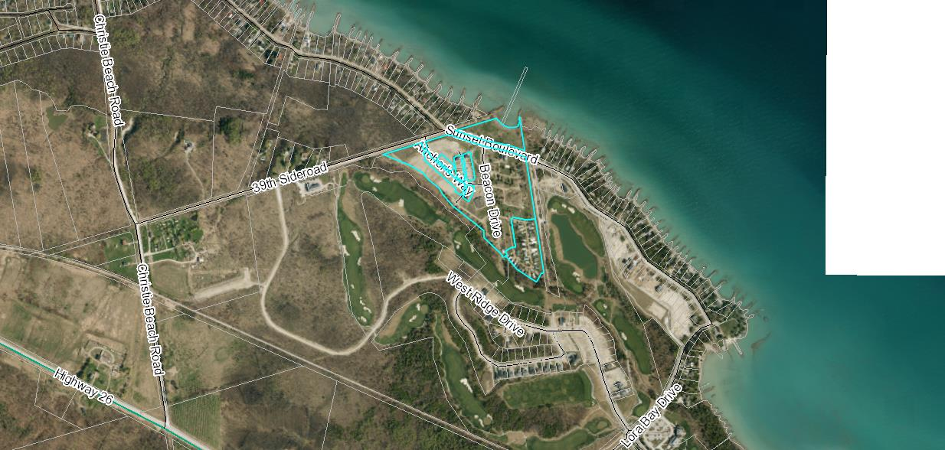The County has received a request from the Owner’s agent requesting an additional three year draft approval extension. The reasons noted in the request letter indicate the following:

* The developers have been actively marketing this project to rejuvenate an interest in this development and they are continuing to work towards finalizing this project but are limited by the number of sales at this point
* They have no issues with the existing draft conditions and do not require any changes at this time
* There have been no changes to the project that would impact the Agreement obligations with the Town.
* They have reviewed the Town’s newly adopted Official Plan and it is their opinion that the project conforms with the policies in the adopted Official Plan.

In a letter dated August 11, 2015 from the Town of The Blue Mountains, the Town indicates that they have no objections to a three year extension.

The standard period of time for extensions of draft approval is one year. The granting or supporting of one year extensions has been delegated to the Director of Planning. Extension requests beyond one year are required to be approved by the Planning and Community Development Committee. County staff typically recommends that extensions to draft approval only be for a one year period to ensure that the proponent is continuing to move forward with fulfilling the conditions and to allow local municipalities to have the option of not extending draft approval if the municipality is experiencing servicing capacity issues.

Based on the reasons for the extension request identified in the letter from the Owner’s agent, and based on the Town of The Blue Mountains supporting the request for a three year extension, County staff recommends that a three (3) year draft approval extension be granted for this development.

## Financial / Staffing / Legal / Information Technology Considerations

At this point there are no financial, staffing, legal or Information Technology considerations. The County has collected a fee for the extension of draft approval.

## Link to Strategic Goals / Priorities

Action 2.10, under Goal 2 of the County’s Strategic Plan requires the continued management of growth and the application of sound land use planning principles. Permitting an extension to draft approval for a previously draft approved subdivision would be considered sound land use planning, given the specific circumstances.

Respectfully submitted by,

Randy Scherzer  
Director of Planning