Grey County Logo Committee Report

# Report PDR-PCD-24-16

**To**: Chair McQueen and Members of the Planning and Community Development Committee

**From**: Randy Scherzer, Director of Planning

**Meeting Date:** June 21, 2016

**Subject: Proposed redline revisions to draft Plan of Subdivision (42-CDM-2007-07) – Private Residences at Georgian Bay Club**

**Status**:

## Recommendation(s)

**WHEREAS plan of condominium application 42-CDM-2007-07 was draft approved effective on January 8, 2008 and later revised on November 18, 2014;**

**AND WHEREAS the County has received a request from the owner to revise the draft approved plan;**

**NOW THEREFORE BE IT RESOLVED THAT Report PDR-PCD-24-16 be received;**

**AND THAT in consideration of the draft plan of condominium and the matters to have regard for under Subsection 51(24) of the Planning Act RSO 1990 as amended, the Grey County Planning and Community Development Committee hereby approves the red-line revision to Plan of Condominium File 42-CDM-2007-07, subject to the conditions set out in the Notice of Decision.**

## Background

The subject properties are known as Block 42, Registered Plan 16M-6, and Block 2 and Part of Block 1, Registered Plan 1157, and Part of Lot 27, Concession 7 (geographic Township of Collingwood) in the Town of The Blue Mountains and are part of the larger Georgian Bay Club Development. The application is being made by the Private Residences at Georgian Bay Club.

The proposed red-line revision is to draft plan of condominium 42-CDM-2007-07, which was approved by the County in 2007 and appealed to the Ontario Municipal Board (OMB). The OMB subsequently approved the draft plan effective January 8, 2008 upon dismissing the appeal. The plan was later revised by the County on November 13, 2014. The current draft approved plan consists of a total of 56 residential units.

The Applicant is requesting that two conditions be added to the draft plan conditions to address matters regarding easements. The two conditions being requested by the Applicant are as follows:

1. *“That easements shall be granted to The Georgian Bay Club Inc. to (i) allow access to The Georgian Bay Club golf course over the access road located on the plan of condominium for the purposes of vehicular and pedestrian ingress and egress; and (ii) for vehicular and pedestrian ingress and egress over such part of the plan of condominium where the cart path servicing the golf course currently traverses the plan of condominium.”*
2. *“That easements for pedestrian and vehicular access over Part 2 on 16R-10709 and over Parts 2 and 3 (being part of PIN 37308-0329LT) be granted in favour of PIN 37308-0213LT (Current Registered Owners: Denise Marie Nella and Robert Vincent Nella).”*

With respect to the first proposed condition, the Applicant is requesting this condition in order to recognize a minor intrusion of the existing golf cart path on to the subject lands.

With respect to the second proposed condition, this easement is necessary due to driveway of the existing house on the property just north of the subject lands encroaching in some areas on the subject lands.

There are no proposed changes to the actual plan itself.

The subject lands are 5.52 acres in size with 85 metres of frontage onto the 7th Line. Frontage and access for the proposed dwelling units would be onto a private condominium road. The proposed development will be serviced by municipal water and sewer services.

In support of the subject applications the Applicant submitted a covering letter as well plans depicting the proposed locations of the easements on the subject lands. Copies of the plans can be found on the County website at the link below:

[Link to the County's Website](http://www.grey.ca/services/planning-development/new-planning-applications/private-residences-at-georgian-bay-club-revision/)

Surrounding the subject lands are a mixture of forested, residential and golf course lands (see map one below). Also enclosed is a copy of the current draft plan of condominium (see map two below).

### Map 1 – Air Photo of the Subject Properties

### Key map showing the subject lands and surrounding properties

### Map 2 – Draft Plan of Condominium

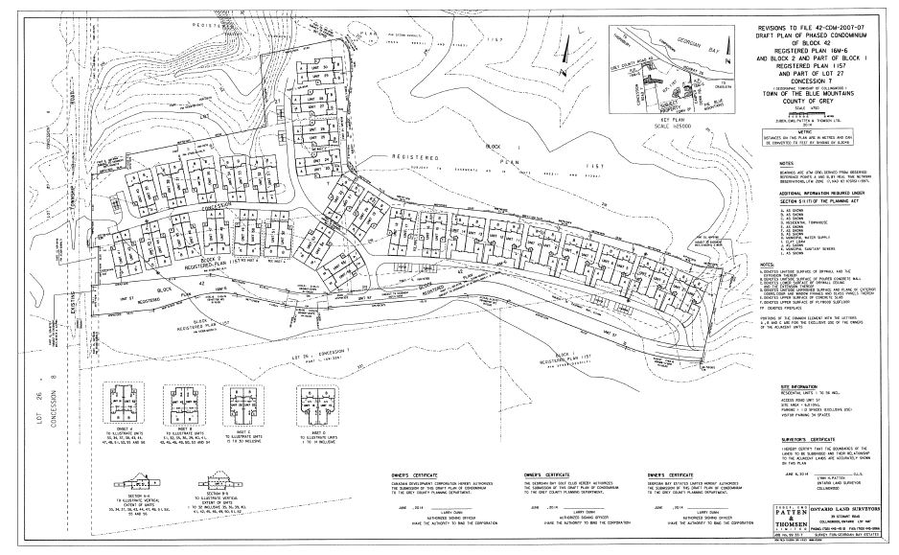

### Agency Comments Received

The proposed revisions were circulated to the Town of The Blue Mountains, Grey Sauble Conservation Authority and the Niagara Escarpment Commission, as well as individuals who previously requested notice of decision.

The following comments were received:

Town of The Blue Mountains (TOTBM) – In a letter dated May 20, 2016, the TOTBM have noted that they are satisfied with the proposed conditions of draft approval. TOTBM notes that documentation on these requirements will need to be put into the condominium agreement. The requirement for a condominium agreement is addressed through the existing draft approved conditions.

No other comments were received prior to the finalization of this report.

### Planning Policy Analysis

Planning decisions in Ontario must have regard for matters of Provincial Interest under the *Planning Act*, be consistent with the Provincial Policy Statement (PPS) 2014, and conform to the goals and objectives of any official plans governing the lands. In this case the County of Grey Official Plan and the Town of The Blue Mountains Official Plan are both applicable to the subject lands.

#### *The Planning Act and Provincial Policy Statement*

Section 1.1 of the *Planning Act* outlines the purposes of the Act. The purposes of the Act promote sustainable economic development in a healthy natural environment within a land use planning system, led by provincial policy and matters of provincial interest. Section 2 of the *Planning Act* outlines matters of Provincial Interest, which decision makers must be consistent with when carrying out their responsibilities under the Act. With respect to the Provincial Policy Statement (PPS), a key goal of the PPS is directing new growth to serviced settlement areas, and promoting the vitality of such settlement areas through re-development and intensification. The proposed revised conditions of draft approval have regard for matters of Provincial Interest under *The Planning Act* and are consistent with the PPS.

#### County of Grey Official Plan

The subject property is designated as ‘Recreational Resort Area’ in the County Official Plan, which is a designated settlement area. Through the development of the golf course and subsequent draft plan approvals there has been a significant amount of development review on the subject lands. The proposed revised conditions conform to the goals and objectives of the County of Grey Official Plan.

## Financial / Staffing / Legal / Information Technology Considerations

At this point there are no financial, staffing, legal or Information Technology considerations beyond those normally encountered in processing a red-line revision. The County has collected an application and associated fee for the red-line revision.

## Link to Strategic Goals / Priorities

Action 2.10, under Goal 2 of the County’s Strategic Plan requires the continued management of growth and the application of sound land use planning principles. Permitting new residential growth in a settlement area, which efficiently uses municipal infrastructure, and provides for a range of housing opportunities, could be considered sound land use planning principles.

## Attachments

Attachment: Notice of Decision

Respectfully submitted by,

Randy Scherzer, MCIP, RPP  
Director of Planning

**NOTICE OF DECISION**

**On Application for Approval of Draft Plan of Condominium**

**under Subsection 51(45) of the Planning Act**

Draft Plan Approval was given by the Ontario Municipal Board effective on January 8, 2008 and was later revised by the County on November 13, 2014. A request has been made to revise the conditions of the draft plan. **Revised** Draft Plan Approval is hereby given by the County of Grey for the application regarding the above noted lands. A copy of the Decision is attached.

**WHEN AND HOW TO FILE A NOTICE OF APPEAL**

Notice to appeal the decision to the Ontario Municipal Board must be filed with the County of Grey no later than 20 days from the date of this notice, as shown above.

The notice of appeal should be sent to the attention of the Director of Planning and Development of the County, at the address shown below and it must,

(1) set out the reasons for the appeal, and

(2) be accompanied by the fee prescribed under the Ontario Municipal Board Act.

**WHO CAN FILE A NOTICE OF APPEAL**

Only individuals, corporations or public bodies may appeal decisions in respect of applications for approval of draft plans of condominium to the Ontario Municipal Board. A Notice of Appeal may not be filed by an unincorporated association or group. However, a Notice of Appeal may be filed in the name of an individual who is a member of the association or group.

**RIGHT OF APPLICANT OR PUBLIC BODY TO APPEAL CONDITIONS**

The applicant or any public body may, at any time before the final plan of condominium is approved, appeal any of the conditions imposed by the County of Grey to the Ontario Municipal Board by filing with the Director of Planning and Development of the County, or her delegate, a Notice of Appeal.

**HOW TO RECEIVE NOTICE OF CHANGED CONDITIONS**

The conditions of an approval of draft plan of condominium may be changed at any time before the final approval is given.

You will be entitled to receive notice of any changes to the conditions of the approval of draft plan of condominium if you have either,

(1) made a written request to be notified of the decision to give or refuse to give approval of draft plan of condominium, or

(2) make a written request to be notified of changes to the conditions of approval of the draft plan of condominium.

**GETTING ADDITIONAL INFORMATION**

Additional information about the application is available for public inspection during regular office hours in the Planning & Development Office at the address noted below or by calling 519-376-2205 or 1-800-567-GREY.

**ADDRESS FOR NOTICE OF APPEAL**

**County of Grey**

**595-9th Avenue East**

**OWEN SOUND, Ontario N4K 3E3**

**Attention: Mr. Randy Scherzer, MCIP RPP**

**Director of Planning & Development**

Plan of Condominium File No. 42-CDM-2007-07 was granted draft approval effective January 8, 2008 and later revised by the County on November 13, 2014. The draft approval is hereby **revised**. The County’s conditions of approval for this draft Plan of Subdivision are amended as follows:

No. Conditions

1. Condition 2 of the conditions of draft approval that were approved on November 13, 2014 is hereby revised by adding the following sub-conditions:
2. **“That easements shall be granted to The Georgian Bay Club Inc. to (i) allow access to The Georgian Bay Club golf course over the access road located on the plan of condominium for the purposes of vehicular and pedestrian ingress and egress; and (ii) for vehicular and pedestrian ingress and egress over such part of the plan of condominium where the cart path servicing the golf course currently traverses the plan of condominium.”**
3. **“That easements for pedestrian and vehicular access over Part 2 on 16R-10709 and over Parts 2 and 3 (being part of PIN 37308-0329LT) be granted in favour of PIN 37308-0213LT (Current Registered Owners: Denise Marie Nella and Robert Vincent Nella).”**
4. That all other conditions of draft approval as granted on November 13, 2014 remain in effect.