Grey County Logo Committee Report

| **To**: | Warden Halliday and Members of Grey County Council |
| --- | --- |
| **Committee Date:** | January 11, 2018 |
| **Subject / Report No:** | PSR-CW-01-18 |
| **Title:** | Chatsworth Paramedic Base and Transportation Depot Construction |
| **Prepared by:** | Kevin McNab and Pat Hoy |
| **Reviewed by:** | Kim Wingrove, Kevin Weppler |
| **Lower Tier(s) Affected:** | Chatsworth, Georgian Bluffs, Grey Highlands, Meaford, Owen Sound |
| **Status:** | Recommendation adopted by Committee as presented per Resolution CW22-18; Endorsed by County Council January 25, 2018 per Resolution CC18-18; |

## Recommendation

1. **That Report PSR-CW-01-18 be received and the plans for the Chatsworth Paramedic Base and Transportation Depot construction be approved as presented; and**
2. **That staff are authorized to proceed to tender for construction of the Chatsworth Paramedic Base and Transportation Depot modifications.**

## Executive Summary

The building of a new Paramedic Services base in the Chatsworth service area will allow for the placement of a permanent ambulance located directly in the response area. When operational, the base will provide greatly improved response times to the Chatsworth and surrounding areas which traditionally have been serviced by the Owen Sound and Markdale bases.

In 2016 there were approximately 400 emergency calls in the proposed Chatsworth base catchment area of which 110 calls were for patients who were considered to be categorized in severity as CTAS 2 on contact. In 2016 the reported County response time for CTAS 2 patients was 89.5% which was 0.5% below the CTAS response time target. It is anticipated that the Chatsworth base will assist the County in meeting response time targets.

Grey County Transportation Services will be renovating the existing depot in conjunction with the new Paramedic Services base addition. Paramedic and Transportation Services staff worked together with the architect on the plan to share site services and space including a common entrance, generator, an accessible washroom and lunchroom facilities.

## Background and Discussion

Included in the 2018 capital budget is the request for funding to build a new ambulance base on County lands to service the Chatsworth, Georgian Bluffs and southwest Meaford areas. The building of a new Paramedic Services base in the Chatsworth service area will allow for the placement of a permanent ambulance based directly in the response area. When operational, the base will provide greatly improved response times to the Chatsworth and surrounding areas which traditionally have been serviced by the Owen Sound and Markdale bases. Responses directly to the Village of Chatsworth, as well as smaller communities such as Keady and Walter’s Falls will be improved as ambulances responding from Owen Sound must navigate through the city prior to leaving it. For calls that originate south of the proposed base, there will be a distance reduction of approximately 12 km or 10 minutes of drive time. When required, the proximity of the new base to Owen Sound will also in turn support the area where 40 percent of the County emergency calls originate.

In 2016 there were approximately 400 emergency calls in the proposed Chatsworth base catchment area, of which 110 calls were graded CTAS 2 on patient contact. In 2016 the reported County response time within 15 minutes for CTAS 2 patients was 89.5% which was 0.5% below the CTAS response time target. It is anticipated that the Chatsworth base will assist the County in meeting all response time targets.

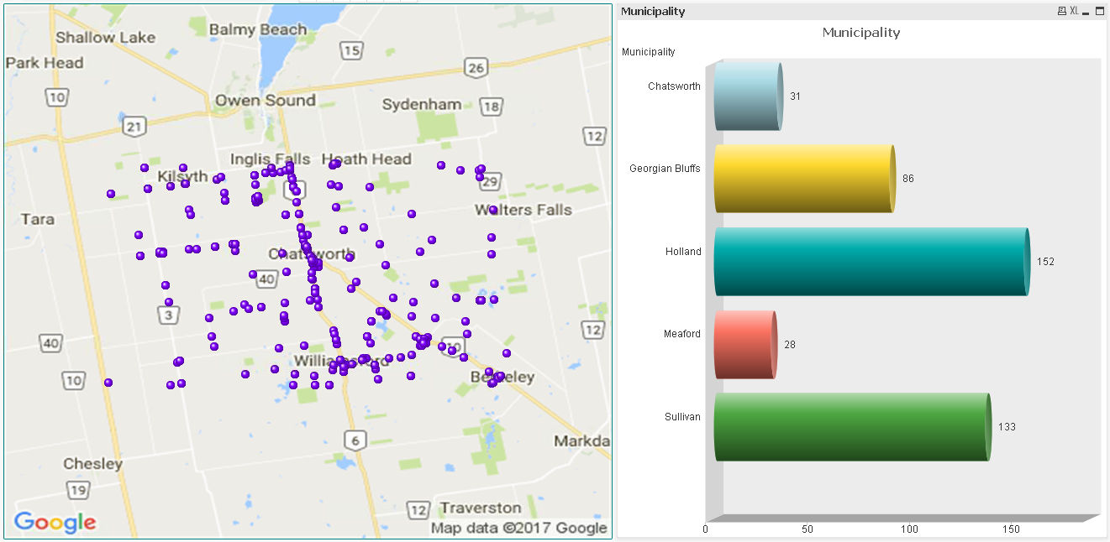

The following map identifies a 15 kilometer response area that would be serviced by the proposed Chatsworth base. The zone buffer will allow for the meeting of the 90th percentile response time target of 15 minutes for CTAS 2 calls within the catchment area.

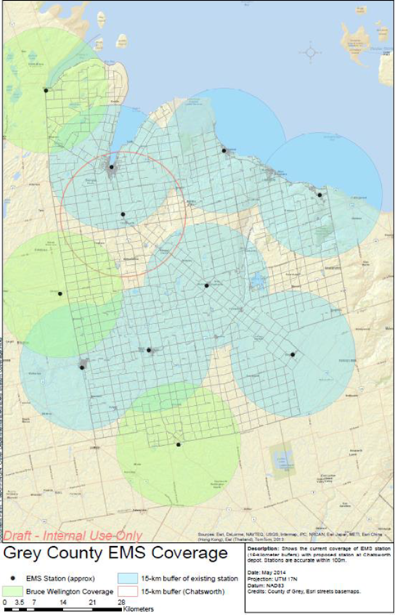

The base would be staffed utilizing existing staffing resources currently in place at the Owen Sound and Durham bases. It is also being proposed that the community paramedic book on and off for their shift at this location which will also allow for first response coverage.

Grey County Transportation Services will be renovating the existing depot in conjunction with the new Paramedic Services base addition. Paramedic and Transportation Services staff worked together with the architect on the plan to share site services and space including a common entrance, generator, an accessible washroom and lunchroom facilities. The following modifications to the previous design have been incorporated:

* The previous base design was 2,336 sq. ft. vs the updated design of 2,406 sq. ft. with the increase in space attributable to the architect recommending the building be squared off. Adding the base to the existing building with fewer corners results in a more efficient build as well as aids with snow clearing. Finished interior space will be 2,282 sq. ft.
* The roof design has been changed to a slanted roof vs flat roof.
* A new washroom has been added to the Transportation Services area (the existing building only has a men’s washroom).
* The double hallway has been reduced to one, and the lockers reconfigured to provide additional space.
* Two larger offices have been made into three offices, with the bridge foreman’s seasonal office moving from the soils lab trailer into the depot building.
* The stock room has been expanded.
* The Paramedic Services base has been moved forward (to the west) to accommodate any future expansion of the Transportation Services Garage portion of the depot.

## Floor Plan of Chatsworth Paramedic Base and Chatsworth Depot Renovations

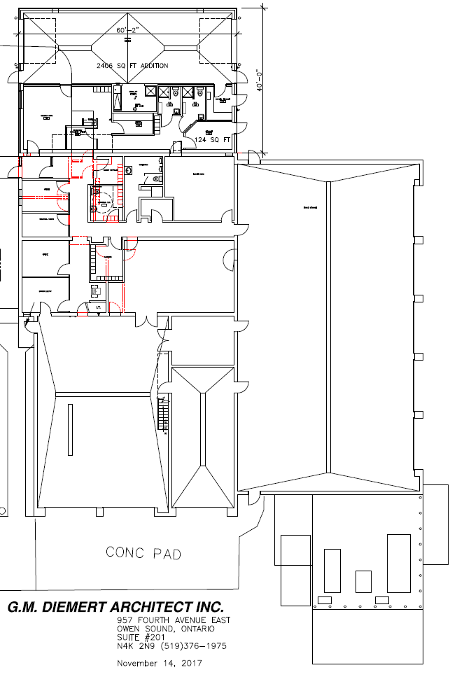

Front View

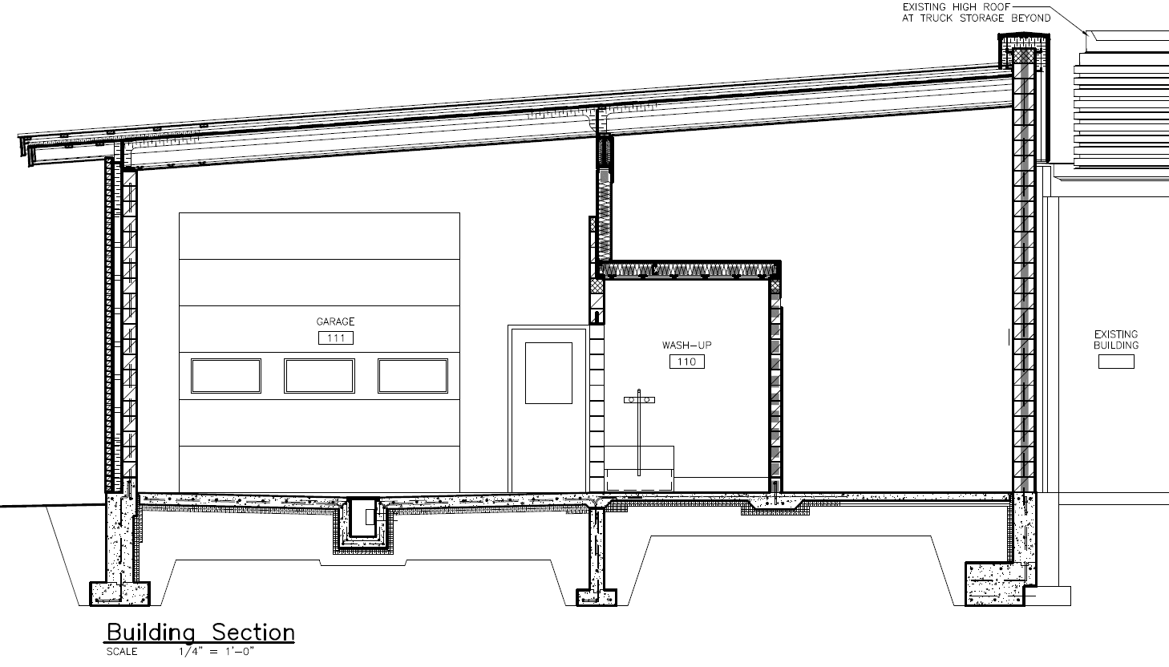

Partial Site Plan

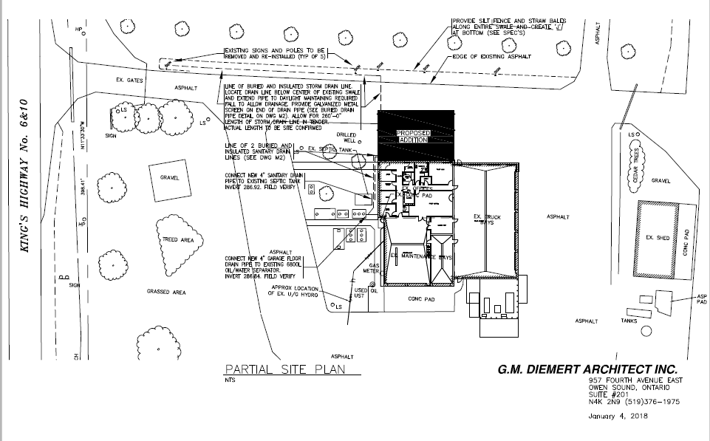

## Legal and Legislated Requirements

Land Ambulance Response Time Standard Reg 257/00 Part VIII

## Financial and Resource Implications

The 2018 draft Paramedic Services budget includes $684,673 to build the Chatsworth base, funded by an internally financed debenture amortized over 15 years with an annual payment of $56,093. The debenture for the build of the Craigleith base was paid off in 2016 and a portion of these funds have been used to fund the debenture cost of the Chatsworth base. The 2018 draft Transportation Services budget includes $60,000 for renovations of the Chatsworth depot.

Once operational, the base will require ongoing utility/operational costs and will need to have a Building Condition Assessment (BCA) completed for long term capital replacement costs.

## Relevant Consultation

External: Grant M. Diemert, OAA *G. M. DIEMERT ARCHITECT INC.*

### Appendices and Attachments

None