Committee Report
To: | Warden Milne and Members of Grey County Council
Committee Date: | 11 May 2023
Subject / Report No: | ITR-CW-02-23
Title: | IT Five-Year Strategic Plan
Prepared by: | Jody MacEachern, Director of IT
Reviewed by: | Kim Wingrove, CAO
Lower Tier(s) Affected: | None.
Status: | Recommendation adopted by Committee as presented per Resolution CW77-23; Endorsed by County Council June 8, 2023, per Resolution CC38-23.

Recommendation
- That report ITR CW-02-23 IT Five-Year Strategic Plan be received; and
- That Council support the goals and objectives of the 2023 IT Strategic Plan as outlined in this report.

Executive Summary
Grey County's information technology department is responsible for supporting or managing approximately 200 unique software applications and 60 technology enabled sites. A sound strategy to guide continuous improvement and maximize the value of investments in technology is necessary.
The four key recommendations from the strategy are to develop a more robust governance model for IT decision making, enhance business solutions and analysis, improve IT engagement with the rest of the County, and modernize and improve online services to the public. Committing to these recommendations and properly resourcing IT to deliver on them will increase staff efficiency, foster innovation, reduce risk and improve the customer experience for our residents.

Background and Discussion
Grey County has maintained IT strategic plans consistently over the past twenty years, with previous strategic plans developed in 2004, 2011, and 2016. Despite considerable change in the County and in technology, these strategic plans have been invaluable tools for guiding the development of IT, and the County has been successful at implementing most of the recommendations in those plans.
In 2022 Grey County engaged Perry Group Consulting (PGC) to develop a new five-year IT strategic plan. Perry Group assessed several aspects of IT services, including governance, resident service delivery, funding and resourcing, underlying technology, and the role IT assumes within the organization in identifying and developing new technology projects.
Adoption of the 2023 IT strategic plan recommendations will facilitate improved outcomes on technology selection and adoption at corporate level. Greater emphasis will be placed on creating stronger links between customer service and technology, and staff will be better supported in learning about and using emerging technology. The overall goal of the plan’s recommendations is to improve the efficiency of workflows and access to data across the corporation and provide the greatest return on technology investments.
This report summarizes Perry Group’s findings and discusses their impacts for Grey County IT service delivery.

Technology and IT Service Assessment
To develop the current strategic plan, Perry Group Consulting used several discovery methods to provide a thorough assessment of Grey County’s operations, including:
- Surveying all staff for general satisfaction with technology and IT service
- Reviewing available IT documentation:
  - Department structure
  - Disaster recovery and business continuity planning
  - Security assessments and road maps
  - IT Helpdesk ticket reporting and change management documentation
  - IT policies and procedures
  - Departmental workplans
  - Other corporate strategy documents
- Interviews with IT teams and departmental leads.
- Assessment of infrastructure
PGC used these reviews to identify gaps in technology, business planning and vision, and identify opportunities for learning. PGC compared results against their conceptual models for IT service delivery in the municipal sector.
The Municipal Technology Model (MTM) assesses IT service delivery through functional areas (e.g. infrastructure, security, web, governance, resident facing).
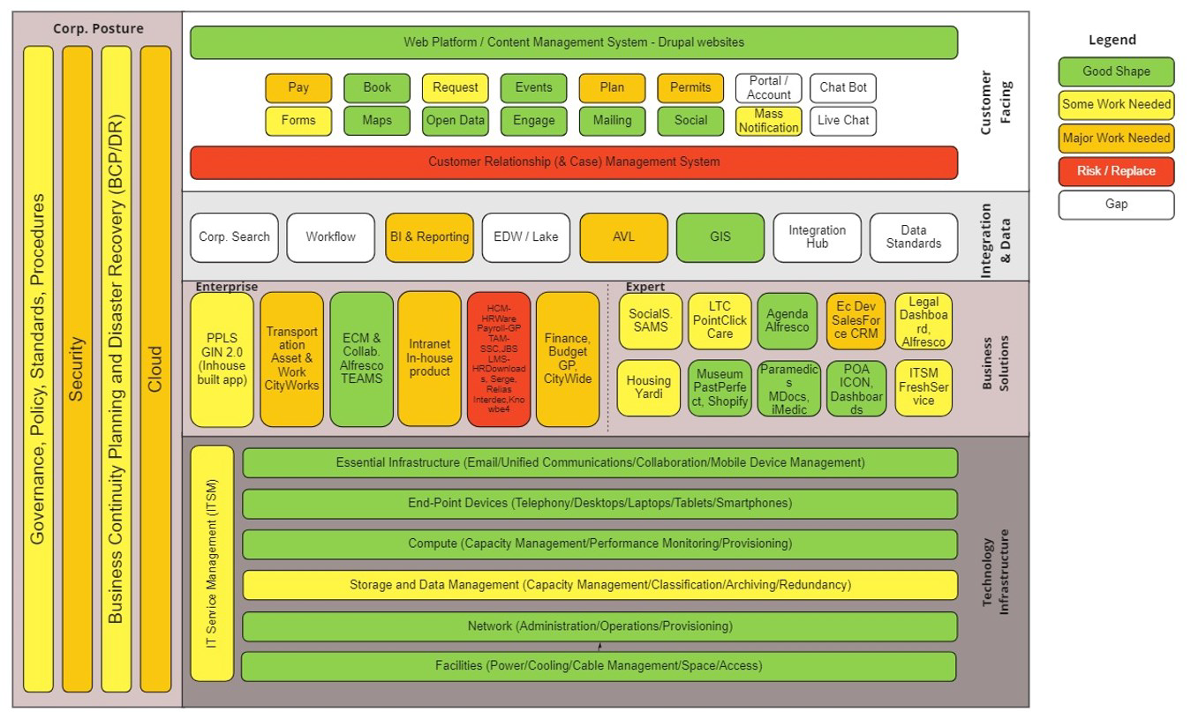
Perry Group Consulting’s Municipal Technology Model. PGC assessed the County as having strong underlying technology structure. They’ve identified a need for improved governance, data (integration and analysis), business planning/technology planning, security, and resident services.

PGC’s main findings are summarized in major categories below. Other notable findings from their assessment include:
- Staff indicated high levels of satisfaction with technology and IT service across the help desk. This level of satisfaction is driven by a high degree of professionalism, expertise, and customer focus in IT.
- Survey respondents would prefer more training and awareness of technology.
- The IT department has implemented robust and reliable infrastructure. Grey County council has supported investment in IT infrastructure and security over the past several years including server modernization and planning for consistent asset lifecycle management in capital budgets.

Key Improvement Areas Identified in the 2022 Strategic Plan
PGC’s recommendations can be summarized into four broad categories, as outlined and described below.

Governance Improvements
Governance is critical for operations in an IT department. This includes foundational policies that define appropriate use of technologies, security, data management and system configuration, but also the procedures in place to ensure that technology is providing the best value to the County. A strong governance model promotes reliable and repeatable processes to make IT efficient and reduces risk by adding controls to processes and data management.
PGC identified several key areas in which Grey County should develop or strengthen their governance model. Those are:

Project Intake, Prioritization and Management
The county has developed a governance model for capturing new technology project proposals, assessing their merit, and approving projects. However, this model has not been fully adopted and projects continued to be approved and managed without a centralized project management office.
PGC recommends re-initiating the project prioritization process for technology projects. Through this process, potential projects would be assessed using quantitative measures of importance (e.g. aligning project work to factors such as replacing aging technology or meeting regulatory requirements) and alignment with strategic initiatives. Further checks and balances would ensure that projects are meeting technology standards, have been thoroughly researched (e.g. commercial solutions versus custom applications), and scoped for effort and resource requirements. Projects can then be assessed across the corporation regarding the fit, priority and timing (resource availability for proposed projects).
PGC further recommended that the County formalize the fundamental requirements of project management into technology projects and also establish (and staff) a Project Management Office. IT staff have drafted policies that would require a minimum standard of project management controls be applied to different sized projects, which address the following:
- Thorough documentation of project scope;
- Measurable business objectives (e.g. value) that can be used to both define the project requirements and measure success;
- A project management plan with stakeholders / resources properly identified and committed to the project.
Strong controls on project selection and formalized management of process will allow the County to focus limited IT resources on the projects that bring the most value to the County or residents, and ensure those projects are run efficiently.

Data Governance
PGC highlighted the need to formalize data governance to ensure that data is properly managed. Proper data management requires that data is classified in terms of sensitivity, stored in systems that protect the data from loss and accidental exposure or breach, and aligned with life cycle management similar to other corporate records (e.g. destroyed when no longer needed by the County as governed by records management policy).
Implementing better data governance would require:
- Adopting a standard for classifying data (e.g. public, internal, confidential).
- Developing a policy describing data governance requirements.
- Ensuring that policy was followed to classify and document data the County collects and identifying those responsible for oversight of sensitive data.
Improved data governance would also address issues related to the format and suitability of data for addressing business problems in the County. Data sets collected by the County can be analyzed for potential opportunities, including improving processes for financial savings, refining procedures for efficiency of staff time, and improving resident facing services.

Adopt Digital Standards
Digital standards have been adopted by both the federal and Ontario provincial governments. Typically, digital standards cover a wide range of issues in technology use, ranging from the technical aspects of system design and security to development, design, ethics, and accessibility.
Adopting a set of digital standards has several benefits for governments:
- It creates a documented, transparent, and quantitative set of criteria that must be considered in new technology projects. This outlines clear requirements for business leads going to market and any vendors wishing to bid on those projects, plus saves staff time drafting technology requirements for RFPs.
- Codifies design elements around consistency (branding) and accessibility into design and procurement processes.
- Aligns technology projects with corporate policies such as security and data management.

Develop Business Solutions Capacity and Service Delivery Model
The majority of PGC’s recommendation in the current strategy plan fall under the broad category of fully utilized business solutions. Although there is some overlap with this category and governance, business solutions in general refers to IT services used to solve business problems. PGC’s recommendations are to improve the management and analysis side of these processes. Grey County has appropriate technical skills in IT, but lacks dedicated business analysts to assess departmental needs either as routine improvement exercises or ahead of major technology upgrades. PGC’s recommendations include the following:

Develop Business Analysis Capacity and Assign Dedicated Business Analysts to Each Department
PGC recommended that each department be assigned a dedicated technology business analyst. While Grey County IT has operated under this model for some time, PGC noted that only one member of the business solutions team had formal training in business analysis, and in general the team lacked resourcing to provide full business solutions services to the organization.
Departmental business analysts would be responsible for thoroughly understanding their clients’ technology and business processes. They would provide recommendations for technology road maps (e.g. noting when on-premise software would require updating or identifying gaps between service vision and technology). Further, they would provide guidance during the exploratory phase of new technology projects to help departmental leads discover technology possibilities and also consider IT requirements for new projects.

Better Technology Planning for Departments and Enterprise Applications
Grey County operations rely on software to manage operations. Some of these processes are complex and have a broad impact on the organization (finance, HR). PGC recommended that the County develop visions or road maps for these business functions such that the county can:
- Choose technologies that support the corporate vision in these areas.
- Plan for software that integrates across connected business processes, reducing staff time on data entry, custom integrations, QC, etc.
- Plans for major changes in either the technology or the industry as a whole (i.e. staying current with software).
PGC outlined several opportunities for visioning exercises and road maps. Grey County staff feel the most valuable are finance and HR, as they use complex software with many integrated processes, and asset and work management. Similar to finance and HR, work and asset management is currently using several integrated applications and has the potential to expand beyond Transportation where it is currently used.

Business Process Optimization Exercises Before Large Technology Projects
Technology projects often proceed with unstated assumptions around business processes – that technology should provide a like-for-like replacement of a business process, or that a business process can’t be improved.
PGC recommended that project teams perform Business Process Optimization exercises ahead of any large technology project. These exercises map the current business process and identify areas for improving efficiency and reducing waste. When business processes are mapped thoroughly, County staff are better able to formulate business requirements before going to market, and also adequately assess potential solutions.

Customer (Resident) Service Improvements and Modernization
Grey County offers approximately fifty different services to residents and businesses across all departments. These services range from requests for information, permits (e.g. oversized loads for transportation, special event permits), applications (e.g. public housing), requests for information, and delegations to council. Most of these services can be initiated online. However, there are a range of different methods used across services, with varying levels of digital maturity. Some of these services are initiated simply through an email to County staff. Others allow for relevant data capture using a fillable PDF.
The most digitally mature service requests are captured using a web form (HTML). Staff can then manage these requests with software, which allow them to track requests, manage and assign requests, and use data to assess trends in service delivery.

Conceptual model for digital service maturity. At the most basic level, residents can find information online about a particular service, but there are no tools for them to start a service request online. The most mature services allow residents to complete an HTML form online and capture that input in software that allows staff to manage requests and analyze data for trends.

Grey County staff have already started work on these initiatives. Recently, staff established a Digital Services Working Group (DSWG) to act as an internal advisory committee on technology standards, governance, adoption and project selection. This group has completed an inventory of all the services that can be initiated from the County’s website, including how those services are initiated (i.e. fillable PDF, web form), whether payments are required for the service, and how payments are made (online, in person).
The DSWG will soon be prioritizing these services for review and further enhancement. The services will be prioritized based on factors such as their frequency of use, financial implications, business value for improved process in terms of employee efficiency, and potential for improved experience for residents.
Having the DSWG lead the review of customer services provides for the best possible cross-departmental perspective on how changes to these services impact staff and residents alike.

Technology Engagement
The pace of change in the tech industry is often portrayed as a unique problem for IT professionals. Without continual professional development IT staff cannot keep abreast of these changes and stay current with the tools required to perform their jobs.
This change impacts not just those who work in the technology field, but those who work with technology to facilitate their core professional skills. Any modern software sees continuous update cycles that release new tools and features, and re-designs that change the look, feel, and workflow through software. New technologies (i.e. artificial intelligence) provide more possibilities in how staff work. Further, cyber security requires ongoing training and awareness to keep staff conscientious of threats and risks they might encounter in their job.
Grey County staff indicated to PGC that they have a desire for more training on technology. While this is important to keep staff current in their roles, there is also greater for potential for innovation if staff have access to both the knowledge of upcoming changes in technology, but also access to new technology to assess how new tools can impact their jobs.
Grey County staff and PGC have identified several opportunities to improve engagement between IT and the rest of the organization, including:
- Assessing IT performance through annual IT satisfaction surveys.
- Tracking help desk performance by allowing staff to provide feedback on help desk ticket closure (e.g. a simple survey).
- Run a bi-annual technology road show at departmental meetings. IT management would promote initiatives, talk about upcoming software changes, and promote awareness and training in key initiatives.
- Provide or promote more training and webinars for a general audience. This would not necessarily require IT running training programs, but simply finding and promoting existing content that’s relevant for Grey County staff.
- Improve communications through emailed updates and increased communication on active project (i.e. project change management).
- Departmental business analysts can also leverage their involvement with departments to promote IT initiatives and technology awareness.
Providing increased engagement for staff can help mitigate how changes in technology impacts their job, whether that’s through IT led projects or through industry changes to the software and tools that staff use (or could potentially use) in their daily work.

Implementing Strategic Priorities
Perry Group Consulting noted in both their IT Strategic Plan as well as their prior IT skills assessment, that Grey County’s IT department is staffed at a level that allows only for maintenance of current operations.
The recommendations outlined in this report allow IT to improve their operations through improved governance, procedures and policies. Further, providing more technology engagement and assessments to other departments allow IT to fulfil their role as a partner in technology planning, rather than purely a supporting service.
In their prior two assessments, PGC concluded that these goals cannot be achieved at current staff levels. Their recommendations included a mix of out-tasking specific tasks and also hiring to fill new roles. Those recommendations from both their IT strategic plan and IT skills assessment are summarized below. It is important to note that, while PGC found the IT team lacking in capacity to offer critical planning and governance services to the organization, neither of their previous engagements assessed the IT department’s capacity to deal with current workloads or anticipated future growth.
Skill | Missing Role | Missing Skill | Under-Resourced | Recommendation
Business Analysis¹ | x |  |  | New Hire
Project Management¹ | x |  |  | New Hire
Data Management² | x |  |  | New Hire
Geographic Information Systems² | x |  | x | New Hire
Data Analysis² |  |  | x
Enterprise and Business Architecture (Business Architecture)² | x |  |  | Consult
Cloud Architecture² |  | x |  | Train/Consult
Systems Design² |  | x |  | Train
Capacity Management² |  | x |  | Train
Risk and Compliance Governance² |  | x |  | Train
Problem Management² |  | x |  | Train
Security Specialist² | x |  |  | Outsource
IT Service Management¹ |  | x |  | Train

PGC also compared Grey County’s IT budget and staffing levels to other organizations (referencing technology advisory group Gartner, and PGC’s own recommendations from working with other Ontario municipal government clients).
In terms of IT operating expenditures, Grey County IT spends considerably less than other North American municipalities. As assessed by Gartner, other municipalities spend on average 4.3% of their budget on IT, compared with only 1.5% for Grey County. Similarly, IT staff level is lower than comparators, with IT staff representing only 1.8% of full-time employees compared with an industry average of 3.9%. While these metrics should not be considered targets in and of themselves, well-selected comparators can nonetheless provide an indication of how similarly sized and funded organizations in the public sector are funding and staffing their IT services.

Target Outcomes and Business Value of IT Strategic Plan
This report provided a summary of key recommendations in PGC’s proposed five-year strategic plan. Committing to these recommendations and properly resourcing IT to deliver these services will provide significant value to Grey County and residents. This includes:
- Increase staff efficiency through better designed processes, better alignment of technology and business processes, improved technology literacy, and governance that provides clear responsibilities and repeatable processes.
- Foster innovation by improving awareness of technology across the organization and designing policies that both allows staff to access the technology they need and democratizes idea promotion through cross-departmental governance committees and working groups.
- Reduces risk through better planning of technology needs and implementation, policies that guide technology use and data management, and project management fundamentals (including defined scope and target value of technology projects).
- Improving customer experience (both resident, and internal “customers” of the IT department) by ensuring technology is designed and implemented with user experience and efficiency of business processes in mind.
Grey County IT staff are committed to these recommendations as they continue to align with industry standards, governance frameworks, and best practices. It is the long-standing goal of IT to act as a partner in technology planning and implementation. The recommendations of PGC will provide significant progress towards those goals.

Legal and Legislated Requirements
None.

Financial and Resource Implications
Endorsement of this report does not commit Council to any new expenditures. Any initiatives that arise out of this strategic planning exercise will be presented to Council for consideration through annual budgeting.
In terms of additional staff, IT management will be prioritizing business analysis, data management, and project management over the next 2-3 budget cycles.

Relevant Consultation
☐ Internal (list)
☐ External (list)

Appendices and Attachments
IT Strategic Plan (ITSP), Final Report. Perry Group Consulting.

