Grey County Logo Committee Report

|  |  |
| --- | --- |
| **To**: | Deputy Warden McQueen and Members of Grey County Council |
| **Committee Date**: | May 12, 2022 |
| **Subject / Report No**: | PDR-CW-19-22 |
| **Title**: | White Rose - Redline Revision – 42T-2018-08 |
| **Prepared by**: | Stephanie Lacey-Avon |
| **Reviewed by**: | Randy Scherzer |
| **Lower Tier(s) Affected**: | Township of Southgate |
| **Status**: | Recommendation adopted by Committee as presented per Resolution CW71-22; Endorsed by County Council May 26, 2022 per Resolution CW71-22 |

# Recommendation

1. **That all written and oral submissions received on the proposed redline revisions to plan of subdivision 42T-2018-08 were considered which helped to make an informed recommendation and decision; and**
2. **That PDR-CW-19-22 be received, and that in consideration of the draft plan of subdivision 42T-2018-08, and the matters to have regard for under Subsection 51(24) of the Planning Act, the County of Grey Committee of the Whole hereby approves the revised plan of subdivision on lands described as Part Lot 227, Concession 2, SWTSR (geographic Township of Proton) in the Township of Southgate.**

## Executive Summary

The report considers a proposed redline revision to draft plan of subdivision 42T-2018-08 known as White Rose. Under the current draft plan, there will be a total of 86 to 88 units, consisting of 30 single detached units, 24 townhouse dwellings, 24 units in 4 senior dwelling blocks, and 8 to 10 units in a future senior dwelling block. The senior dwelling blocks will be developed as medium density, accessible bungalow, or freehold townhouse units. The revision proposes to extend the Stormwater Management (SWM) Block 60 by an additional 0.04 ha (0.08 ac) into Block 65 – the significant wildlife habitat/wetland. Block 60 requires a modest expansion to accommodate adequate area for the maintenance access road and grading to create the containment berm and ponding for final design. The block limit will extend into Block 65 but will remain outside of the 15-metre wetland buffer as required by Grand River Conservation Authority (GRCA). This proposal will not affect the previously approved lot fabric, unit count, road network, or servicing. All written and verbal comments regarding the proposed revision were considered and it is recommended that Committee approve the revision to the draft plan.

## Background and Discussion

The County has received a redline revision application that proposes a minor change to draft plan of subdivision 42T-2018-08 known as White Rose. The proposed subdivision is located on Part of Lot 227, Concession 2, SWTSR (geographic Township of Proton), in the Township of Southgate. Access to the development will be provided by an extension of Bradley Street (i.e., Street “B”), from the south, with a proposed future road connection to the north should the settlement area expand in the future. From the west, an extension from the adjoining subdivision (Southgate Cedarpoint) Todd Crescent to future street (i.e., Street “A” will also connect to the subject lands).

There will be a total of 86 to 88 units, consisting of 30 single detached units, 24 townhouse dwellings, 24 units in 4 senior dwelling blocks, and 8 to 10 units in a future senior dwelling block. The senior dwelling blocks will be developed as medium density, accessible bungalow, or freehold townhouse units.

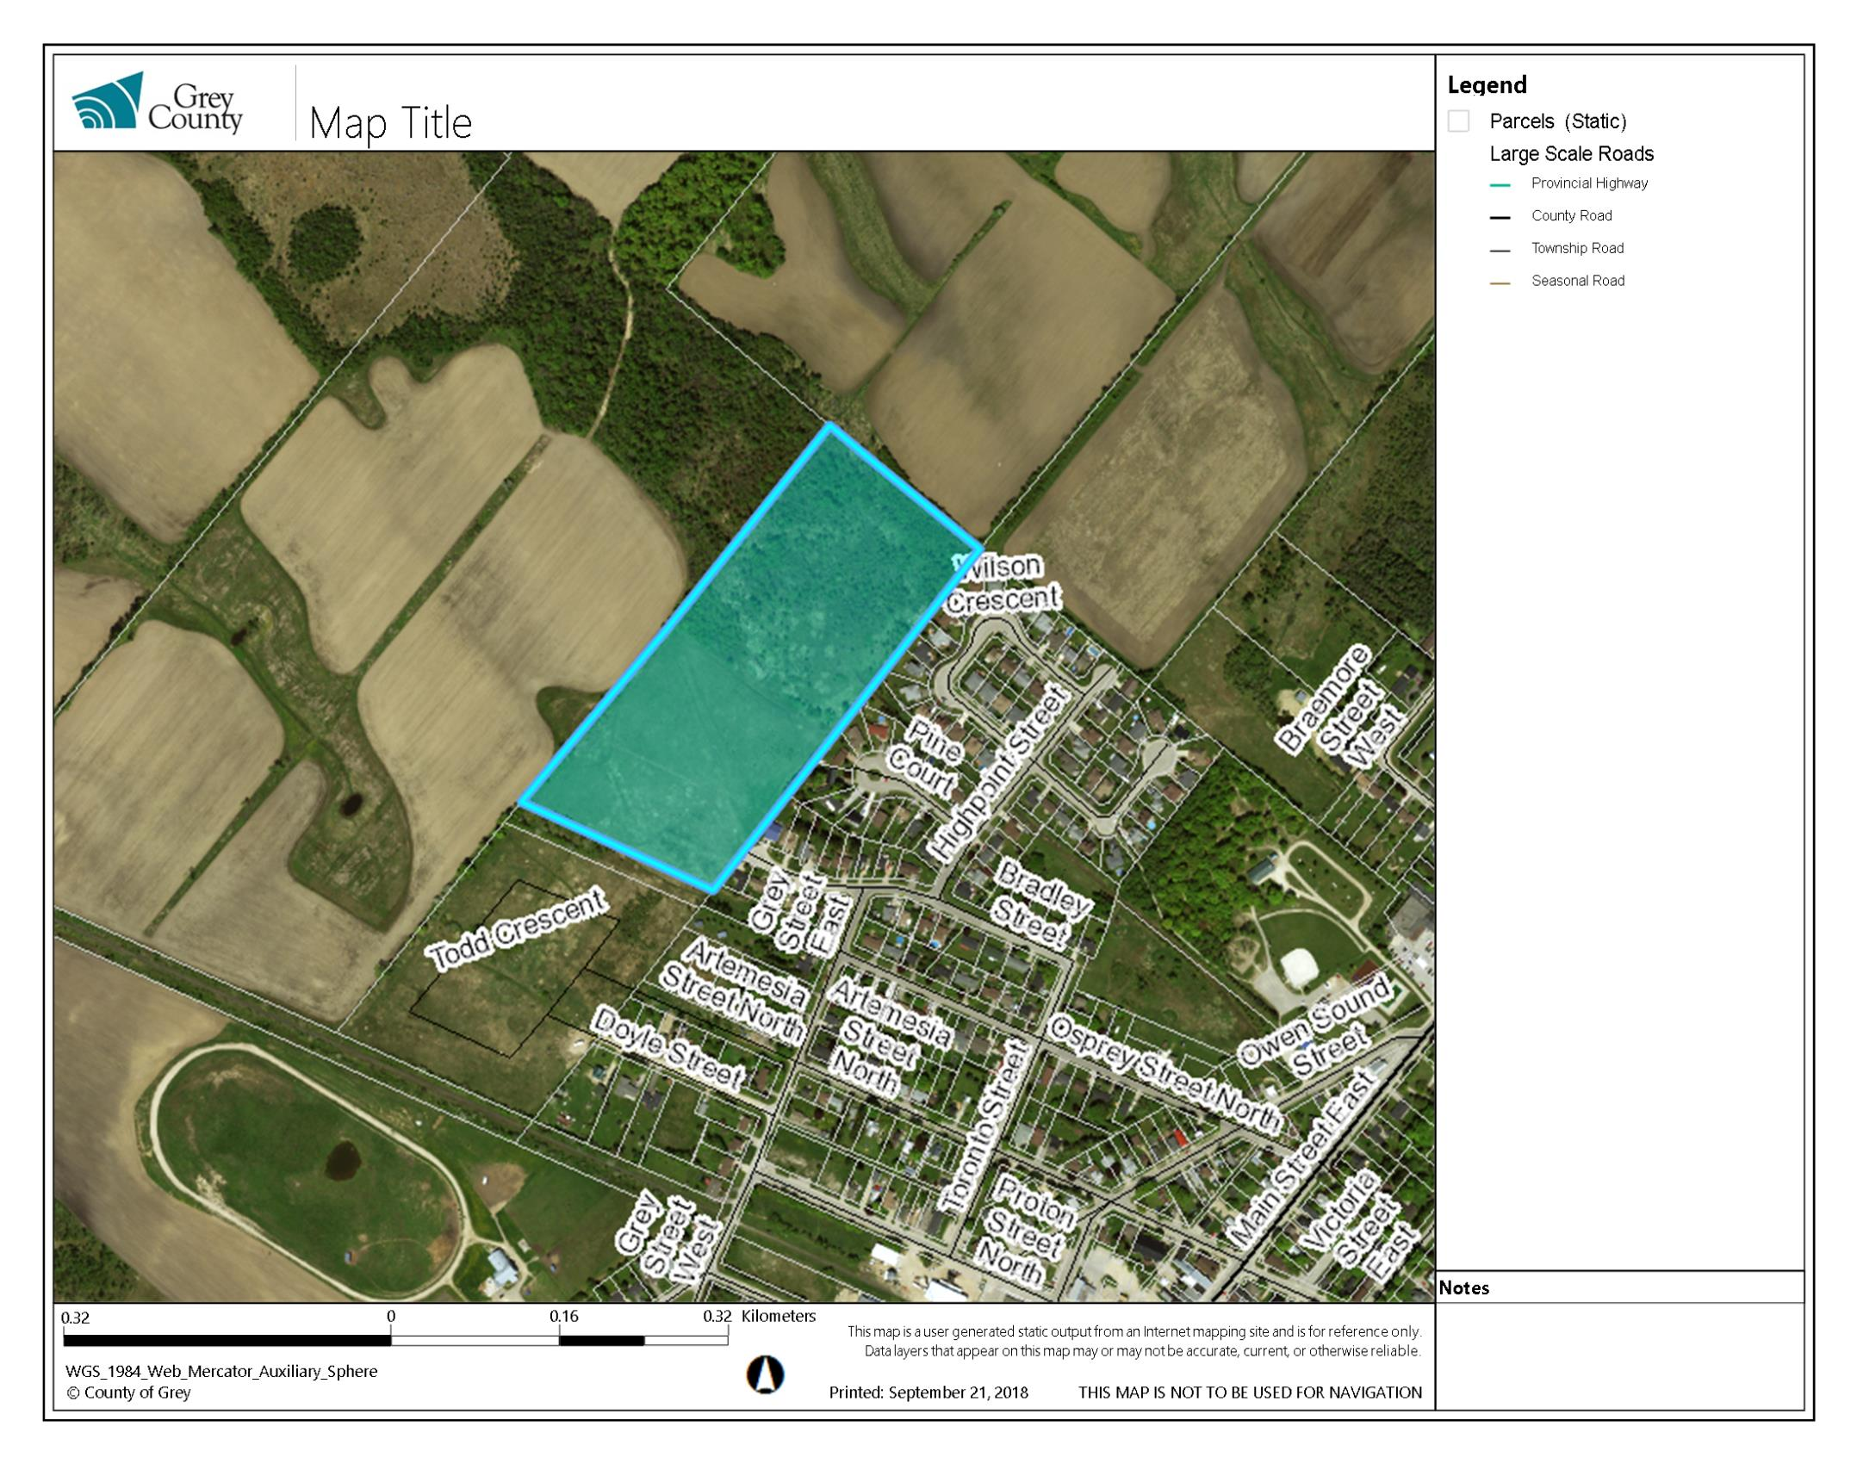

Map 1: Airphoto of Subject Lands

The revision proposes to extend the Stormwater Management (SWM) Block 60 by an additional 0.04 ha (0.08 ac) into Block 65 – the significant wildlife habitat/wetland. Block 60 requires a modest expansion to accommodate adequate area for the maintenance access road and grading to create the containment berm and ponding for final design. The block limit will extend into Block 65 but will remain outside of the 15-metre wetland buffer as required by Grand River Conservation Authority (GRCA). This proposal will not affect the previously approved lot fabric, unit count, road network, or servicing.

The Applicant has submitted a Planning Summary Letter and a Revised Draft Plan. An associated zoning amendment application was submitted to the Township of Southgate and was recently approved by the Township. Copies of all background reports and plans can be found at [this link.](https://www.grey.ca/planning-development/planning-applications)

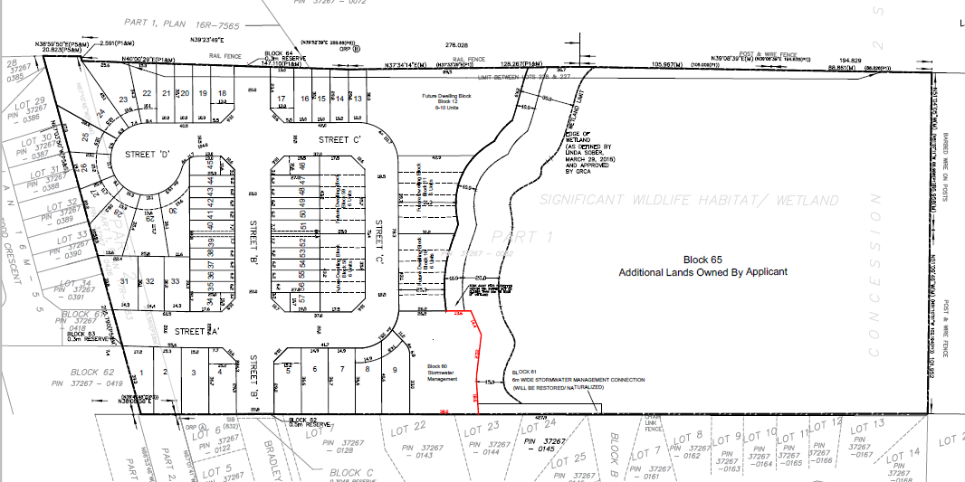

Map 2: Proposed Revised Plan of Subdivision (see redline)

### Public and Agency Comments Received

#### Public Comments

As part of the subdivision application process, there were no public comments received.

#### Agency Comments

As part of the subdivision application process comments were received by the following groups, agencies, and public bodies.

##### Grand River Conservation Authority (GRCA)

GRCA provided review and comment July 8th, 2021, regarding this proposed SWM infrastructure extension. They noted that extending the SWM block as indicated should not be an issue if that is what is needed to accommodate grading and landscaping features. The 15-metre wetland buffer to the SWM block should be maintained, which appears to be the case.

##### Township of Southgate

The Township prepared a staff report (PL2022-010) February 16, 2022, for the associated zoning by-law amendment for the subject lands. This amendment included the revised area of the SWM block as per the proposed redline revision. The Township passed the subject by-law (No. 2022-026) on February 16th, 2022, with the appeal period ending March 21st, 2022. The staff report concluded that the proposal was consistent with the policies from the County of Grey Official Plan and conforms to the Township of Southgate Official Plan. There were no concerns indicated in this report with respect to the proposed redline revision.

## Analysis of Planning Issues

When rendering a land use planning decision, planning authorities must have regard to matters of Provincial Interest under the *Planning Act*, be consistent with the Provincial Policy Statement (PPS) 2020 and conform to any official plans or provincial plans that govern the subject lands. In this case, the County of Grey Official Plan and the Township of Southgate Official Plan have jurisdiction over the subject property.

### The Planning Act

Section 1.1 of the *Planning Act* outlines the purposes of the Act. The purposes of the Act promote sustainable economic development, in a healthy natural environment, within a land use planning system led by provincial policy and matters of provincial interest. Section 2 of the *Planning Act* outlines matters of Provincial Interest, which decision makers must be consistent with when carrying out their responsibilities under the Act. The proposed redline revision is minor in nature and results in improved SWM for the subject development. The redline revision with the attached revised conditions of draft plan approval have regard for matters of Provincial interest under the Planning Act including Section 51(24).

### Provincial Policy Statement (PPS)

A key goal of the PPS is directing new growth to serviced settlement areas and promoting the vitality of such settlement areas through re-development, infill, and intensification. The subject lands have been designated for residential growth and are within a settlement area.

Section 1.6.6.7 of the PPS outlines how planning for stormwater management shall take place. Areas of focus and concern include ensuring SWM systems are optimized, feasible, and financially viable over the long term, mitigate risks to human health, safety, property, and the environment, and promote stormwater management best practices. The proposed redline revisions accommodate adequate area for the maintenance access road and grading to create the containment berm and ponding for final SWM design.

It can be concluded that the proposed redline revision with the attached revised conditions of draft plan approval are consistent with the PPS.

### County Official Plan

The proposed plan of subdivision is on lands designated as ‘Primary Settlement Area’ and ‘Hazard Lands’ in the County Official Plan. Primary Settlement Areas are identified as principal centres in which to focus new residential growth in the County.

Section 8.9 of the County OP are policies which govern roads, transportation, and stormwater management. In all new subdivisions and other large-scale developments, surface water management will be included to prevent on or off-site flooding. A SWM report was completed, March 2020. The proposed redline revision is required to ensure the SWM Block 60 is sufficiently sized to accommodate all technical needs. Subject to the revised conditions of draft plan approval attached to this report, the application conforms to the goals and objectives of the County of Grey Official Plan.

## Legal and Legislated Requirements

The application has been processed in accordance with the *Planning Act*.

## Financial and Resource Implications

There are no anticipated financial, staffing, or legal considerations associated with the proposed redline revisions, beyond those normally encountered in processing the application. The County has collected the requisite fee for this application.

## Relevant Consultation

Internal: Planning Staff

External: Township of Southgate, agencies under the Planning Act.

### Appendices and Attachments

*Revised Conditions of Draft Approval (attached)*

# **NOTICE OF DECISION**

**On Application for Revision to Approval of Draft Plan of Subdivision**

**under Subsection 51(45) of the Planning Act**

Draft Plan Approval was originally given by the County to Plan of Subdivision 42T-2018-08 on March 25, 2021. Revised Draft Plan Approval is hereby given by the County of Grey for the application regarding the above noted lands. A copy of the Decision is attached.

**PUBLIC AND AGENCY COMMENTS RECEIVED ON THE FILE**

All written and oral submissions received on the application were considered; the effect of which helped to make an informed recommendation and decision.

**WHEN AND HOW TO FILE A NOTICE OF APPEAL**

Notice to appeal the decision to the Local Planning Appeal Tribunal must be filed with the County of Grey no later than 20 days from the date of this notice, as shown above.

The notice of appeal should be sent to the attention of the Director of Planning and Development of the County, at the address shown below and it must,

(1) set out the reasons for the appeal,

(2) be accompanied by the fee required by the Tribunal as prescribed under the Local Planning Appeal Tribunal Act, and

(3) Include the completed appeal forms from the Tribunal’s website.

**WHO CAN FILE A NOTICE OF APPEAL**

Only individuals, corporations or public bodies may appeal decisions in respect of a proposed plan of subdivision to the Local Planning Appeal Tribunal. A notice of appeal may not be filed by an unincorporated association or group. However, a notice of appeal may be filed in the name of an individual who is a member of the association or group on its behalf.

No person**\*** or public body shall be added as a party to the hearing of the appeal of the decision of the approval authority, including the lapsing provisions of the conditions, unless the person or public body, before the decision of the approval authority, made oral submissions at a public meeting or written submissions to the council, or made a written request to be notified of changes to the conditions or, in the Local Planning Appeal Tribunal’s opinion, there are reasonable grounds to add the person or public body as a party.

**\***Notwithstanding the above, only a ‘person’ listed in subsection 51(48.3) of the Planning Act may appeal the decision of the County of Grey to the Ontario Land Tribunal (OLT) as it relates to the proposed plan of subdivision. Below is the prescribed list of ‘persons’ eligible to appeal a decision of the County of Grey related to the proposed plan of subdivision as per subsection 51(48.3) of the Planning Act.  These are changes that have been made to the Planning Act by the province. A link to the revised Planning Act can be found here - <https://www.ontario.ca/laws/statute/90p13>. For more information about these recent changes, please visit the OLT website or contact OLT - <https://olt.gov.on.ca/about-olt/>.

The prescribed list of ‘persons’ eligible to appeal a decision of the County on the proposed plan of subdivision as per subsection 51(48.3) of the Planning Act is as follows:

1. A corporation operating an electric utility in the local municipality or planning area to which the plan of subdivision would apply.
2. Ontario Power Generation Inc.
3. Hydro One Inc.
4. A company operating a natural gas utility in the local municipality or planning area to which the plan of subdivision would apply.
5. A company operating an oil or natural gas pipeline in the local municipality or planning area to which the plan of subdivision would apply.
6. A person required to prepare a risk and safety management plan in respect of an operation under Ontario Regulation 211/01 (Propane Storage and Handling) made under the Technical Standards and Safety Act, 2000, if any part of the distance established as the hazard distance applicable to the operation and referenced in the risk and safety management plan is within the area to which the plan of subdivision would apply.
7. A company operating a railway line any part of which is located within 300 metres of any part of the area to which the plan of subdivision would apply.
8. A company operating as a telecommunication infrastructure provider in the area to which the plan of subdivision would apply.

**RIGHT OF APPLICANT OR PUBLIC BODY TO APPEAL CONDITIONS**

The following may, at any time before the approval of the final plan of subdivision, appeal any of the conditions imposed by the approval authority to the Tribunal by filing a notice of appeal with the approval authority: the applicant; any public body that, before the approval authority made its decision, made oral submissions at a public meeting or written submissions to the approval authority; the Minister; or the municipality in which the subject land is located.

**HOW TO RECEIVE NOTICE OF CHANGED CONDITIONS**

The conditions of an approval of draft plan of subdivision may be changed at any time before the final approval is given.

You will be entitled to receive notice of any changes to the conditions of the approval of draft plan of subdivision if you have made a written request to be notified of changes to the conditions.

**GETTING ADDITIONAL INFORMATION**

Additional information about the application is available for public inspection during regular office hours in the Planning & Development Office at the address noted below or by calling 519-376-2205 or 1-800-567-GREY.

**ADDRESS FOR NOTICE OF APPEAL**

**County of Grey**

**595-9th Avenue East**

**OWEN SOUND, Ontario N4K 3E3**

**Attention: Mr. Randy Scherzer, MCIP RPP**

**Deputy CAO**

Plan of Subdivision File No. 42T-2018-08 has been revised and granted draft approval. The draft plan is hereby revised. The County’s conditions of final plan approval for this draft Plan of Subdivision are amended as follows:

No. Conditions

1. Condition 1 of the draft plan conditions approved March 25, 2021, is hereby deleted and replaced with the following:

That the final plan shall conform to the Draft Plan of Subdivision File No. 42T-2018-08 prepared by MHBC Planning, dated March 15, 2022, showing:

* 1. Twelve (12) 40 ft single detached lots,
  2. Eighteen (18) 30 ft single detached lots,
  3. Twenty-four (24) 19.5 ft townhouse lots, all to gain access off roads to be constructed as part of the overall development shown on Streets ‘A’, ‘B’, ‘C’, and ‘D’,
  4. Four blocks to create ‘senior dwellings’ (Block 58, 59, 10, & 11), with frontage on Street ‘C’,
  5. A Stormwater Management Block (Block 60), and
  6. A Future Development Block (Block 12).

The legal description of the subject lands is Part Lot 227, Concession 2 SWTSR, geographic Township of Proton, Township of Southgate, County of Grey.

1. That all other conditions of draft approval as granted on March 25, 2021, remain in effect.