Grey County Logo Committee Report

# Report ITR-CS-15-15

**To**: Chair Bob Pringle and Members of Corporate Services Committee

**From**: Geoff Hogan, Information Technology (IT) Director

Mike Alguire, Purchasing and Materials Manager  
**Meeting Date:** November 10, 2015

**Subject: EDRMS Single Source Procurement**

**Status**: Recommendation adopted by Committee as presented per Resolution CS109-15; Endorsed by County Council November 24, 2015 per Resolution CC161-15;

## Recommendation(s)

**WHEREAS the corporate electronic document and records management software (EDRMS) is critical for the effective and efficient operation of the County;**

**AND WHEREAS the current EDRMS software is difficult to maintain and no longer adequate for the County’s needs;**

**AND WHEREAS after significant research Alfresco software has been determined to provide the best value and the best fit for the County’s current and future EDRMS needs;**

**NOW THEREFORE BE IT RESOLVED THAT report ITR-CS-15-15 EDRMS Single Source Procurement be received;**

**AND THAT Alfresco One software be single sourced;**

**AND FURTHER THAT the annual subscription cost be funded from the Information Systems Operating budget and the $100,000 installation and configuration be funded from the Information Technology reserve.**

## Background

Grey County purchased the County’s first electronic document and records management system (EDRMS**)**, internally called GreyDocs, in 2007. The system has significantly improved internal and customer facing processes and reduced network storage requirements over the previous systems.

The company that created the current EDRMS software was called Stellent. Just prior to the County completing the procurement for the software, Stellent was acquired by Oracle. Oracle, the second largest software company in the world, has integrated the EDRMS software into their enterprise middleware[1] basket of software products. The Oracle acquisition has had two negative outcomes for the County:

1. The complexity of the underlying technology has become more complicated which makes the software difficult to administer and update.
2. The integration of the software into the Oracle middleware stack means that changes to the software happen slowly as it needs to integrate with the other software in the stack.

The County stopped paying the $50,000 / year support charge from Oracle in 2014 because the software was no longer meeting the County’s needs due to increasing complexity and interoperability issues with other modern software and operating systems like Apple iOS. The $50,000 has been funding a reserve for a future EDRMS replacement since that time.

In the fall of 2014 after Apple iOS devices were deployed to staff and council, an Apple security update changed the security system of all Apple devices and GreyDocs authentication no longer worked on Apple iOS devices. No authentication means GreyDocs links do not work on iOS devices like iPads and iPhones. The IT Department has been actively researching fixes to Oracle and other alternatives to Oracle since that time. The newest version of Oracle was evaluated and tested and does fix the link issue but presents a number of other problems.

## Suggested Approach

The approach staff used was:

* Determine whether the software needed to be changed
* What options does the County require now and in the future
* Where do we want to be based on a needs assessment

Changing the software the County uses for document and records management is very complicated technically but the impact on the users is even more significant than the technology change. We currently have 250 regular users of the system and 150 occasional users. It is the intent that all 800 employees will be using the software within a few years. When looking for a new EDRMS for the County the following primary criteria were taken into account:

1. Scalability – the software must scale to meet the future needs of the corporation
2. Cross platform capability – the software must be easy to use on all platforms (Windows, MAC, Linux, iOS, Android and Blackberry) and all form factors (screen, tablet and phone)
3. Existing data (and records) must be able to migrate to new platform
4. Ease of Integration – new software must be able to integrate with existing and future software platforms at the County
5. Intuitive user interface – software must be easy to learn and intuitive so users can quickly adopt it without a difficult learning curve
6. Software must use less staff time to support

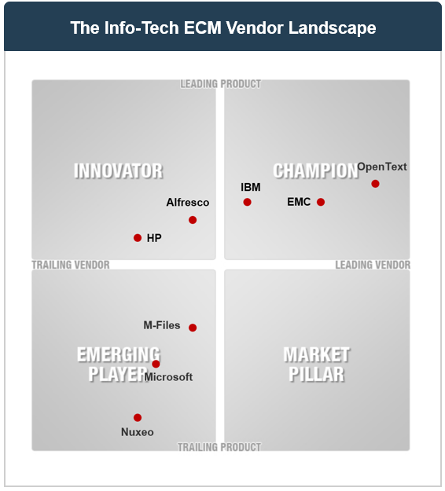

Figure - EDRMS Vendors

The County subscribes to the Infotech Research Group research service. Infotech is a neutral third party that provides insight into software and other IT services. Figure 1 illustrates where the primary Enterprise Content Management or EDRMS vendors fall on the landscape according to Infotech. Staff has invested significant time into investigating appropriate software from this list (and others) and have identified Alfresco as the best fit for the County. The companies listed in the champion quadrant were reviewed and not added to the short list for various reasons including costs, functionality and usability.

IT staff have done two proof of concepts (POC), Alfresco and Oracle after narrowing the list of suitable vendors. The Clerks department (responsible for records at the County), IT Staff, the EDRMS steering committee (cross departmental group for GreyDocs metadata project) and the senior management team have all compared the Alfresco POC to Oracle and prefer the user interface and other features over Oracle. Both the Clerk and IT departments expect to see greater adoption of document and records management at Grey due to the improved ease of use of Alfresco.

# Financial / Staffing / Legal / Information Technology (IT) Considerations

The County and Alfresco have been negotiating for over six months. Currently Alfresco licenses its’ product by named user (every individual accessing the software requires a license). County staff have suggested a municipal licensing model that is based on population. Many of the County’s other software vendors have a model like this, it is easy for the municipality to manage and makes the software more attractive to municipalities so Alfresco has more opportunities to sell the software to other municipalities. Alfresco has added wording to the proposed contract that allows the County to move to the new model when it becomes available. The County’s member municipalities should be able to take advantage of the software as a shared service if the municipal licensing model is implemented.

Alfresco has applied a significant discount to the software to make it affordable for the County. In year one they are providing an additional discount by pricing the software in Canadian dollars. The $75,000 2016 cost of Alfresco has been included in the 2016 draft budget and will be funded from the levy in the Information Services Operating budget. In 2015 that budget provided $50,000 to reserve that will be replaced with the $75,000 annual payment to Alfresco, a $25,000 per year increase to the levy in 2016. In 2017 if Alfresco has not implemented the municipal pricing model the cost of the software will be $75,000 USD (~$100,000 at today’s exchange rate).

The $100,000 conversion cost to put the software in and import the GreyDocs data will be funded from the IT reserve which currently has a projected yearend balance of $226,005. The table below has the total costs (excluding the non-refundable portion of the HST) for the two primary options.

| **Product** | **One-time License cost** | **Yearly cost** | **Conversion cost** | **5 year Total Cost of Ownership** |
| --- | --- | --- | --- | --- |
| Oracle | $ 98,375.4 | $21,594 |  | $ 206,345 |
| Alfresco |  | $ 95,000[2] | $100,000 | $575,000 |

The five year cost of the Oracle option is lower than the Alfresco option on the surface but when you compare the total cost of ownership (TCO) Alfresco is far more attractive:

* Time IT staff currently spends on maintaining the complex Oracle system can now be spent providing process improvements to other departments. Moving to Alfresco will free up about ¼ of an employee’s time ($25,000 annual savings)
* Time spent by other staff to accomplish everyday tasks can be automated using Alfresco. One example alone saves $20,000-$25,000 of staff time, the process to track certificates of insurance will be automated and save 10 hours per week of one employee’s time. There are many more examples of savings like this.
* Upgrading to the latest version of Oracle will take a significant amount of County IT staff time. Significant internal staff time will be avoided when the vendor installs the Alfresco software.

Staff are recommending that Alfresco be single sourced for the following reasons:

* County staff have over 8 years of direct experience with EDRMS systems and know exactly what features and functionality the County needs in the new software.
* The IT department has thoroughly researched the market and Alfresco provides the best set of functionality (content and records management) and value for the County.
* IT staff have spent over 150 hours testing and installing Alfresco to confirm it will meet the County’s needs.
* The core of the Alfresco product is open source, an open standards-based, flexible, transparent, and cost-effective system which gives us access to the open source developer community

## Link to Strategic Goals / Priorities

4.4 Embrace and continually invest in technology in order to enhance the operations of all county services as well as the County’s overall state of future preparedness.

## Attachments

Respectfully submitted by,

Geoff Hogan  
Director of Information Technology

1. not transactional software like financials or backend software like a database, middleware
2. $75,000 CAD in year one, $75,000 USD ($100,000 CAD) thereafter (on named user licensing model)