Grey County Logo Committee Report

|  |  |
| --- | --- |
| **To**: | Warden McQueen and Members of Grey County Council |
| **Committee Date**: | May 14, 2020 |
| **Subject / Report No**: | PDR-CW-20-20 |
| **Title**: | Saugeen Cedar Heights East - Redline Revision – 42T-2018-09 |
| **Prepared by**: | Scott Taylor |
| **Reviewed by**: | Randy Scherzer |
| **Lower Tier(s) Affected**: | Town of Hanover |
| **Status**: | Recommendation adopted by Committee as presented per Resolution CW85-20; Endorsed by County Council May 28, 2020 per Resolution CC54-20; *Report corrected following May 14 Committee meeting to note approval of 107 units |

# Recommendation

1. **That PDR-CW-20-20 regarding the Saugeen Cedar Heights East-Redline Revision – 42T-2018-09 be received, and**
2. **That all written and oral submissions received on the proposed redline revisions to plan of subdivision 42T-2018-09 were considered which helped to make an informed recommendation and decision; and**
3. **That in consideration of the revised draft plan of subdivision 42T-2018-09, and the matters to have regard for under Subsection 51(24) of the Planning Act, the County of Grey Committee of the Whole hereby approves the revised plan of subdivision on lands described as Part of Lots 11, 12, 13, and 14, Concession 1 NDR, Town of Hanover, g**eographic Township of Bentinck**.**

## Executive Summary

The report considers proposed revisions to draft plan of subdivision 42T-2018-09 known as Saugeen Cedar Heights East. The current draft plan consists of a total of 99 residential units. The revisions propose to increase the subdivision to a total to 107 residential units. An associated zoning by-law amendment to support the proposed subdivision changes has recently been approved by the Town of Hanover, and is now in the appeal period. All comments regarding the proposed revisions have been considered and it is recommended that Committee approve the revisions to the draft plan.

## Background and Discussion

The County has received a redline revision application that proposes changes to draft plan of subdivision 42T-2018-09 known as Saugeen Cedar Heights East. The draft approved plan is in the settlement area of Hanover on lands situated northeast of the intersection for Grey Road 4 (10th Street) and Grey Road 28 (24th Avenue). The lands are described as Part of Lots 11, 12, 13, and 14, Concession 1 NDR, Town of Hanover, geographic Township of Bentinck. This subdivision was originally draft approved in May 2019, and a link to the staff report recommending draft approval has been included in the Attachments section of this report. Figure 1 below shows the subject lands, while Figure 2 shows the proposed revised plan of subdivision.

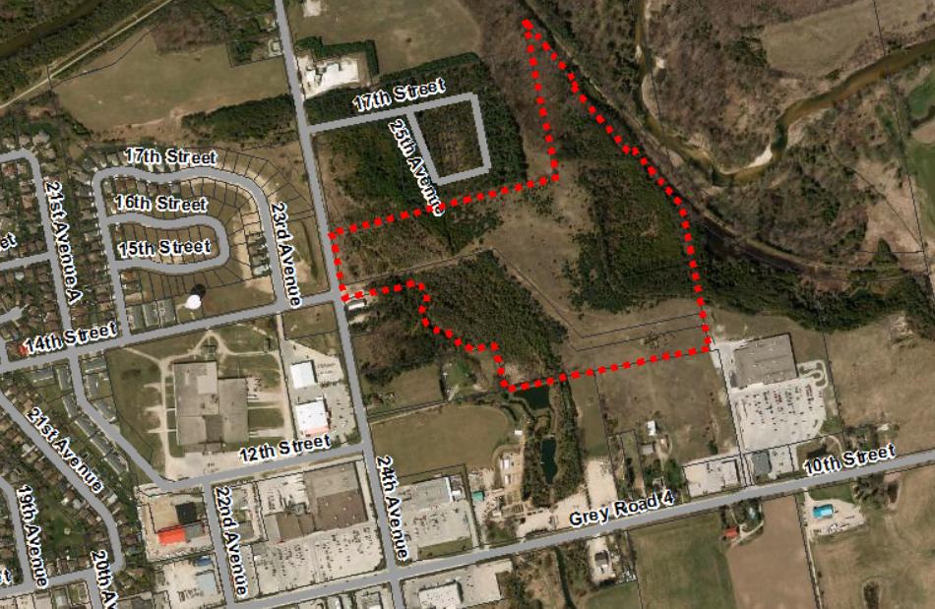

### Figure 1: Subject Lands – Saugeen Cedar Heights East

The revisions propose to increase the number of residential units to a total of 107 units, from the current draft approved total of 99 units. The 107 units consist of 41 detached dwelling lots, 40 lots for semi-detached dwellings, 6 lots for townhouses, and an additional block for 20 additional townhouses. Additional lands for roads, open space, and hazard areas are also included in this subdivision, as per the original draft approval.

The Applicant has submitted a Planning Summary Letter, an Engineering opinion and a Revised Draft Plan. Copies of all background reports and plans can be found at [this link.](https://www.grey.ca/planning-development/planning-applications)

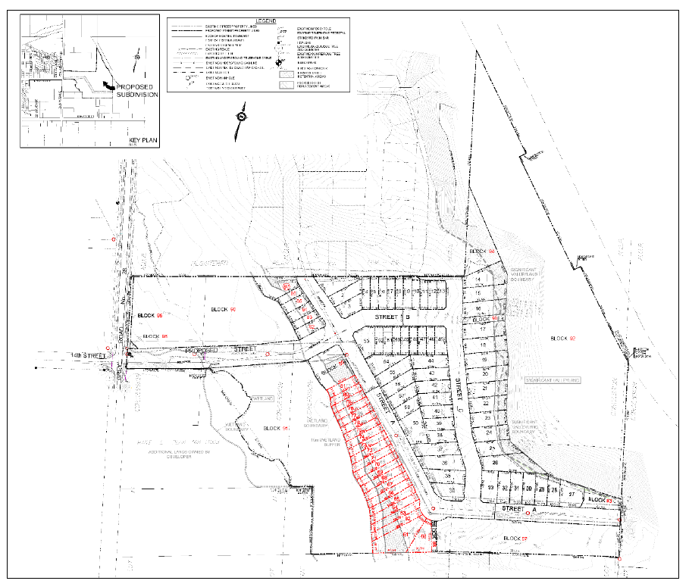

### Figure 2: Proposed Revised Plan of Subdivision

An associated zoning by-law amendment has also recently been approved by the Town of Hanover, in support of this redline revision, and is now in the appeal period.

### Public and Agency Comments Received

#### Public Comments

As part of the planning application process, there were no public comments received.

#### Agency Comments

As part of the planning application process comments were received by the following groups, agencies and public bodies.

##### Saugeen Valley Conservation Authority (GRCA)

In a letter dated April 15, 2020, the SVCA notes that they have no objections to the proposed revisions.

##### Enbridge Gas Inc.

Enbridge Gas Inc. noted that they have no issues in an email dated March 19, 2020.

##### Grey County Transportation Services

In an email dated March 26, 2020, Grey County Transportation Services indicated that a new street entrance permit is required for the proposed access for construction, with a mud mat to be installed. Transportation Services have no further comments.

##### Town of Hanover

In correspondence dated April 30, 2020, the Town of Hanover noted that they support the proposed redline revision, and that zoning by-law amendment 3108-20 has been passed by Town Council. Staff noted that there would be minor tweaks needed to the subdivision agreement prior to registration.

## Analysis of Planning Issues

When rendering a land use planning decision, planning authorities must have regard to matters of Provincial Interest under the *Planning Act*, be consistent with the Provincial Policy Statement (PPS) 2020, and conform to any official plans or provincial plans that govern the subject lands. In this case, the County of Grey Official Plan and the Town of Hanover Official Plan have jurisdiction over the subject property.

A fulsome planning analysis was completed prior to the original draft plan approval in staff report Addendum to PDR-CW-33-18 (linked to in the Attachments section of this report). An abbreviated planning analysis will be provided below, building off the analysis done in the earlier report.

### The Planning Act

Section 1.1 of the *Planning Act* outlines the purposes of the Act. The purposes of the Act promote sustainable economic development, in a healthy natural environment, within a land use planning system led by provincial policy and matters of provincial interest. Section 2 of the *Planning Act* outlines matters of Provincial Interest, which decision makers must be consistent with when carrying out their responsibilities under the Act. Although the proposed revisions will add 8 residential units, the changes will not develop any further lands than were contemplated through the original draft approval. The proponent’s engineer has confirmed that the stormwater management and servicing of the additional units can be accommodated. The subject redline revision application, with the attached revised conditions of draft approval, has regard for matters of Provincial Interest under the *Planning Act* including Section 51(24).

### Provincial Policy Statement (PPS) 2020

A key goal of the PPS is directing new growth to serviced settlement areas, and promoting the vitality of such settlement areas through re-development, infill and intensification. The subject lands have been designated for residential growth and are within a settlement area. The proposed redline revision would have the effect of adding additional residential units, thereby intensifying this development.

Section 1.6.6.1 of the PPS outlines the servicing hierarchy to be utilized in the Province of Ontario. At the top of the hierarchy are municipal water and sewer services. The proposed development will be serviced by municipal water and sewer services, and Town staff have confirmed that sufficient water and wastewater capacities exist to service the additional 8 residential units.

The proposed redline revisions, with the attached revised conditions of draft approval, are consistent with the PPS.

### County Official Plan

The proposed plan of subdivision is designated as ‘Primary Settlement Area’ and ‘Hazard Lands’ within the County’s Recolour Grey Official Plan. Increasing the density in this subdivision more closely aligns with the County’s density policies, than the previously draft approved plan did. The proposed subdivision also provides a good mix of singles, semi-detached, and townhouse dwellings. The lots being amended through this redline to increase the density are bordering on two hazard lands blocks. As a result, this added density would not have any land use compatibility issues with any neighbouring residential or commercial uses.

These lands are fully serviced by municipal water and sewer services and therefore conform to section 5.3 of the County Plan.

Subject to the revised conditions of draft approval attached to this report, the application conforms to the goals and objectives of the County of Grey Official Plan.

### Town of Hanover Official Plan

The subject lands are designated ‘Residential’, ‘Hazard’ and ‘Large Format Commercial’ in the Town of Hanover Official Plan. Town staff have not flagged any conformity issues with the proposed redline revision. As noted earlier in this report, the Town has approved a zoning amendment to support this redline revision.

With the attached recommended revised draft plan conditions, County staff are of the opinion that the proposed redline revision:

1. has regard for matters of Provincial interest under the *Planning Act*;
2. is consistent with the Provincial Policy Statement;
3. conforms to the County of Grey Official Plan; and
4. conforms to the Town of Hanover Official Plan.

## Legal and Legislated Requirements

The application has been processed in accordance with the *Planning Act*.

## Financial and Resource Implications

There are no anticipated financial, staffing or legal considerations associated with the proposed redline revisions, beyond those normally encountered in processing the application. The County has collected the requisite fee for this application.

## Relevant Consultation

Internal: Planning Staff, Transportation Services

External: Town of Hanover, agencies under the Planning Act.

### Appendices and Attachments

[Addendum to PDR-CW-33-18 Saugeen Cedar East Final Report](https://docs.grey.ca/share/public?nodeRef=workspace://SpacesStore/0726f216-c2aa-4f4d-b2ce-7f03ec670168)

*Revised Conditions of Draft Approval (attached)*

# **NOTICE OF DECISION**

**On Application for Revision to Approval of Draft Plan of Subdivision**

**under Subsection 51(45) of the Planning Act**

Draft Plan Approval was originally given by the County to Plan of Subdivision 42T-2018-09 on May 9, 2019. Revised Draft Plan Approval is hereby given by the County of Grey for the application regarding the above noted lands. A copy of the Decision is attached.

**PUBLIC AND AGENCY COMMENTS RECEIVED ON THE FILE**

All written and oral submissions received on the application were considered; the effect of which helped to make an informed recommendation and decision.

**WHEN AND HOW TO FILE A NOTICE OF APPEAL**

Notice to appeal the decision to the Local Planning Appeals Tribunal must be filed with the County of Grey no later than 20 days from the date of this notice, as shown above.

The notice of appeal should be sent to the attention of the Director of Planning and Development of the County, at the address shown below and it must,

(1) set out the reasons for the appeal,

(2) be accompanied by the fee prescribed under the Local Planning Appeals Tribunal Act, and

(3) Include the completed appeal form from the LPAT’s website.

**WHO CAN FILE A NOTICE OF APPEAL**

Only individuals, corporations or public bodies may appeal decisions in respect of a proposed plan of subdivision to the Local Planning Appeal Tribunal. A notice of appeal may not be filed by an unincorporated association or group. However, a notice of appeal may be filed in the name of an individual who is a member of the association or group on its behalf.

No person**\*** or public body shall be added as a party to the hearing of the appeal of the decision of the approval authority, including the lapsing provisions of the conditions, unless the person or public body, before the decision of the approval authority, made oral submissions at a public meeting or written submissions to the council, or made a written request to be notified of changes to the conditions or, in the Local Planning Appeal Tribunal’s opinion, there are reasonable grounds to add the person or public body as a party.

**\***Notwithstanding the above, only a ‘person’ listed in subsection 51(48.3) of the Planning Act may appeal the decision of the County of Grey to the Local Planning Appeal Tribunal (LPAT) as it relates to the proposed plan of subdivision. Below is the prescribed list of ‘persons’ eligible to appeal a decision of the County of Grey related to the proposed plan of subdivision as per subsection 51(48.3) of the Planning Act.  These are recent changes that have been made to the Planning Act by the province. A link to the revised Planning Act can be found here - <https://www.ontario.ca/laws/statute/90p13>. For more information about these recent changes, please visit the LPAT website or contact LPAT - <https://elto.gov.on.ca/tribunals/lpat/about-lpat/>.

The prescribed list of ‘persons’ eligible to appeal a decision of the County on the proposed plan of subdivision as per subsection 51(48.3) of the Planning Act is as follows:

1. A corporation operating an electric utility in the local municipality or planning area to which the plan of subdivision would apply.
2. Ontario Power Generation Inc.
3. Hydro One Inc.
4. A company operating a natural gas utility in the local municipality or planning area to which the plan of subdivision would apply.
5. A company operating an oil or natural gas pipeline in the local municipality or planning area to which the plan of subdivision would apply.
6. A person required to prepare a risk and safety management plan in respect of an operation under Ontario Regulation 211/01 (Propane Storage and Handling) made under the Technical Standards and Safety Act, 2000, if any part of the distance established as the hazard distance applicable to the operation and referenced in the risk and safety management plan is within the area to which the plan of subdivision would apply.
7. A company operating a railway line any part of which is located within 300 metres of any part of the area to which the plan of subdivision would apply.
8. A company operating as a telecommunication infrastructure provider in the area to which the plan of subdivision would apply.

**RIGHT OF APPLICANT OR PUBLIC BODY TO APPEAL CONDITIONS**

The following may, at any time before the approval of the final plan of subdivision, appeal any of the conditions imposed by the approval authority to the Tribunal by filing a notice of appeal with the approval authority: the applicant; any public body that, before the approval authority made its decision, made oral submissions at a public meeting or written submissions to the approval authority; the Minister; or the municipality in which the subject land is located.

**HOW TO RECEIVE NOTICE OF CHANGED CONDITIONS**

The conditions of an approval of draft plan of subdivision may be changed at any time before the final approval is given.

You will be entitled to receive notice of any changes to the conditions of the approval of draft plan of subdivision if you have made a written request to be notified of changes to the conditions.

**GETTING ADDITIONAL INFORMATION**

Additional information about the application is available for public inspection during regular office hours in the Planning & Development Office at the address noted below or by calling 519-376-2205 or 1-800-567-GREY.

**ADDRESS FOR NOTICE OF APPEAL**

**County of Grey**

**595-9th Avenue East**

**OWEN SOUND, Ontario N4K 3E3**

**Attention: Mr. Randy Scherzer, MCIP RPP**

**Director of Planning & Development**

Plan of Subdivision File No. 42T-2018-09 has been revised and granted draft approval. The draft plan is hereby revised. The County’s conditions of final plan approval for this draft Plan of Subdivision are amended as follows:

No. Conditions

1. Condition 1 of the draft plan conditions approved on May 9, 2019 is hereby deleted and replaced with the following:

**That this approval applies to the draft Plan of Subdivision as prepared by Cobide Engineering Inc. dated March 17, 2020, showing 107 residential lots, including 41 lots for detached dwellings (Lots 1 to 3, 14 to 44, 53 to 59), 40 residential lots for semi-detached dwellings (Lots 4 to 13, 45 to 52, and 60 to 81), 6 lots for townhouse dwellings (Lots 82 to 87), future development blocks (94 and 97), drainage block (98), utility corridor (88 and 89), hazard land blocks (90, 91, and 92), temporary turning circle block (93), road widening and daylight triangle (Blocks 95 and 96) and a proposed street (14th Street), and Streets ‘A’, ‘B’ and ‘C’ on Part of Lots 11,12,13 and 14, Concession 1, North of the Durham Road, geographic Township of Bentinck, Town of Hanover, County of Grey.**

1. Condition 2 of the draft plan conditions approved on May 9, 2019 is hereby deleted and replaced with the following:

**That 14th Street and Streets 'A', 'B', and ‘C’ be deeded to the Town of Hanover and named to the satisfaction of the Town of Hanover. In addition, a 3.048 metre (10 foot) widening (Block 95) along Grey Road 28 (24th Avenue), and 10 metre (32.8 foot) daylight (Block 96) at the northeast corner of Grey Road 28 (24th Avenue) and 14th Street shall be deeded to the County of Grey.**

1. Condition 7 of the draft plan conditions approved on May 9, 2019 is hereby deleted and replaced with the following:

**That this draft approval represents the allocation by the Town of Hanover of water and wastewater treatment capacity for one-hundred and seven (107) residential units.**

1. Condition 13 of the draft plan conditions approved on May 9, 2019 is hereby deleted and replaced with the following:

**That the Subdivision Agreement between the owner and the Town contain the following provisions with wording acceptable to the Saugeen Valley Conservation Authority:**

1. **The Developer agrees to carry out or cause to be carried out the works recommended in the Stormwater Management Report, Sediment Control Plan, and Lot Grading Plan.**
2. **The Developer agrees to carry out or cause to be carried out the recommendations in the Environmental Impact Study and Tree Retention Plan.**
3. **The Developer agrees to carry out or cause to be carried out the recommendations in the Floodplain Analysis.**
4. **The Developer agrees to carry out or cause to be carried out the works recommended in the Geotechnical Report and Slope Stability Analysis.**
5. **The Developer agrees to carry out or cause to be carried out notification of subsequent purchasers of properties within tree retention areas, hazard lands, slope setbacks, and the Saugeen Valley Conservation Authority’s Regulated Area for the information of future land owners.**
6. **That Blocks 89, 90, 91, and 92 are labeled as undevelopable Blocks in the Subdivision Agreement.**
7. **That Block 93 be utilized for the purposes of a temporary turning circle, until such time as the street connection south to 10th Street (Grey Road 4) has been established. Once this road connection has been established, should the lands no longer be needed for road or turning circle purposes, Block 93 may be developable for a residential dwelling, subject to meeting the requirements of the Town of Hanover and the Saugeen Valley Conservation Authority.**
8. Condition 14 of the draft plan conditions approved on May 9, 2019 is hereby deleted and replaced with the following:

**That wording be included in the Subdivision Agreement that Blocks 89, 90, 91, and 92 be deeded to the Town of Hanover for stormwater purposes at an appropriate time over the course of the development.**

1. That all other conditions of draft approval as granted on May 9, 2019 remain in effect.