Grey County Logo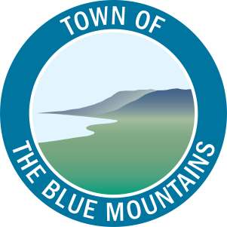

Committee Agenda

# Grey County – The Blue Mountains Task Force September 19, 2019 – 2:30 PM

Heritage Room, Grey County Administration Building

1. **Call to Order**
2. **Declaration of Pecuniary Interest**
3. **Adoption of Minutes**
   1. Grey County – The Blue Mountains Task Force minutes dated June 20, 2019

**That the Grey County – The Blue Mountains Task Force minutes dated June 20, 2019 be adopted as presented.**

1. **Items for Direction and Discussion**
   1. Update on Grey County Services and Funding in The Blue Mountains
   2. Community Improvement Plan Update
   3. Co-Funding for the Blue Mountains Attainable Housing
2. **Other Business**
3. **Next Meeting Date**
   1. To be determined
4. **Adjournment**