Grey County Logo Committee Report

|  |  |
| --- | --- |
| **To**: | Warden Hicks and Members of Grey County Council |
| **Committee Date**: | September 22nd, 2022 |
| **Subject / Report No**: | PDR-CW-31-22 |
| **Title**: | Wilder Lake - Redline Revision – 42T-2019-04 |
| **Prepared by**: | Liz Buckton |
| **Reviewed by**: | Scott Taylor |
| **Lower Tier(s) Affected**: | Township of Southgate |
| **Status**: | Recommendation adopted by Committee as presented per Resolution CW133-22; Endorsed by County Council October 13, 2022, per Resolution CC81-22. |

# Recommendation

1. **That all written and oral submissions received on the proposed redline revisions to plan of subdivision 42T-2019-04 were considered, which helped to make an informed recommendation and decision; and**
2. **That report PDR-CW-31-22 be received, and that in consideration of the draft plan of subdivision 42T-2019-04, and the matters to have regard for under Subsection 51(24) of the Planning Act, the County of Grey Committee of the Whole hereby approves the revised plan of subdivision on lands described as Part of Lots 2, 3 and 4, Concession 21, Part of Part 1, Parts 2 & 3, RP 16R-11219 (Geographic Township of Egremont) in the Township of Southgate.**

## Executive Summary

The report considers a proposed redline revision to the draft plan of subdivision 42T-2019-04, known as Wilder Lake Subdivision. Under the current draft plan approval, there is a total of 29 single detached lots, 1 lot associated with the golf course/clubhouse, 3 blocks for stormwater management, 1 block associated with the dock (Block 34), and 1 future road. The proposed Redlined Revision to the Draft Plan seeks to remove the dock at Wilder Lake (currently forming part of the ‘dock block’, Block 34) from those lands subject to Draft Plan approval and to merge the remainder of that block with the adjacent Lot 6. This will effectively eliminate Block 34 and increase the area of Lot 6.

Three Conditions of Draft Plan Approval are also proposed to be modified as part of the redline revision, being Conditions #7, #26 and #27. The three proposed amended conditions are in relation to the removal of the dock from those lands subject to the draft plan and the merger of the remainder of Block 34 with abutting Lot 6; the acquisition of the Stormwater Management Blocks by the Township, subject to necessary easement and maintenance agreements; and the siting of dwellings on Lot 1 and Lot 7 prior to final approval, subject to the requirements of a Model Home Agreement.

All written and verbal comments regarding the proposed revision were considered and it is recommended that Committee approve the revision to the draft plan.

## Background and Discussion

The County has received a redline revision application that proposes changes to the draft plan of subdivision 42T-2019-04, known as Wilder Lake Subdivision. The proposed subdivision is located on Part of Lots 2, 3 and 4, Concession 21 (geographic Township of Egremont) in the Township of Southgate. Access to the development will be provided via Homestead Road with a future public street (Sunny Rock Drive) servicing the various lots and blocks within the subdivision.

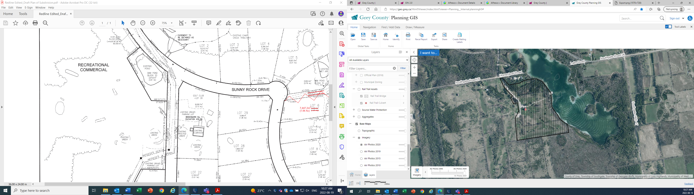

Map 1: Airphoto of Subject Lands

The Applicant has submitted a Planning Brief, a Revised Draft Plan and proposed revised condition wording. Copies of all background reports and plans can be found at [this link.](https://www.grey.ca/planning-development/planning-applications)

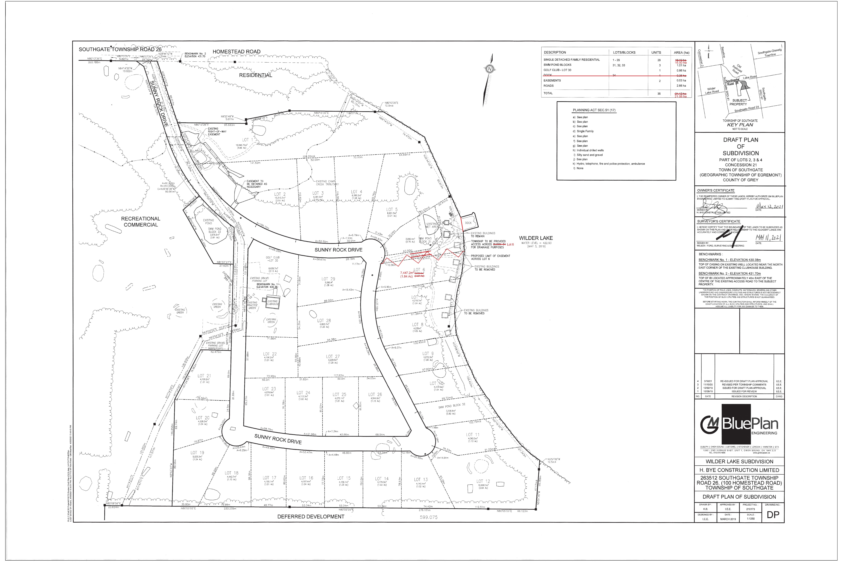

Map 2: Proposed Revised Plan of Subdivision (see redline)

### No further Township planning applications were required with the redline revision.

### Public and Agency Comments Received

#### Public Comments

As part of the redline revision process, public comments were received from local landowners Tom & Heather Arnott and Rob & Monica Caprini. These owners requested certain clarifications around the redline revision and raised questions and concerns relating to:

* ongoing public access to the lake,
* private commercial/event use & zoning permissions,
* dock ownership,
* access and liability considerations,
* lighting, and
* the construction of model homes on the lands, prior to final plan approval.

A comment and response table has been affixed to this report and provides detailed commentary on those matters raised within the public comments submitted. A recommended additional condition of approval arises from this review, as there does appear to be some ongoing intention for private recreational/commercial use of Block 34 in keeping with the existing Open Space zoning permissions.

#### Agency Comments

As part of the redline revision process, comments were received by the following groups, agencies, and public bodies.

##### Saugeen Valley Conservation Authority (SVCA)

SVCA staff advised that they have reviewed the file and related documents and find the redline revision acceptable.

## Analysis of Planning Issues

When rendering a land use planning decision, planning authorities must have regard to matters of Provincial Interest under the *Planning Act*, be consistent with the Provincial Policy Statement (PPS) 2020, and conform to any official plans or provincial plans that govern the subject lands. In this case, the County of Grey Official Plan and the Township of Southgate Official Plan have jurisdiction over the subject property.

A detailed planning analysis was undertaken at the time of the initial draft approval of this plan of subdivision. A link to that planning analysis in staff report Addendum to PDR-CW-16-20 has been included in the Attachments section of this report. What follows is a planning analysis that is focused specifically on the redline revision changes.

### The Planning Act

Section 1.1 of the *Planning Act* outlines the purposes of the Act and promotes sustainable economic development, in a healthy natural environment, within a land use planning system led by provincial policy and matters of provincial interest. Section 2 of the *Planning Act* outlines matters of Provincial Interest, which decision-makers must be consistent with when carrying out their responsibilities under the Act. The redline revision with the attached revised conditions of draft plan approval has regard for matters of Provincial interest under the *Planning Act*, including Section 51(24).

### Provincial Policy Statement (PPS)

The PPS establishes that settlement areas shall be the focus of growth and development. The subject lands have been identified for residential growth and are located within a designated settlement area.

Policies of the PPS are intended to be read comprehensively, and such policies address a broad range of matters such as sewage, water and stormwater, natural hazard and heritage considerations, transportation infrastructure, and promotion of access to public and open spaces.

The proposed redline revision is generally minor in nature and does not undermine the overall consistency of the subdivision with the policies of the PPS, though with consideration to PPS Policy 1.5.1 (c), which encourages the provision of public access to shorelines, Staff note that the redline revision is anticipated to *alter* the initially planned nature of local access to Wilder Lake.

Under the existing approval, Block 34, the dock and three Stormwater Management Blocks were planned to be held as condominium common elements, with each subdivision lot being a parcel of tied land, requiring that all owners would share in ongoing costs and maintenance of such lands and affording each lot owner access over Block 34, to Wilder Lake via the dock.

As outlined within the Planning Brief submitted as part of the redline revision request, the primary reason for the requested modifications relates to the ownership of the dock itself, which was to form part of Block 34. As part of the Draft Plan and Land Titles Absolute application processes, it was determined that the title to the dock itself, which rests on the lakebed of Wilder Lake, may remain with the Crown.

To avoid potential issues during circulation under the Land Titles Absolute process, the dock is proposed to be removed from the Draft Plan lands. Removal of the dock eliminates the requirement for Block 34 as an Open Space amenity block, which eliminates the primary need for a condominium exemption application, given that the Township has now also agreed to accept ownership of the Stormwater Blocks. Upon approval of the proposed draft plan revision, Block 34 will no longer exist, and these lands will instead comprise part of the abutting Lot 6, intended for residential purposes.

Township Council approved a related subdivision agreement on August 18, 2022, which includes provisions for the dedication of the Stormwater blocks to the Township and, further, requires an easement over Lot 6 (formerly described as Block 34) for related drainage purposes. As broad easements or requirements for public and/or subdivision-lot owner access over these lands, to Wilder Lake do not form a component of the approved agreement, it is inferred that the Township is generally satisfied that the alternate existing access points to Wilder Lake are adequate to accommodate visitation by the interior lot owners within the subdivision who will not have their own direct access to the lake.

It is concluded that the proposed redline revision, subject to the attached revised conditions of draft plan approval, is consistent with the PPS.

### County Official Plan

The proposed plan of subdivision is on lands designated as ‘Inland Lakes & Shoreline’ and ‘Hazard Lands’ in the County Official Plan. The Inland Lakes & Shoreline area is identified as a ‘Settlement Area’, intended to accommodate low-density residential dwellings, resource-based recreational uses, and other compatible and ancillary uses.

Subject to the revised conditions of draft plan approval attached to this report, staff are of the opinion the redline revision application generally conforms to the goals and objectives of the County of Grey Official Plan.

### Public Access and Accountability Tools

As identified above, the proposed redline revision has general regard for matters of Provincial Interest under the Planning Act, is consistent with the policies of the PPS and conforms to the Official Plan. Accordingly, approval of the redline revision is recommended.

Staff note, however, that in foregoing the parcel-of-tied land approach for the former Block 34 lands (dock block), the proposed manner of public access to Wilder Lake is altered, and future Owners within the Subdivision would not be expected to have a right of use or access over the Block 34 lands or the dock, to access Wilder Lake from within the subdivision. As this former dock block (other than the dock itself) will now form part of privately-owned Lot 6, the use of these lands will be at the discretion of this private lot owner, in-keeping with the Open Space zoning permissions of the Zoning By-law and other by-law requirements and standards of the Township.

Through discussion with the proponent and their Planner, Staff understand that there remains an intention to resolve or formalize ownership, license or use permissions for the dock abutting these lands, and to subsequently extend access permissions, by right-of-way, over the part of Lot 6 comprising the former Block 34 to the benefit of the lots within the subdivision. The approval of such future Planning Act application would be at the discretion of the Township. County Staff would generally recommend that the Township, in considering future easements for public access, have regard for the interplay of such proposed public access together with:

A) the Township’s easement across Lot 6 (formerly Block 34) for Stormwater Management Facility access and drainage purposes; and,

b) the exercise of private/commercial/outdoor recreational use-permissions under the Zoning By-law, by the private owner of the enlarged Lot 6 and the ways in which such use may functionally impact upon access/use by other authorized owners.

County Staff regard the parcel-of-tied land approach as being a well-suited tool to balance these various interests and functional compatibility, while maintaining the lands in shared ownership/ responsibility for administration by the related Condominium Board. Should Ownership of the dock be resolved in the near future, reconsideration of this approach is encouraged.

## Legal and Legislated Requirements

The application has been processed in accordance with the *Planning Act*.

## Financial and Resource Implications

There are no anticipated financial, staffing, or legal considerations associated with the proposed redline revisions beyond those normally encountered in processing the application. The County has collected the requisite fee for this application.

## Relevant Consultation

Internal: Planning and Legal Services Staff

External: Township of Southgate, members of the public who requested notice of decision on the original subdivision application, and agencies under the *Planning Act*.

### Appendices and Attachments

# [Addendum to PDR-CW-16-20 Wilder Lake Subdivision Final Report 42T-2019-04](https://docs.grey.ca/share/public?nodeRef=workspace://SpacesStore/73464b7a-42fc-478c-96f5-1a71b6fbcd5f)

*Revised Conditions of Draft Approval*

*Public Comment and Response Table*

# **NOTICE OF DECISION**

**On Application for Revision to Approval of Draft Plan of Subdivision**

**under Subsection 51(45) of the Planning Act**

Draft Plan Approval was originally given by the County to Plan of Subdivision 42T-2019-04 on July 8th, 2021. Revised Draft Plan Approval is hereby given by the County of Grey for the application regarding the above noted lands. A copy of the Decision is attached.

**PUBLIC AND AGENCY COMMENTS RECEIVED ON THE FILE**

All written and oral submissions received on the application were considered; the effect of which helped to make an informed recommendation and decision.

**WHEN AND HOW TO FILE A NOTICE OF APPEAL**

Notice to appeal the decision to the Ontario Land Tribunal must be filed with the County of Grey no later than 20 days from the date of this notice, as shown above.

The notice of appeal should be sent to the attention of the Director of Planning and Development of the County, at the address shown below and it must,

(1) set out the reasons for the appeal,

(2) be accompanied by the fee prescribed under the Ontario Land Tribunal Act, and

(3) Include the completed appeal form from the OLT’s website.

**WHO CAN FILE A NOTICE OF APPEAL**

Only individuals, corporations or public bodies may appeal decisions in respect of a proposed plan of subdivision to the Ontario Land Tribunal. A notice of appeal may not be filed by an unincorporated association or group. However, a notice of appeal may be filed in the name of an individual who is a member of the association or group on its behalf.

No person**\*** or public body shall be added as a party to the hearing of the appeal of the decision of the approval authority, including the lapsing provisions of the conditions, unless the person or public body, before the decision of the approval authority, made oral submissions at a public meeting or written submissions to the council, or made a written request to be notified of changes to the conditions or, in the Ontario Land Tribunal’s opinion, there are reasonable grounds to add the person or public body as a party.

**\***Notwithstanding the above, only a ‘person’ listed in subsection 51(48.3) of the Planning Act may appeal the decision of the County of Grey to the Ontario Land Tribunal (OLT) as it relates to the proposed plan of subdivision. Below is the prescribed list of ‘persons’ eligible to appeal a decision of the County of Grey related to the proposed plan of subdivision as per subsection 51(48.3) of the Planning Act.  These are changes that have been made to the Planning Act by the province. A link to the revised Planning Act can be found here - <https://www.ontario.ca/laws/statute/90p13>. For more information about these recent changes, please visit the OLT website or contact OLT - <https://olt.gov.on.ca/about-olt/>.

The prescribed list of ‘persons’ eligible to appeal a decision of the County on the proposed plan of subdivision as per subsection 51(48.3) of the Planning Act is as follows:

1. A corporation operating an electric utility in the local municipality or planning area to which the plan of subdivision would apply.
2. Ontario Power Generation Inc.
3. Hydro One Inc.
4. A company operating a natural gas utility in the local municipality or planning area to which the plan of subdivision would apply.
5. A company operating an oil or natural gas pipeline in the local municipality or planning area to which the plan of subdivision would apply.
6. A person required to prepare a risk and safety management plan in respect of an operation under Ontario Regulation 211/01 (Propane Storage and Handling) made under the Technical Standards and Safety Act, 2000, if any part of the distance established as the hazard distance applicable to the operation and referenced in the risk and safety management plan is within the area to which the plan of subdivision would apply.
7. A company operating a railway line any part of which is located within 300 metres of any part of the area to which the plan of subdivision would apply.
8. A company operating as a telecommunication infrastructure provider in the area to which the plan of subdivision would apply.

**RIGHT OF APPLICANT OR PUBLIC BODY TO APPEAL CONDITIONS**

The following may, at any time before the approval of the final plan of subdivision, appeal any of the conditions imposed by the approval authority to the Tribunal by filing a notice of appeal with the approval authority: the applicant; any public body that, before the approval authority made its decision, made oral submissions at a public meeting or written submissions to the approval authority; the Minister; or the municipality in which the subject land is located.

**HOW TO RECEIVE NOTICE OF CHANGED CONDITIONS**

The conditions of an approval of draft plan of subdivision may be changed at any time before the final approval is given.

You will be entitled to receive notice of any changes to the conditions of the approval of draft plan of subdivision if you have made a written request to be notified of changes to the conditions.

**GETTING ADDITIONAL INFORMATION**

Additional information about the application is available for public inspection during regular office hours in the Planning & Development Office at the address noted below or by calling 519-376-2205 or 1-800-567-GREY.

**ADDRESS FOR NOTICE OF APPEAL**

**County of Grey**

**595-9th Avenue East**

**OWEN SOUND, Ontario N4K 3E3**

**Attention: Mr. Scott Taylor, MCIP RPP**

**Director of Planning**

Plan of Subdivision File No. 42T-2019-04 has been revised and granted draft approval. The draft plan is hereby revised in-keeping with the redline plan annotations submitted as part of the revision application. The County’s conditions of final plan approval for this draft Plan of Subdivision are amended as follows:

No. Conditions

1. Condition 1 of the draft plan conditions approved on July 8th, 2021 is hereby amended by adding the words ‘**as further amended by redline revision**’ following ‘last revised March 18th, 2021) and by deleting item ‘d’ and the text ‘1 block associated with the dock (Block 34)’, and re-lettering item ‘e’, accordingly.
2. Condition 7 of the draft plan conditions approved on July 8th, 2021 is hereby deleted and replaced with the following:

**That Blocks 31-33 be deeded to the Township for stormwater management purposes. The subdivision agreement shall include provisions with respect to any easements required by the Township to provide any future access to the blocks to the satisfaction of the Township of Southgate and the County of Grey. Requirements related to general maintenance of Blocks 31-33 (i.e. access for grass cutting and related care of the blocks) shall be stipulated in a separate agreement between the Developer and the Township.**

1. Condition 26 of the draft plan conditions approved on July 8th, 2021 is hereby deleted and replaced with the following:

**The Draft Plan conditions acknowledge that at the locations of proposed Lots 1 and 7 on the draft development drawings will have residences located on the property and prior to subdivision approval. It is the responsibility of the applicant to ensure the residences are properly situated in the final plan of subdivision for approval relative to property line setbacks, road design and property access to Lots 1 and 7. The residences established on Lots 1 and 7 will be subject to the requirements of a Model Home Agreement between the Developer and the Township.**

1. Condition 27 of the draft plan conditions approved on July 8th, 2021 is hereby deleted and replaced with the following:

**That prior to final approval, that the 6 cottages to the south of the dock are to be demolished and removed from the property and that zoning provisions be included for the relevant portion of Lot 6, as part of the zoning amendment to allow that two of the existing cottages/buildings can be retained and used as a change room use to support the use of Wilder Lake for recreational purposes, but neither structure can be used for the purpose of overnight accommodations.**

1. That all other conditions of draft approval as granted on July 8th, 2021 remain in effect.

|  |  |  |
| --- | --- | --- |
| Comments Provided By: | Theme/Summary of Consideration Raised | County Staff Commentary |
| Arnott, Heather & Tom | Ongoing Public Access to the Lake; Private Event Use & Zoning Permissions:  These local landowners express concern regarding the zoning/permitted uses and future nature of uses that may occur upon Block 34 and the abutting dock. They ask, for example, if this area will still be used for golf course events, weddings, other commercial events, and if ongoing access by local owners will be permitted.  They note that this arrangement had been proposed initially by the applicant, but it had been discouraged by the Township due to the limitations of private ownership over the balance of time, in facilitating ongoing public access to the dock/lake.  The landowners question if other existing public access points to the lake are adequate to accommodate access in absence of Block 34.  They further query the Open Space (OS) Zoning applicable to the block and question if this is appropriate for the enlarged privately owned lot (i.e. would R5 be more appropriate for the proposed privately owned lands?) | Former Block 34, which is proposed to be consolidated with abutting Lot 6 via Redline Revision, is subject to the OS-503 zone of the Township’s Zoning By-law.  The core OS Zone, addressed at Section 27.1 of the By-law, permits:  (a) A public park, private park, golf course, outdoor recreational use, recreational use, forestry, or conservation  (b) Agricultural uses, other than a livestock operation and buildings or structures accessory thereto  (c) Uses, buildings and structures accessory to the uses permitted in Clause (a) and (b) above.  The site-specific zoning exception articulates that there is to be no overnight accommodation on the lands; that toilets/ restrooms may only be provided on a temporary, seasonal basis; and, further requires that all lighting be dark-sky compliant/directed downwards to prevent light trespass. The zoning exception also deems existing structures to comply with the by-law.  The above permissions facilitate ongoing private outdoor/recreational use of the lands which is understood to include permissions for ancillary gatherings or events.  Under the present draft plan approval and conditions, the dock access area (Block 34) and retained cabin structures, together with the Stormwater Management (SWM) Blocks were to be established as common elements through a condominium exemption process with the Lots being ‘parcels of tied land’. This approach addressed the Township’s position at the time, that the SWM blocks would not be assumed by the Township for ongoing maintenance purposes. The tied-land approach would have established that these blocks of land would be instead administered and maintained by the condominium corporation, with financial contribution from all subdivision lot owners.  With the Township having now updated their position such that assumption of the SWM Blocks into their public ownership is generally acceptable (subject to maintenance agreements for the lands), the applicant proposes that Block 34 would no longer be held as a common element and would instead be merged with Lot 6, the abutting residential lot, which is zoned R5.  While split-zoning of lands is appropriate in a wide variety of circumstances to facilitate different uses on different parts of a property, it has been identified by local property owners that in this circumstance, the change to the planned ownership/administration of the lands creates potential functional and accountability concerns for neighbours, despite the fact no zoning change has been proposed.  Under the approved common element/tied-land approach, where the Block 34 lands were to be administered by a Condominium Corporation, there would presumably have been an agreement established between the condominium board and any private or commercial user of Block 34, to govern use, maintenance, liability/insurances, etc. for the lands. This agreement and the shared responsibility for the lands would be expected to provide lot owners with recourse to address and negotiate change around use of the lands for private recreational purposes (i.e. on a commercial basis) should concerns arise. Further, under such arrangement all landowners within the subdivision would be able to access Block 34 and the abutting dock.  Under the proposed redline revision, Block 34 will be privately-owned by the residential lot owner (together with Lot 6) and while easements will be established to facilitate Township access to the abutting SWM pond (Block 31) and for drainage purposes, the redline request does not articulate any requirement to maintain public use or access to the lands or abutting dock, though this remains an intent of the proponent over the mid-term, once Ownership of the abutting dock is resolved.  Future use of the former Block 34 lands, for example for private/commercial recreational use, would continue to be permitted based on lands subject to the existing Open Space Zoning following redline approval, however being held in private ownership, the nature, frequency and duration of use would be at discretion of that private landowner, rather than being administered by the Condominium Board via use agreements.    While the intention of the proponent is to maintain personal Ownership of Lot 6, and to facilitate ongoing public recreational use of the lands (subject to the Dock Ownership being resolved) together with the hosting of occasional gatherings or special events, Staff suggest that the status-quo use of the lands and any informal standing arrangements with the current owner should not be relied upon to facilitate ongoing local public access to the Lake, nor to address any potential for disruptive private/commercial use of these lands over the long-term. The application of formal planning tools, is preferred.  Based upon discussion with Township Staff regarding the applicable Open Space zoning and related land use permissions, County Staff understand that local Staff are generally satisfied with the various tools available to the Township for enforcement purposes, should concerns regarding use of these lands arise. In addition to the Zoning By-law, the Township has a Noise By-law in effect, and an Illumination By-law (i.e. Dark Sky) is in process.  Regarding provision of access to Wilder Lake, Staff note that approval of the related Subdivision Agreement was granted by Township Council on August 18th,2022. Accordingly, Staff understand that the Township supports the proposed redline revision in-principle and specifically, that there is an intent by the Township to assume the SWM blocks (Blocks 31, 32, 33) for ownership purposes, subject to necessary easements and agreements relating to maintenance of the lands.  As broad easements or requirement for public access over Block 34 to Wilder Lake do not form a component of the approved Agreement, it is inferred that the Township is generally satisfied that the alternate access points to Wilder Lake are adequate to accommodate visitation by the interior lot owners within the subdivision who will not have direct access to the Lake. |
| Dock Ownership and By-law conformity; Lighting:  The landowners ask for clarification regarding the ownership of the dock itself (it has been established that lakebed remains with the crown).  The landowners note 22 existing lights on Block 34 and the dock. They query the need for such lighting in a non-commercial context, and the future intent of the Township in ensuring by-law conformity/enforcement for these lands. | County Staff understand that ownership of the lakebed remains with the Crown however do not have an explicit understanding of ownership/responsibility for the dock abutting Block 34 (which is proposed for consolidation with Lot 6).  In conversation with the proponent’s Planner, Staff understand that investigation around the dock ownership continues, though the dock has been removed from the lands subject to the draft Plan of Subdivision (via this redline) to eliminate title or other issues that such ambiguity may create as the lands are legally prepared for registration of the Plan.  While the dock itself is proposed to be excluded from those lands subject to the draft plan approval via the redline revision, a clearer understanding of Ownership may be useful to inform the need for any additional easements over Block 34, for example to provide access for dock maintenance purposes.  In considering any future easement for public access purposes across former Block 34, Staff would recommend that the Township consider the interplay of such proposed public access together with:  a) the Township’s easement across Lot 6 for Stormwater Management Facility access and drainage purposes; and,  b) the exercise of private/commercial/outdoor recreational use-permissions under the Zoning By-law, by the private owner of the enlarged Lot 6 and the ways in which such use may functionally impact upon access/use by other authorized persons.  County Staff regard the parcel-of-tied land approach as being a well-suited tool to balance these various interests and functional compatibility, while maintaining the lands in shared ownership/ responsibility for administration by the related Condominium Board. Should Ownership of the dock be resolved in the near future, reconsideration of this approach is encouraged.  Regarding lighting of the dock, County Staff understand that the Township has been working on an Illumination/Dark Sky Lighting by-law, which may be applicable in this circumstance. County Staff would generally direct local landowners to discuss lighting matters or concerns with the Township directly, as with passing of such by-law the Township would be empowered to enforce these by-law provisions. |
| Liability:  The landowners query if the Township retains any liability relating to use of Block 34, and the dock by the public. | An easement is required across Block 34 (to be consolidated with Lot 6) to ensure appropriate municipal access to the SWM block and for drainage-related purposes. No broad ‘public access’ easement is contemplated across Block 34 to provide access to the dock and it is County Staff’s understanding that these lands would be administered and insured as private property. |
| Model Homes:  The landowner queries why an additional model home is requested on Lot 7 (i.e. why not Lot 6 as initially proposed?). | Staff understand that this is a matter of landowner preference and would suggest that this change is not functionally relevant to the redline revision. Further, staff note that the use of Model Home Agreements to address the construction of dwellings prior to final approval is quite typical. Such agreements routinely articulate and address such construction as being at the applicant’s own risk, and often include provisions that address timing of construction, outline interim use of such structures (e.g. sales office) and set out any necessary conditions or restrictions relating to residential occupancy of the dwelling. |
| Caprini, Rob & Monica | Ongoing Public Access to the Lake; Private Event Use & Zoning Permissions:  These landowners note that the existing cottages and dock on Block 34 have been historically used for commercial purposes, in addition to providing local public access. They query if the developer will be required to remove the cottages and alter the dock to conform to the residential nature of other lakefront lots within the subdivision.  They additionally query future use of the dock and any recourse of the neighbours relating to ongoing commercial use, within the context of a residential development.  The letter encourages the Township to consider the potential impacts upon the other existing public access points to the lake due to increased usage, should public access at Block 34 be eliminated. The landowners request clarification what permissions exist for other lot owners to establish docks or boathouses for private lake access, in absence of public access via Block 34. | As above. |
| Dock Ownership  The landowners request clarification on the ownership of the dock in the instance where the land beneath the dock is Crown Land (as is understood to be the case) and in the circumstance where the land beneath the dock is privately owned but not by the Crown.  They further opine that indeterminate ownership of the dock may pose problems for the future owner of Block 34/Lot 6. | As above. |
| SVCA | “Please be advised that the SVCA has reviewed the above noted file, and the related documents. Please be advised that the SVCA find the redline revision acceptable.” | No comment/requirement. |