NOTICE OF COMPLETE APPLICATION AND PUBLIC MEETING
WE WANT TO HEAR FROM YOU
WHAT: The County is seeking input on a development application within 120 metres of your property that would consider allowing a 22 lot plan of subdivision.
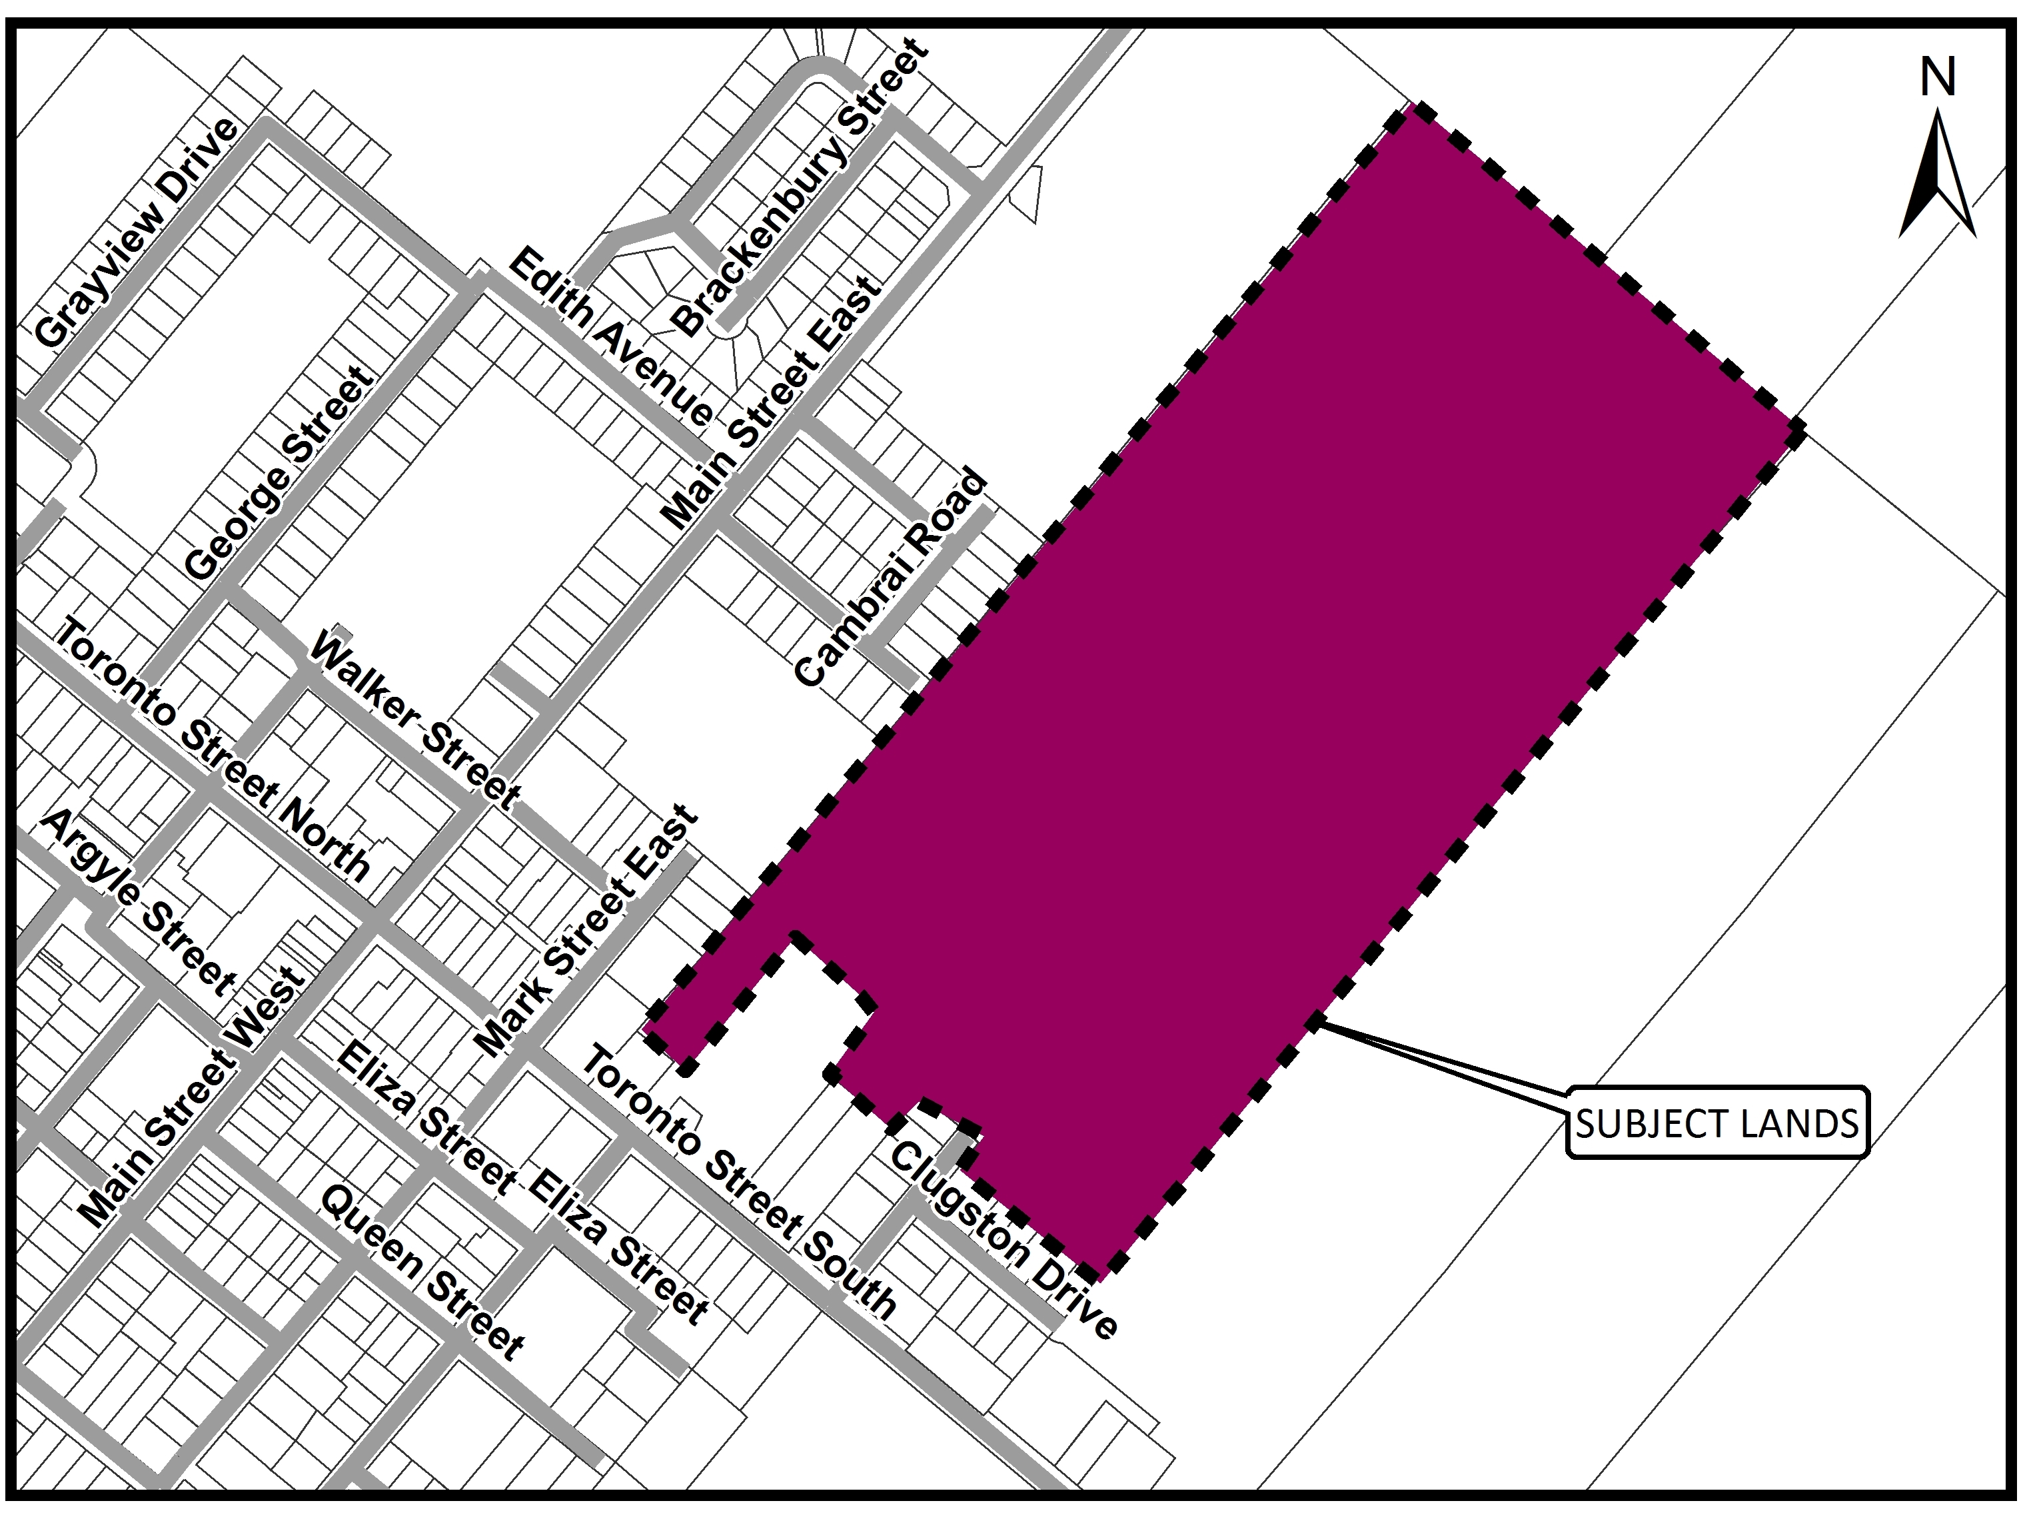
SITE: Located at Part Lot 5, Jones Range, Township of Georgian Bluffs, in the geographic Township of Keppel.

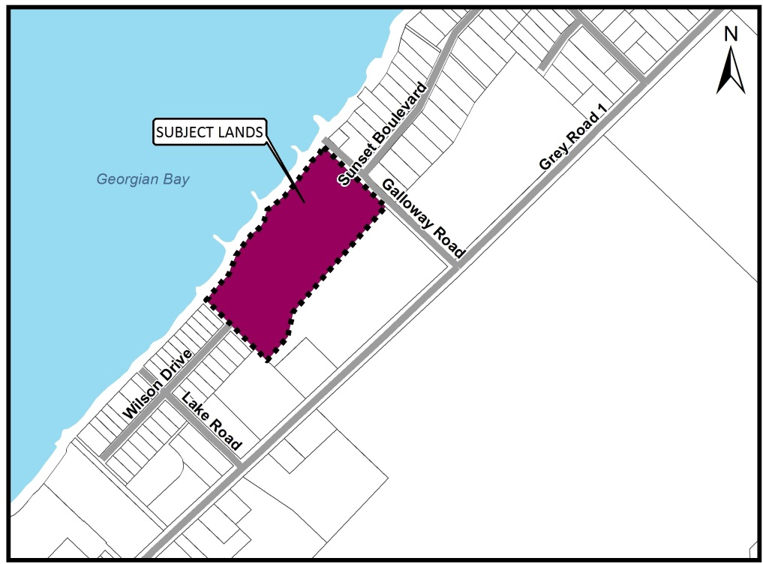

Location of Public Meeting – Township of Georgian Bluffs Municipal Office (Council Chambers) at 177964 Grey Road 18, Springmount, Ontario

Timing of Public Meeting – Wednesday, June 20th, 2018 at 7:00 p.m.
How can I contribute my opinion?
Any person or agency may attend the Public Meeting and/or make verbal or written comments regarding this proposal.

Request for information:
For information, including all supporting studies and reports for the proposed Plan of Subdivision visit:
www.grey.ca/planning-development/planning-applications

How do I submit comments?
Submit written comments or sign-up to be notified of a decision by mailing or contacting:

Scott Taylor
County of Grey Planning Department
595 9th Avenue East
Owen Sound, ON, N4K 3E3
scott.taylor@grey.ca
519-372-0219 ext. 1238

What is being proposed through this application?
Below is a map showing the proposed plan of subdivision. A full version of this map is available on the County website, or at the County offices in Owen Sound.
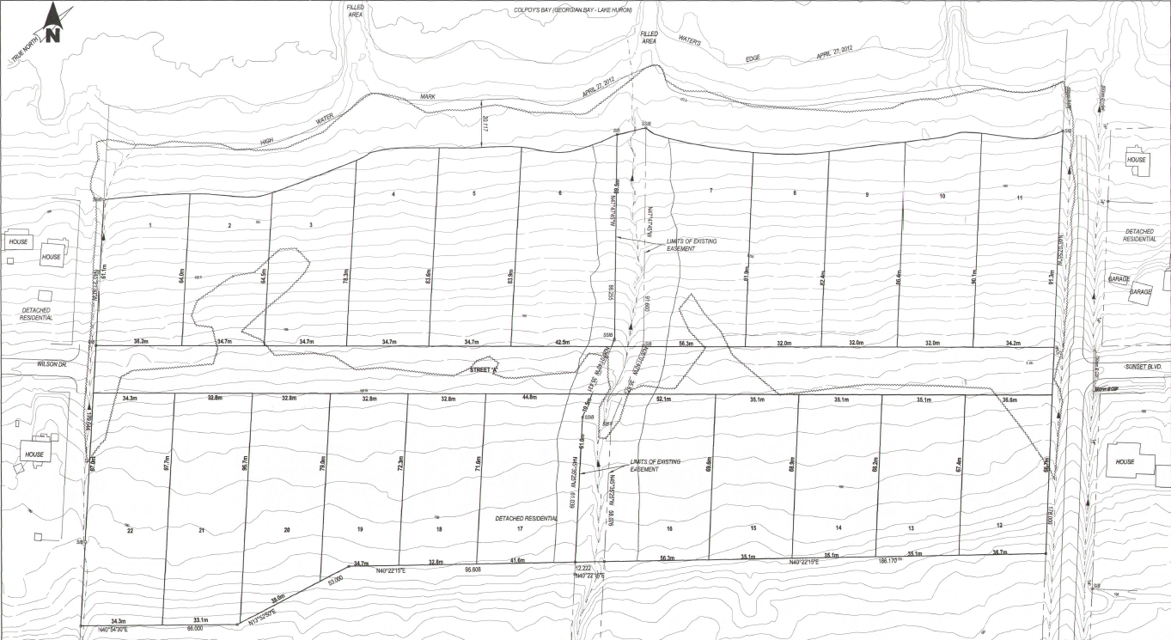
The purpose and effect of the plan of subdivision is to create a twenty-two (22) lot plan of subdivision for detached residential dwellings on approximately 7.1 hectares of land. The proposed plan of subdivision application is a re-submission of an application that was draft approved in March 2015, but lapsed earlier in 2018. The current proposal is seeking to reinstate the 22 lot plan of subdivision. The lots would front onto a new road that would connect Sunset Boulevard to Wilson Drive. The new 2018 plan of subdivision is the same as what was previously draft approved in 2015. Conditional approvals have already been issued by the Niagara Escarpment Commission on the development permit applications associated with this subdivision.

What can I expect at the Public Meeting?
The public meeting is an opportunity for members of the public to learn more about the proposed development. Attendees have the opportunity to hear a brief presentation about the development, ask questions, and/or make statements either in favour of, or in opposition to the development. At the meeting members of the public will also hear a summary of any comments received about the proposed development prior to the public meeting.
The public meeting will take place at a meeting of Council and the Mayor or Chair will act as the moderator for the meeting. The moderator will keep the meeting in order and allow the applicant (and their development team), the public, and members of Council to speak and ask questions.
This meeting is an opportunity to learn about the proposed development application and provide feedback.

Why is this Public Meeting being held and what are your rights?
Within Ontario the planning and development process is an open and transparent process, where opinions from all individuals and groups are welcomed. By law a municipality must hold a public meeting, and this meeting is just one of your chances to learn about the development proposal and offer your opinions. Under the legislation governing this development, which is Section 51of the Planning Act, you have the following rights:
- Any persons may attend the public meeting and/or make written or verbal representation either in support of or in opposition to the proposed plan of subdivision.
- If a person or public body would otherwise have an ability to appeal the decision of County of Grey in reference to the plan of subdivision, to the Local Planning Appeal Tribunal but the person or public body does not make oral submissions at a public meeting or make written submissions to Grey County before a decision is rendered on the subdivision, the person or public body is not entitled to appeal the decision.
- If a person or public body does not make oral submissions at a public meeting, or make written submissions to County of Grey in reference to the plan of subdivision, before a decision is rendered on the subdivision, the person or public body may not be added as a party to the hearing of an appeal before the Local Planning Appeal Tribunal unless, in the opinion of the Tribunal, there are reasonable grounds to do so.
- If you wish to be notified of the decision of the County of Grey in respect to the approval or refusal of the plan of subdivision, you must make a written request to the County, at the addresses noted on the previous page. Please note the project name “Boulter Estates” or the plan of subdivision file # 42T-2013-04.
If you have any questions please do not hesitate to contact County staff, who would be happy to answer any questions on the matter.
Dated at Owen Sound this 22nd day of May, 2018.

