Grey County Logo Committee Report

| **To**: | Warden Hicks and Members of the Committee of the Whole |
| --- | --- |
| **Committee Date:** | November 12, 2021 |
| **Subject / Report No:** | HDR-CW-24-21 |
| **Title:** | Purchase of a Building for Transitional/Supportive Housing |
| **Prepared by:** | Anne Marie Shaw, Director of Housing |
| **Reviewed by:** | Kim Wingrove, CAO |
| **Lower Tier(s) Affected:** | All |
| **Status:** | Recommendation adopted by Committee as presented per Resolution CW182-21; Endorsed by County Council November 25, 2021 per Resolution CC87-21; |

## Recommendation

1. **That Report HDR-CW-24-21 regarding the purchase of land and a building for developing transitional/supportive housing be received; and**
2. **That pursuant to the terms of a conditional Agreement of Purchase and Sale dated November 2, 2021 Grey County purchase the land and building located at 396 14th Street West, Owen Sound, legal description:** **PT PARKLT 14-15 RANGE 1 WR PL OWEN SOUND AS IN R493973; S/T R514577, R74342; OWEN SOUND, PIN 37047-0097 for the purpose of developing transitional/supportive housing, subject to satisfaction of due diligence inspections, for a purchase price of $1,200,000; and**
3. **That in accordance with the Acquisition of Land Procedure (G-GEN-003-002) a by-law be brought forward to approve the purchase and to delegate to the Chief Administrative Officer, in consultation with the Director of Housing and the Director of Legal Services, the authority to take all necessary steps to conclude the purchase, including waiving or releasing the County’s inspection conditions in the Agreement of Purchase and Sale and**
4. **That the purchase of the property be funded from the Social Services Relief Fund Phase Four.**
5. **That staff be directed to initiate an RFP process to secure the services of an architect to complete site plan and building renovation plans and bring the RFP results to a meeting of the Affordable Housing Task Force for consideration.**

## Executive Summary

As the Consolidated System Service Manager, Grey County is responsible for providing affordable, temporary and emergency housing for those experiencing homelessness in our community. This purchase of property proposed in this report will enable the formation of a partnership in which the County provides the building and community partners provide the supportive services for those most in need in our communities.

The County received $1,989,200 in phase four of Social Services Relief Fund (SSRF). The funds can be used for the acquisition of a building and renovations to increase supportive and transitional housing availability.

The property and building located at 396 14th Street West, Owen Sound is felt to be very suitable for the purpose of transitional/supportive housing. Staff were as successful in negotiating a conditional Agreement of Purchase and Sale to purchase the land and building.

Staff are recommending that Council approve the purchase of the property, subject to the completion of a due diligence review of site suitability.

## Background

The County needs safe and stable temporary housing for those experiencing homelessness in our community. The County’s By-Name List currently has 36 people experiencing chronic homelessness, meaning they have been homeless for more than six months of the year, that are waiting for housing and services. Community partners such as Grey Bruce Health Services and Canadian Mental Health Association have people on their waitlists in need of supportive housing.

A partnership in which the County provides the bricks and mortar housing and community partners provide onsite supportive services, would provide badly needed safe and secure alternate housing.

The County received $1,989,200 in Phase four of the Social Services Relief Fund (SSRF) from the Province. The funding can be used for the purchase and renovation of a building to increase supportive and transitional housing availability. The funding cannot be used for a new build due to the tight timelines in the SSRF program. The property must be acquired by March 1, 2022 and the building renovation completed by March 2023.

Staff undertook a search for suitable properties. They identified the subject lands as having potential. Salter Pilon Consulting was hired to carry out a site analysis of a building located at 396 14th Street West in Owen Sound as a candidate for supportive housing. The location is ideal as it is close to the Salvation Army and Grey County Housing buildings. Adjacent properties are mainly commercial use. The building is currently being used by one or more commercial tenants as a warehouse, gym and offices; staff propose to negotiate with any tenants under leases to have them release their lease so that their space may be converted. The layout provides a blank space in which to convert into 8-10 single units and provide a room for a hub for individuals to attend; it currently has offices that would remain for staff use. Staff are recommending that Council approve the purchase of the property, subject to staff being satisfied with the results of the site and environmental investigations.

At the Affordable Housing Task Force meeting October 26, 2021 staff were directed to negotiate a conditional purchase of the building located at 396 14th Street West, Owen Sound for the purpose of transitional/supportive housing. Staff were successful in negotiating a conditional Agreement of Purchase and Sale to purchase the land and building. The Agreement, which is conditional on satisfactory site and environmental investigations and County Council approval was drafted by the County’s realtor, in conjunction with the Clerk’s office and Legal Services, and through negotiations with the owners of the property and their realtor. It was signed November 4, 2021.

In order to carry out the environmental investigations, staff have enlisted GM BluePlan to complete a Phase One and Phase Two Environmental Site Assessment, as well as file any necessary Record of Site Condition with the Ministry of Environment, Conservation and Parks. The condition states Grey County has until December 23, 2021 to obtain an environmental site assessment that is satisfactory. If all conditions are satisfied, the County would obtain title to the property by January 20, 2022.

Staff will be returning to the Affordable Housing Task Force with a workplan for this project and the results of the RFP to retain an architect to develop the site plan and renovation plan for the property.

### Figure 1 – Map of Subject Lands

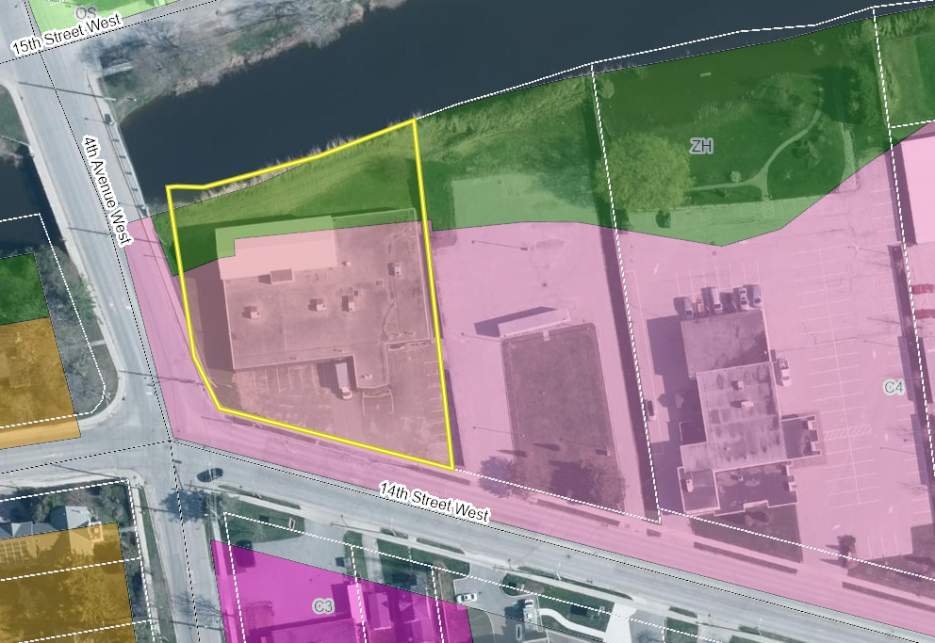

## Legal and Legislated Requirements

Pursuant to the Acquisition of Land Procedure (G-GEN-003-002), a by-law must be brought forward to approve the purchase.

Under the SSRF Funding requirements, the County is required to enter into an agreement with the Province by December 31, 2021.

The property may be subject to leases in favour of one or more current tenants. Releases of these leases may be necessary in order to require the tenants to vacate the property.

## Financial and Resource Implications

The owners have executed a conditional Agreement of Purchase and Sale with the County for the purchase price of $1,200,000.

The Purchase of the property be funded from the Social Services Relief Fund Phase 4.

## Relevant Consultation

Internal: CAO, Planning, Grey Roots, Clerks’ Office, Legal Services

External: Salter Pilon, City of Owen Sound Staff, GM Blue Plan, Realtor, Grey Sauble Conservation Authority

## Appendices and Attachments

[Conditional Agreement](https://docs.grey.ca/share/public?nodeRef=workspace://SpacesStore/0f7ac2f6-7a4b-4f15-8536-81f35fd922cd)