Grey County Logo Committee Report

| **To**: | Warden Hicks and Members of Grey County Council |
| --- | --- |
| **Committee Date:** | March 11, 2021 |
| **Subject / Report No:** | County Official Plan Amendment 42-04-360-OPA-07 / Report PDR-CW-09-21 |
| **Title:** | Thompson Official Plan Amendment Merit Report |
| **Prepared by:** | Stephanie Lacey-Avon |
| **Reviewed by:** | Randy Scherzer |
| **Lower Tier(s) Affected:** | Township of Chatsworth |
| **Status:** | Recommendation adopted by Committee as presented per Resolution CW56-21; Endorsed by Council per Resolution CC29-21. |

## Recommendation

1. **That Report PDR-CW-09-21 regarding a proposed County Official Plan Amendment be received; and**

## **That the proposal proceeds to a Public Meeting to consider an amendment to the County of Grey Official Plan on lands designated ‘Rural’ and ‘Hazard Lands’, to re-establish two parcels that inadvertently merged, with frontage along Connell Lake Road at 200 and 201 Connell Lake Road, Concession 10 EGR PT Lot 12, Township of Chatsworth, geographic Township of Holland, provided the Township is prepared to hold a joint public meeting in consideration of the necessary local amendment requirements.**

## Executive Summary

A proposed County official plan amendment application (42-04-360-OPA-07) has been submitted to amend the rural density and minimum non-farm lot size policies as it applies to the subject lands to re-establish two parcels that inadvertently merged, with frontage along Connell Lake Road. Each parcel, as is today has a seasonal residential unit, separate well and septic systems, driveways, and boathouse structures. This amendment application would also involve zoning by-law amendment and consent applications to the Township of Chatsworth.

## Background and Discussion

The County has received an application from Kristine Loft, Loft Planning Inc (representing private property owners Elizabeth Mary-Jean Thompson, Mark Graydon Thompson, and Clayton Bruce Thompson) to amend the Grey County Official Plan as it applies to the subject lands. The amendment would allow the property owners to re-establish two parcels that inadvertently merged, with frontage along Connell Lake Road.

* The severed lands (200 Connell Lake Road) are 0.596 ha in area, with 30.6 m frontage onto Connell Lake Road.
* The retained lands (212 Connell Lake Road) are 0.118 ha in area, with 40.5 m frontage onto Connell Lake Road.

The proposed amendment also requires an amendment to the Township of Chatsworth zoning by-law and a consent application.

The subject lands are located at 200 and 201 Connell Lake Road, Concession 10 EGR PT Lot 12, Township of Chatsworth, geographic Township of Holland.

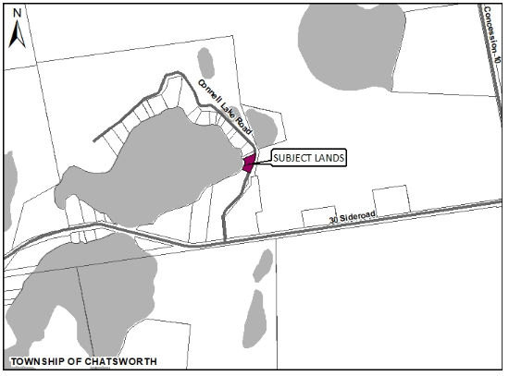

#### Map 1: Airphoto of the Subject Lands proposed to be severed

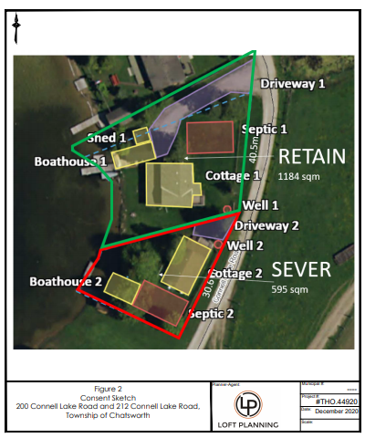

#### Map 2: Airphoto of the Subject Lands showing the existing two seasonal residential units (courtesy of Loft Planning)

The subject lands are designated ‘Rural’ and ‘Hazard Lands’. The reason for this amendment is because there are limited rural lot creation provisions under the County Plan, whereas on original township lots 80 ha in size (applicable to the subject lands), a total of 6 lots are permitted (section 5.4.1(1)). There is upwards of 40 lots located on this original township lot. The subject lands are within a cluster of seasonal recreational cottages along the shoreline of Connell’s Lake. Section 5.4.1(g) of the County Official Plan states *recreational or tourist-based rural clusters (e.g. cottages, yurts, or a similar form of development under common ownership)* are permitted. An amendment is also needed to the County’s Official Plan policy that speaks to minimum new non-farm sized lot size requirements, being 0.8 hectares in size.

The subject lands currently comprise of two seasonal residential units, separate well and septic systems, driveways, and boathouse structures. They inadvertently merged on title.

Existing and surrounding land uses are described as follows:

● North: Seasonal cottages, natural areas, some farmland, and an unnamed lake.

● East: Farmland immediately west and Saugeen Conservation Lands east of Concession Road 10.

● South: Seasonal cottages along Hines Lake, Clarke’s Lake and Robson Lake and a Residential, Subdivision to the west of Robson Lake.

● West: Seasonal cottages on Connell’s Lake and Mud Lake, Moggie Valley Timber, Holland Pit and Campground.

Kristine Loft, a land use planning consultant working on behalf of the applicant has submitted a Planning Justification Report in support of the proposal. The following background information has also been provided as part of the overall submission: comments from Mike Givens, fire chief, Township of Chatsworth, comments from Gerald Madill, licensed septic installer, and copy of deed and PIN map.

A copy of the report and background materials can be found at the below link:

[Link to Background Materials](https://www.grey.ca/planning-development/planning-applications)

## Analysis of Planning Issues

In rendering decisions, planning authorities must have regard to matters of Provincial interest under the *Planning Act* and be consistent with the Provincial Policy Statement (PPS). Decisions within the County must also conform to the County of Grey Official Plan and any Provincial plans in force and effect.

A detailed planning analysis has not been undertaken at this stage. Following the public process, and agency comments, a thorough analysis and staff recommendation will be provided. Key Provincial and County policies have been flagged below for consideration.

### Provincial Legislation – The Planning Act

Most notable to this proposed official plan amendment are the following clauses from the *Planning Act*, which will need to be considered.

1. **the protection of ecological systems, including natural areas, features and functions,**

The subject lands abut Connell Lake. No further development is proposed through the subject proposal, aside from severing the two respective parcels.

1. **the protection of agricultural resources of the Province,**

The subject lands are designated ‘Rural’ as per Schedule A of the County Official Plan. As per section 5.4.1(g) of the County Official Plan, *recreational or tourist-based rural clusters (e.g. cottages, yurts, or a similar form of development under common ownership)* are permitted.

1. **the supply, efficient use and conservation of energy and water,**

Comments were received from Gerald Madill, a licensed septic installer to determine whether the subject lands can safely and adequately accommodate two septic systems, given the property size for both the severed and retained is significantly less than 0.8 ha. The local conservation authority will be circulated for comments and review.

**(o) the protection of public health and safety**

Comments were submitted from Mike Givens, fire chief, Township of Chatsworth.

### Provincial Policy Statement (PPS 2020)

Section 1.1.5 of the PPS outlines recreational and residential uses as permitted uses in the rural area, provided development is compatible with the rural landscape and can be sustained by rural service levels. No additional development is being proposed, the subject lands currently comprise of two seasonal residential units, separate well and septic systems, driveways, and boathouse structures.

Section 1.6.6.4 of the PPS details the provisions that should be considered when individual on-site sewage services and individual on-site water services are proposed. These include ensuring the site conditions are suitable for the long-term provision of such services with no negative impacts.

### County of Grey Official Plan

Section 5.4.1(2) of the County OP states recreational uses are recognized as a permitted use.

Section 5.4.2(2) outlines minimum new non-farm sized lot size requirements, being 0.8 hectares in size.

Section 5.4.2(4) states new non-farm sized lot creation shall not be permitted within *Aggregate Resource Areas* on Schedule B to this Plan. Schedule B of the County OP identifies the entirety of the subject lands as an ‘aggregate resource area’. This policy area will be further reviewed.

Section 5.4.3(1) details the lot density provisions under the rural land use designation. This policy is proposed to be amended as part of the subject application, as the lot density of the original township lot significantly exceeds the total lots permitted on an 80-hectare lot.

Section 7.2 of the County OP will be addressed as it relates to the ‘Hazard Lands’ located on the subject lands.

As noted above, following the public and agency processes, a thorough planning analysis and staff recommendation will be provided.

## Legal and Legislated Requirements

The application will be processed in accordance with the Planning Act.

## Financial and Resource Implications

There are no anticipated financial, staffing, or legal considerations associated with the proposed official plan amendment, beyond those normally encountered in processing an amendment. The County has collected the requisite application fee and peer review deposit for this application.

## Relevant Consultation

Internal: Planning Staff

External: Township of Chatsworth, required agencies under the *Planning Act*, and the public

### Appendices and Attachments

*None*