Grey County Logo Committee Report

| **To**: | Warden Hicks and Members of Grey County Council |
| --- | --- |
| **Committee Date:** | January 10, 2019 |
| **Subject / Report No:** | PDR-CW-06-19 Information Report |
| **Title:** | Ridge Estates Plan of Subdivision and Condominium 42T-2018-13A and 42-CDM-2018-13B |
| **Prepared by:** | Randy Scherzer |
| **Reviewed by:** | Kim Wingrove |
| **Lower Tier(s) Affected:** | Town of The Blue Mountains |
| **Status:** | Recommendation adopted by the Committee of the Whole as presented as per Resolution *CW15-19;*Endorsed by County Council on January 24, 2019 as per Resolution *CC12-19*. |

## Recommendation

1. **That Report PDR-CW-06-19 be received for information which provides an overview of proposed plan of subdivision and condominium applications 42T-2018-13A and 42-CDM-2018-13B, consisting of thirty-one (31) single detached residential parcels and a private recreational facility to be accessed by a proposed condominium road on lands described as Block 38, Registered Plan 16M-24, Town of The Blue Mountains, g**eographic Township of Collingwood**.**

## Executive Summary

The County has received a plan of subdivision application and a related condominium application known as Ridge Estates (County file numbers 42T-2018-13A and 42-CDM-2018-13B), to create 31 single detached residential lots and a private recreational facility in the Town of the Blue Mountains. Access to the lots would be off a new proposed condominium road that would connect to George McRae Road. Servicing to the proposed subdivision would be via municipal water and sewer services. Various technical reports have been submitted with the proposed subdivision application, as well a zoning by-law amendment application to the Town of The Blue Mountains. The applications and supporting studies have been circulated to prescribed agencies and the public for review and comment. Following the public process, and agency review process, a thorough analysis and staff recommendation will be provided.

## Background and Discussion

The County has received a plan of subdivision application, known as Ridge Estates which proposes to create 31 single detached residential lots and a private recreational facility. An associated condominium application has been submitted which proposes to create a condominium road that would provide access to the proposed lots and would connect to George McRae Road (see Map 1 below). The private recreational facility would also be created as a common element condominium facility for the owners of the lots within the subdivision.

The subject lands are located in the Recreational Resort Area designation under the County Official Plan. The proposed subdivision is located on Block 38, Registered Plan 16M-24, Town of The Blue Mountains, geographic Township of Collingwood.

The subject lands are approximately 2.37 hectares in size and are currently vacant with some trees located on portions of the property. Servicing to the proposed lots would be via municipal water and sewer services.

This site is located in the Camperdown area which is located south of Highway 26 between the Town of Thornbury and Grey Road 19. The lands are located south of the Georgian Bay Club. A residential development exists to the east of the subject lands. Farmlands exist west of the subject lands and directly south are vacant lands.

Map 1 below shows the subject lands and surrounding area, while Map 2 shows the proposed plan of subdivision.

Map 1: Airphoto of Subject Lands

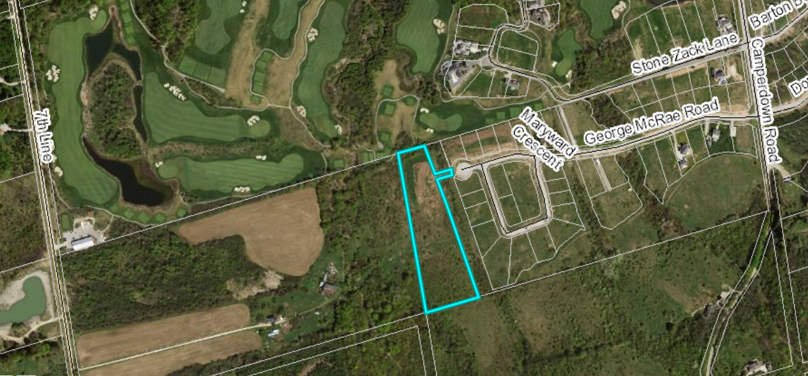

### Map 2: Proposed Plan of Subdivision

(Map 2 Courtesy of Pascuzzo Planning Inc.)

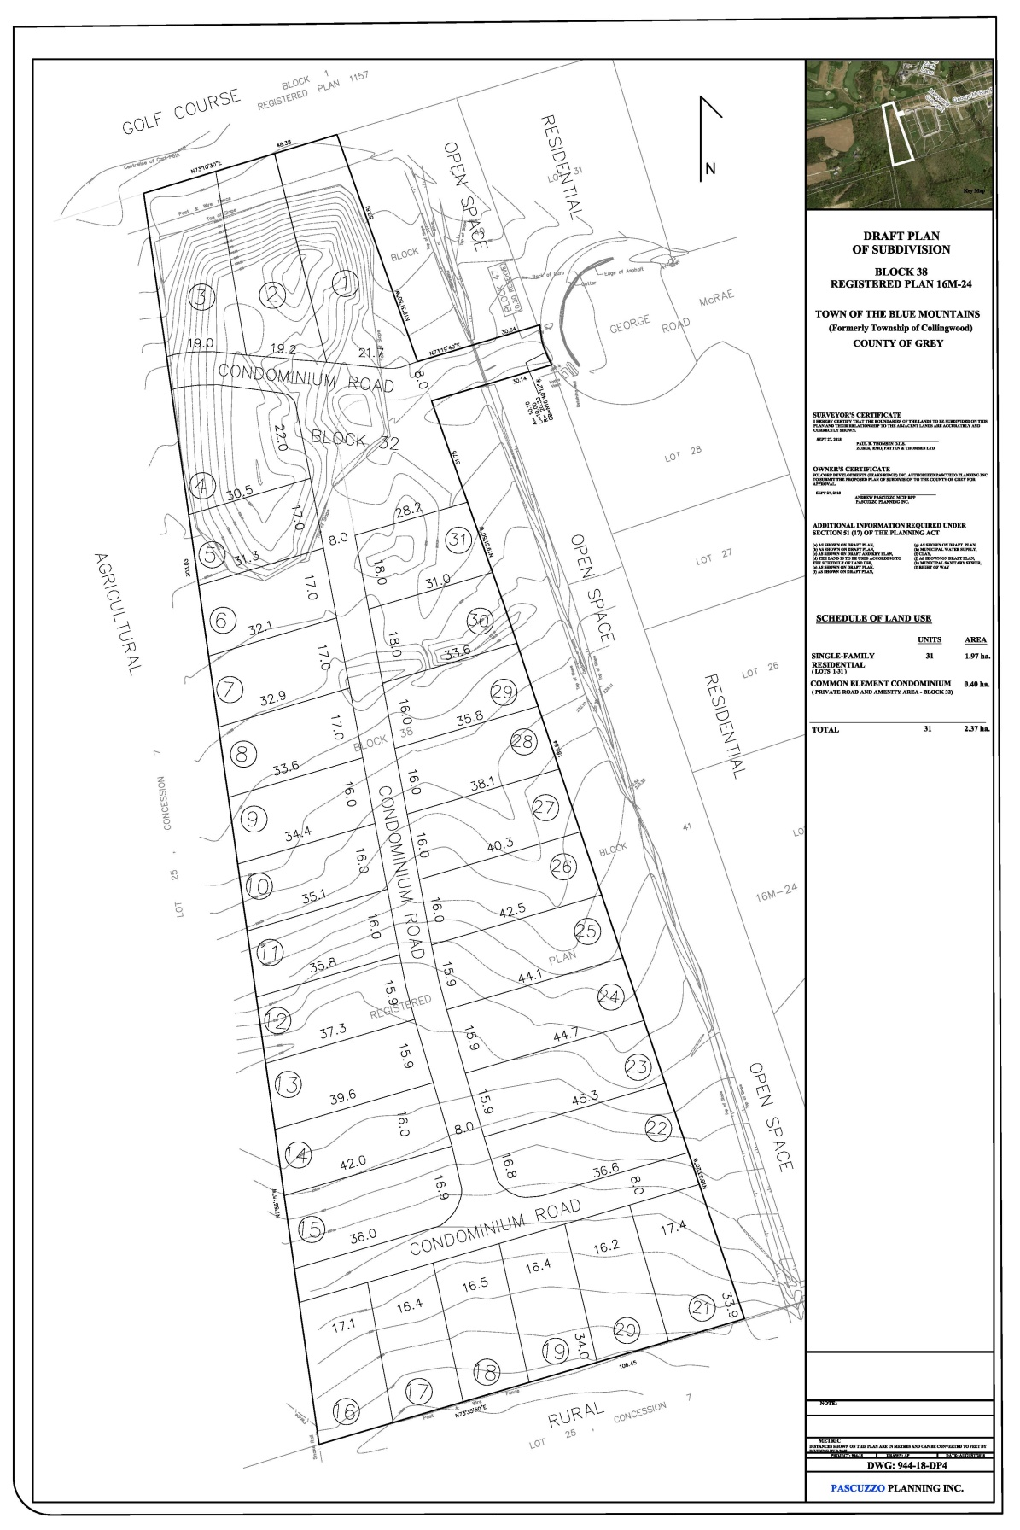

The proposed development also requires a zoning by-law amendment from the Town of The Blue Mountains.

Pre-submission consultation between the proponent, the Town of The Blue Mountains, the Grey Sauble Conservation Authority, the Niagara Escarpment Commission, and the County identified the submission requirements for the proposed development. Copies of all background reports and plans can be found at [this link](https://www.grey.ca/planning-development/planning-applications/ridge-estates).

#### Analysis of Planning Issues

When rendering a land use planning decision, planning authorities must have regard to matters of Provincial Interest under the *Planning Act*, be consistent with the Provincial Policy Statement (PPS) 2014, and conform to any Provincial Plans or Municipal Official Plans that govern the subject lands. In this case, the County of Grey Official Plan and the Town of The Blue Mountains Official Plan have jurisdiction over the subject property. The subject lands are also located within the Niagara Escarpment Plan area.

#### Provincial Policy and Legislation

Both the *Planning Act* and the PPS speak to the efficient use of land within settlement areas. The proposed plan of subdivision is within an existing settlement area designation that will be serviced with municipal water and sewer services.

The supply of an adequate range and distribution of residential housing types is required in both Provincial documents. In this case, the proposed plan of subdivision is providing new single detached lots, which are the common form of housing in the Camperdown area.

Other policies in the PPS speak to connected, walkable communities, with provisions for public parkland and open space. The proposal is to provide a cash-in-lieu payment for parkland.

The protection of significant environmental features is also required through the legislation and policy. Appendix A of the County Official Plan identifies the subject lands as potentially containing karst topography. The Official Plan permits residential development on full municipal services within potential karst areas. The County Plan does not map any significant natural features on the subject lands. Appendix B does identify Significant Woodlands located on the adjacent lands situated southwest of the subject property and therefore a small portion of the southwest corner of the subject property is located within the adjacent lands to the Significant Woodlands. An Environmental Impact Study has been submitted with the proposed applications examining the potential for impacts on the natural environment.

Following the public and agency review periods, staff will provide a more fulsome analysis of the Provincial legislation and policy.

#### County of Grey Official Plan

The proposed plan of subdivision is on lands designated as ‘Recreational Resort Area’ in the County Official Plan. Recreational Resort Areas are identified as locations in which to focus new residential and recreational growth in the County.

The County Plan also requires the protection of cultural and archaeological resources. A Stage 1 – 2 Archaeological Assessment was conducted for this development.

Section 5.3 of the County Plan provides a similar servicing hierarchy to that found in the PPS, which has been noted above. Elsewhere in section 5 of the Plan, are policies which govern roads, transportation, and stormwater management. County Official Plan policies will be further assessed following agency review and the public process.

#### Town of The Blue Mountains Official Plan

The subject lands are designated “Residential Recreational Area” (RR) on Schedule A-3 (Camperdown) of the Town of The Blue Mountains Official Plan. The Residential Recreational Area designation contemplates development of this nature.

Other Official Plan policies in the Town Plan mimic those in the County Plan and the PPS. A more thorough analysis of the Town Official Plan policies will follow the agency review and the public process.

## Legal and Legislated Requirements

The application will be processed in accordance with the *Planning Act.*

## Financial and Resource Implications

There are no anticipated financial, staffing or legal considerations associated with the proposed subdivision and condominium, beyond those normally encountered in processing a subdivision/condominium application. The County has collected the requisite fee and peer review deposit for these applications.

## Relevant Consultation

Internal: Planning and Transportation Services

External: The public, Town of The Blue Mountains, and required agencies under the *Planning Act*.

### Appendices and Attachments

None