Grey County Logo Committee Report

| To: | Warden McQueen and Members of Grey County Council |
| --- | --- |
| Committee Date: | January 9, 2020 |
| Subject / Report No: | TR-CW-04-20 |
| Title: | Road Widening Acquisition Grey Road 170 |
| Prepared by: | Lacey Thompson, Contract and Real Estate Coordinator and Pat Hoy, Director of Transportation Services |
| Reviewed by: | Kim Wingrove, CAO |
| Lower Tier(s) Affected: | Township of Georgian Bluffs |
| Status: | Recommendation adopted by Committee as presented per Resolution CW19-20; Endorsed by County Council January 23, 2020 per Resolution CC18-20; |

# Recommendation

1. **That Report TR-CW-04-20 regarding the acquisition of road widening be received and that the property identified as Part of Lot 18 Concession 12 Keppel shown as Part 5 on Plan 16R-10010; Geographic Township of Keppel, Township of Georgian Bluffs, County of Grey be acquired by The Corporation of the County of Grey for road widening purposes.**

## Executive Summary

The Township of Georgian Bluffs granted severance application B13-2019 for the purpose of a lot addition. The existing lot to be added to was created with Planning Act consent in 1991.

Lots created with Planning Act consent cannot be re-registered to merge with adjacent land unless they are physically changed or altered.

The acquisition of a road widening parcel by the County off the front of the lot that was created in 1991 will alter the parcel and allow the two parcels to merge on title in accordance with Condition 3 of Severance B13-2019.

## Background and Discussion

The Township of Georgian Bluffs granted severance application B13-2019 for the purpose of a lot addition. The property to be added to was created with Planning Act Consent pursuant to a decision granted by the Grey County Planning Approval Committee in 1991 under its file number 1019-89.

Under subsection 50 (12) of the Planning Act, R.S.O. 1990, c. P. 13 as amended, commonly referred to as the “Once a Severance, Always a Severance Rule”, the original severed parcel could potentially be sold, transferred, or mortgaged separate from the lot addition parcel. This would result in the unauthorized creation of three separate lots.

Given that the creation of the proposed lot is dependent on it merging with the existing lot created with Planning Act Consent in 1991 it is necessary to alter the dimensions of the existing lot to ensure the parcels can legally merge on title.

Transportation Services tried to acquire the property several years ago and had the widening surveyed and Reference Plan was deposited at the Land Registry office in 2011. The widening was not acquired at that time.

Transportation staff negotiated with the landowner who has agreed to transfer the road widening parcel to the County for the nominal consideration price of $2.00 provided the County pay for all legal expenses in relation to the transfer of this parcel of land.

The acquisition of a 17 foot road widening parcel by the County off the front of the lot that was created in 1991 will alter the dimensions of this parcel and effectively break the “Once a Severance, Always a Severance Rule” ensuring that the original lot created in 1991 cannot be sold, transferred, or mortgaged separate from the lot addition parcel.

It is recommended that the County acquire Part 5 on Plan 16R-10010 and join it to the abutting county road network. The acquisition of this parcel will result in a 30.5 metre (100 foot) right-of-way width in this area of Grey Road 170, which supports the County’s long-term goal in accordance with the Transportation Master Plan.

## Legal and Legislated Requirements

Section 50 (12) of the *Planning Act* states that “where a parcel of land is conveyed by way of a deed or transfer with a consent given under section 53, subsection (3) and (5) of this section do not apply to subsequent, or other transactions involving, the identical parcel of land unless the council or the Minster, as the case may be, in giving consent, stipulates either that subsection (3) or subsection (5) shall apply to any such subsequent conveyance or transaction.”

## Financial and Resource Implications

The legal costs to finalize the transfer are estimated to be under $1,000.00.

The anticipated total cost of the acquisition is expected to be approximately $1,000.00.

The funding will come from the Transportation Services Land Acquisition budget.

## Relevant Consultation

Internal

Clerks Department

External

Alan Wilford, Lawyer  
Property Owner

### Appendices and Attachments

Location Map  
Plan 16R-10010

Grey Road 170 Road Widening Acquisition Agreement

### Location Map

Location Map

## Plan 16R-10010

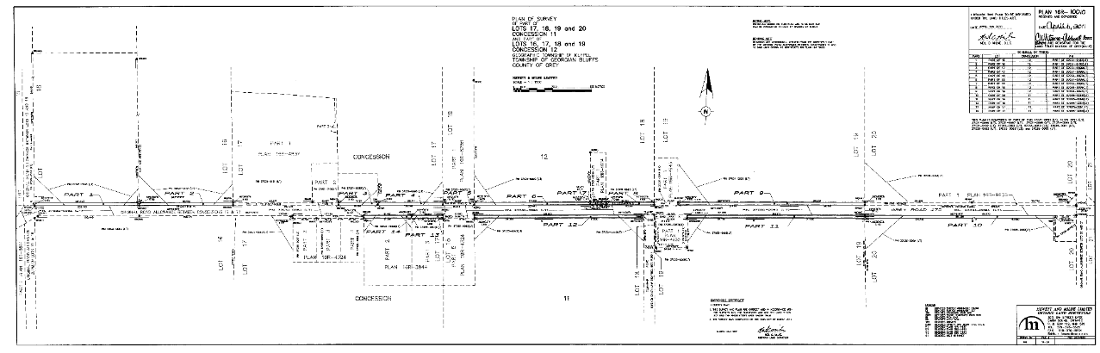

## Grey Road 170 Road Widening Acquisition Agreement

This Agreement made in duplicate this ________ day of ________________, 20____, between:

**The Corporation of the County of Grey**

(herein called the “County”)

- and-

**Tammy Jean Wilder and Todd Jason Wilder**

(herein called the “Owner”)

**WHEREAS** the Owner owns a parcel of land situated intheTownship of Georgian Bluffs in the County of Grey; adjacent to County Road 170.

**AND WHEREAS** the County wants to purchase and the Owner is agreeable to sell part of the land for road widening purposes.

The Owner and the County agree that in consideration of the rounded sum of **$2.00,** receipt and sufficiency of which is hereby acknowledged, the parties, intending to be legally bound, agree as follows:

The Owner agrees to transfer to the County, a parcel of land legally described as Part of Lot 18 Concession 12, Township of Georgian Bluffs (in the former geographic Township of Keppel), in the County of Grey depicted as Part(s) 5 on Reference Plan No. 16R-10010 (the “Purchased Parcel”).

Additional Details: None

The Owner agrees to provide the County with a valid Transfer/Deed of Land conveying unencumbered title to, and releasing all claims in respect of, the Purchased Parcel and the additional lands. The Transfer/Deed of Land shall be prepared at the expense of the County by its lawyers. The County agrees to cover all legal costs of the seller associated with this transfer.

The Owner shall obtain release of any existing mortgage or other encumbrance on the purchased parcel and additional lands. The Owner represents that spousal consent is not necessary to this transaction under the provisions of the Family Law Act (Ontario), unless the Owner’s spouse has executed the consent below. The Owner represents that the Owner is not a non-resident of Canada within the meaning of the *Income Tax Act.*

The obligation of the County to complete the transaction contemplated by this agreement shall be conditional upon County Council passing a motion approving the acquisition of the Purchased Parcel.

The transaction shall be completed on or before a date specified by the County by notice sent to the Owner not less than 30 days prior to the specified completion date.

If this transaction is subject to Harmonized Sales Tax such tax shall be included in the purchase price.

The heirs, executors, administrators, successors in title and assigns of the Owner are bound by the terms of this agreement.

In witness, the parties have signed, sealed and delivered this agreement.

**The Corporation of the County of Grey**

(seal) Paul McQueen, Warden

Heather Morrison, Clerk

______________________________ (seal)

Tammy Jean Wilder Witness

______________________________ (seal)

Todd Jason Wilder Witness

The undersigned Spouse of the Owner consents to the disposition agreed to herein pursuant to the provisions of the Family Law Act (Ontario), and hereby agree with the County that he or she will execute all necessary documents to complete the sale.

______________________________ (seal)

Spouse of Owner (if not property owner) Witness