Grey County Logo Committee Report

# Report PDR-PCD-05-15

**To**: Chair Wright and Members of the Planning and Community Development Committee

**From**: Alisha Buitenhuis, Planner

**Meeting Date:** January 15, 2015

**Subject: 42-42-000-OPA-130 Scenic Caves Merit Report**

**Status**: Recommendation adopted by committee as presented per Resolution PCD16-15; Endorsed by County Council February 3, 2015 per Resolution CC34-15; Also see Addendum Report April 21, 2015;

## Recommendation(s)

**THAT Report PDR-PCD-05-15 regarding a proposed County Official Plan Amendment be received;**

**AND THAT the proposal proceed to a Public Meeting to consider the Amendment to the County of Grey Official Plan to re-designate the subject lands from ‘Rural’ to ‘Rural with Exception’ for the lands described as Part of Lot 14, Concession 3, geographic Township of Collingwood, in the Town of the Blue Mountains, provided the Town of the Blue Mountains is prepared to hold a joint public meeting in consideration of the necessary Zoning By-law Amendment requirements.**

## Background

The County of Grey has received an application to amend the County Official Plan to allow for the severance of a residential parcel from a larger farm parcel. The vacant retained parcel would be merged with an adjacent property. An Official Plan Amendment is required because the severance would exceed the permitted density within the Rural designation for this area.

The subject property is 38.6 hectares (95.4 acres) in size and is legally described as Part of Lot 14, Concession 3, geographic Township of Collingwood in the Town of the Blue Mountains. The property contains a single detached dwelling. The lands are designated ‘Rural’, ‘Niagara Escarpment Plan Area’, and ‘Escarpment Recreation Area’ in the Official Plan. The lands are located within an ‘Area of Natural and Scientific Interest’ and contain ‘Significant Woodlands’ and an ‘other identified wetland’.

The subject property is located approximately 1.8 kilometres southwest of Blue Mountain Village and is owned by Scenic Caves Nature Adventures. The surrounding area consists of primarily residential, farm, and recreational uses, and is designated Rural, Niagara Escarpment Plan Area, and Escarpment Recreation Area. The owner wishes to sell the existing house and use the retained parcel for recreational purposes.

Georgian Planning Solutions has submitted a Planning Justification Report in support of the proposed amendment. No other reports or studies were deemed necessary at the time of pre-submission consultation.

A Municipal Zoning By-law Amendment and Consent Application will be required from the Town of The Blue Mountains.

### Map 1 – Location of Subject Lands

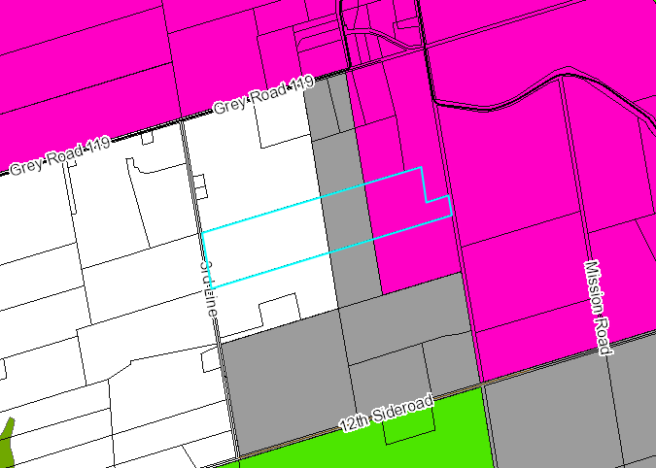

### Analysis of Planning Issues

Planning authorities must have regard to matters of Provincial Interest, the criteria of the Planning Act and be consistent with the Provincial Policy Statement (PPS). Decisions must also conform to the County of Grey Official Plan and any Municipal Official Plans which are in force and effect.

Section 2 of the *Planning Act* sets out matters of Provincial Interest, which all land use decisions shall have regard for. Sections (b), *the protection of the agricultural resources of the Province,* and (p), *the appropriate location of growth and development*, are the most applicable to this application.

Section 1.1.5.4 of the PPS encourages development that is compatible with the rural landscape and can be sustained by rural service levels.

Section 2.3.4(2) of the County Official Plan allows for the creation of two lots plus the retained lot per 40 hectares in the Rural designation. Lot density is determined based on the original Township lot fabric and is pro-rated up or down based on the size of the original Township lot. In this case, the original Township lot was established as a 200 acre parcel. Part of this parcel is located within the Niagara Escarpment Plan Area and Escarpment Recreation Area designations, with 100 acres designated Rural. This would allow for two lots plus the retained, which have already been created. No additional lot creation is permitted by the Official Plan within this area.

Section 6.3 of the County Official Plan contemplates amendments to the plan, provided that the criteria of the relevant sections of the Plan can be addressed. Limiting non-farm residential development beyond settlement areas is a major objective of the Plan.

The applicant has submitted a Planning Justification Report to address Provincial and Municipal land use policy.

## Financial / Staffing / Legal / Information Technology Considerations

There are no expected financial, staffing or legal considerations beyond those normally encountered in processing an Official Plan Amendment application. The County has received an amendment application fee and peer review deposit with the file.

## Link to Strategic Goals / Priorities

The subject application is a private development application, and the processing of such applications in a timely and efficient manner would fall under the Planning department’s core business mandate. This application also supports the conservation of natural and cultural heritage resources and landscapes within the County. Action 3.4 in the Strategic Plan would be supported by this application as well, because it would encourage greater economic and tourism initiatives that support the protection and enhancement of the natural environment.

This development application should have no direct impact on the County’s ability to achieve corporate strategic goals and priorities.

## Attachments

None

Respectfully submitted by,

Alisha Buitenhuis  
Planner

Director Sign Off: Randy Scherzer