Grey County Logo Committee Report

| To: | Warden Hicks and Members of Grey County Council |
| --- | --- |
| Committee Date: | October 10, 2019 |
| Subject / Report No: | CAOR-CW-15 -19 |
| Title: | Sydenham Campus Update |
| Prepared by: | Savanna Myers, Manager of Economic Development |
| Reviewed by: | Kim Wingrove, CAO |
| Lower Tier(s) Affected: | All |
| Status: | Recommendation adopted by Committee as presented per Resolution CW195-19; Endorsed by Council October 24, 2019 per Resolution CC83-19; |

## Recommendation

1. That Report CAOR-CW-15-19 regarding a Sydenham Campus Update, be received for information.

## Executive Summary

The development of Sydenham Campus is proceeding well. An updated business plan is now complete and new partnerships, renovations and occupancy and are underway.

## Background and Discussion

Over the past six months, several projects have been completed to prepare for the launch of Sydenham Campus.

* Following report CAOR-CW-05-19 Doran Consulting was retained to develop an updated business plan, including a communications plan and fundraising plan for the Sydenham Innovation Campus. These documents provide flexible roadmaps with many phases and opportunities for staff and partners to grow.
* The Grey Bruce Business Generator has been formalized and a Manager of Program Development has been contracted for six months beginning mid October to develop the business accelerator program alongside Innovation Guelph.
* A three-way public private partnership has been developed with the Business Enterprise Centre, Grey Bruce Business Generator and the Bluewater Angel Investors Group to create a one-stop-shop for entrepreneurial activity in the region, including a comprehensive mentorship program.
* A brand has been drafted for the Sydenham Campus and is expected to launch mid October.
* Renovations are being completed to replace two sections of the roof along with interior upgrades of new flooring, paint and ceilings within the Innovation wing. Furniture for the Innovation wing has been ordered.
* Staff are regularly engaging with potential tenants and expressions of interest are currently being accepted.

Business Plan Refresh

The updated business plan is being used as a guiding document by staff and should be read as a flexible tool outlining an array of options that can be deployed to fully realize the vision. It is a living document; factors will change quickly and the plan should be adjusted accordingly.

The plan includes a materials and equipment list for developing the fabrication and innovation areas along with programming and training opportunities. A criteria for tenants has also been established to ensure proper fit with the ecosystem and reduced competition. The intent is to use Sydenham as a pipeline that helps businesses establish a permeant base locally following their temporary training and development support.

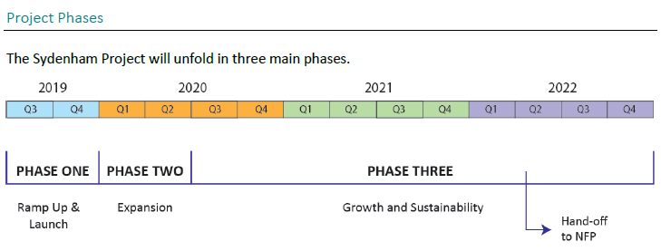

The following Vision, Mission and Values statements were developed to account for the new information obtained through the Environmental Scan and to appeal to the general public and stakeholders of the Campus.

Vision

Empowering the citizens and businesses of Grey & Bruce Counties with training and resources that drive regional prosperity and competitive advantage.

**Mission**

The partners and tenants of Sydenham Campus form a collection of trainers and businesses that support workers, entrepreneurs, and local organizations by providing access to education & training, business services, labs and technology. The Campus provides employees and businesses with the skills and advantages they need to succeed in a rapidly changing work world.

**Values**

Sydenham Campus will value cooperation; collaboration; diversity; integrity; value creation; passion; and leadership.

The building concept was also redrawn to account for extended and enhanced uses beyond the original scope.

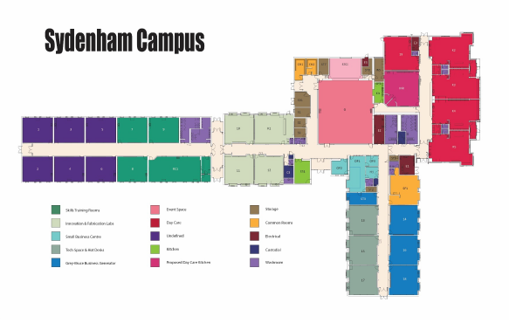

The plan continues to demonstrate the ability for Sydenham to be self-financing within six years based on a mix of revenue streams.

Occupancy

Planned occupancy will be phased in, beginning October 15, 2019 when the Business Enterprise Centre (BEC) and Grey Bruce Business Generator relocate services to the site. Bruce Community Futures Development Corporation (CFDC) relocation will closely follow. The BEC, Generator and CFDC will meet with clients, offer training, mentorship, financing and entrepreneurial support. A comprehensive marketing campaign is being developed to create awareness and redirect clients to Sydenham where all services will be offered under one roof.

Parking

To curb the use of our parking lot by neighbouring students, faculty and visitors, ‘Sydenham Campus Parking Only’ signs are being installed as a friendly reminder to park in assigned lots.

Based on the proposed, future new uses of the building, the Owen Sound zoning by-law will likely trigger the need to develop more parking spaces as the building fills. Our architect is currently developing an updated site plan to determine where spaces could be infilled given the vacant bus loading zones.

Child Care Changes

Given the changing environment and reduced funding, plans for the child care wing have been suspended. That said, staff remain open to proposals and continue to pursue the option of child minding for on site clients and expect the service could be available in 2020.

Upcoming Renovations

Further renovations will continue through 2020 with the remaining budget allocated in 2019. Funding applications have been submitted to help offset the cost.

* A lighting audit is being completed to upgrade existing lights to LED through an energy program. This will improve the quality of the space and offer cost savings.
* Power upgrades to three-phase may be required to carry the growing load of the building and enable the installation of fabrication and training equipment and future HVAC upgrades.
* Washrooms will be remodeled and a new accessible washroom will be developed.
* The building automated system (BAS) which controls heating and cooling requires new hardware and software to bring the system up to date.

Legal and Legislated Requirements

There are no legal or legislated requirements with this information report.

## Financial and Resource Implications

There are no additional financial or resource implications with this report beyond the approved 2019 budget. Staff are recommending that any capital budget not spent in 2019 be held in reserve for use in 2020 to complete renovations that were not possible this year.

## Relevant Consultation

Internal – CAO, Director of Corporate Services, Planning, Children’s Services, Housing, IT, Maintenance.

External – City of Owen Sound, Professional Services, Private Sector

### Appendices and Attachments

[Business Plan](https://docs.grey.ca/share/public?nodeRef=workspace://SpacesStore/e2df3dfd-ad51-4fad-b700-4d9aa449dcea)