Grey County Logo Committee Report

# Report PDR-CW-45-17

**To**: Warden Barfoot and Members of Grey County Council

**From**: Randy Scherzer, Director of Planning

**Meeting Date:** November 9, 2017

**Subject: Draft Approval Extension – Windfall, Town of The Blue Mountains (42T-2010-03)**

**Status**: Recommendation adopted by Committee as presented per Resolution CW238-17; Endorsed by County Council November 23, 2017 per Resolution CC65-17;

## Recommendation

1. **That Report PDR-CW-45-17 be received and that an extension of draft approval for Plan of Subdivision File 42T-2010-03 – Windfall in the Town of The Blue Mountains be granted to November 15, 2020 as per Section 51(33) of the Planning Act, RSO 1990, as amended.**

## Background

Plan of Subdivision File 42T-2010-03 (Georgian Gate/Windfall) was originally draft approved on November 15, 2011 and was later revised on May 10, 2012, September 16, 2014, and October 13, 2016. The current draft approved plan consists of a total of 609 residential units (Lots 1 to 480 comprises of 351 detached dwellings and 258 semi-detached dwellings) as well as the creation of a number of blocks for various purposes (e.g. open space/recreation blocks, stormwater management blocks, etc.). The draft approved subdivision is located on lands legally described as Part of Lot 16, Concession 1, Town of The Blue Mountains (see Map 1 below). The subject lands are located on the north side of Grey Road 19 between the roundabout on Grey Road 19 and the intersection of Grey Road 19 and Grey Road 21.

The County has received a request from the Owner’s agent requesting an additional three year draft approval extension. The Owner’s agent indicates that the draft approved plan anticipates a total of six phases and is proceeding at an aggressive pace, with Phase 2C currently under construction.

In a letter from the Town of The Blue Mountains dated October 12, 2017, the Town indicates that they have no objections to a three year extension.

### Map 1: Windfall Subject Lands

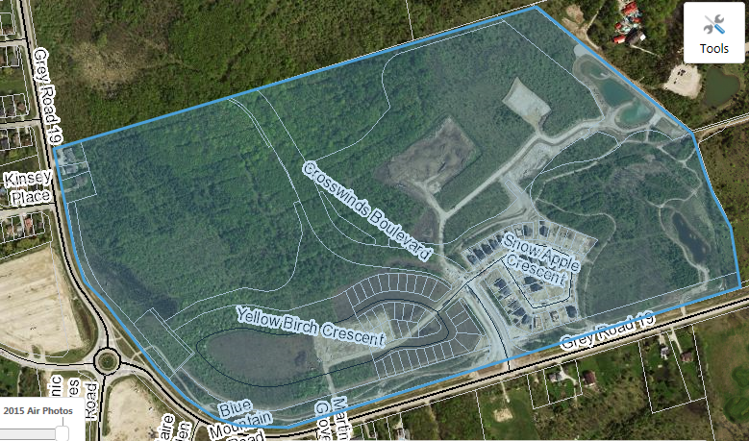

Based on the Town of The Blue Mountains supporting the request for a three year extension, County staff recommends that a three (3) year draft approval extension be granted.

## Financial/Staffing/Legal/Information Technology Considerations

At this point there are no financial, staffing, legal or Information Technology considerations. The County has collected a fee for the extension of draft approval.

## Link to Strategic Goals/Priorities

Goal 1 of the Corporate Strategic Plan is to Grow the Grey County Economy and Goal 2 is to support healthy, connected communities. Approving a draft approval extension for a previously draft approved subdivision would be considered sound land use planning, given the specific circumstances.

Respectfully submitted by,

Randy Scherzer  
Director of Planning