Rockwood Terrace

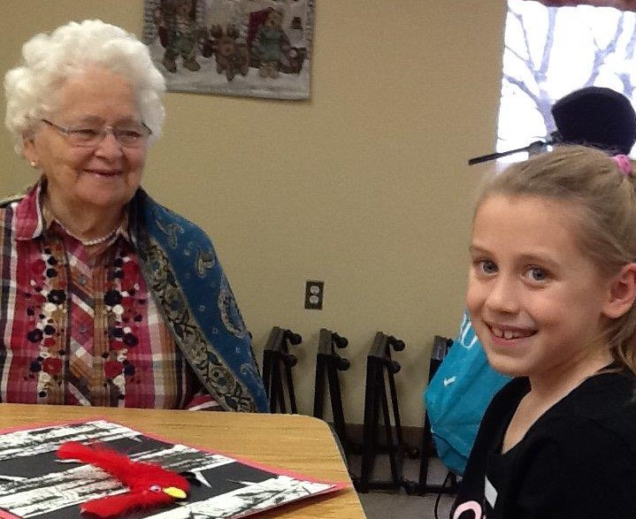
  - Grey County Operations Report to Committee of Management
  - Open Session

  - Submission Date: January 8, 2019
  - Information for the Month of: November 16–December 15, 2018

Financials
Financial analysis will be transitioned to Sienna in 2019.

Scorecard: Quality
Data Source (unadjusted):
- Canadian Institute for Health Information (CIHI) Quarter 2 (July-Sept 2018)
- Quality Improvement Plan (QIP)- Home Specific April 1 2018-March 31, 201
Indicator (%) | QIP Performance April 1, 2018 | CIHI Q2 Performance | Home Target March 31, 2019
Reduce stage 2-4 pressure ulcers | 7.92 | 6.2 | 5.3
Reduce Antipsychotic medications | 4.15 | 9.3 | 6
Reduce the number of falls | 17.43 | 19.5 | 15
Reduce the number of restraints | 3.19 | 3.0 | 5
Health Equity Leadership training | 0 | 12.5 | 100
Complaints acknowledged to the individual who made a complaint. | 100 | 100 | 100
Improve Resident Satisfaction | 98 | Coming soon! | 95
Reduce transfers to Emergency department | 17.48 | 5.8 | 16.55

We will continue with the action plan that was developed in March 2018 to address performance and meet targets.

Ministry of Health and Long-Term Care (MOHLTC) Compliance Orders /Inspection Findings Summary
No visits in this reporting period.

Scorecard: People
We are pleased to welcome Catharine Martinak to the position of Office Clerk. This new role replaces the Receptionist/Bookkeeper position. Once orientation is completed Catharine will support the home during the evening hours.
We are recruiting for an Associate Director of Care (ADOC) position which is funded by the Ministry of Health and Long-Term Care specific for the creation of a Registered Nurse position to enhance the provision of care. The ADOC will provide support into the evening hours.
Recruitment efforts continue for the RAI Coordinator.

Sienna Partner Visits
- November 16- Quality & Informatics Partner visit, provided support to team member currently fulfilling the RAI MDS role, ensured successful completion of Quarter 2 2018 CIHI submission.
- Nov 19, 30- Laundry and Housekeeping Partner teleconference, bimonthly meeting and policy review
- November 22 and December 10- Administrator attended Region 7 meetings in Bradford.
- Nov 26- Dietary and Nutritional Care Partner, policy review teleconference
- Dec 13- Resident Experience Partner visit, collaborative meeting on the admission process

Projects, Location Events and Other
- Christmas Bazaar- The annual Christmas Bazaar was held on Saturday November 17. A large crowd was present for the event, and residents enjoyed shopping at the various vendors in attendance.
- Memorial Service- The fourth and final Memorial Service of the year was held on November 18 with Chaplin Dianne Drysdale. Eight Residents were remembered and celebrated at this service.
- Grand Pal Program- The Grand Pal program is underway again this year and residents were able to meet this year’s pen pals on December 3.
- A Winter Wonderland formal dinner was provided for residents on December 11. Happy hour occurred prior to the service of a special prime rib dinner which was served by the Leadership Team.

Long Term Care

Occupancy
- Year to date as of Nov 30- 97.13% occupancy
- During the reporting period- 5 move ins, 4 discharges

Regulatory visits i.e. Ministry of Labour, Public Health
There were no regulatory visits during this time period.

Written and Verbal Complaints Summary
Type of Compliant | Summary | Outcome (s)
Verbal | Family concerned regarding resident to resident relationship | Resident moved to different floor.  Resolved
Verbal | Resident complaint related to other residents entering her room. | Yellow barrier strip applied to door. Resident is on an internal list for a room change.  Ongoing
Verbal | Family upset regarding assessed level of assistance required for transfers. | Resident was re-assessed by the Physiotherapist  Resolved
Verbal x 2 | Two families expressed concern related to the new $5.00 monthly charge from the Pharmacy. | Letter provided from pharmacy outlining the reason for the change. Provided with direct line number for Pharmacy Customer Service.  Ongoing
Verbal | Family complaint related to pain resident experiencing. | Resident was assessed by Physician and pain addressed  Resolved
Verbal | Family upset regarding Mom’s health status and fact that she had not been assessed by the Physician | Physician assessed  Resolved
Verbal | Family upset regarding resident’s items that were missing. | Family found the items  Resolved
Verbal | Family complaint regarding resident not being seen by Physician. | Will be seen by Physician December 19.  Ongoing

Compliments Summary
Received a card from the family of a former resident thanking the team for the excellent care provided to their loved one.
Recognized by family of a former resident in the local paper-“The family would like to say a very special “Thank You” to the staff at Rockwood Terrace for their kindness, loving care and dedication to Mom.”

Occupational Health and Safety Issues
Influenza Immunization rates as follows:
- Residents-93%
- Staff-82%
The Home continues to address a severe nut allergy.

Resident and Family Satisfaction Survey
Resident and Family Surveys completed, results will be shared at an upcoming Committee of Management meeting.

Resident/Family Council Updates
Resident Council meeting held on November 23, 2018. Information was shared with Residents regarding the automated phone system and the winter/spring menu was approved.
Resident Council meeting held on December 7, 2018. The Administrator provided an update regarding redevelopment.
Family Council meeting held November 21, 2018. Breakfast tray service, telephone automation and the incontinent product survey were discussed at this meeting.

Emergency Preparedness and Environmental concerns (including emergency codes practiced)
Fire drills held for November.

