Grey County Federation of Agriculture
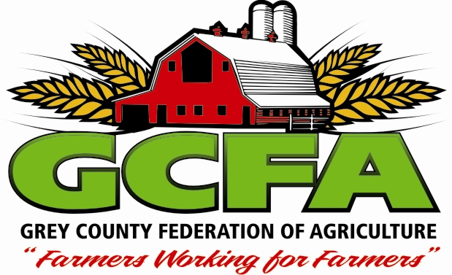
Board of Directors’ Meeting ~ January 20, 2016

The Grey County Federation of Agriculture (GCFA) Board of Directors’ met on Wednesday September 2, 2015 at Grey Ag Services in Markdale. President Mike Ryan called the meeting to order at 8:00pm.

Present: Don Hill, Mun. of Georgian Bluffs,
Elizabeth Thompson, Township of Chatsworth,
Mike Ryan, President
Jackie Pennings, Office Administrator
Kevin Eccles, Grey County Rep,
Paul DeJong, Twp of Southgate Rep.
Kevin Raszmann, West Grey Rep.
Bob Aitcheson, Township of Chatsworth Rep.,
Keith Reed,
Karl Chittka, Southgate Rep
Phillip Eagles, Mun. of Grey Highlands Rep,

Absent: Paul Wettlaufer, Zone 2 Rep, Allen Hughes, Mun. of Meaford Rep, OFA Policy Advisor for Grey North, Bruce Saunders, Twp of Chatsworth, Jacquie Hendry, Mun. of Blue Mountains Rep,

Regrets: Joanne Hughes, Member Service Representative, Hugh Simpson, Grey Highlands Rep

Quorum was present.

- Agenda Additions and Approval: Karl moved to approve the agenda, seconded by Elizabeth. CARRIED

- Minutes from November 4 and December 9, 2015 Board meetings: Paul made a motion seconded by Kevin R to accept the minutes. CARRIED

Business from Minutes: The 4 County Planning survey is open to be answered until the end of January. They haven’t had a huge response yet and are requesting that everyone participate.
- Correspondence: Received several thank you cards from the recipients of the Ag bursary awards. Letter from Ministry of Citizenship, Immigration and International Trade regarding Ontario Volunteer Service Award.
- Financial Report: Paul made a motion seconded by Karl to accept the treasurer’s report as presented.

- New Business:
  - Politicians Meeting: The meeting has been set for March 19th, 2016 in Elmwood. Possible topics suggested by GCFA include Diesel Fuel Tax (coloured fuel), OBA (bee keepers) and Green in Grey.
  - Tommy Cooper Evening: The date has been set for April 15, 2016 at Elmwood Community Centre. Karl suggested that the GCFA nomination be Allen Hughes. Kevin is calling Kevin Stoltz a framer/comedian from the Listowel area to see if he is available to be the entertainment.
  - FAB Award: It was reported that the executive suggested to nominate Ray Robertson for this award. Kevin Eccles made a motion seconded by Karl to accept the motion from the executive and nominate Ray for the honour. CARRIED
  - Executive Meeting Update: The summer social event ideas were discussed. It was decided to have an event that brings rural and urban together. Kevin made a motion seconded by Paul to host a summer event this year. CARRIED
Karl suggested we look for sponsorship, Jackie will start by applying to the Proud to Lead fund from OFA. We are still looking for an event location. A committee has been formed including Hugh, Keith and Mike. Kevin Eccles suggested contacting Philly Markowitz from Grey County.
Nottawasaga Valley Conservation Authority has requested representation on their board. The executive suggested to have Hugh be our representative with Mike as the alternate. Kevin made a motion seconded by Paul to accept the executive’s recommendation. CARRIED
  - Green in Grey: Karl brought this issue to the board’s attention. This is a green space corridor for wildlife. Southgate council is requesting a 60 day extension on the comment period. It can be found at http://www.grey.ca/services/planning-development/natural-environment-study/green-in-grey-notices-information/
We will have Joanne discuss this issue with OFA and see what our options are. We are going to invite Grey County to our next meeting to update us on the issue. Also, an email will be sent to our members so they can comment if they want to (new deadline is March 19th).
  - Egremont/Proton Funding: Paul made a motion seconded by Kevin to give the 2016 funding to Egremont/Proton ($5/member=$1000). CARRIED
  - Farm Safety Report: Karl reported that the farm safety association is looking to have a public meeting regarding the new ATV rules. They are looking for GCFA support and would like to host a meeting near the end of the summer.
  - Rabies in Grey County: There have been new cases of rabies found in Grey County. There was discussion that the rate is higher because of the milder winter and the fact that MNR is no longer baiting.
  - Meeting Dates: Keith made a motion seconded by Kevin to change the date for the February meeting to either the 10th or 17th depending on the availability of Grey County representative to come to the meeting, also to move the March meeting to the 9th. CARRIED
  - Curling Bonspiel: Bob reported that there is still room for more teams at the Curling Bonspiel.
  - Grown in Grey: Don reported that the event is being held on April 19 and 20th. They are looking for GCFA to have a learning station again this year. Also, they are hoping we will cover them with our insurance again this year. Kevin made a motion seconded by Keith to have them covered by our insurance. CARRIED
  - Public Speaking: Karl made a motion seconded by Paul to add a $25 prize for the best jr. and sr. agricultural speech at the semi finals. CARRIED
  - Chesley Agri Fair: Karl made a motion seconded by Don to share a both again this year with Bruce County. Half a booth cost $150. CARRIED

- Mike’s Report: Mike reported on the SVCA meeting he attended at the beginning of January. They received 200 thousand from GLASI to hire an employee for two years to host meetings for farmers regarding bee health, etc. They hired Ian McCormick for this position. He is interested in coming and speaking to the board once he settles in to his new position. They are reviewing the Conservation Authority Act now. One of the issues with the SVCA is to confirm what their mandate is. There will be another meeting in 6 weeks.
Joanne Report: Joanne left a report. She has been dealing with a drainage issue. She worked Grey Bruce Farmers week this year in Ray’s absence. If anyone has suggested topics for next year, they are having a meeting in early march. Joanne was contacted by Jennifer Van Dyk, from the Grey Bruce Health Unit . Grey Bruce has the highest rate of Salmonella and third highest rate of Campylobacter in Ontario. This year the Infectious disease program is hoping to reduce this. They would like to work with the federation for ideas to reduce this. She will be in touch over the next few months.

Paul’s Report: N/A

- Adjournment: Mike adjourned the meeting at 9:00pm.

President: ___________________________________ Office Administrator: _________________________________
Mike Ryan Jackie Pennings

Summary of Financial and Important Motions Made at this Meeting
$150 for ½ booth at Chesley Agri Fair
$1000 for Egremont Proton funding

Action Items
Item | Owner | Due Date | Comments
Proud to Lead funding | Jackie |  | For summer event
FAB nomination | Jackie
Green in Grey to next meeting | Jackie

