Rockwood Terrace

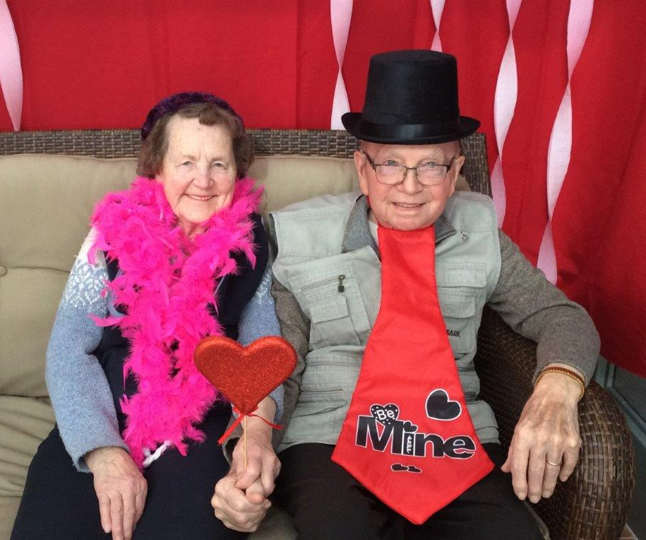
Grey County Operations Report to Committee of Management Open Session
Submission Date: March 10, 2020
Information for the Months of: December 15, 2019-February 14, 2020
Endorsed by Council: April 9, 2020

Quality
Publicly reported indicators/Survey Results

Q2 2019 (July - September 2019)
Indicates Better than Ontario Average
Indicates Worse than Ontario Average

Indicator | Ontario  Average | Rockwood Terrace
 |  | Q3  Oct-Dec/18 | Q4  Jan-Mar 19 | Q1  Apr-Jun 19 | Q2  Jul-Sept 19
Improved or remained independent in mid- loss ADL | 29.0% | 39.40% | 38.90% | 37% | 37.5%
Worsened ADL | 32.4% | 34% | 31.3% | 33.7% | 29.9%
Worsened behavioural symptoms | 12.5% | 14.4% | 11.5% | 13% | 12.2%
Worsened mood from symptoms of depression | 22.4% | 30.7% | 23.6% | 23.3% | 16.7%
Taken antipsychotics without a diagnosis of psychosis | 18.7% | 9.3% | 7.3% | 5% | 2.7%
Has fallen | 16.4% | 14.4% | 14.2% | 13.3% | 11.9%
Worsened stage 2 to 4 pressure ulcer | 2.5% | 3.5% | 5% | 4.4% | 3.1%
New stage 2 to 4 pressure ulcer | 2.1% | 3.1% | 4.6% | 4.1% | 2.9%
Daily physical restraints | 3.8% | 1.8% | 1.9% | 1.7% | 1.5%
Worsened bladder continence | 17.5% | 16.1% | 18.8% | 21.1% | 20.5%
Has pain | 5.7% | 2.5% | 0.40% | 0.20% | 1.0%
Worsened pain | 9.6% | 13.4% | 7.20% | 7.9% | 5.5%

The 2nd quarter data from the Canadian Institute for Health Information (CIHI) has recently been released. Rockwood Terrace is higher than Provincial average in eight (up from six in the first quarter) of the twelve indicators. Three of the remaining four indicators are trending down.
We continue to work on the quality improvement program for wound care/pressure ulcers.

Ministry of Long-Term Care (MOLTC) Compliance Orders /Inspection Findings Summary
An inspector from the Ministry of Health and Long-Term Care attended Rockwood Terrace January 21 and 22, 2020. The purpose of this inspection was to conduct a Critical Incident System Inspection. During this inspection, there was one area of non-compliance related to a delay in the investigation of alleged neglect. A written plan of correction has been developed for achieving compliance to ensure that every alleged, suspected or witnessed incident of abuse or neglect that the licensee knows of, or that is reported, is immediately investigated.
Critical Incident Inspection Jan 27, 2020 - PDF

People
The Care Community said good-bye to two very special high school co-op students when they finished their five-month placement in January. Torrie, a grade ten student and Madison, a grade twelve student both from John Diefenbaker Senior School made a huge impression with team members, families and residents. Both students helped in the nursing and program departments. The students were celebrated with a farewell tea.

Projects, Location Events and Other
Unfortunately, a respiratory outbreak at our home just before Christmas affected many of our Christmas and New Year’s Programs. We were lucky enough to still have Santa Claus Visit on Christmas Day. Our volunteer Santa “Al” along with his wife Kim who is a PSW at the home helped to spread some Christmas Cheer prior to lunchtime. Residents were delighted to receive their cozy Sherpa Blankets at this time.
On Friday January 24th we celebrated Robbie Burns Day with Helen and Bill McMeekin. Residents always enjoy this annual event which includes a delicious lunch served by the Dietary Department and bagpipe music played throughout the home, as the “haggis” is piped in prior to the meal.
Our first Celebration of Life Service for 2020 was held on February 2nd. We honoured thirteen residents who had passed away since our last service. This event was very well attended by both current residents and families of loved ones who had passed away. Our Chaplain Dianne Drysdale led the service and guests enjoyed refreshments and fellowship after the service. Many families who attended expressed gratitude for the care their family member received during their stay at our home.
On Tuesday February 4th we hosted a coffee break to raise money for this worthy cause. Residents enjoyed scrumptious treats at the tuck shop with proceeds going to Heart and Stroke. Rockwood Terrace raised $122.00.
The program staff set up a photo booth for Valentine’s Day which gave our residents an opportunity to get dressed up and have their photos taken on their own, with fellow residents and with their loved ones. Lots of fun was had putting on silly hats and glasses while celebrating this special day!
Music Programs – Residents enjoyed several music programs during this time with the highlight being the return of Spencer Bristow as Elvis. Attendees always look forward to an engaging entertaining show which was held on Feb 8th.
We also initiated some new programs here at the home including a sculpting activity and a scrapbook program. These hands-on activities were greatly enjoyed and will be repeated as the feedback was very positive!

Occupancy
2020 Occupancy Data | Reporting Period | Year to Date
Occupancy | 99.29% | 99.26%
Move-Ins | 10 | 6
Discharges | 9 | 6

Stakeholders (i.e. Ministry of Labour, Public Health, Fire)
There were no visits from Stakeholders during the reporting period.

Environmental (i.e. Emergency Preparedness, Occupational Health and Safety)
Fire drills were held for December and January.
The Care Community experienced a Gastro-Intestinal outbreak from January 5-10.
The Care Community is currently renewing mask fit testing for all team members.
Signage and visitor self screening tools are in place as related to 2019 Norvel Coronavirus.

Written Complaints Summary
There were no written complaints received during the reporting period.

Compliments/ Colour It Story
The Care Community received a card from family of a former resident which stated: “The care she received while a resident was second to none and having come from a private home to Rockwood, I was in a position to see the difference in her personal care and attention.”
There have also been many positive comments at recent care conferences.

Resident/Family Council Updates
The January Resident Council meeting was held on the 25th. As well as the usual agenda, residents were provided a review of Resident’s Rights.
There was no Family Council meeting held during these months.

